🔹 1. API DEVELOPMENT
Build REST APIs:
- /ingest/json → load JSON data
- /ingest/xml → load XML data
- /ingest/csv → load CSV data
- /analytics/summary → return aggregated metrics

🔹 2. DATA PROCESSING (CORE TEST)
Candidates must:
- Flatten nested JSON (orders + items)
- Parse XML properly
- Join datasets (orders + shipments + products)
- Handle:
  - Missing values
  - Data inconsistencies
  - Type conversions

🔹 3. COMPLEX TRANSFORMATIONS
They should derive:
- Total order value
- Delivery delay flag
- Category-level aggregation
- Currency conversion (using API)

🔹 4. DATA STORAGE
Candidates can choose:
- In-memory (dict / pandas)
- SQLite / PostgreSQL
👉 Decision-making is part of evaluation.

🔹 5. PERFORMANCE & DESIGN
Expect:
- Modular code
- Separation of concerns
- Error handling
- API response structuring

🎨 FRONTEND REQUIREMENTS (REACT)

🖥️ DASHBOARD EXPECTATION
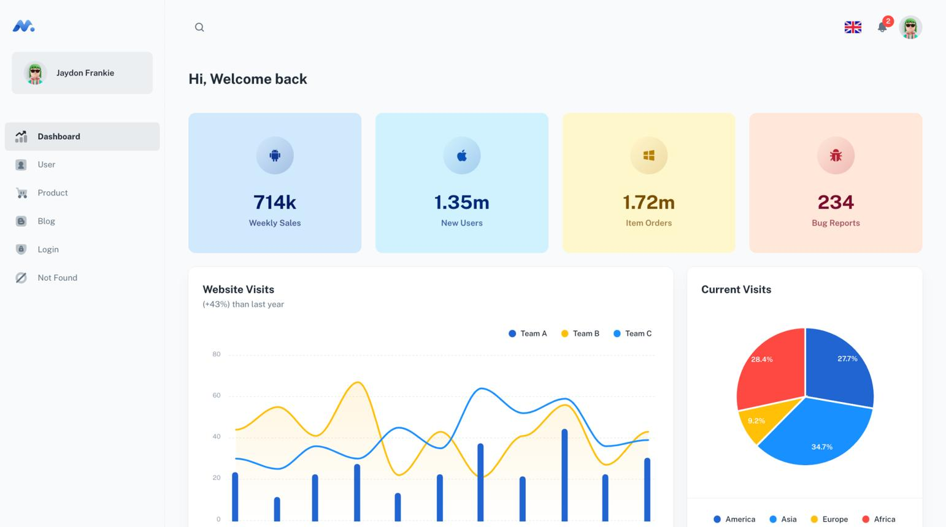
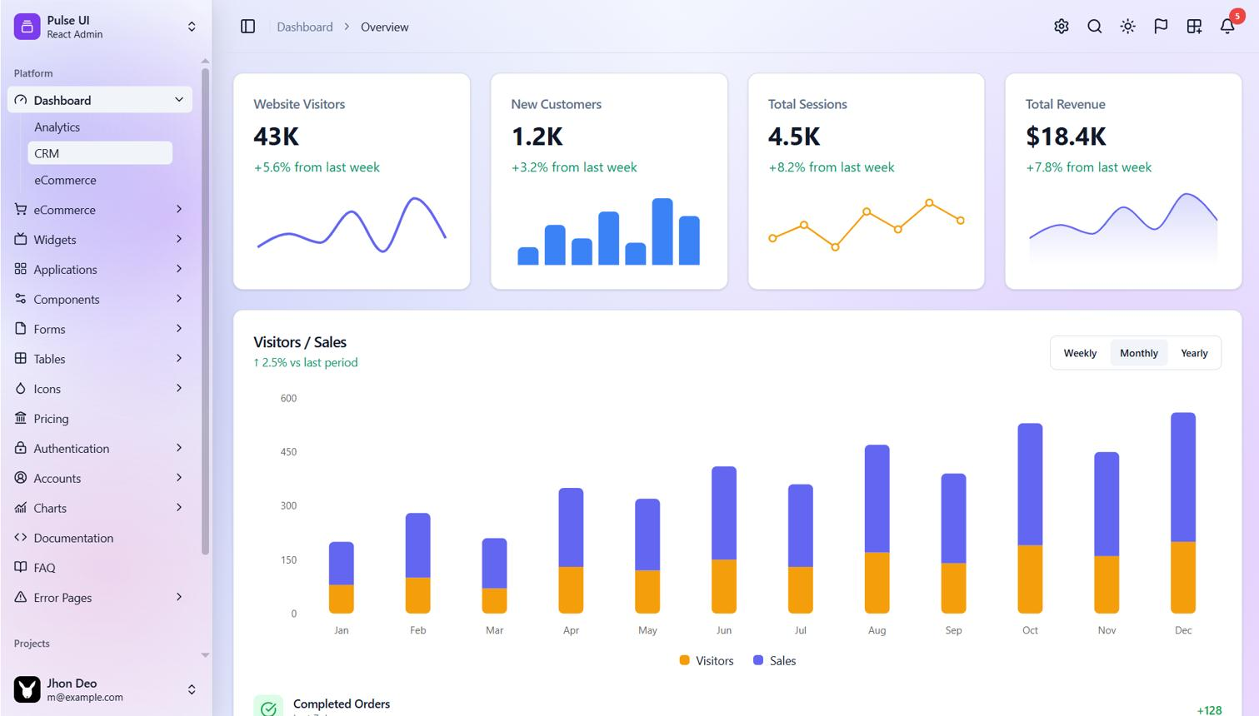
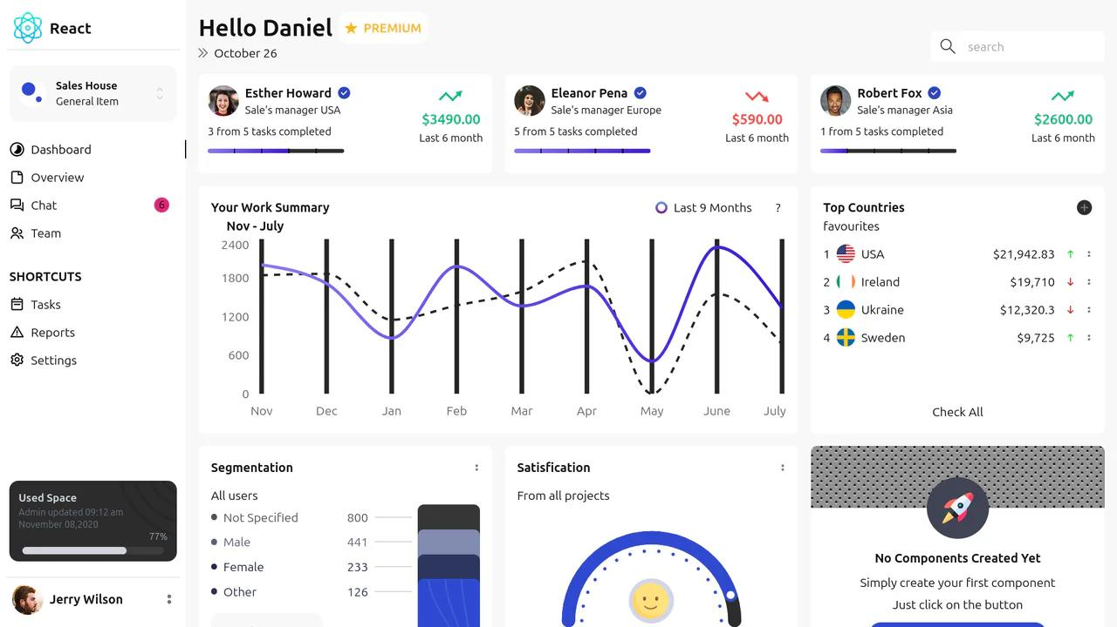
6

🔹 FEATURES TO IMPLEMENT

📊 1. Dashboard Page
- KPI Cards:
  - Total Orders
  - Total Revenue
  - Delayed Orders
- Charts:
  - Revenue trend
  - Category-wise revenue
  - Delivery performance

🎛️ 2. Filters
- Date range
- Category
- Delivery status

🔄 3. Dynamic Data Fetching
- Use API endpoints
- Handle loading + error states

🧩 4. Advanced UI
- Toggle views (e.g., Revenue vs Orders)
- Drill-down capability
- Reusable components

🔥 ADVANCED REQUIREMENTS

Backend
- API pagination
- Caching (optional)
- Async processing (bonus)

Frontend
- State management (Redux / Context)
- API integration best practices
- Responsive design

🧠 WHAT CANDIDATES MUST DECIDE

They should figure out:
- Data model design
- API structure
- Transformation logic
- UI/UX decisions

