Question-1:

Write a program to declare a square matrix A[][] of order (M x M) where ‘M’ must be greater than 3 and less than 10. Allow the user to input positive integers into this matrix. Perform the following tasks on the matrix:

(a) Sort the non-boundary elements in ascending order using any standard sorting technique and rearrange them in the matrix.

(b) Calculate the sum of both the diagonals.

(c) Display the original matrix, rearranged matrix and only the diagonal elements of the rearranged matrix with their sum.

Test your program with the sample data and some random data:

Example 1

INPUT :M = 4

9 2 1 5

8 13 8 4

15 6 3 11

7 12 23 8

OUTPUT:

ORIGINAL MATRIX

9 2 1 5

8 13 8 4

15 6 3 11

7 12 23 8

REARRANGED MATRIX

9 2 1 5

8 3 6 4

15 8 13 11

7 12 23 8

DIAGONAL ELEMENTS

9 5

3 6

8 13

7 8

SUM OF THE DIAGONAL ELEMENTS = 59

Question-2:

Given a square matrix M [ ] [ ] of order ‘n’. The maximum value possible for ‘n’ is 10. Accept three different characters from the keyboard and fill the array according to the instruction given below.

Fill the upper and lower elements formed by the intersection of the diagonals by character 1.

Fill the left and right elements formed by the intersection of the diagonals by character 2.

Fill both the diagonals by character 3.

Output the result in format given below:

Example 1

ENTER SIZE : 4

INPUT : FIRST CHARACTER : ‘*’

SECOND CHARACTER : ‘?’

THIRD CHARACTER : ‘#’

OUTPUT :

# * * #

? # # ?

? # # ?

# * * #

Example 2

ENTER SIZE : 5

INPUT : FIRST CHARACTER : ‘$’

SECOND CHARACTER : ‘!’

THIRD CHARACTER : ‘@’

OUTPUT :

@ $ $ $ @

! @ $ @ !

! ! @ ! !

! @ $ @ !

@ $ $ $ @

Example 3

ENTER SIZE : 65

OUTPUT : SIZE OUT OF RANGE

Question-3:

Write a Program in Java to input a 2-D square matrix and check whether it is a Lower Triangular Matrix or not.

Lower Triangular Matrix : A Lower Triangular matrix is a square matrix in which all thse entries above the main diagonal are zero. The entries below or on the main diagonal themselves may or may not be zero.

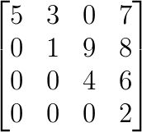

Question-4:

Write a Program in Java to input a 2-D square matrix and check whether it is an Upper Triangular Matrix or not.

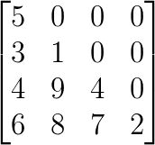

Upper Triangular Matrix : An Upper Triangular matrix is a square matrix in which all the entries below the main diagonal (↘) are zero. The entries above or on the main diagonal themselves may or may not be zero.

Question-5:

Write a Program in Java to input a 2-D square matrix and check whether it is a Scalar Matrix or not.

Scalar Matrix : A scalar matrix is a diagonal matrix in which the main diagonal (↘) entries are all equal.

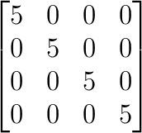

Write a Program in Java to input a 2-D square matrix and check whether it is a Diagonal Matrix or not.

Diagonal Matrix : A diagonal matrix is a matrix (usually a square matrix) in which the entries outside the main diagonal (↘) are all zero. The diagonal entries themselves may or may not be zero (but all diagonal entries cannot be zero).

Question-7:

Write a program to declare a square matrix A[ ][ ] of order ‘n’. Allow the user to input positive integers into this matrix. Perform the following tasks on the matrix:

(i) Output the original matrix.

(ii) Find the SADDLE POINT for the matrix. If the matrix has no saddle point, output the message “NO SADDLE POINT”.

[Note: A saddle point is an element of the matrix such that it is the minimum element for the row to which it belongs and the maximum element for the column to which it belongs. Saddle point for a given matrix is always unique.]

Example: In the Matrix

4 5 6

7 8 9

5 1 3

Saddle point = 7 because it is the minimum element of row 2 and maximum element of column 1

Question-8:

Write a Program in Java to fill a 2-D array with the first ‘m*n’ prime numbers, where ‘m’ is the number of rows and ‘n’ is the number of columns.

For example: If rows = 4 and columns = 5, then the result should be:

Question-8:

Write a Program in Java to input a 2-D array of size ‘m*n’ and print its boundary (border) elements.

For example:

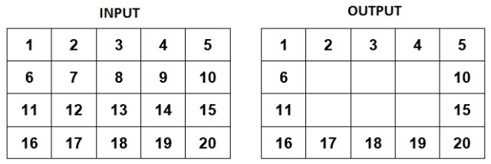

Question-9:

A square matrix is said to be a Magic Square, if the sum of each row, each column and each diagonal is same. Write a program to enter an integer number ‘n’. Create a magic square of size ‘n*n’. Finally, print the elements of the matrix as Magic Square.

Note: n <= 5

Sample Input: Enter the size of the matrix : 4

Sample Output: The Magic Matrix of size 4×4 is: