Day-15 of 101days Coding challenge.

--------------------------------------------------POINTER------------------------------------------

* \* dereferencing , (or used to access the value)
* & referencing , (or using the address of the variable)
* Pointer----

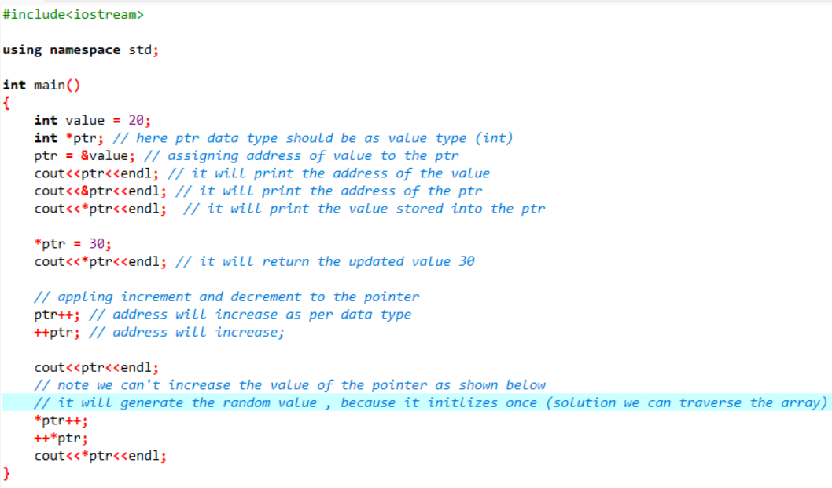

* Output-----

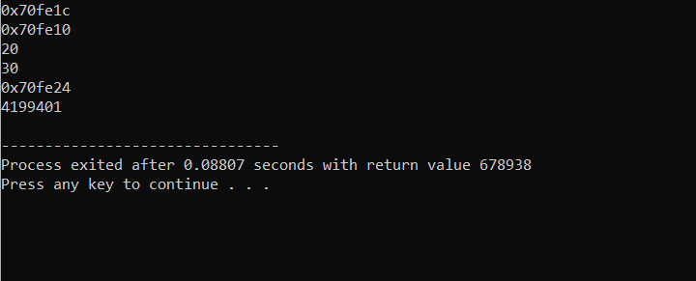

* Pointer To array

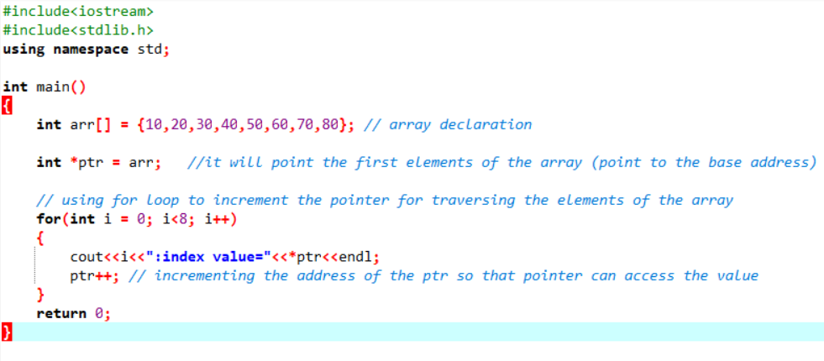

* Output

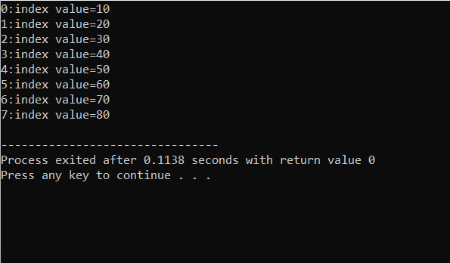

* Pointer To pointer

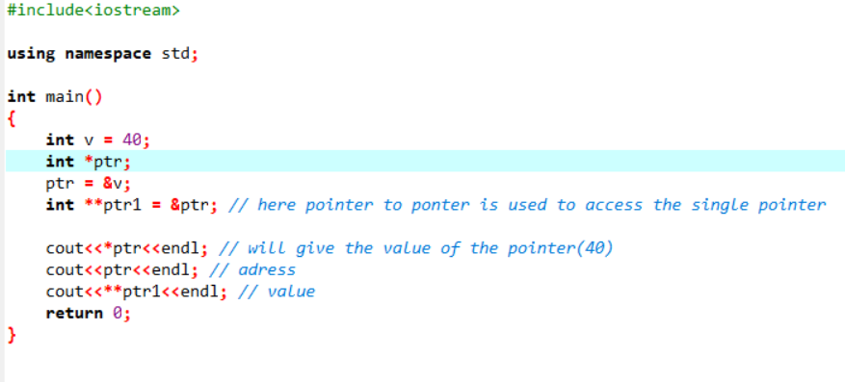

* Output

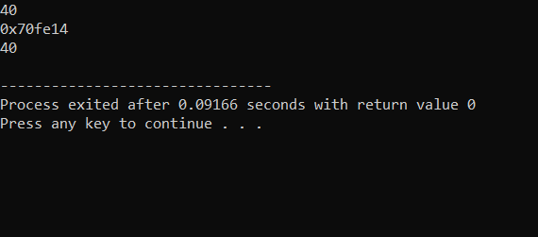

------------------Now Some Online Found Resources------------

* Pointer

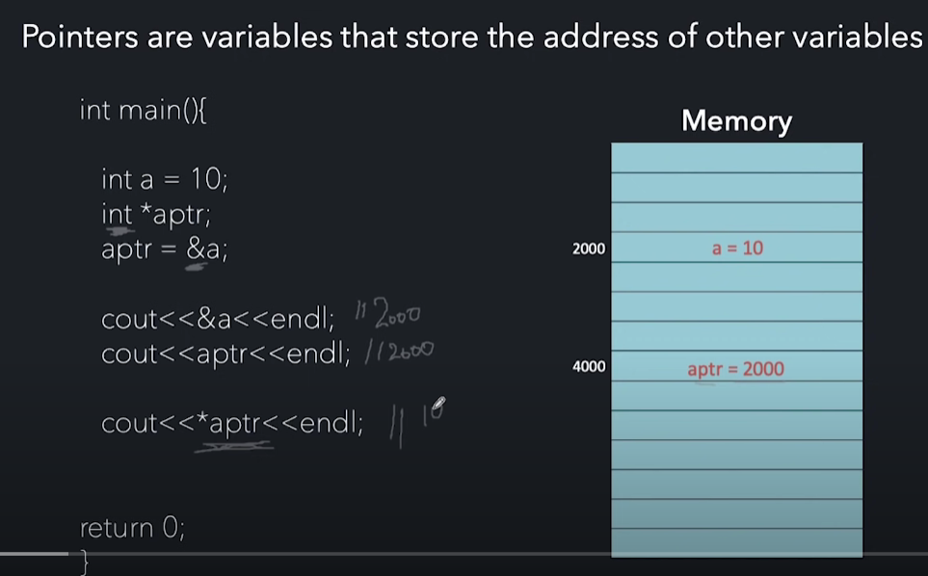

* Pointer To Pointer

