**Day – 18 of 101 days coding challenge**

**---------------------------------------------------String------------------------------------------**

* 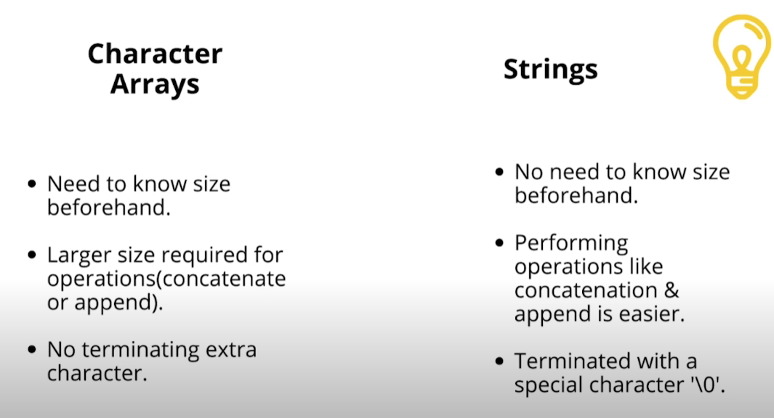

**Code:-**

**#include<iostream>**

**#include<algorithm>**

**#include<string.h>**

**using namespace std;**

**int main()**

**{**

**// diiferent way of input string**

**string str2 = "Ravi kumar Pathak";**

**string str1, str3, str4;**

**string str(12, 'n'); // it will show 12 times ravi**

**cout<<str<<endl;**

**cout<<"Enter the string"<<endl; // 2nd way**

**cin>>str1;**

**cout<<str2<<endl; // 3rd way**

**// string functions**

**cout<<"String functions"<<endl;**

**// adding two string**

**str3 = "Hello,";**

**str4 = "Ravi";**

**str3.append(str4); // 1st way**

**cout<<str3<<endl;**

**cout<<str1 + str2 <<endl; // 2nd way**

**// accessing the particuler charecter of the string**

**cout<<str3[2]<<endl;**

**// comparing the size of the string**

**cout<<str3.compare(str4)<<endl; // if 0 then equal +(str3 >) and -(str3<)**

**// empty**

**cout<<str3.empty()<<endl;**

**// inserting element into the string**

**cout<<str3.insert(3, "go")<<endl;**

**// finding the length**

**cout<<str3.length()<<endl;**

**// sorting the string**

**sort(str3.begin(), str3.end());**

**cout<<str3<<endl;**

**return 0;**

**}**

**Output:-**

