Day – 19 of the 101 days of coding challenge

-----------------------------String continue…..-------------------------------------

Ques – Given strings convert into upper case and lower case both.

Code:-

#include<iostream>

#include<string.h>

using namespace std;

int main()

{

string str;

cout<<"Enter the string"<<endl;

cin>>str;

// upper case converting

for(int i = 0; i<str.size(); i++)

{

if(str[i] >= 97 && str[i]<=122)

{

str[i]-=32;

}

}

cout<<str<<endl;

// Lower case converting

for(int i = 0; i<str.size(); i++)

{

if(str[i] >= 65 && str[i]<=90)

{

str[i]+=32;

}

}

cout<<str<<endl;

return 0;

}

Output:-

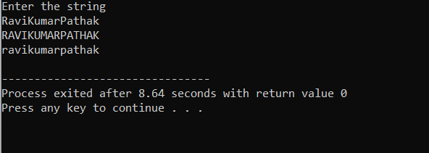

2-Method By using the algorithms—

Code:-

#include<iostream>

#include<algorithm>

#include<string.h>

using namespace std;

int main()

{

string str;

cout<<"Enter the string"<<endl;

cin>>str;

// using built in algorithms

// for upper case

transform(str.begin(), str.end(), str.begin(), :: toupper);

cout<<str<<endl;

// for lower case

transform(str.begin(), str.end(), str.begin(), :: tolower);

cout<<str<<endl;

return 0;

}

Output:-

