**Day -21 of 101 days coding challenge**

**---------------------Sieve of Eratosthenes--------------------------------------------------**

* **Suppose we are going to find the prime number of the given Number**
* **According to this approach we are going to make one array till we want**
* **And divide with each prime number if it is divided then we mark it if not divided then unmark it , that unmark is a prime number.**

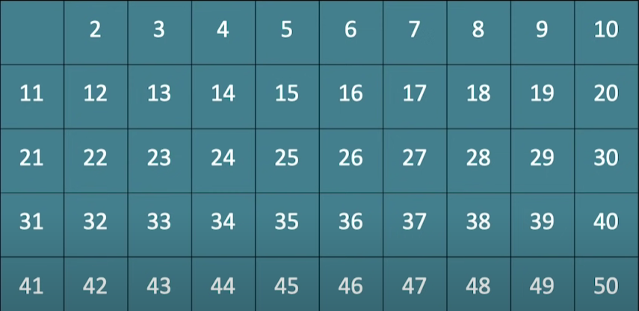

**According to the above’s array we can start this process by 2 as it is first prime number here.**

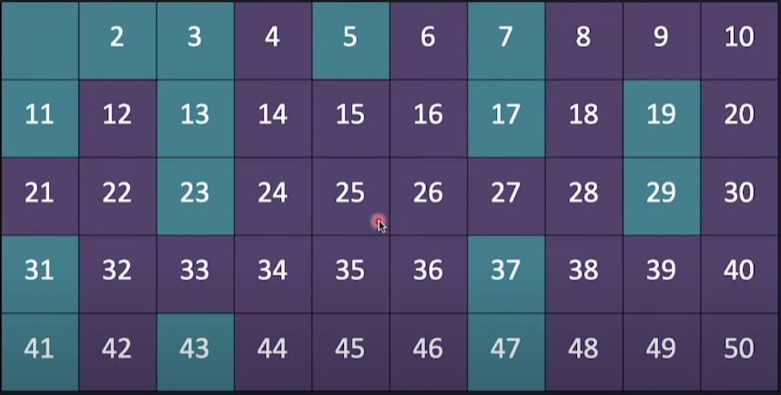

* **All the colored number is a non-prime number and remaining’s is prime number.**

**Code:**

#include<iostream>

using namespace std;

int sieveEratosth(int n)

{

int prime[100] = {0}; // initilize the array with zero (at the begining 0 will reflect to the all indexes)

int i,j;

for(i = 2; i<=n; i++) // i = 2 due to prime number starts from 2

{

if(prime[i] == 0) // if unmarked then

{

for(j = i*i; j<=n; j+=i)

{

prime[j] = 1; // here if found divisible from the ith number will marked as 1

}

}

}

// going tp print that number which has 0 (unmarked)

for(i = 2; i<=n; i++)

{

if(prime[i] == 0)

{

cout<<i<<" ";

}

}cout<<endl;

}

int main()

{

int n;

cout<<"Enter the Size till you want make the arrray"<<endl;

cin>>n;

// calling and passing the number into the function

cout<<"All the prime numbers"<<endl;

sieveEratosth(n);

return 0;

}

Output:

