**Day-25 of the 101 days Coding challenge**

* **Backtracking**
* **It’s a Concept where we are finding the feasible Solutions**
* **Like-> If one node goes to the one solution and it does not fit the node, then it will come to its previous positions, and from there again, try another option, so this situation is known as backtracking.**

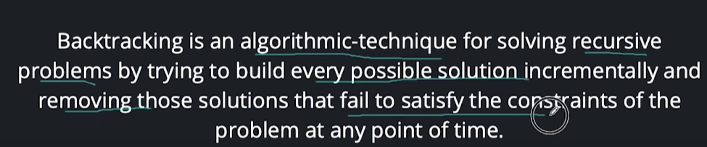

**Problem:**

**Input:**

**0 denotes wall, 1 denotes free path**

**two numbers n, m**

**Next n lines contain m numbers (0 or 1)**

**Output:**

**Print 1 if rat can reach (n-1,m-1)**

**Print 0 if it can not reach (n-1,m-1)**

**Test Case 1:**

**Input:**

**5 5**

**1 0 1 0 1**

**1 1 1 1 1**

**0 1 0 1 0**

**1 0 0 1 1**

**1 1 1 0 1**

**Output:**

**1**

**Code:**

#include<iostream>

using namespace std;

// checking our position is right or wrong

bool isSafe(int **arr, int x, int y, int n)

{

if(x<n && y<n && arr[x][y] == 1) // if it is in right position

{

return true;

}

return false; // if not in right position(if arr[x][y] == 0) return false

}

bool inBoxposition(int **arr, int x, int y, int n, int **outArr)

{

// base condition

if(x == n-1 && y == n-1)

{

outArr[x][y] = 1; // stores 1 on sucessful

return true;

}

if(isSafe(arr,x,y,n)){

outArr[x][y] = 1;

if(inBoxposition(arr, x+1, y, n, outArr)) // recursivly calling if condition is satisfied then incrementing the path on x axis

return true;

if(inBoxposition(arr, x, y+1, n, outArr)) // recursivly calling if condition is satisfied then incrementing the path on y axis

return true;

}

arr[x][y] = 0; // backtracking

return false;

}

int main()

{

int n;

cout<<"Enter the size of the elements"<<endl;

cin>>n;

// dynamically alocating the memory

int **arr = new int*[n];

for(int i = 0; i<n; i++)

{

arr[i] = new int [n]; // one D

}

// user Input

for(int i = 0; i<n; i++)

{

for(int j = 0; j<n; j++)

{

cin>>arr[i][j];

}

}

cout<<endl;

// Solution array

int **outarr = new int*[n];

for(int i = 0; i<n; i++)

{

outarr[i] = new int [n];

// intilizing the initial value 0 so that garbage value will not occur into the array

for(int j = 0; j<n; j++)

{

outarr[i][j] = 0;

}

}

// now calling the function

cout<<"Output :"<<endl;

if(inBoxposition(arr, 0, 0, n,outarr))

{

for(int i = 0; i<n; i++)

{

for(int j = 0; j<n;j++)

{

cout<<outarr[i][j]<<" ";

} cout<<endl;

}

}

return 0;

}

Output:

