**Day – 26 of the 101 days coding challenge**

* Merge Sort
* It’s also a type of sorting algorithm that applies the concept of divide and conquer.
* Example-

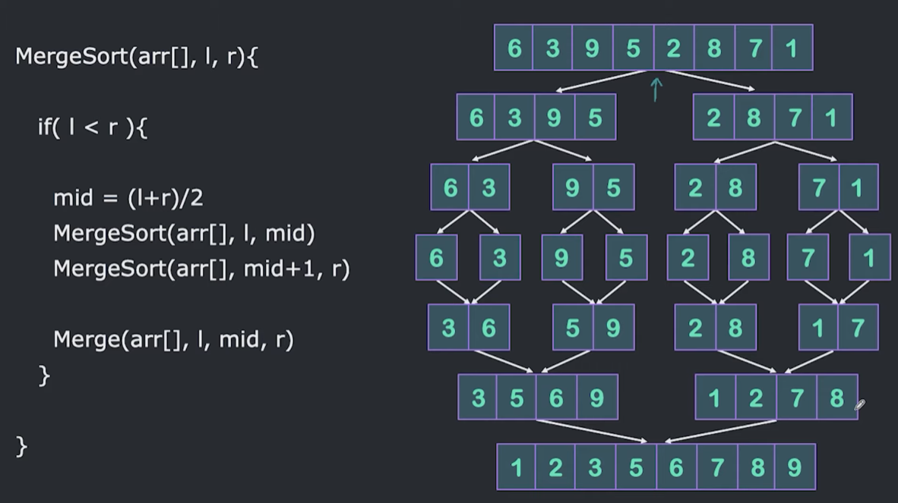

* After dividing and merging we would be having two array
* First array’s first elements will point by the one pointer and another one from another pointer then will compare each.

Code:

#include<iostream>

using namespace std;

void merge(int arr[], int l, int mid, int r){

int n1 = mid-l+1;

int n2=r-mid;

int a[n1];

int b[n2];

for(int i=0;i<n1;i++){

a[i]=arr[l+i];

}

for(int i=0;i<n2;i++){

b[i]=arr[mid+1+i];

}

int i=0;

int j=0;

int k=l;

while(i<n1 && j<n2){

if(a[i]<b[j]){

arr[k] = a[i];

k++;

i++;

}

else{

arr[k] = b[j];

k++;

j++;

}

}

while(i<n1){

arr[k]=a[i];

k++;

i++;

}

while(j<n2){

arr[k]=b[j];

k++;

j++;

}

}

void mergeSort(int arr[], int l, int r)

{

if(l<r){

int mid = (l+r)/2;

mergeSort(arr, l, mid);

mergeSort(arr, mid+1, r);

merge(arr,l,mid,r);

}

}

int main()

{

int arr[] = {5,4,3,2,1};

mergeSort(arr,0,4);

for(int i=0;i<5;i++){

cout<<arr[i]<<" ";

}

cout<<endl;

return 0;

}

Output:

