**Day-27 of 101 days coding challenge**

* **Solved Different Pattern Problems**

1. **Triangle:**

**Code:**

#include<iostream>

using namespace std;

int main()

{

int size, i, j; // both row and column is same

cout<<"Enter the size of the row and column:"<<endl;

cin>>size;

int num = 1;

cout<<"Created Pattern"<<endl;

for(i = 1; i<=size; i++)

{

for(j = 1; j<=i; j++){

cout<<num<<" ";

num++;

}

cout<<endl;

}

}

Output:

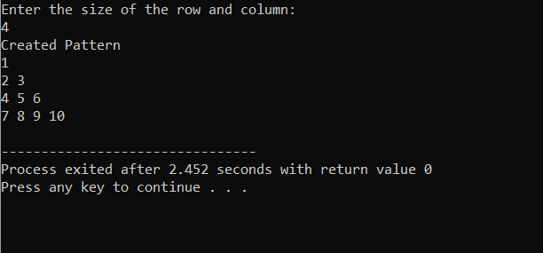

2->

Code:

#include<iostream>

using namespace std;

int main()

{

int size, i, j; // both row and column is same

cout<<"Enter the size of the row and column:"<<endl;

cin>>size;

int num;

cout<<"Created Pattern"<<endl;

for(i = 1; i<=size; i++)

{

num = i;

for(j = 1; j<=i; j++){

cout<<num<<" ";

num++;

}

cout<<endl;

}

}

Output:

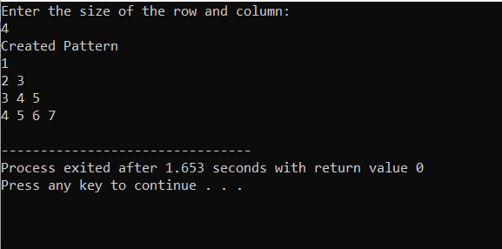

3->

#include<iostream>

using namespace std;

int main()

{

int size, i, j; // both row and column is same

cout<<"Enter the size of the row and column:"<<endl;

cin>>size;

int num;

cout<<"Created Pattern"<<endl;

for(i = 1; i<=size; i++)

{

num = i;

for(j = 1; j<=i; j++){

cout<<num<<" ";

num--;

}

cout<<endl;

}

}

Output:

