**Day-32 of the 101days Coding challenge**

* **Swapping the Alternate elements of the array**
* **Like – [1,2,3,4,5,6]**
* **Ans=> [2,1,4,3,6,5]**

**Code:**

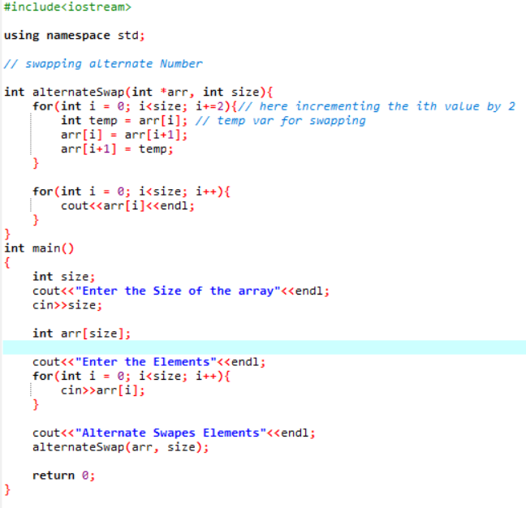

Output:

