**Day-41 of the #101 days of coding challenge—**

**Problem:-** Write a C++ program to update every array element by multiplication of the next and previous values of a given array of integers.

Code:-

#include<iostream>

using namespace std;

void replaceNextMulPrevious(int *arr, int n)

{

int i,j;

int *arrCopy;

// coping all array elements to the another array

for(i = 0; i<n; i++)

{

arrCopy[i] = arr[i];

}

for(i = 0; i<n; i++)

{

for(j = 0; j<n; j++)

{

if(j == 0) // for initial elements there will br not any elements so elements itself multiply by next one

{

arr[j] = arrCopy[j] * arrCopy[j+1];

}

else if(j == n-1) // at the end itself multiply by previous one

{

arr[j] = arrCopy[j] * arrCopy[j-1];

}

else{ // multiply current element's previous and next and replace it to the current

arr[j] = arrCopy[j-1] * arrCopy[j+1];

}

}

}

}

int main()

{

int n;

cout<<"Enter the size of the elements"<<endl;

cin>>n;

int arr[n];

cout<<"Enter the array's elements"<<endl;

for(int i = 0; i<n; i++)

{

cin>>arr[i];

}

replaceNextMulPrevious(arr, n);

cout<<"Solved :"<<endl;

for(int i = 0; i<n; i++)

{

cout<<arr[i]<<" ";

}

return 0;

}

Output:-

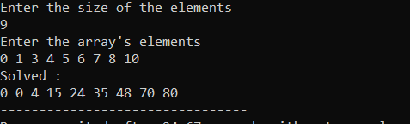

**Problem:-** Write a C++ program to rearrange the elements of a given array of integers in a zig-zag pattern.  
Note: The format zig-zag array in form a < b > c < d > e < f.

Code:-

#include<iostream>

using namespace std;

void swap(int *a, int *b)

{

int temp;

temp = *a;

*a = *b;

*b = temp;

}

void zigzagPatteren(int *arr, int n)

{

int i, j;

for(i = 0; i<n; i++)

{

for(j = 1; j<n-1; j+=2) // swap on each odd number index

{

swap(&arr[j], &arr[j+1]);

}

}

}

int main()

{

int n,i;

cout<<"Enter the size of the array"<<endl;

cin>>n;

int arr[n];

cout<<"Enter the elements of the array"<<endl;

for(i = 0; i<n; i++)

{

cin>>arr[i];

}

zigzagPatteren(arr, n);

cout<<"Solved:"<<endl;

for(i = 0; i<n; i++)

{

cout<<arr[i]<<" ";

}

return 0;

}

Output:-

