**Problem** Solving**-------**

1. Finding two Significant elements of the array.

Code—

**#include<iostream>**

**using namespace std;**

**int findTwoSignificantElements(int *arr, int n)**

**{**

**int i, j, count = 0;**

**for(i = 0; i<n; i++)**

**{**

**for(j = 0; j<n; j++)**

**{**

**if(arr[i] < arr[j])**

**{**

**count++;**

**if(count==2)**

**{**

**cout<<arr[i] <<" ";**

**break;**

**}**

**}**

**}**

**count = 0;**

**}**

**}**

**int main()**

**{**

**int n, i;**

**cout<<"Enter the size of the array"<<endl;**

**cin>>n;**

**int arr[n];**

**cout<<"Enter the array's elements"<<endl;**

**for(i = 0; i<n; i++)**

**{**

**cin>>arr[i];**

**}**

**findTwoSignificantElements(arr, n);**

**return 0;**

**}**

**// finding significant elements------**

**//12, 23, 4, 6, 78**

**//**

**//1-> 12> 23, 78 true**

**//2-> 4> 6, 12, 23, 78 true**

**//3-> 6> 12, 23, 78 true**

**//4-> 23> 78(only one elements) false**

**//last one false**

**Output:-**

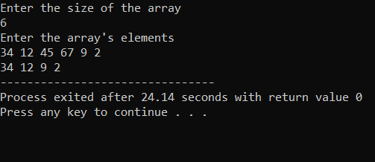

1. **Finding Most frequent elements into the array-----**

**Code—**

**#include<iostream>**

**using namespace std;**

**int mostFrequentElements(int *arr, int n)**

**{**

**int i,j, count, countPrev = 0;**

**int temp = -1;**

**for(i = 0; i<n; i++)**

**{**

**count = 1; // on each new iteration of i counter set 1**

**for(j = i+1; j<n; j++) // here j = i+1 so that array out of bound eroor will not occur**

**{**

**if(arr[i] == arr[j])**

**{**

**count++;**

**}**

**}**

**if(count>countPrev) // if getting higher frequency then updating the counter value**

**{**

**countPrev = count;**

**temp = arr[i]; // storing mostFrequent elements then previousOne**

**}**

**}**

**cout<<"Most Frequent Element is: "<<temp<<":: Occures ::"<<countPrev<<"::Times"<<endl;**

**}**

**int main()**

**{**

**int n, i;**

**cout<<"Enter the size of the array"<<endl;**

**cin>>n;**

**int arr[n];**

**cout<<"Enter the array's elements"<<endl;**

**for(i = 0; i<n; i++)**

**{**

**cin>>arr[i];**

**}**

**mostFrequentElements(arr, n);**

**return 0;**

**}**

**// mostFrequentElements**

**//12 23 34 5 12 23 34, 5, 34, 23, 34;**

**//1st iteration----**

**//12 -> 2 times = countPrev = 2**

**//23 -> 3 times = countPrev = 3**

**//34 -> 4 times = countPrev = 4**

**Output—**

