 | 

Project Report
on
Personal Budget Tracker
CI/CD Pipeline Automation using Jenkins
Submitted by
Rahul Kumar
25MCC20051
25MCC-101 ‘A’
SUBJECT: DEVOPS PROCESS AUTOMATION LAB
MASTER OF COMPUTER APPLICATIONS
CLOUD COMPUTING & DEVOPS

Chandigarh University
OCT 2026

Abstract
This report documents the automation of the build, test and deployment workflow of a Personal Budget Tracker using a Jenkins declarative CI/CD pipeline. The application is a Python Flask web application with a MongoDB database, which was previously containerized with Python virtual environment and native MongoDB. In this lab project, a Jenkins Pipeline job named budget-tracker was created that pulls the source code and the Jenkinsfile from a GitHub repository (branch main), checks the Python environment, runs the automated pytest suite, executes the Application Verification stage, and performs a verification stage, followed by post-build actions.
The pipeline was executed seven times. Builds #2 to #6 failed while the pipeline was being configured and corrected; builds #5 and #6 failed in the Automated Tests stage, and build #7 (29 Oct 2026, 15:25:27) completed successfully in 18 seconds with every stage passing. The purpose of the project is to remove manual, repeated steps from the delivery process and to give the developer fast, repeatable feedback on every change.
Keywords: Personal Budget Tracker, DevOps, CI/CD, Jenkins, Jenkinsfile, Declarative Pipeline, Pytest, Docker, GitHub, Flask, MongoDB, Process Automation.

1. Introduction

1.1 Background
A personal budget tracker application supports operations such as tracking income, expense categorization (Food, Travel, Bills, Shopping, Healthcare), and calculating remaining balance. Every change to such an application must be built, tested and deployed. When these steps are performed by hand they are slow, easy to forget and different on every machine, so defects can reach the deployed system.
DevOps process automation addresses this by describing the build, test and deployment steps as code and running them automatically on a CI/CD server. In this project Jenkins is used as the automation server. The pipeline definition is stored in a file named Jenkinsfile inside the project repository, so it is version-controlled together with the application source code.

1.2 Aim
To automate the checkout, environment verification, automated testing, Application Verification stage and verification of the Flask-based Personal Budget Tracker using a Jenkins declarative pipeline connected to a GitHub repository.

1.3 Objectives
- To create a Jenkins Pipeline job that loads its Jenkinsfile from source control (Pipeline script from SCM).
- To connect Jenkins to the GitHub repository and the main branch of the project.
- To verify the Python and pip tools available on the build agent before building.
- To run the automated pytest suite on every build and stop the pipeline when a test fails.
- To run the Application Verification stage and a final verification stage only after the tests pass.
- To monitor build history, stage timings and results through the Jenkins dashboard.

1.4 Technologies Used
Technology | Role in this project
Jenkins 2.568.1 | CI/CD automation server that runs the pipeline job
Jenkins Declarative Pipeline | Pipeline syntax used in the Jenkinsfile (pipeline, agent, environment, stages, steps, post)
GitHub | Hosts the source code and the Jenkinsfile (Rahulkumar18-11/budget)
Git | Source control; Jenkins checks out branch */main
Python 3.13 / pip | Runtime and package manager on the Windows build agent
Pytest | Automated test framework executed in the Automated Tests stage
Flask + MongoDB | Personal Budget Tracker application and its database
Native MongoDB Database | Containerization of the application (covered in the earlier Docker report) and the Application Verification stage of the pipeline
Antigravity IDE | Editor used to write the Jenkinsfile and project code
Table 1.1: Technology stack of the project

2. System Design and Pipeline Architecture
The developer pushes code and the Jenkinsfile to the main branch of the GitHub repository. The Jenkins job budget-tracker is configured as “Pipeline script from SCM”: Jenkins clones the repository, reads the Jenkinsfile from the repository root and executes the stages in order. A failure in any stage stops the pipeline, and the later stages are skipped.
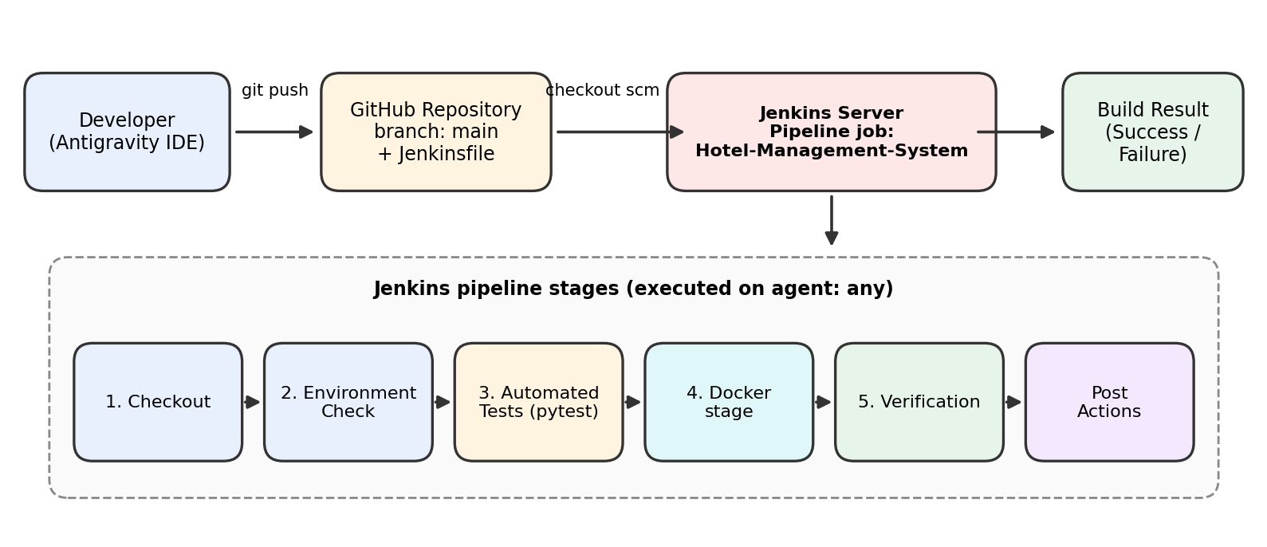
Figure 2.1: Logical architecture of the Jenkins CI/CD pipeline

2.1 Pipeline Stages
No. | Stage | Purpose
0 | Declarative: Checkout SCM | Automatic first stage in which Jenkins fetches the Jenkinsfile from the repository.
1 | Checkout | Runs checkout scm to obtain the application source code in the workspace.
2 | Environment Check | Prints python.exe --version and python.exe -m pip --version to confirm the tools exist on the agent.
3 | Automated Tests | Runs python.exe -m pytest -v. The build fails here if any test fails.
4 | Application Verification stage | Docker-related step of the pipeline (shown as “Docker…” in the Stages view).
5 | Verification | Final verification step after the Application Verification stage (shown as “Verification…” in the Stages view).
6 | Post Actions | Declarative post section that always runs, whether the build passes or fails.
Table 2.1: Stages of the budget-tracker pipeline
Note: the Jenkinsfile screenshot shows the first three stages in full. The stage names of stages 4 and 5 are truncated in the Stages view, so their exact names and commands should be checked in the Jenkinsfile and written in here before submission.

2.2 Build Agent
The pipeline uses agent any, so Jenkins runs it on any available executor. The steps use the bat step with python.exe, which shows that the build agent is a Windows machine with Python 3.13 installed. The dashboard shows two idle executors and an empty queue.

3. Jenkinsfile Configuration
The Jenkinsfile is stored in the root of the project, next to app.py, Dockerfile, docker-compose.yml and requirements.txt. The beginning of the file, as visible in the IDE, is shown below.

3.1 Jenkinsfile (first part, as shown in the IDE)
pipeline {
agent any

environment {
APP_NAME = "budget"
PORT = "5000"
PYTHONPATH = "."
PATH = "C:\\Python313\\Scripts;C:\\Python313;..." // Windows paths
}

stages {
stage('Checkout') {
steps {
echo ' Stage 1: Checkout Source Code'
checkout scm
}
}
stage('Environment Check') {
steps {
echo ' Stage 2: Checking Python & Tools'
bat 'python.exe --version'
bat 'python.exe -m pip --version'
}
}
stage('Automated Tests') {
steps {
echo ' Stage 3: Running Automated Pytest Suite'
bat 'python.exe -m pytest -v'
}
}
// Docker, Verification stages and post { } section follow in the file
}
}

3.2 Explanation of the Jenkinsfile
Element | Purpose
pipeline { } | Root block of a declarative pipeline.
agent any | Allows the pipeline to run on any available Jenkins agent.
environment { } | Defines variables available to all stages: APP_NAME, PORT (5000, the Flask port), PYTHONPATH (project root) and PATH (Python locations).
stages / stage | Divides the work into named steps that appear as columns in the Stages view.
checkout scm | Checks out the same repository and branch that the job is configured with.
bat | Runs a Windows batch command on the agent.
python.exe -m pytest -v | Runs the automated tests in verbose mode; a non-zero exit code fails the stage.
post { } | Runs after the stages; shown as the “Post Actions” stage in the Stages view.
Table 3.1: Main elements of the Jenkinsfile
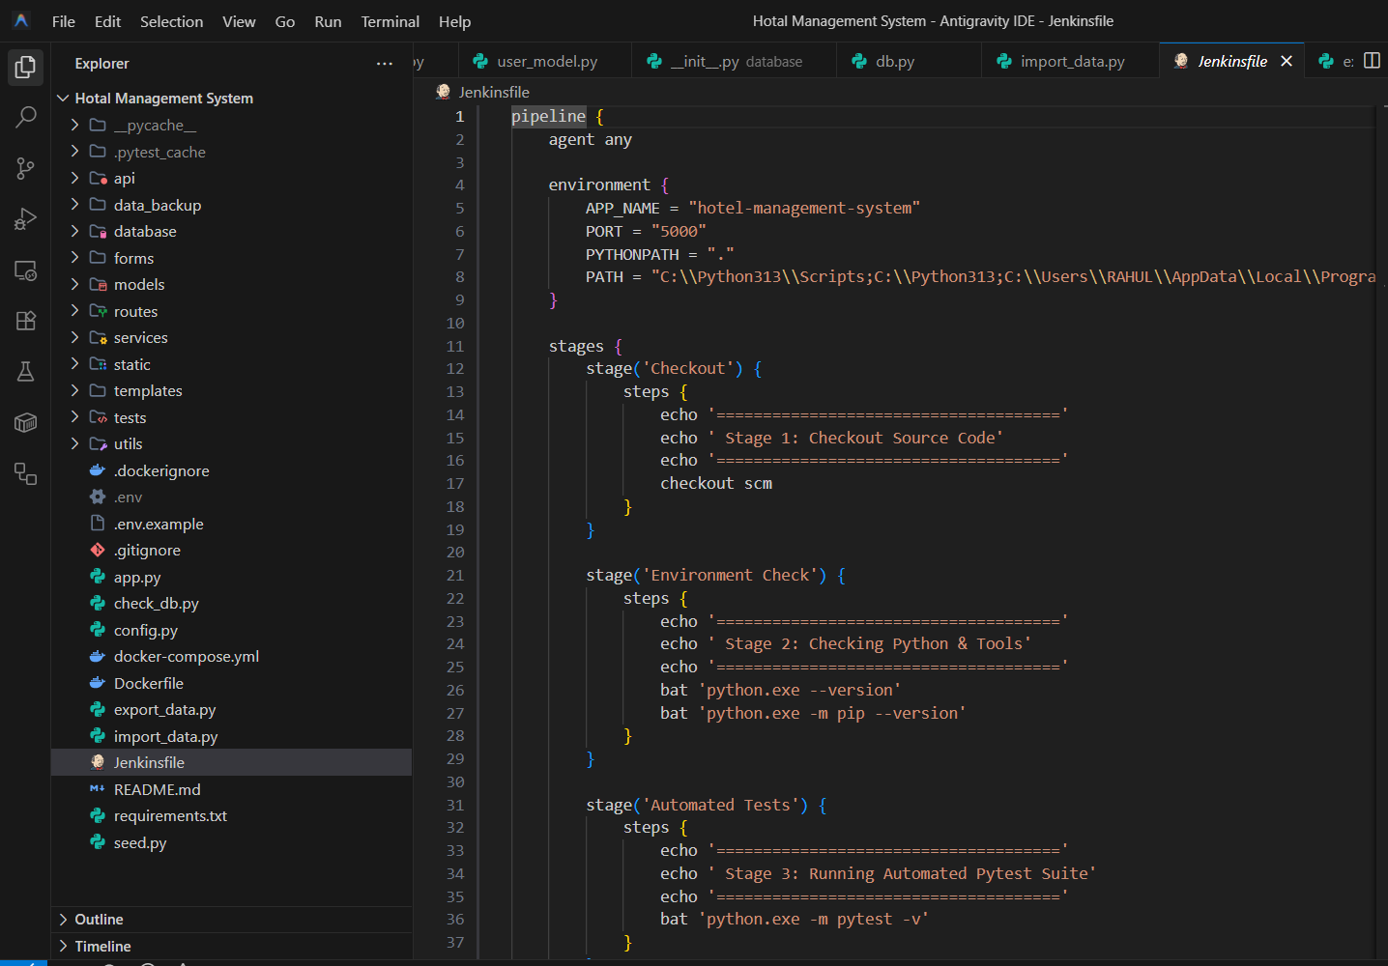
Figure 3.1: Jenkinsfile opened in the Antigravity IDE

4. Jenkins Job Configuration
A new item of type Pipeline named budget-tracker was created in Jenkins. Its description is “CI/CD Automated Deployment Pipeline for Personal Budget Tracker”. The settings below were used.
Setting | Value
Job type / name | Pipeline / budget-tracker
Status | Enabled
Definition | Pipeline script from SCM
SCM | Git
Repository URL | https://github.com/Rahulkumar18-11/budget.git
Credentials | - none - (repository accessed without stored credentials)
Branch specifier | */main
Script path | Jenkinsfile
Lightweight checkout | Enabled
Table 4.1: Jenkins job configuration
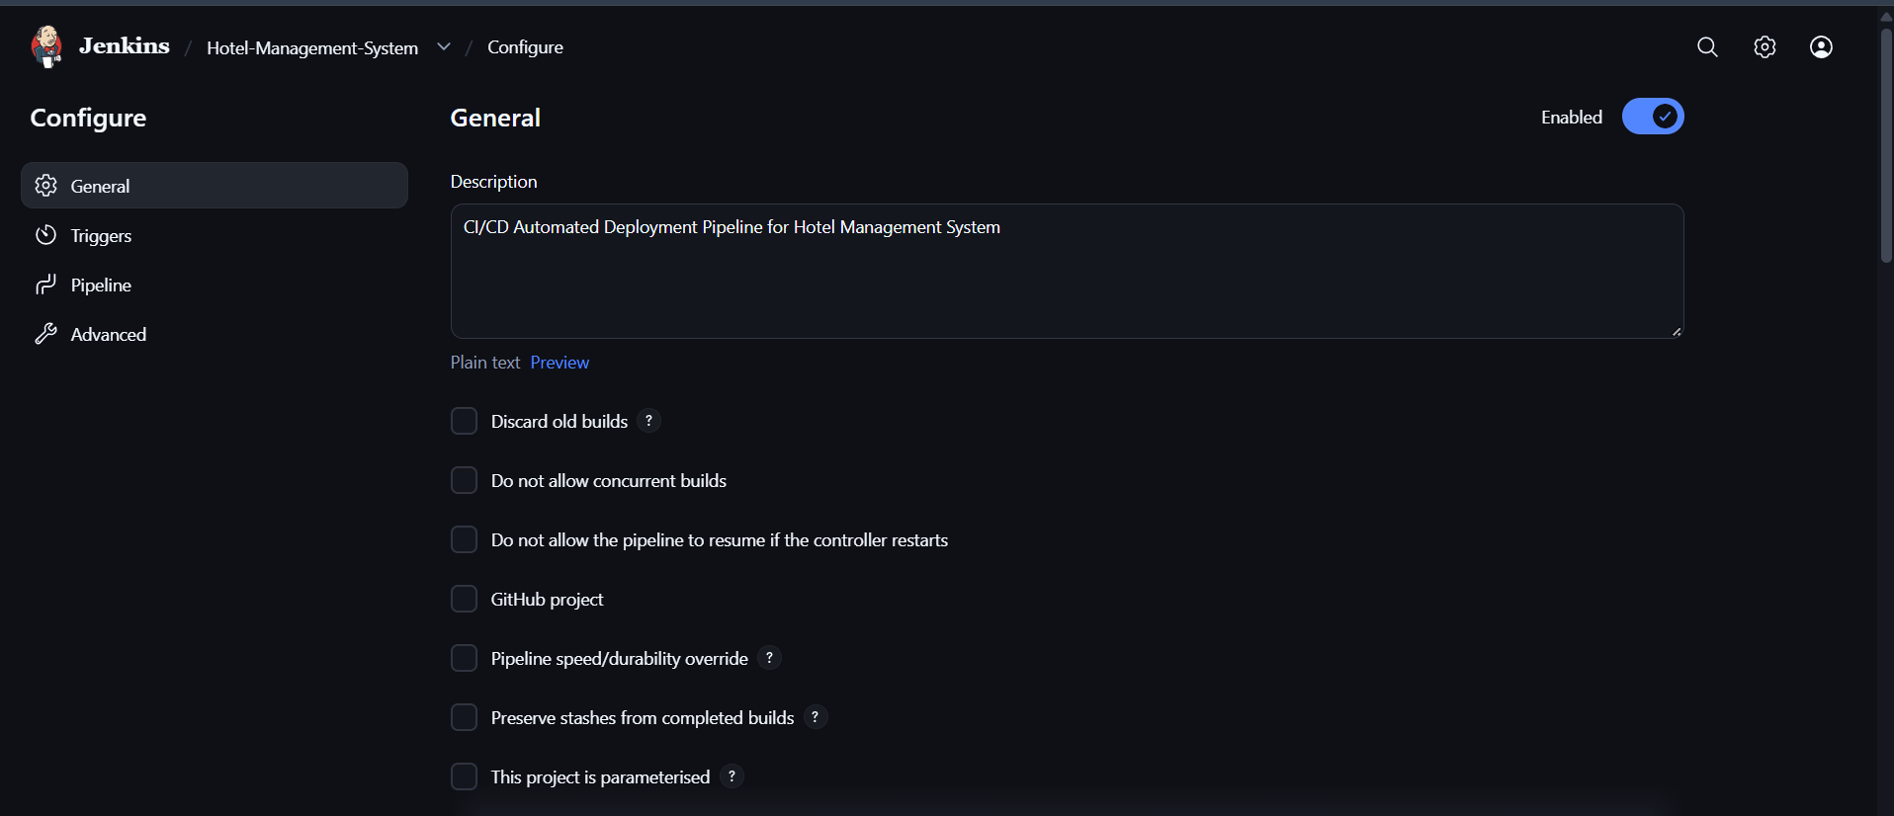
Figure 4.1: Configure → General (job description and options)
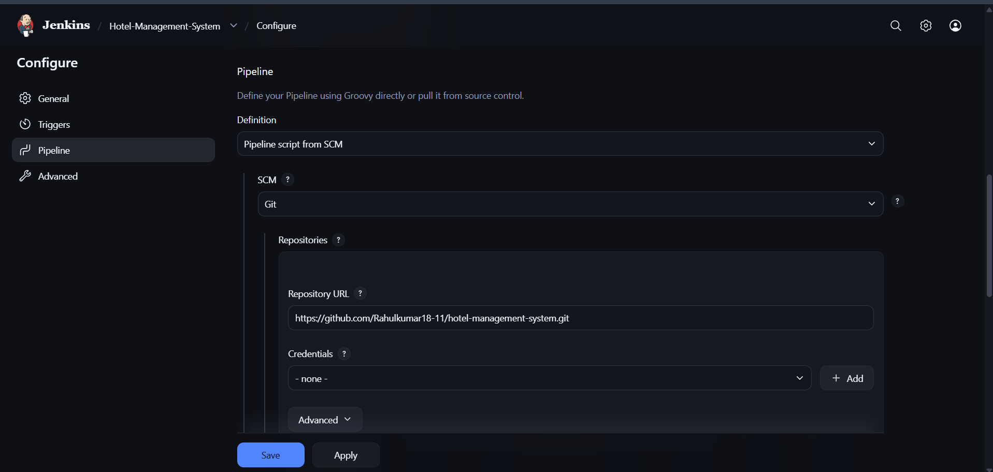
Figure 4.2: Configure → Pipeline (Pipeline script from SCM, Git repository URL)
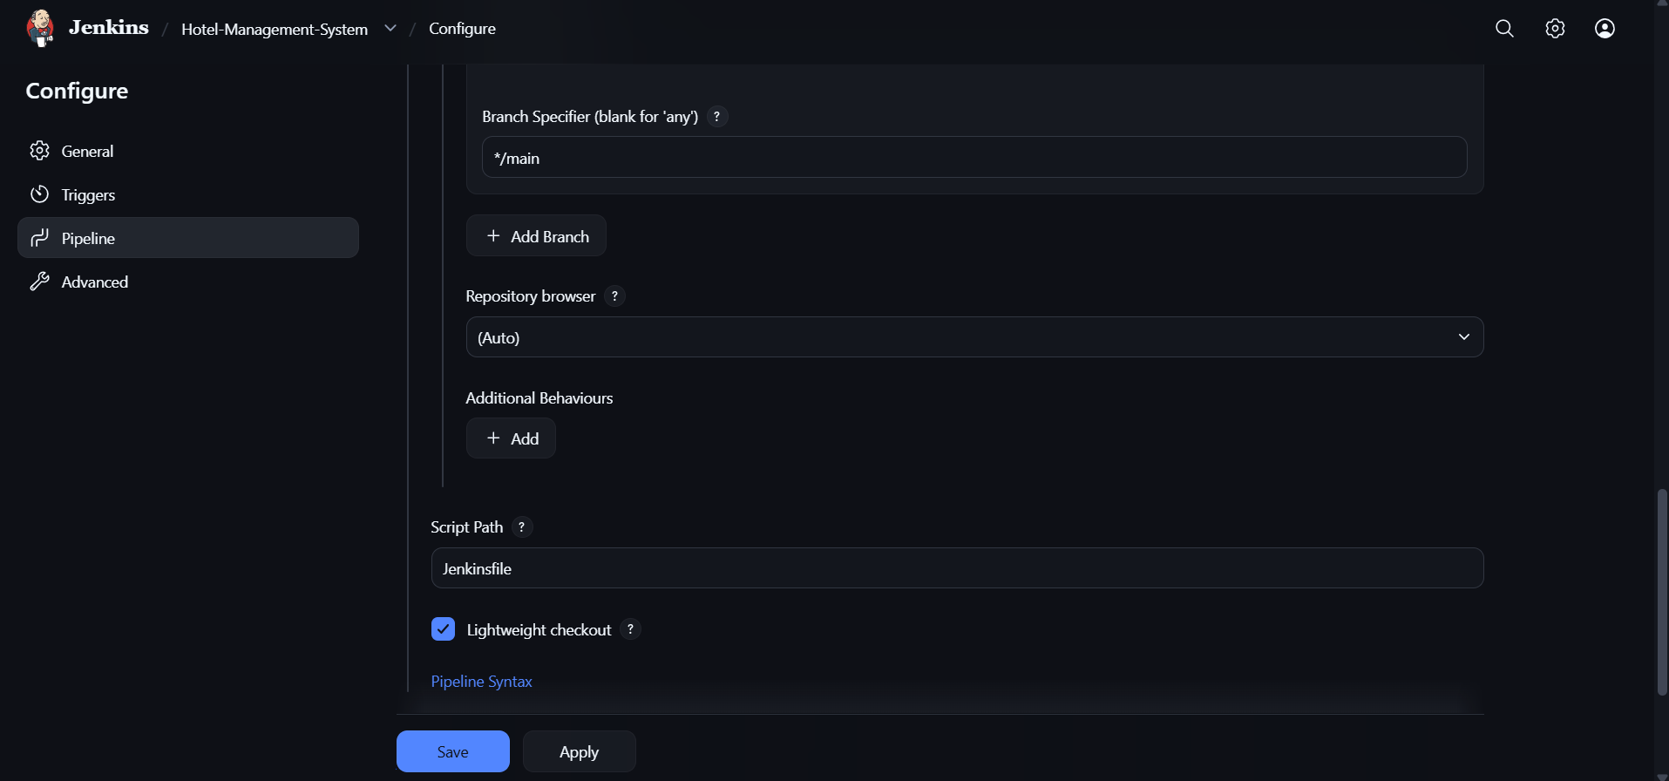
Figure 4.3: Configure → Pipeline (branch */main and script path Jenkinsfile)

5. Implementation Procedure

5.1 Prepare the Repository
Keep the application source, Dockerfile, docker-compose.yml, requirements.txt and the Jenkinsfile in the project root and push them to the main branch of the GitHub repository. Make sure real secrets (the .env file, SECRET_KEY and Cloudinary keys) are not committed; .gitignore and .dockerignore are present in the project for this purpose.

5.2 Prepare the Build Agent
Install Python 3.13 and pip on the Windows machine that runs Jenkins, install the packages from requirements.txt together with pytest, and make sure Docker is available to the Jenkins service account for the Application Verification stage.

5.3 Create the Pipeline Job
In Jenkins choose New Item, enter budget-tracker, select Pipeline, set the definition to “Pipeline script from SCM”, select Git, enter the repository URL, set the branch to */main and the script path to Jenkinsfile, and click Save.

5.4 Run and Monitor the Build
Click Build Now. Jenkins queues the build, runs the stages and shows progress in the Stages view. The Console Output page shows the full log of every stage, and the Pipeline Steps page lists each step that was executed.

5.5 Fix Failures and Re-run
When a stage fails, open the console output of that build, correct the cause in the code, tests or Jenkinsfile, commit the change and run the pipeline again. The Stages view marks the failed stage in red and the skipped stages with a skip symbol, which makes the point of failure easy to find.

6. Build Results and Testing

6.1 Jenkins Dashboard
The dashboard lists all jobs on the server. budget-tracker shows a green status, last success build #7 (11 minutes earlier), last failure build #6 (14 minutes earlier) and a last duration of 18 seconds. The build queue is empty and 0 of 2 executors are busy.
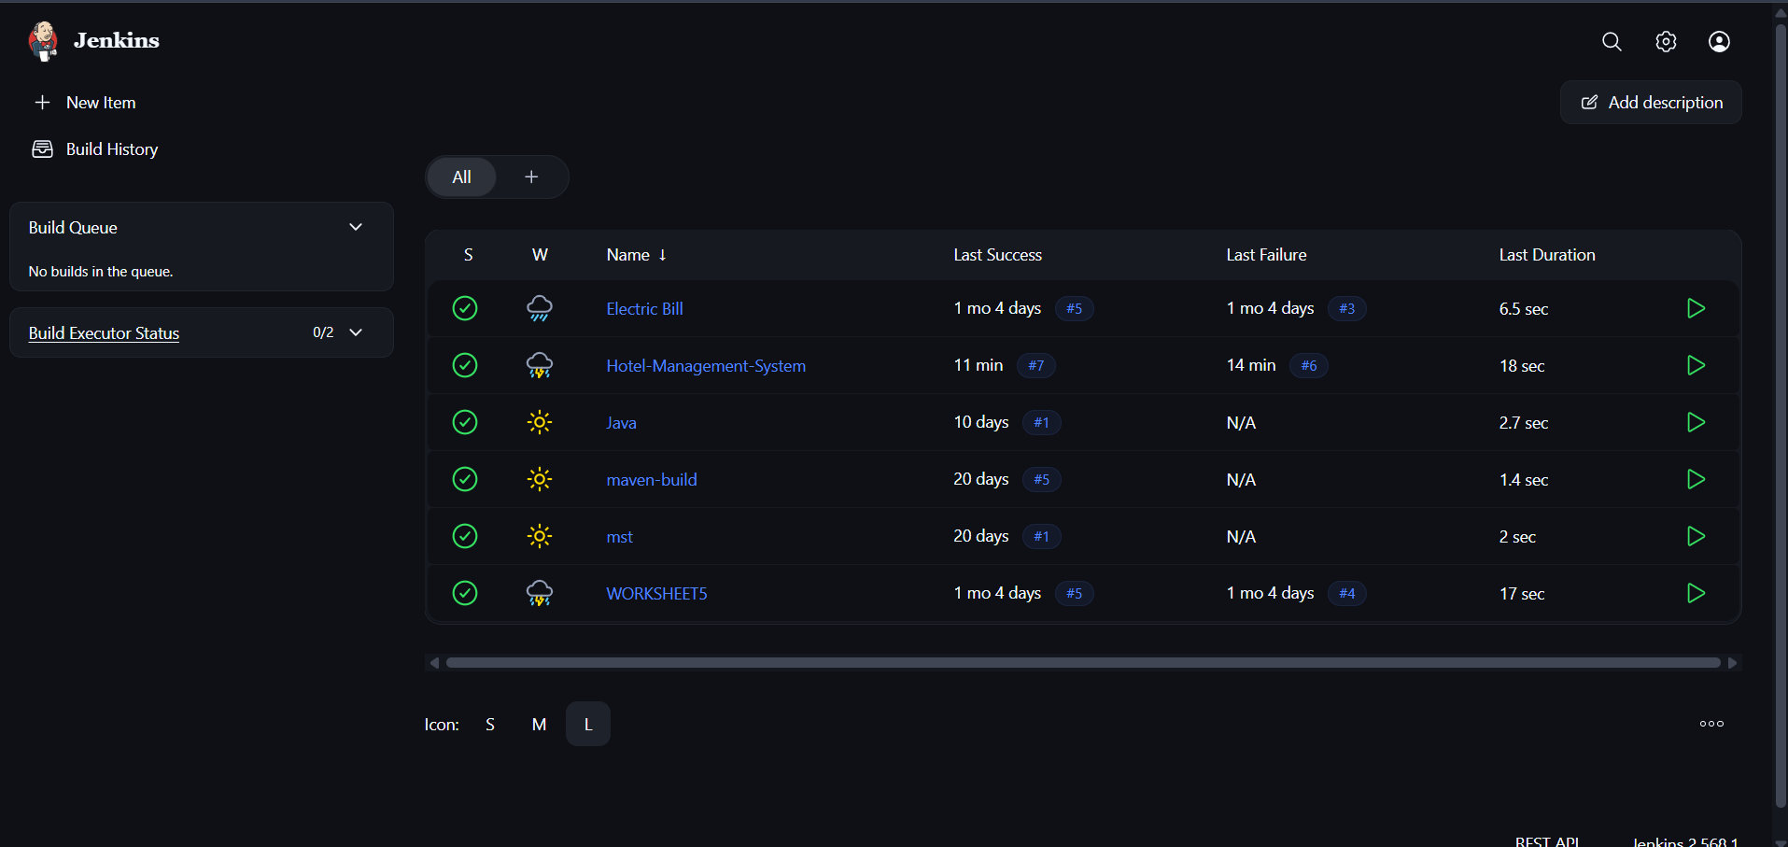
Figure 6.1: Jenkins dashboard showing the budget-tracker job

6.2 Job Status and Build History
The job page lists the permalinks: last build, last stable build and last successful build are #7, while the last failed and last unsuccessful build is #6. The build history shows seven builds on 29 October 2026: #2 (15:05), #3 (15:10), #4 (15:16), #5 (15:21) and #6 (15:22) failed, and #7 (15:25) succeeded.
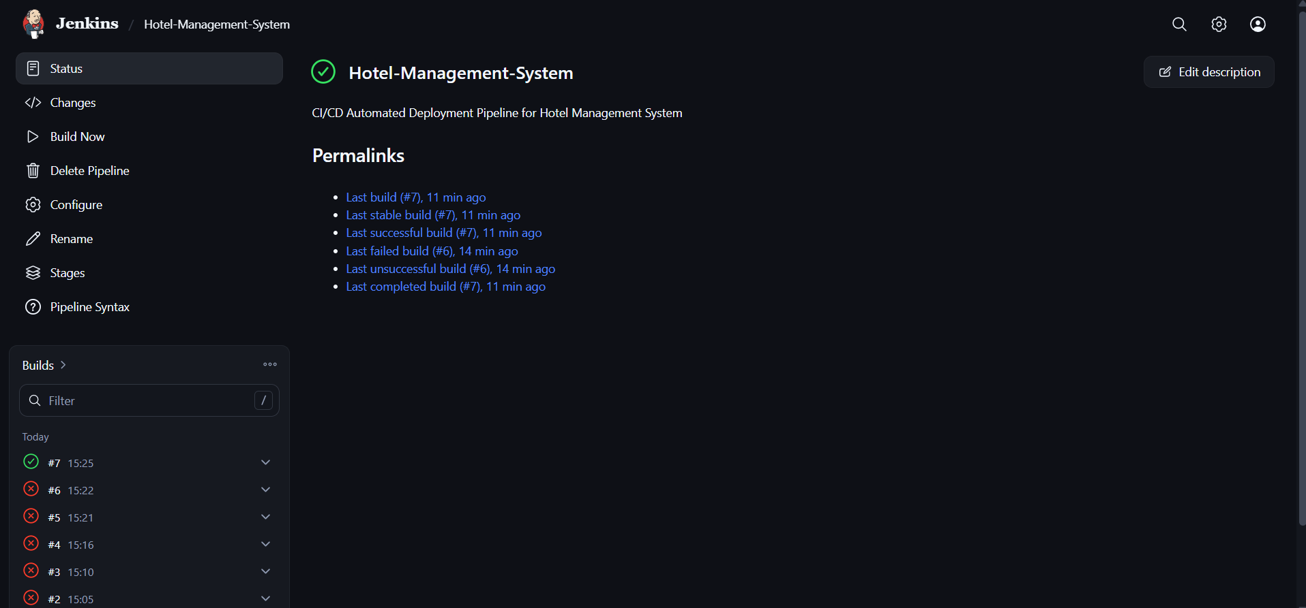
Figure 6.2: Job page with permalinks and build history

6.3 Successful Build #7
Build #7 was started by user Rahul Kumar on 29 Oct 2026 at 15:25:27 and took 18 seconds. It used revision 4e0f42a92e3c56b26222b708f586c83af9c280bd of the repository on branch refs/remotes/origin/main.
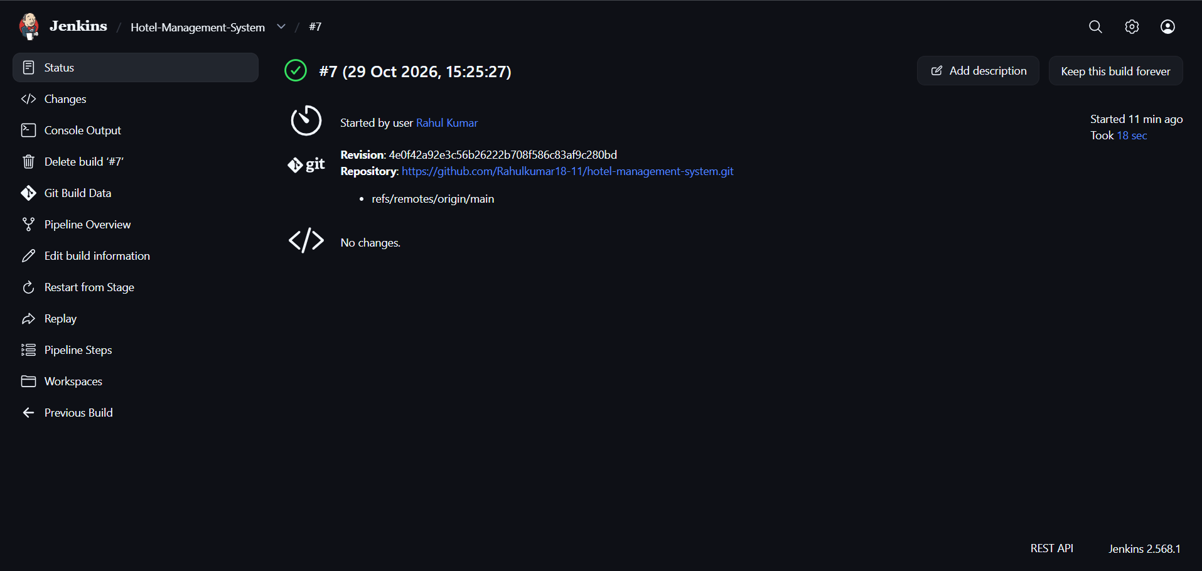
Figure 6.3: Build #7 details (revision, repository and branch)

6.4 Stage View
The Stages view compares the builds stage by stage. In build #7 all stages are green: Declarative Checkout SCM (1 s), Checkout (1 s), Environment Check (0.92 s), Automated Tests (2 s), Application Verification stage (6 s), Verification (1 s) and Post Actions (0.51 s). In builds #6 and #5 the Automated Tests stage failed (2 s and 0.93 s); the Docker and Verification stages were skipped because an earlier stage had failed, while Post Actions still ran. This shows that the pipeline blocks the later stages when a test fails.
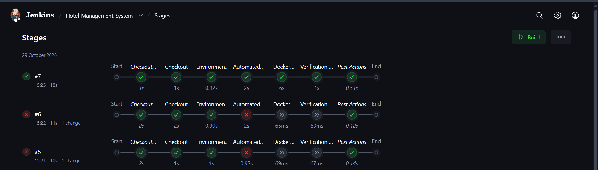
Figure 6.4: Stage view for builds #7, #6 and #5

6.5 Verification Summary
ID | Check | Expected result | Observed result
T1 | Job configuration | Jenkins loads Jenkinsfile from GitHub main | Done, build #7 used the main branch and its Jenkinsfile
T2 | Environment check | Python and pip versions are printed | Stage passed (0.92 s)
T3 | Automated tests | All pytest tests pass | Failed in #5 and #6; passed in #7 (2 s)
T4 | Application Verification stage | Stage runs after tests pass | Skipped in #5 and #6; passed in #7 (6 s)
T5 | Verification | Runs after the Application Verification stage | Skipped in #5 and #6; passed in #7 (1 s)
T6 | Overall result | Build ends as SUCCESS | Build #7: SUCCESS in 18 s
Table 6.1: Verification of the pipeline using the Jenkins results
The results above are taken from the Jenkins screenshots. The cause of the earlier failed builds (#2 to #6) is visible only in their console output, which is not included in the screenshots; it can be added from the Console Output page if the examiner asks for it.

7. Why Jenkins and Pipeline as Code Were Chosen
- Automation: every build runs the same steps without manual work.
- Fast feedback: a failing test is found within seconds, as the red Automated Tests stage in builds #5 and #6 shows.
- Pipeline as code: the Jenkinsfile is stored in Git, so changes to the process are reviewed, versioned and can be rolled back.
- Visibility: the dashboard, Stages view and console output show the history and timing of every build.
- Quality gate: later stages do not run when an earlier stage fails, so a broken build is not passed on to the Application Verification stage.
- Reuse of earlier work: the Python virtual environment and native MongoDB configuration from the previous project is reused inside the pipeline.
A single Jenkins server with one pipeline is suitable for a lab or small project. A production setup would also need dedicated agents, backups of Jenkins and controlled access.

8. Security and Reliability Considerations
- Credentials: the job uses no stored credentials (“- none -”), which works for a public repository. For a private repository, add a Jenkins credential and never put tokens in the Jenkinsfile.
- Secrets: SECRET_KEY and Cloudinary keys must be supplied through Jenkins credentials or a local .env file that is not committed to Git.
- Hard-coded paths: the PATH variable in the Jenkinsfile contains Windows paths of one machine (including a user profile folder). This makes the pipeline dependent on that machine; use the Jenkins tool configuration or agent labels in a shared setup.
- Build triggers: builds were started manually with Build Now. A GitHub webhook or SCM polling trigger can be added so that every push starts the pipeline automatically.
- Build retention: “Discard old builds” and “Do not allow concurrent builds” are not enabled in the General settings. Enabling them saves disk space and avoids two builds using the same workspace.
- Reporting: publishing the pytest result (for example as a JUnit report) would show test trends in Jenkins.
- Docker host: the user that runs Jenkins can control Docker, which is a powerful permission; restrict the access to the Jenkins server.

9. Learning Outcomes
The project gave practical experience in creating a Jenkins Pipeline job, writing a declarative Jenkinsfile, connecting Jenkins to GitHub, running automated pytest tests inside a pipeline, adding a Application Verification stage, reading the Stages view and the console output, and correcting a failing pipeline through repeated builds until it passed.

10. Conclusion
The Personal Budget Tracker now has an automated CI/CD pipeline in Jenkins. Each build checks out the code from GitHub, verifies the Python environment, runs the pytest suite, executes the Application Verification stage and verifies the result. Several failed builds led to the corrected pipeline, and build #7 passed all stages in 18 seconds. The work shows how process automation reduces manual effort, finds errors early and provides a foundation for later automatic deployment of the containerized application to a cloud environment.

