Since 30 years | Phone (O) : 91-79-26852427, 26850829  Phone (F) : 91-79-26767512, 26767649  E-Mail : sales@sigmatrainers.com  drluhar@gmail.com  Mobile : 9824001168  Website : www.sigmatrainers.com

SIGMA TRAINERS AND KITS
Regd. Office: E-113, Jai Ambenagar, Near Udgam School, Thaltej, AHMEDABAD -380 054.

Date:26/12/2016

To whom so Ever this may concern

We Sigma Trainers and Kits declare that this material are solely are for demonstration purpose. It does not have any commercial value, so we are carrying this back to our facility.

Item Description:

1. COM116M (BPSK Modulation and demodulation trainer) - 5Nos.
2. WSN100L (Wireless sensor network trainer) - 5Nos.

For Sigma Trainers and Kits

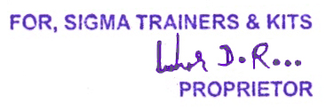11
Proprietor.
M.tech(Communication)
Gold Medallist.
Ex-Professor.

