SD7501 – Web Application Development - Assignment 2 – Group Project
Ravi Pratap 22502798

Real Estate Web Application Idea – Assignment 2
Contents
Real Estate Web Application Idea 1
About the application: 1
Conceptual Framework For Assignment 2: 2
Features (Scope): 2
Advanced Features: 2
Main Classes: 2
Properties involved 3
Purpose for each main class 3
User 3
Admin 3
Property 3
Viewing 3
Transaction: 3
CheckoutViewModel: 3
Relationships: 4
Constraints (Errors) and strategies during development 5
Conceptual Framework for Final Project 6
References 7

Figure 1: Screenshot of Relationships for the web application as done via ERD (Entity Relationship Diagram) 4
Figure 2: Screenshot for solution to working with both SQLite & SQL Server 5

About the application:
This is application is focused on the retail sector specifically for real estate, where people can find, purchase and live in a new home, whether it be a flat, apartment or 1-2 story housing etc. It will also include extra security features. And cookies to assist in authentication for the login and registration. Users can also search for any accommodation that they prefer based on their preferences, same with searching/ filtering. Once a user purchases an property an email should be sent to them, users should also be able to book a viewing for properties that are available for viewing.

Conceptual Framework For Assignment 2:
For this framework we will covering over for this assignment, would be the following features that will be implemented into this application focusing on the retail sector as said before. We will only be focusing on the users and admins.

Features (Scope):
- Login/Registration
- Users and Admins
- Users – Browse Website, looking for accommodations (flats, apartments, houses, 1-2 story houses etc.), READ only
- Admin – Is able to add, delete, view and update, accommodations, users as well as booked viewings (Create, Read, Update & Delete), Full CRUD
  - Excluding Create, Update and Delete for the transaction
- Searching & Filtering which accommodations the user wants by number of pets, bedrooms/bathrooms, price, roommates, location etc.
  - Detailed description shows up when the user views one of the available accommodation options
- Viewing
  - Users can see what houses are available for viewing
- Transaction & Checkout systems
  - Purchasing an available accommodation
  - Email Notifications

Advanced Features:
- Cookies Authentication
- Extra Security features – What Security Features?

Main Classes:
- User (A)
- Admin (B)
- Property (C)
- Viewing (D)
- Transaction (E)
- CheckoutViewModel (F)
Properties are below and are listed as A – F to their respective classes.

Properties involved
- UserID, User First Name, User Last Name, Email, UserName, Password
- Admin UserName & Password
- PropertyID, Property Name, Property Address, Property Bedrooms, Property Bathrooms, Property Pets & Property Garage(s), Extended Description, IsAvailable, Nearby Schools, Nearby Shops
- ViewingID, PropertyID, UserID, Viewing_TimeDate
- TransactionID, PropertyID, UserID, Price, UserEmail, Buyer Name, Purchase Date
- PropertyID, Property Name, Property Address, Price, Buyer Name, UserEmail, Phone Number, Billing Address, Card Number, Card holder name, Expiry Date, CVV

Purpose for each main class

User
This class holds all of the necessary data for the users such as first and last names, email addresses, usernames and passwords. As well as holding data for the properties they buy and book for a viewing. It’s also the main daily user that comes and goes, visiting the web application, browsing through, booking viewing appointments and purchasing properties.

Admin
This class is responsible for the administration data like the admin username and password. This class will help with managing the application data for users, properties, viewings booked and inspecting transactions

Property
This class is for all of the property information like bedrooms, bathrooms, pets, garages, nearby school & shops as well as the name, address, and availability for viewings.

Viewing
The viewing class is responsible for holding the user who booked and the property information as well as the property the user has booked, and the date/time that the viewing is booked on. This class is for the users to book a viewing to see what the property looks like, location observation, condition of the property etc.

Transaction:
The transaction would be responsible for each transaction such as the user purchasing a property, keeping records of every transaction detail like price, UserEmail,

CheckoutViewModel:
This class is responsible for the checkout operation, as it holds the necessary data for the checkout when a user purchases a property, like the card information and the property the user is purchasing.

Relationships:
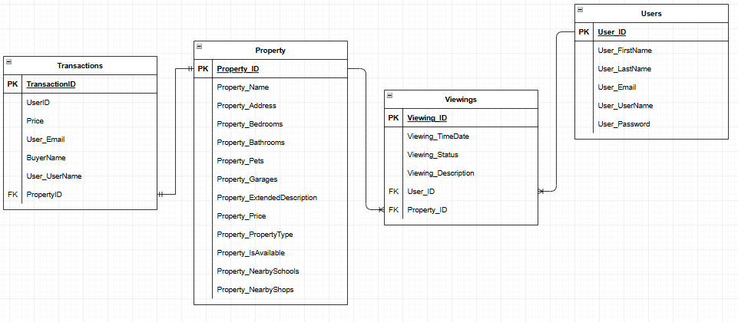
Figure 1: Screenshot of Relationships for the web application as done via ERD (Entity Relationship Diagram)
Here is screenshot of the tables and relationships we will be implementing into our web application. Each relationship between the necessary tables is shown below:
- User to Property (1 to Many)
- Transaction to Property (1 to 1)
- Property to Viewings (1 to Many)
- User to Viewings (1 to Many)

Constraints (Errors) and strategies during development
The main issues in development were switching from 8.0.0 to 10.0.0. We had a lot of issues readjusting to the new ASP.NET Core (framework) of 10.0.0 & SQLite + SQL Server compatibility issues.
With solving the issue of switching to the new 10.0.0 version of ASP.NET Core, we mainly had to download a the newer Visual Studio IDE which is Visual Studio 2026 and adapted to using this instead of using the Visual Studio 2022 IDE as that IDE could not support this version of ASP.NET Core.
We also had many issues with having to use both SQLite and SQL Server, especially when. We both had to use commands for both SQLite and SQL Server migrations. As according to (Bahreini, 2020) We have used something similar to this in our appsettings.json file where all of our connection strings for each database are located, we needed to have 2 separate strings, 1 for the SQLite database and 1 for the SQL Server database, like what is shown in the screenshot below.
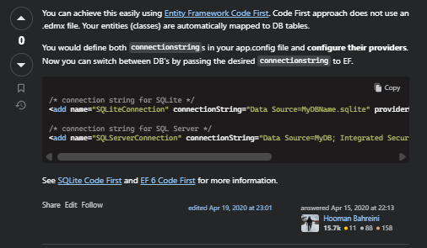
Figure 2: Screenshot for solution to working with both SQLite & SQL Server

And for the commands we used were: “dotnet ef migrations add InitialCreate –context AppDbContext” for the SQLite database and commands like “Add-Migration -Context AppDbContext AddPropertiesTransactionsData” for the SQL Server database.

Conceptual Framework for Final Project
For this part of the conceptual framework in doing the final project we will be implementing these last features below:
- Implementation of Identity library for the User/Admin authentication
- Request System for the User to contact the Admin so that their properties can be added by the administrators or Agents
- Might implement Agents in case of a third person is needed for the request system or for users to pick agents for the viewings
- Chatbot feature to help users with navigation and errors
- Might add open-home listings for newly added homes
- Might implement a different admin to handle the finances such as the transactions (Finance administrator)

Contribution of each team member
Ravi – Ravi has done the Login and Registration parts, he has also added the User/Admin models, giving the correct role access to both the user and admin pages, implemented the viewing (booking/appointments) model where user book a viewing to inspect properties that they are interested in potentially purchasing. Lastly, to implementing the cookie authentication for both the administrator and user as an advanced feature.
Justin – Justin has done the property model which is for each and every property for the application, Justin has also done the Search and filtering for the properties, He has also implemented the transactions & checkout system as well as an email notification on purchase. Lastly, he has implemented the extra security features for the application as the other advanced feature.

References
Bahreini, H. (2020, Apr. 15). Using entity framework with both SQL Server and SQLite databases simultaneously. Retrieved from https://stackoverflow.com/questions/19568250/using-entity-framework-with-both-sql-server-and-sqlite-databases-simultaneously#:~:text=Are%20you%20passing%20in%20the,.Data.SqlClient%22%20/%3E

