SD7501 – Web Application Development - Assignment 2 – Group Project - Real Estate
Ravi Pratap | 22502798 & Justin Theodore Regidor | 21802610

Real Estate Web Application Documentation
Contents
Real Estate Web Application Documentation 1
About the application: 2
Conceptual Framework For Assignment 2: 2
Features (Scope): 2
Advanced Features: 3
Main Classes: 3
Properties involved 3
Purpose for each main class 4
User 4
Property 4
Viewing 4
Transaction: 4
CheckoutViewModel: 4
Relationships: 5
Constraints (Errors) and strategies during development 6
Contribution of each team member 7
Conceptual Framework for the Final Project 7
Project Resources 8
References 9

Figure 1: Screenshot of Relationships for the web application as done via ERD (Entity Relationship Diagram) 5
Figure 2: Screenshot for solution to working with both SQLite & SQL Server 6

About the application:
This application is focused on the retail sector specifically for real estate, where people can find, purchase and live in a new home, whether it be a flat, apartment or 1-2 story housing etc. Users can also search for any accommodation that they prefer based on their preferences, same with searching/filtering. Once a user purchases a property an email should be sent to them, users should also be able to book a viewing for properties that interests them and are available for viewing.
It will also include extra security features as an advanced feature such as password hashing with auto-rehash and legacy upgrade from old plain-text passwords, anti-forgery on every POST method, role-based authorization done by an IsAdmin flag, and lastly, validation for usernames and emails by using unique index constraints. As well as for cookies as another advanced feature to assist in authentication/authorization for the login and registration process by assigning and maintaining roles for the users and admins.

Conceptual Framework For Assignment 2:
For this framework we will covering over for this assignment, would be the following features that will be implemented into this application focusing on the retail sector as said before. We will also only be focusing on the users and admins.

Features (Scope):
- Login/Registration:
- Users and Admins:
- Users – Browse Website, look for accommodations (flats, apartments, houses, 1-2 story houses etc.), READ only.
- Admin – Is able to add, delete, view and update, accommodations, users as well as booked viewings (Create, Read, Update & Delete), Full CRUD.
  - Excluding Create, Update and Delete for the transactions – READ only.
- Searching & Filtering which accommodations the user wants by number of pets, bedrooms/bathrooms, price, location etc.
  - Detailed description shows up when the user views one of the available accommodation options.
- Viewing
  - Users can see what houses are available for viewing
- Transaction & Checkout systems
  - Purchasing an available accommodation
  - Email Notifications

Advanced Features:
- Cookies Authentication – Assists in the login and registration process by assigning roles and maintaining these roles throughout the application.
- Extra Security features – Such as password hashing with auto-rehash and legacy upgrade from old plain-text passwords, anti-forgery on every POST method, role-based authorization done by an IsAdmin flag, and lastly, validation for usernames and emails by using unique index constraints.

Main Classes:
- User (A)
- Property (B)
- Viewing (C)
- Transaction (D)
- CheckoutViewModel (E)

Properties involved
- UserID, User First Name, User Last Name, Email, UserName, Password
- Admin UserName & Password (saved in the same database as the users)
- PropertyID, Property Name, Property Address, Property Bedrooms, Property Bathrooms, Property Pets & Property Garage(s), Extended Description, IsAvailable, Nearby Schools, Nearby Shops
- ViewingID, PropertyID, UserID, Viewing_TimeDate
- TransactionID, PropertyID, UserID, Price, UserEmail, Buyer Name, Purchase Date
- PropertyID, Property Name, Property Address, Price, Buyer Name, UserEmail, Phone Number, Billing Address, Card Number, Card holder name, Expiry Date, CVV

Purpose for each main class

User
This class holds all of the necessary data for the users such as first and last names, email addresses, usernames and passwords. As well as holding data for the properties they buy and book for a viewing. It’s also the main daily user that comes and goes, visiting the web application, browsing through, booking viewing appointments and purchasing properties.

Property
This class is for all of the property information like bedrooms, bathrooms, pets, garages, nearby schools & shops as well as the name, address, and availability for viewings.

Viewing
The viewing class is responsible for holding the information of the user who booked the viewing appointment and the property information of what property the user has booked for, the date/time that the viewing is booked on. Lastly, this class is mainly for the users to book a viewing to see what the property looks like, location observation and condition of the property etc.

Transaction:
The transaction class would be responsible for each transaction such as the user purchasing a property, keeping records of every transaction detail like price, UserEmail, Buyer name and purchase date.

CheckoutViewModel:
This class is responsible for the checkout operation, as it holds the necessary data for the checkout when a user purchases a property, like the card and user personal information in finalizing the purchase of property.

Relationships:
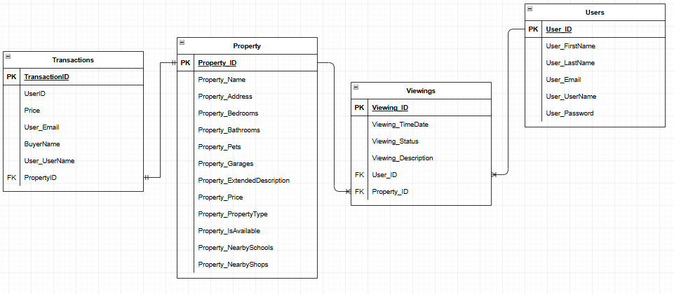
Figure 1: Screenshot of Relationships for the web application as done via ERD (Entity Relationship Diagram)
Here is a screenshot of the tables and relationships we will be implementing into our web application. Each relationship between the necessary tables is shown below:
- User to Property (1 to Many)
- Transaction to Property (1 to 1)
- Property to Viewings (1 to Many)
- User to Viewings (1 to Many)

Constraints (Errors) and strategies during development
The main issues in development were switching from ASP.NET Core 8.0.0 to ASP.NET Core 10.0.0. And compatibility issues in using both SQLite + SQL Server for our database operations. Also, we had issues when it came to developing the IRepository and IUnitofWork patterns. Lastly, we had issues with adapting to just 1 DBContext for our whole application.
With solving the issue of switching to the new 10.0.0 version of ASP.NET Core, we mainly had to download the newer Visual Studio IDE, which is Visual Studio 2026 and adapted to using this instead of using the Visual Studio 2022 IDE as that IDE could not support this latest version of ASP.NET Core.
We also had many issues with having to use both SQLite and SQL Server this mainly caused migration conflicts, hardcoding the database providers kept breaking our build. So, we both had to use commands separately for SQLite and SQL Server migrations. As according to (Bahreini, 2020) We have used something similar to this in our appsettings.json file or appsetting.development.json file where all of our connection strings for each database were located and for each device to pick either SQLite or SQL Server, we then needed 2 separate connection strings, 1 for the SQLite database and 1 for the SQL Server database, like what is shown in the screenshot below.
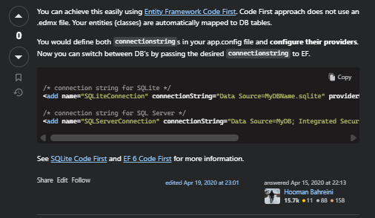
Figure 2: Screenshot for solution to working with both SQLite & SQL Server

And for the commands we used in adding migrations were: “dotnet ef migrations add InitialCreate –context AppDbContext” for the SQLite database and commands like “Add-Migration -Context AppDbContext AddPropertiesTransactionsData” for the SQL Server database.
In the issue of the IUnitofWork and IRepository patterns was that every controller was communicating to the database and querying the same query code so eventually if we needed to make changes we needed to edit the same code in many places. We fixed this by only adapting to using 1 repository per table and a Unitofwork pattern that saves it all together, so these controllers instead call one clean method in order to operate the CRUD operations efficiently.
However, the issue in using 1 DBContext was that we originally use 2 DBContexts which caused frequent migration conflicts and caused duplicate table definitions, so we fixed this by merging the 2 DBContexts into 1 DBContext with 1 set of migrations.

Contribution of each team member
Justin – Justin has done the property model which is for each and every property for the application, Justin has also done the search and filtering for the properties, He has also implemented the transactions & checkout system as well as an email notification on purchase. Lastly, he has implemented the extra security features for the application as an advanced feature.
Ravi – Ravi has done the Login and Registration parts, he has also added the User/Admin models, giving the correct role access to both the user and admin pages, implemented the viewing (booking/appointments) model where users book a viewing to inspect properties that they are interested in and potentially purchasing. Ravi has also implemented the cookie authentication for both the administrator and users as the other advanced feature.

Conceptual Framework for the Final Project
For this part of the conceptual framework in doing the final project we will be implementing these last features below:
- Implementation of the Identity library for the User/Admin authentication.
- Request System for the user to contact the Admin so that their properties can be added by the administrators or to contacting Agents, so the agents can contact the admins so the user’s properties can be added.
- Might implement Agents in case of a third person who is needed for the request system or for users to pick agents for the viewings or for agents to be assigned to these properties in the viewings, open-home listings and any other potential scheduling (like for meetings).
- Chatbot feature to help users with navigation and errors
- Might add open-home listings for newly added homes.
- Might implement a different admin to handle the finances such as the transactions (Financial administrator).

Project Resources
IDE used: Visual Studio 2026
Framework used: ASP.NET Core 10.0.0
Documentation software used: Microsoft Word

References
Bahreini, H. (2020, Apr. 15). Using entity framework with both SQL Server and SQLite databases simultaneously. Retrieved from https://stackoverflow.com/questions/19568250/using-entity-framework-with-both-sql-server-and-sqlite-databases-simultaneously#:~:text=Are%20you%20passing%20in%20the,.Data.SqlClient%22%20/%3E

