Lab 4

Q1. Implement mid circle algorithm. Print the pixel coordinates of the circle centre.

#include <GL/glut.h>
#include <stdio.h>

int xc = 0, yc = 0, r = 100;

void display()
{
int x = 0;
int y = r;
int p = 1 - r;

glClear(GL_COLOR_BUFFER_BIT);

glBegin(GL_POINTS);

while (x <= y)
{

glVertex2i(xc + x, yc + y);
glVertex2i(xc - x, yc + y);
glVertex2i(xc + x, yc - y);
glVertex2i(xc - x, yc - y);
glVertex2i(xc + y, yc + x);
glVertex2i(xc - y, yc + x);
glVertex2i(xc + y, yc - x);
glVertex2i(xc - y, yc - x);

x++;

if (p < 0)
{
p = p + 2 * x + 1;
}
else
{
y--;
p = p + 2 * x - 2 * y + 1;
}
}

glEnd();
glFlush();
}

void init()
{
glClearColor(1.0, 1.0, 1.0, 1.0);
glColor3f(0.0, 0.0, 1.0);

glMatrixMode(GL_PROJECTION);
glLoadIdentity();
gluOrtho2D(-250, 250, -250, 250);
}

int main(int argc, char** argv)
{
printf("Enter radius: ");
scanf("%d", &r);

glutInit(&argc, argv);
glutInitDisplayMode(GLUT_SINGLE | GLUT_RGB);
glutInitWindowSize(800, 800);
glutCreateWindow("Midpoint Circle - No Separate Function");

init();
glutDisplayFunc(display);
glutMainLoop();

return 0;
}

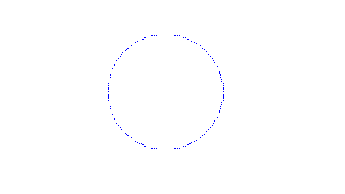

Q2. Draw circle at any given centre.

#include <GL/glut.h>
#include <stdio.h>

int xc, yc, r;

void display()
{
int x = 0;
int y = r;
int p = 1 - r;

glClear(GL_COLOR_BUFFER_BIT);
glColor3f(1.0, 0.0, 0.0);
glPointSize(3);

glBegin(GL_POINTS);

while (x <= y)
{

glVertex2i(xc + x, yc + y);
glVertex2i(xc - x, yc + y);
glVertex2i(xc + x, yc - y);
glVertex2i(xc - x, yc - y);
glVertex2i(xc + y, yc + x);
glVertex2i(xc - y, yc + x);
glVertex2i(xc + y, yc - x);
glVertex2i(xc - y, yc - x);

x++;

if (p < 0)
p = p + 2 * x + 1;
else
{
y--;
p = p + 2 * x - 2 * y + 1;
}
}

glEnd();
glFlush();
}

void init()
{
glClearColor(1.0, 1.0, 1.0, 1.0);

glMatrixMode(GL_PROJECTION);
glLoadIdentity();
gluOrtho2D(-500, 500, -500, 500);
}

int main(int argc, char** argv)
{
printf("Enter center (xc yc): ");
scanf("%d %d", &xc, &yc);

printf("Enter radius: ");
scanf("%d", &r);

glutInit(&argc, argv);
glutInitDisplayMode(GLUT_SINGLE | GLUT_RGB);
glutInitWindowSize(600, 600);
glutCreateWindow("User Input Circle - Midpoint Algorithm");

init();
glutDisplayFunc(display);
glutMainLoop();

return 0;
}

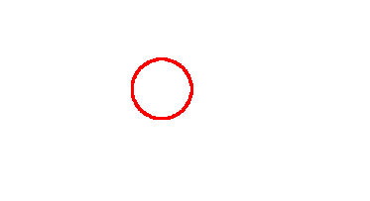

Q3. Draw concentric circle

#include <GL/glut.h>

void drawCircle(int xc, int yc, int r)
{
int x = 0;
int y = r;
int p = 1 - r;

glBegin(GL_POINTS);

while (x <= y)
{

glVertex2i(xc + x, yc + y);
glVertex2i(xc - x, yc + y);
glVertex2i(xc + x, yc - y);
glVertex2i(xc - x, yc - y);
glVertex2i(xc + y, yc + x);
glVertex2i(xc - y, yc + x);
glVertex2i(xc + y, yc - x);
glVertex2i(xc - y, yc - x);

x++;

if (p < 0)
p = p + 2 * x + 1;
else
{
y--;
p = p + 2 * x - 2 * y + 1;
}
}

glEnd();
}

void display()
{
glClear(GL_COLOR_BUFFER_BIT);

int xc = 0, yc = 0;
glColor3f(1.0, 0.0, 0.0);
drawCircle(xc, yc, 40);

glColor3f(0.0, 0.0, 0.0);
drawCircle(xc, yc, 160);

glFlush();
}

void init()
{
glClearColor(1.0, 1.0, 1.0, 1.0);

glMatrixMode(GL_PROJECTION);
glLoadIdentity();
gluOrtho2D(-250, 250, -250, 250);
}

int main(int argc, char** argv)
{
glutInit(&argc, argv);
glutInitDisplayMode(GLUT_SINGLE | GLUT_RGB);
glutInitWindowSize(500, 500);
glutCreateWindow("Concentric Circles - Midpoint Algorithm");

init();
glutDisplayFunc(display);
glutMainLoop();

return 0;
}

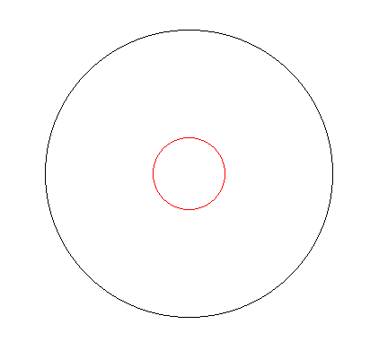

Q4. Draw Multiples circles at different position

#include <GL/glut.h>
#include <stdio.h>

void drawCircle(int xc, int yc, int r)
{
int x = 0;
int y = r;
int p = 1 - r;

glBegin(GL_POINTS);

while (x <= y)
{

glVertex2i(xc + x, yc + y);
glVertex2i(xc - x, yc + y);
glVertex2i(xc + x, yc - y);
glVertex2i(xc - x, yc - y);
glVertex2i(xc + y, yc + x);
glVertex2i(xc - y, yc + x);
glVertex2i(xc + y, yc - x);
glVertex2i(xc - y, yc - x);

x++;

if (p < 0)
p = p + 2 * x + 1;
else
{
y--;
p = p + 2 * x - 2 * y + 1;
}
}

glEnd();
}

void display()
{
glClear(GL_COLOR_BUFFER_BIT);

glColor3f(1.0, 0.0, 0.0);
drawCircle(0, 0, 80);

glColor3f(0.0, 0.0, 1.0);
drawCircle(150, 0, 50);

glColor3f(0.0, 0.7, 0.0);
drawCircle(-150, 0, 50);

glFlush();
}

void init()
{
glClearColor(1.0, 1.0, 1.0, 1.0);

glMatrixMode(GL_PROJECTION);
glLoadIdentity();
gluOrtho2D(-300, 300, -300, 300);
}

int main(int argc, char** argv)
{
glutInit(&argc, argv);
glutInitDisplayMode(GLUT_SINGLE | GLUT_RGB);
glutInitWindowSize(600, 600);
glutCreateWindow("Multiple Circles - Midpoint Algorithm");

init();
glutDisplayFunc(display);
glutMainLoop();

return 0;
}

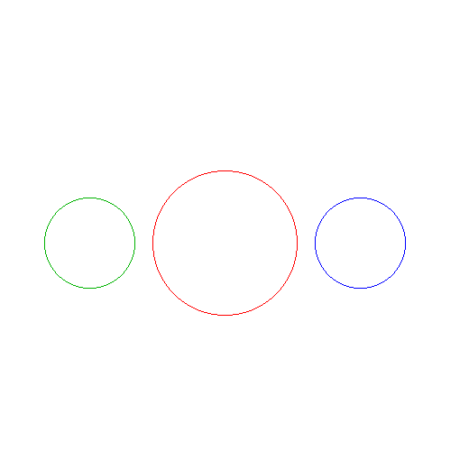

Q5. Draw olympic rings

#include <GL/glut.h>

void drawCircle(int xc, int yc, int r)
{
int x = 0;
int y = r;
int p = 1 - r;

glBegin(GL_POINTS);

while (x <= y)
{

glVertex2i(xc + x, yc + y);
glVertex2i(xc - x, yc + y);
glVertex2i(xc + x, yc - y);
glVertex2i(xc - x, yc - y);
glVertex2i(xc + y, yc + x);
glVertex2i(xc - y, yc + x);
glVertex2i(xc + y, yc - x);
glVertex2i(xc - y, yc - x);

x++;

if (p < 0)
p = p + 2 * x + 1;
else
{
y--;
p = p + 2 * x - 2 * y + 1;
}
}

glEnd();
}

void display()
{
glClear(GL_COLOR_BUFFER_BIT);
glPointSize(3);

int r = 60;

glColor3f(0.0, 0.0, 1.0);
drawCircle(-120, 40, r);

glColor3f(0.0, 0.0, 0.0);
drawCircle(0, 40, r);

glColor3f(1.0, 0.0, 0.0);
drawCircle(120, 40, r);

glColor3f(1.0, 1.0, 0.0);
drawCircle(-60, -40, r);

glColor3f(0.0, 1.0, 0.0);
drawCircle(60, -40, r);

glFlush();
}

void init()
{
glClearColor(1.0, 1.0, 1.0, 1.0);

glMatrixMode(GL_PROJECTION);
glLoadIdentity();
gluOrtho2D(-300, 300, -200, 200);
}

int main(int argc, char** argv)
{
glutInit(&argc, argv);
glutInitDisplayMode(GLUT_SINGLE | GLUT_RGB);
glutInitWindowSize(800, 800);
glutCreateWindow("Olympic Rings - Midpoint Circle");

init();
glutDisplayFunc(display);
glutMainLoop();

return 0;
}
