Lab 2

Q1. Input the points as array int point [3][2]={ {50, 100}, {75, 150}, {100, 200}}. Use loops to traverse and draw the lines.

#include <GL/glut.h>

int points[3][2] = {{50,100},{75,150},{100,200}};

void init() {
glClearColor(1,1,1,1);
glColor3f(0,0,0);
glMatrixMode(GL_PROJECTION);
glLoadIdentity();
gluOrtho2D(0,500,0,500);
}

void display() {
glClear(GL_COLOR_BUFFER_BIT);

glBegin(GL_LINE_STRIP);
for(int i=0;i<3;i++)
glVertex2iv(points[i]);
glEnd();

glFlush();
}

int main(int argc,char** argv) {
glutInit(&argc,argv);
glutInitDisplayMode(GLUT_SINGLE|GLUT_RGB);
glutInitWindowSize(500,500);
glutCreateWindow("Array of Points");
init();
glutDisplayFunc(display);
glutMainLoop();
return 0;
}

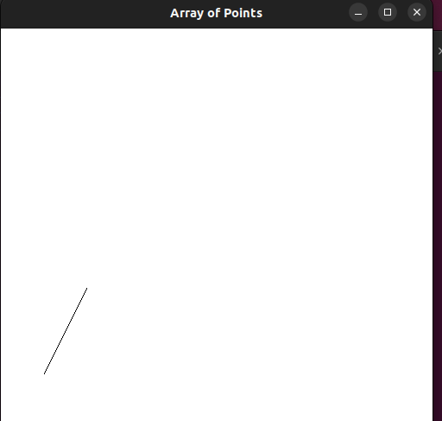

Q2. Define an array of points and connect them in sequence using lines. Ensure that last point connects back to first point to form a closed loop.

#include <GL/glut.h>

int points[4][2] = {{100,100},{300,100},{300,300},{100,300}};

void init() {
glClearColor(1,1,1,1);
glColor3f(0,0,0);
glMatrixMode(GL_PROJECTION);
glLoadIdentity();
gluOrtho2D(0,500,0,500);
}

void display() {
glClear(GL_COLOR_BUFFER_BIT);

glBegin(GL_LINE_LOOP);
for(int i=0;i<4;i++)
glVertex2iv(points[i]);
glEnd();

glFlush();
}

int main(int argc,char** argv) {
glutInit(&argc,argv);
glutInitDisplayMode(GLUT_SINGLE|GLUT_RGB);
glutInitWindowSize(500,500);
glutCreateWindow("Closed Loop");
init();
glutDisplayFunc(display);
glutMainLoop();
return 0;
}

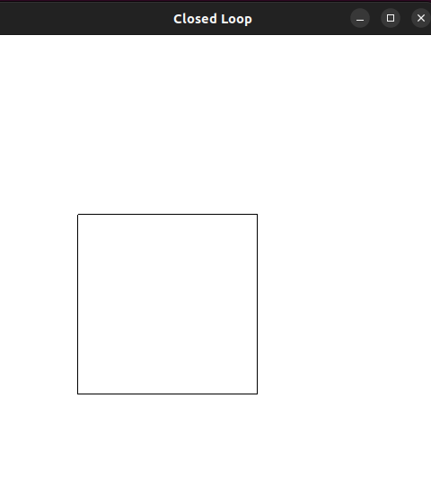

Q3. Use a loop to draw zigzag using lines. Alternate endpoints of the lines between two horizontal levels.

#include <GL/glut.h>

void init() {
glClearColor(1,1,1,1);
glColor3f(0,0,0);
glMatrixMode(GL_PROJECTION);
glLoadIdentity();
gluOrtho2D(0,500,0,500);
}

void display() {
glClear(GL_COLOR_BUFFER_BIT);

int x1 = 50, x2 = 450;
int y1 = 200, y2 = 300;

glBegin(GL_LINES);
for(int i=0;i<10;i++) {
if(i%2==0) {
glVertex2i(x1,y1);
glVertex2i(x2,y2);
} else {
glVertex2i(x1,y2);
glVertex2i(x2,y1);
}
y1 += 10;
y2 += 10;
}
glEnd();

glFlush();
}

int main(int argc,char** argv) {
glutInit(&argc,argv);
glutInitDisplayMode(GLUT_SINGLE|GLUT_RGB);
glutInitWindowSize(500,500);
glutCreateWindow("Zig Zag Pattern");
init();
glutDisplayFunc(display);
glutMainLoop();
return 0;
}

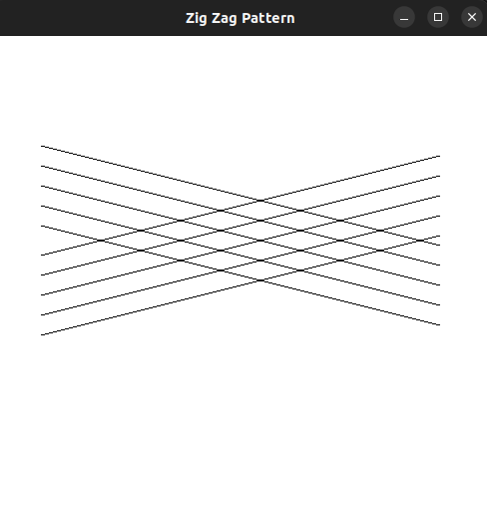

Q4. Draw a star shape by connecting specific points.

#include <GL/glut.h>

void init() {
glClearColor(1,1,1,1);
glColor3f(0,0,0);
glMatrixMode(GL_PROJECTION);
glLoadIdentity();
gluOrtho2D(0,500,0,500);
}

void display() {
glClear(GL_COLOR_BUFFER_BIT);

glBegin(GL_LINES);
glVertex2i(250,400); glVertex2i(150,150);
glVertex2i(250,400); glVertex2i(350,150);
glVertex2i(150,150); glVertex2i(400,250);
glVertex2i(400,250); glVertex2i(100,250);
glVertex2i(100,250); glVertex2i(350,150);
glEnd();

glFlush();
}

int main(int argc,char** argv) {
glutInit(&argc,argv);
glutInitDisplayMode(GLUT_SINGLE|GLUT_RGB);
glutInitWindowSize(500,500);
glutCreateWindow("Star Shape");
init();
glutDisplayFunc(display);
glutMainLoop();
return 0;
}

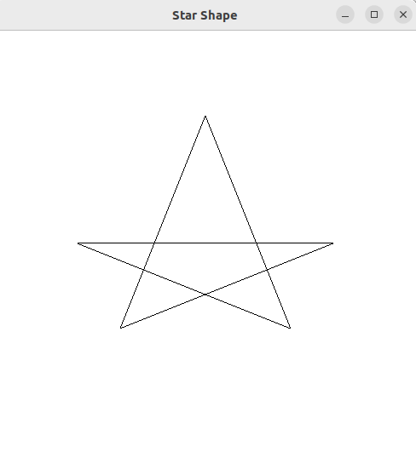

Q5. Implement program to draw line strip by connecting multiple points in sequence. Use an array to store the points and loop through them to render the strip.

#include <GL/glut.h>

int pts[4][2] = {{50,50},{150,200},{250,100},{350,250}};

void init() {
glClearColor(1,1,1,1);
glColor3f(0,0,0);
glMatrixMode(GL_PROJECTION);
glLoadIdentity();
gluOrtho2D(0,500,0,500);
}

void display() {
glClear(GL_COLOR_BUFFER_BIT);

glBegin(GL_LINE_STRIP);
for(int i=0;i<4;i++)
glVertex2iv(pts[i]);
glEnd();

glFlush();
}

int main(int argc,char** argv) {
glutInit(&argc,argv);
glutInitDisplayMode(GLUT_SINGLE|GLUT_RGB);
glutInitWindowSize(500,500);
glutCreateWindow("Line Strip");
init();
glutDisplayFunc(display);
glutMainLoop();
return 0;
}

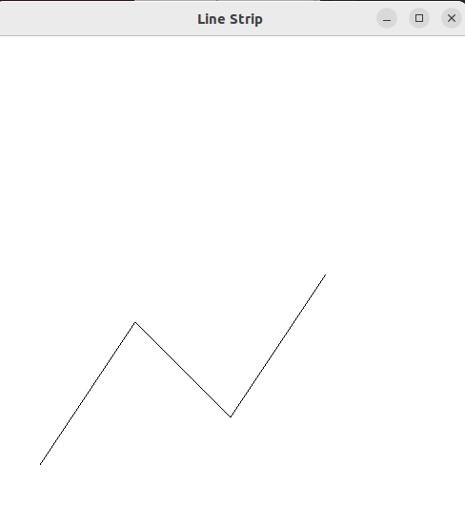

Q6. Allow the user to click on the window to place points dynamically. Use glutMouseFunc() to handle mouse input and plot the points in the clicked locations.

#include <GL/glut.h>

void init() {
glClearColor(1,1,1,1);
glColor3f(0,0,0);
glPointSize(5);
glMatrixMode(GL_PROJECTION);
glLoadIdentity();
gluOrtho2D(0,500,0,500);
}

void mouse(int button,int state,int x,int y) {
if(button==GLUT_LEFT_BUTTON && state==GLUT_DOWN) {
glBegin(GL_POINTS);
glVertex2i(x,500-y);
glEnd();
glFlush();
}
}

void display() {
glClear(GL_COLOR_BUFFER_BIT);
glFlush();
}

int main(int argc,char** argv) {
glutInit(&argc,argv);
glutInitDisplayMode(GLUT_SINGLE|GLUT_RGB);
glutInitWindowSize(500,500);
glutCreateWindow("Mouse Input");
init();
glutDisplayFunc(display);
glutMouseFunc(mouse);
glutMainLoop();
return 0;
}

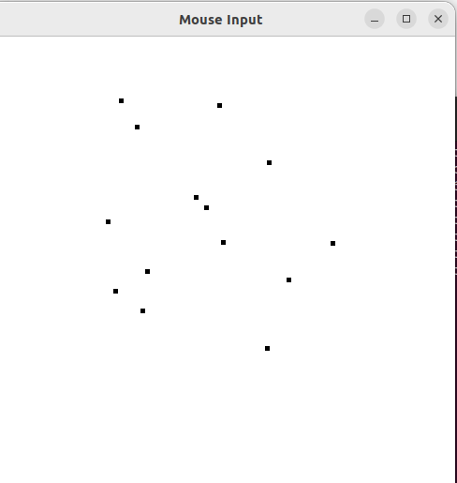

Q7. Wap to draw regular polygon using loops. Allow the user to specify the no of sides. Hint : Use trigonometry to calculate the vertices of the polygon.

#include <GL/glut.h>
#include <math.h>
#include <stdio.h>

int n;

void init() {
glClearColor(1,1,1,1);
glColor3f(0,0,0);
glMatrixMode(GL_PROJECTION);
glLoadIdentity();
gluOrtho2D(0,500,0,500);
}

void display() {
glClear(GL_COLOR_BUFFER_BIT);

float r = 150, cx = 250, cy = 250;

glBegin(GL_LINE_LOOP);
for(int i=0;i<n;i++) {
float angle = 2 * M_PI * i / n;
glVertex2f(cx + r*cos(angle), cy + r*sin(angle));
}
glEnd();

glFlush();
}

int main(int argc,char** argv) {
printf("Enter number of sides: ");
scanf("%d",&n);

glutInit(&argc,argv);
glutInitDisplayMode(GLUT_SINGLE|GLUT_RGB);
glutInitWindowSize(500,500);
glutCreateWindow("Regular Polygon");
init();
glutDisplayFunc(display);
glutMainLoop();
return 0;
}

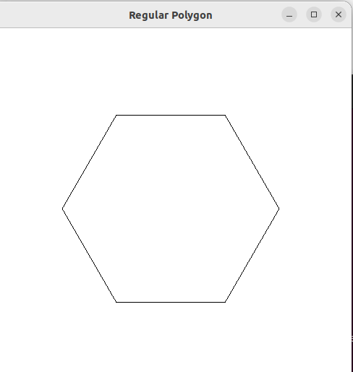

Q8. Combine multiple primitives to create a simple scene, such as a house with roof , door and windows using points and lines.

#include <GL/glut.h>

void init() {
glClearColor(1,1,1,1);
glColor3f(0,0,0);
glMatrixMode(GL_PROJECTION);
glLoadIdentity();
gluOrtho2D(0,500,0,500);
}

void display() {
glClear(GL_COLOR_BUFFER_BIT);

glBegin(GL_LINE_LOOP);
glVertex2i(150,100);
glVertex2i(350,100);
glVertex2i(350,250);
glVertex2i(150,250);
glEnd();

glBegin(GL_LINES);
glVertex2i(150,250); glVertex2i(250,350);
glVertex2i(250,350); glVertex2i(350,250);
glEnd();

glBegin(GL_LINE_LOOP);
glVertex2i(220,100);
glVertex2i(280,100);
glVertex2i(280,180);
glVertex2i(220,180);
glEnd();

glBegin(GL_LINE_LOOP);
glVertex2i(170,180);
glVertex2i(210,180);
glVertex2i(210,220);
glVertex2i(170,220);
glEnd();

glFlush();
}

int main(int argc,char** argv) {
glutInit(&argc,argv);
glutInitDisplayMode(GLUT_SINGLE|GLUT_RGB);
glutInitWindowSize(500,500);
glutCreateWindow("House");
init();
glutDisplayFunc(display);
glutMainLoop();
return 0;
}

