Computer graphics Lab3

Q 1. Implement DDA line drawing algorithm make sure the algorithm should work for all slop cases print the intermediate pixel value in all those cases

#include<GL/glut.h>
#include<bits/stdc++.h>
#include<vector>
using namespace std;
float x1=50 ,y_1=50 ;
float x2=100 ,y2=100;

void MYInit()
{
glClearColor(0 , 0 , 0 ,0);
glColor3f(1, 0 , 0);
glPointSize(4.0f);

glMatrixMode(GL_PROJECTION);
gluOrtho2D(0 , 500, 0 , 500);
}

void ddaline(float x1 , float y_1 , float x2 , float y2)
{
float dx=x2-x1;
float dy=y2-y_1;

int step;
if(abs(dx)>abs(dy))
{
step=abs(dx);
}
else{

step=abs(dy);

}

float xinc=dx/step;
float yinc=dy/step;
float x=x1;
float y=y_1;

glBegin(GL_POINTS);

for (int i = 0; i <= step; i++)
{
cout << i << "\t" << x << "\t" << y
<< "\t(" << round(x) << "," << round(y) << ")" << endl;

glVertex2i(round(x), round(y));

x=x+xinc;
y=y+yinc;

}
glEnd();

}

void Draw()
{
glClear(GL_COLOR_BUFFER_BIT);
glLineWidth(3.0f);
ddaline(x1, y_1 ,x2, y2);

glFlush();

}
int main(int c , char *v[])
{

glutInit(&c , v);

glutInitDisplayMode(GLUT_RGB |GLUT_SINGLE);
glutInitWindowSize(800 , 800);
glutInitWindowPosition(200,200);
glutCreateWindow("this is second opengle program");

MYInit();
glutDisplayFunc(Draw);
glutMainLoop();
return 0;

}

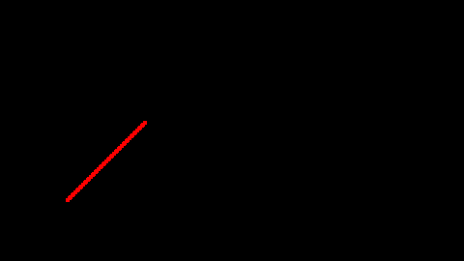

Q 2. Impliment Bresenhams line drawing algorithm sure all slop cases

#include <GL/glut.h>
#include <cmath>
using namespace std;

int x1 = 200, y_1 = 200;
int x2 = 1000, y2 = 100;

void MYInit()
{
glClearColor(0, 0, 0, 0);
glColor3f(1, 0, 0);
glPointSize(4.0);

glMatrixMode(GL_PROJECTION);
glLoadIdentity();
gluOrtho2D(0, 500, 0, 500);
}

void bresenhamLine(int x1, int y_1, int x2, int y2)
{
int dx = abs(x2 - x1);
int dy = abs(y2 - y_1);

int sx = (x1 < x2) ? 1 : -1;
int sy = (y_1 < y2) ? 1 : -1;

int p = dx - dy;

glBegin(GL_POINTS);
while (true)
{
glVertex2i(x1, y_1);

if (x1 == x2 && y_1 == y2)
break;

int p2 = 2 * p;

if (p2 > -dy)
{
p -= dy;
x1 += sx;
}

if (p2 < dx)
{
p += dx;
y_1 += sy;
}
}
glEnd();
}

void Draw()
{
glClear(GL_COLOR_BUFFER_BIT);
bresenhamLine(x1, y_1, x2, y2);
glFlush();
}

int main(int argc, char **argv)
{
glutInit(&argc, argv);
glutInitDisplayMode(GLUT_RGB | GLUT_SINGLE);
glutInitWindowSize(800, 800);
glutInitWindowPosition(200, 200);
glutCreateWindow("Simple Bresenham Line");

MYInit();
glutDisplayFunc(Draw);
glutMainLoop();
return 0;
}

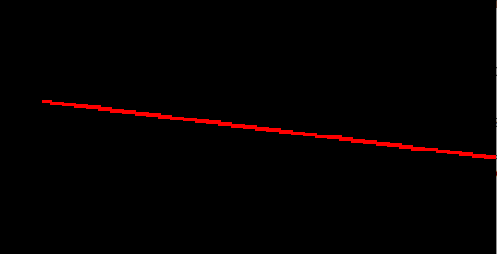

Q.3 IMPLEMENT ANY OF THE LINE DRAWING ALGORITHM TO DRAW FOLLOWING KINDS OF THE LINE

A. DOTTED LINE

#include<GL/glut.h>
#include<bits/stdc++.h>
#include<vector>
using namespace std;
float x1=100 ,y_1=100 ;
float x2=300 ,y2=300;

void MYInit()
{
glClearColor(0 , 0 , 0 ,0);
glColor3f(1, 1 , 1);
glPointSize(4.0f);

glMatrixMode(GL_PROJECTION);
gluOrtho2D(0 , 500, 0 , 500);
}

void ddaline(float x1 , float y_1 , float x2 , float y2)
{
float dx=x2-x1;
float dy=y2-y_1;

int step;
if(abs(dx)>abs(dy))
{
step=abs(dx);
}
else{

step=abs(dy);

}

float xinc=dx/step;
float yinc=dy/step;
float x=x1;
float y=y_1;

glBegin(GL_POINTS);

for (int i = 0; i <= step; i++)
{
if(i%2==0)
glVertex2i(round(x), round(y));

x=x+xinc;
y=y+yinc;

}
glEnd();

}

void Draw()
{

glClear(GL_COLOR_BUFFER_BIT);
glLineWidth(1);
ddaline(x1, y_1 ,x2, y2);

glFlush();

}
int main(int c , char *v[])
{

glutInit(&c , v);

glutInitDisplayMode(GLUT_RGB |GLUT_SINGLE);
glutInitWindowSize(800 , 800);
glutInitWindowPosition(200,200);
glutCreateWindow("this is second opengle program");

MYInit();
glutDisplayFunc(Draw);
glutMainLoop();
return 0;

}

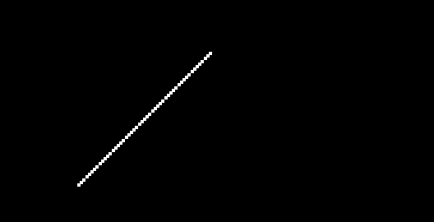

B.DASHED DOTTED LINE

#include <GL/glut.h>
#include <cmath>
using namespace std;

float x1 = 50, y_1 = 50;
float x2 = 200, y2 = 100;

void MYInit()
{
glClearColor(0, 0, 0, 0);
glColor3f(1, 0, 0);
glPointSize(5.0f);

glEnable(GL_POINT_SMOOTH);

glMatrixMode(GL_PROJECTION);
glLoadIdentity();
gluOrtho2D(0, 500, 0, 500);
}

void ddaDotDashLine(float x1, float y_1, float x2, float y2)
{
float dx = x2 - x1;
float dy = y2 - y_1;

int step = (abs(dx) > abs(dy)) ? abs(dx) : abs(dy);

float xinc = dx / step;
float yinc = dy / step;

float x = x1;
float y = y_1;

int pattern[] = {1, 1, 5, 1};
int patternLength = 4;
int patternIndex = 0;
int current = 0;

glBegin(GL_POINTS);
for (int i = 0; i <= step; i++)
{
if (patternIndex % 2 == 0)
glVertex2i(round(x), round(y));

x += xinc;
y += yinc;

current++;
if (current >= pattern[patternIndex])
{
patternIndex = (patternIndex + 1) % patternLength;
current = 0;
}
}
glEnd();
}

void Draw()
{
glClear(GL_COLOR_BUFFER_BIT);
ddaDotDashLine(x1, y_1, x2, y2);
glFlush();
}

int main(int argc, char **argv)
{
glutInit(&argc, argv);
glutInitDisplayMode(GLUT_RGB | GLUT_SINGLE);
glutInitWindowSize(800, 800);
glutInitWindowPosition(200, 200);
glutCreateWindow("Dot-Dash Line - DDA Algorithm");

MYInit();
glutDisplayFunc(Draw);
glutMainLoop();
return 0;
}

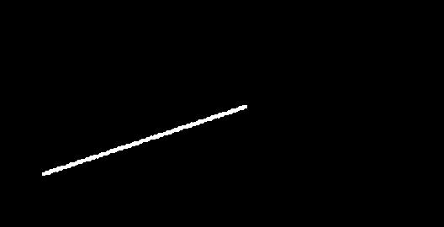

Q 4. USE ANY LINE DRAWING ALGORITHM TO PRINT “HELLO”

#include <GL/glut.h>
#include <cmath>
using namespace std;

void ddaLine(float x1, float y1, float x2, float y2)
{
float dx = x2 - x1;
float dy = y2 - y1;
int steps = (abs(dx) > abs(dy)) ? abs(dx) : abs(dy);

float xInc = dx / steps;
float yInc = dy / steps;

float x = x1, y = y1;

glBegin(GL_POINTS);
for (int i = 0; i <= steps; i++)
{
glVertex2i(round(x), round(y));
x += xInc;
y += yInc;
}
glEnd();
}

void drawHello()
{
glClear(GL_COLOR_BUFFER_BIT);

ddaLine(50, 200, 50, 100);
ddaLine(80, 200, 80, 100);
ddaLine(50, 150, 80, 150);

ddaLine(120, 200, 120, 100);
ddaLine(120, 200, 160, 200);
ddaLine(120, 150, 155, 150);
ddaLine(120, 100, 160, 100);

ddaLine(180, 200, 180, 100);
ddaLine(180, 100, 220, 100);

ddaLine(240, 200, 240, 100);
ddaLine(240, 100, 280, 100);

ddaLine(300, 200, 340, 200);
ddaLine(300, 100, 340, 100);
ddaLine(300, 100, 300, 200);
ddaLine(340, 100, 340, 200);

glFlush();
}

void MYInit()
{
glClearColor(0, 0, 0, 0);
glColor3f(1, 1, 0);
glPointSize(3.0f);

glMatrixMode(GL_PROJECTION);
glLoadIdentity();
gluOrtho2D(0, 500, 0, 500);
}

int main(int argc, char **argv)
{
glutInit(&argc, argv);
glutInitDisplayMode(GLUT_RGB | GLUT_SINGLE);
glutInitWindowSize(600, 400);
glutInitWindowPosition(200, 200);
glutCreateWindow("Draw HELLO - DDA Line Drawing");

MYInit();
glutDisplayFunc(drawHello);
glutMainLoop();
return 0;
}



