Lab 8

1.Write an OpenGL program to perform 3D Translation of a Cube and display both the original and translated cube.
#include <GL/glut.h>
float tx = 1.0f, ty = 0.5f, tz = -1.0f;
void drawCube() {
glutSolidCube(1.0);
}
void drawWireCube() {
glutWireCube(1.0);
}
void display() {
glClear(GL_COLOR_BUFFER_BIT | GL_DEPTH_BUFFER_BIT);
glLoadIdentity();
gluLookAt(3.0, 3.0, 7.0,
0.0, 0.0, 0.0,
0.0, 1.0, 0.0);

glColor3f(1.0, 1.0, 1.0);
drawWireCube();
glPushMatrix();
glTranslatef(tx, ty, tz);
glColor3f(0.0, 0.5, 1.0);
drawCube();
glPopMatrix();
glutSwapBuffers();
}
void init() {
glEnable(GL_DEPTH_TEST);
glClearColor(0.1, 0.1, 0.1, 1.0);
glMatrixMode(GL_PROJECTION);
glLoadIdentity();
gluPerspective(45.0, 1.33, 1.0, 20.0);
glMatrixMode(GL_MODELVIEW);
}
int main(int argc, char** argv) {
glutInit(&argc, argv);
glutInitDisplayMode(GLUT_DOUBLE | GLUT_RGB | GLUT_DEPTH);
glutInitWindowSize(800, 600);
glutCreateWindow("OpenGL 3D Translation - Original vs Translated");
init();
glutDisplayFunc(display);
glutMainLoop();
return 0;
}

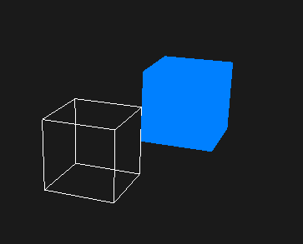

2. Program to perform 3D Scaling of a Pyramid and display both the original and scaled object.
#include <GL/glut.h>

float sx = 1.5f, sy = 1.5f, sz = 1.5f;

void drawPyramidBoundary() {
glBegin(GL_LINE_LOOP);
glVertex3f(0.0f, 1.0f, 0.0f);
glVertex3f(-1.0f, -1.0f, 1.0f);
glVertex3f(1.0f, -1.0f, 1.0f);
glEnd();

glBegin(GL_LINE_LOOP);
glVertex3f(0.0f, 1.0f, 0.0f);
glVertex3f(1.0f, -1.0f, 1.0f);
glVertex3f(1.0f, -1.0f, -1.0f);
glEnd();

glBegin(GL_LINE_LOOP);
glVertex3f(0.0f, 1.0f, 0.0f);
glVertex3f(1.0f, -1.0f, -1.0f);
glVertex3f(-1.0f, -1.0f, -1.0f);
glEnd();

glBegin(GL_LINE_LOOP);
glVertex3f(0.0f, 1.0f, 0.0f);
glVertex3f(-1.0f, -1.0f, -1.0f);
glVertex3f(-1.0f, -1.0f, 1.0f);
glEnd();

glBegin(GL_LINE_LOOP);
glVertex3f(-1.0f, -1.0f, 1.0f);
glVertex3f(1.0f, -1.0f, 1.0f);
glVertex3f(1.0f, -1.0f, -1.0f);
glVertex3f(-1.0f, -1.0f, -1.0f);
glEnd();
}

void display() {
glClear(GL_COLOR_BUFFER_BIT | GL_DEPTH_BUFFER_BIT);
glLoadIdentity();

gluLookAt(4.0, 4.0, 8.0, 0.0, 0.0, 0.0, 0.0, 1.0, 0.0);

glColor3f(1.0, 1.0, 1.0);
drawPyramidBoundary();

glPushMatrix();
glScalef(sx, sy, sz);
glColor3f(0.0, 1.0, 1.0);
drawPyramidBoundary();
glPopMatrix();

glutSwapBuffers();
}

void init() {
glEnable(GL_DEPTH_TEST);
glClearColor(0.0, 0.0, 0.0, 1.0);
glMatrixMode(GL_PROJECTION);
glLoadIdentity();
gluPerspective(45.0, 1.33, 1.0, 20.0);
glMatrixMode(GL_MODELVIEW);
}

int main(int argc, char** argv) {
glutInit(&argc, argv);
glutInitDisplayMode(GLUT_DOUBLE | GLUT_RGB | GLUT_DEPTH);
glutInitWindowSize(800, 600);
glutCreateWindow("3D Scaling - Boundary Only");
init();
glutDisplayFunc(display);
glutMainLoop();
return 0;
}
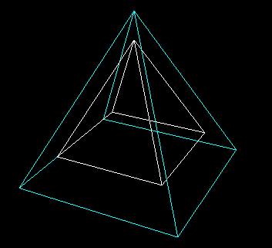

3. Program to perform 3D Rotation about the X-axis and display the rotated object along with the original.
#include <GL/glut.h>

float angle = 45.0f;

void drawWireCube() {
glutWireCube(1.0);
}

void display() {
glClear(GL_COLOR_BUFFER_BIT | GL_DEPTH_BUFFER_BIT);
glLoadIdentity();

gluLookAt(3.0, 3.0, 7.0, 0.0, 0.0, 0.0, 0.0, 1.0, 0.0);

glColor3f(1.0, 1.0, 1.0);
drawWireCube();

glPushMatrix();
glRotatef(angle, 1.0, 0.0, 0.0);
glColor3f(1.0, 0.0, 0.0);
drawWireCube();
glPopMatrix();

glutSwapBuffers();
}

void init() {
glEnable(GL_DEPTH_TEST);
glClearColor(0.0, 0.0, 0.0, 1.0);
glMatrixMode(GL_PROJECTION);
glLoadIdentity();
gluPerspective(45.0, 1.33, 1.0, 20.0);
glMatrixMode(GL_MODELVIEW);
}

int main(int argc, char** argv) {
glutInit(&argc, argv);
glutInitDisplayMode(GLUT_DOUBLE | GLUT_RGB | GLUT_DEPTH);
glutInitWindowSize(800, 600);
glutCreateWindow("3D Rotation X-Axis - Boundary Only");
init();
glutDisplayFunc(display);
glutMainLoop();
return 0;
}
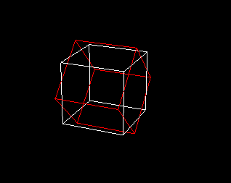

4. Program to implement the Cohen–Sutherland Line Clipping Algorithm to clip a line against a rectangular clipping window.
#include <GL/glut.h>
#include <iostream>
using namespace std;

float xmin, ymin, xmax, ymax;

const int LEFT = 1, RIGHT = 2, BOTTOM = 4, TOP = 8;

int getCode(float x, float y) {
int code = 0;

if (x < xmin) code |= LEFT;
if (x > xmax) code |= RIGHT;
if (y < ymin) code |= BOTTOM;
if (y > ymax) code |= TOP;

return code;
}

void cohenClip(float x1, float y1, float x2, float y2) {
int code1 = getCode(x1, y1);
int code2 = getCode(x2, y2);

while (true) {
if (!(code1 | code2)) {
glBegin(GL_LINES);
glVertex2f(x1, y1);
glVertex2f(x2, y2);
glEnd();
break;
}
else if (code1 & code2) {
break;
}
else {
float x, y;
int codeOut = code1 ? code1 : code2;

if (codeOut & TOP) {
x = x1 + (x2 - x1) * (ymax - y1) / (y2 - y1);
y = ymax;
}
else if (codeOut & BOTTOM) {
x = x1 + (x2 - x1) * (ymin - y1) / (y2 - y1);
y = ymin;
}
else if (codeOut & RIGHT) {
y = y1 + (y2 - y1) * (xmax - x1) / (x2 - x1);
x = xmax;
}
else if (codeOut & LEFT) {
y = y1 + (y2 - y1) * (xmin - x1) / (x2 - x1);
x = xmin;
}

if (codeOut == code1) {
x1 = x;
y1 = y;
code1 = getCode(x1, y1);
} else {
x2 = x;
y2 = y;
code2 = getCode(x2, y2);
}
}
}
}

void display() {
glClear(GL_COLOR_BUFFER_BIT);

glColor3f(1, 1, 1);
glBegin(GL_LINE_LOOP);
glVertex2f(xmin, ymin);
glVertex2f(xmax, ymin);
glVertex2f(xmax, ymax);
glVertex2f(xmin, ymax);
glEnd();

glColor3f(0, 1, 0);
cohenClip(50, 50, 450, 450);
cohenClip(50, 400, 450, 100);

glFlush();
}

void init() {
glClearColor(0, 0, 0, 1);
gluOrtho2D(0, 500, 0, 500);
}

int main(int argc, char** argv) {
cout << "Enter xmin ymin: ";
cin >> xmin >> ymin;
cout << "Enter xmax ymax: ";
cin >> xmax >> ymax;

glutInit(&argc, argv);
glutInitDisplayMode(GLUT_SINGLE | GLUT_RGB);
glutInitWindowSize(500, 500);
glutCreateWindow("Cohen-Sutherland Line Clipping");

init();
glutDisplayFunc(display);

glutMainLoop();
return 0;
}

