Lab 5

Q1. Implement Ellipse drawing algorithm.

#include <GL/glut.h>
#include <cmath>
#include <iostream>

int xc = 0, yc = 0;
int rx = 200, ry = 100;

void plotPoints(int x, int y)
{
glVertex2i(xc + x, yc + y);
glVertex2i(xc - x, yc + y);
glVertex2i(xc + x, yc - y);
glVertex2i(xc - x, yc - y);
}

void midpointEllipse()
{
int x = 0;
int y = ry;

float dx, dy;
float d1, d2;

dx = 2 * ry * ry * x;
dy = 2 * rx * rx * y;

d1 = (ry * ry) - (rx * rx * ry) + (0.25 * rx * rx);

glBegin(GL_POINTS);

while (dx < dy)
{
plotPoints(x, y);

if (d1 < 0)
{
x++;
dx = dx + (2 * ry * ry);
d1 = d1 + dx + (ry * ry);
}
else
{
x++;
y--;
dx = dx + (2 * ry * ry);
dy = dy - (2 * rx * rx);
d1 = d1 + dx - dy + (ry * ry);
}
}

d2 = ((ry * ry) * ((x + 0.5) * (x + 0.5))) +
((rx * rx) * ((y - 1) * (y - 1))) -
(rx * rx * ry * ry);

while (y >= 0)
{
plotPoints(x, y);

if (d2 > 0)
{
y--;
dy = dy - (2 * rx * rx);
d2 = d2 + (rx * rx) - dy;
}
else
{
y--;
x++;
dx = dx + (2 * ry * ry);
dy = dy - (2 * rx * rx);
d2 = d2 + dx - dy + (rx * rx);
}
}

glEnd();
}

void display()
{
glClear(GL_COLOR_BUFFER_BIT);

glColor3f(1.0, 1.0, 1.0);
midpointEllipse();

glFlush();
}

void init()
{
glClearColor(0.0, 0.0, 0.0, 1.0);
glColor3f(1.0, 1.0, 1.0);

glMatrixMode(GL_PROJECTION);
gluOrtho2D(-400, 400, -300, 300);
}

int main(int argc, char** argv)
{
glutInit(&argc, argv);
glutInitDisplayMode(GLUT_SINGLE | GLUT_RGB);
glutInitWindowSize(800, 600);
glutCreateWindow("Midpoint Ellipse Algorithm");

init();
glutDisplayFunc(display);
glutMainLoop();
return 0;
}
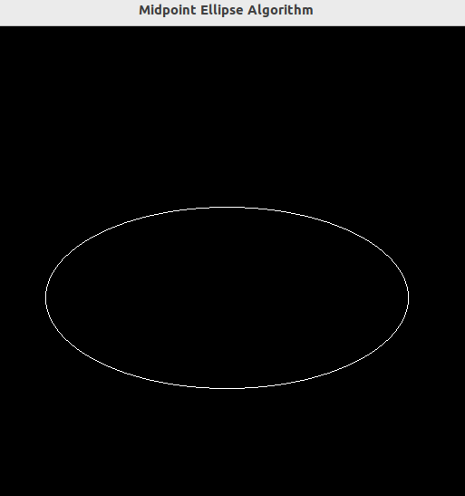

Q2. Create 3 houses , Sun and Fence.

#include <GL/glut.h>
#include <cmath>

void drawSun(float cx, float cy, float radius)
{
int segments = 100;

glBegin(GL_LINE_LOOP);
for(int i = 0; i <= segments; i++)
{
float theta = 2.0f * 3.14159f * i / segments;
float x = cx + radius * cos(theta);
float y = cy + radius * sin(theta);
glVertex2f(x, y);
}
glEnd();

glBegin(GL_LINES);
for(int i = 0; i < 12; i++)
{
float angle = 2.0f * 3.14159f * i / 12;
float x1 = cx + radius * cos(angle);
float y1 = cy + radius * sin(angle);
float x2 = cx + (radius + 20) * cos(angle);
float y2 = cy + (radius + 20) * sin(angle);
glVertex2f(x1, y1);
glVertex2f(x2, y2);
}
glEnd();
}

void drawHouse()
{

glBegin(GL_LINE_LOOP);
glVertex2f(-40, -50);
glVertex2f(40, -50);
glVertex2f(40, 20);
glVertex2f(-40, 20);
glEnd();

glBegin(GL_LINE_LOOP);
glVertex2f(-50, 20);
glVertex2f(0, 70);
glVertex2f(50, 20);
glEnd();

glBegin(GL_LINE_LOOP);
glVertex2f(-15, -50);
glVertex2f(15, -50);
glVertex2f(15, 0);
glVertex2f(-15, 0);
glEnd();
}

void drawFence()
{

glBegin(GL_LINES);
glVertex2f(-300, -80);
glVertex2f(300, -80);

glVertex2f(-300, -60);
glVertex2f(300, -60);
glEnd();

glBegin(GL_LINES);
for(int i = -300; i <= 300; i += 20)
{
glVertex2f(i, -100);
glVertex2f(i, -50);
}
glEnd();
}

void display()
{
glClear(GL_COLOR_BUFFER_BIT);

glColor3f(0.0f, 0.0f, 0.0f);

drawSun(200, 180, 30);

glPushMatrix();
glTranslatef(-150, 0, 0);
drawHouse();
glPopMatrix();

glPushMatrix();
drawHouse();
glPopMatrix();

glPushMatrix();
glTranslatef(150, 0, 0);
drawHouse();
glPopMatrix();

drawFence();

glFlush();
}

void init()
{

glClearColor(1.0f, 1.0f, 1.0f, 1.0f);

glPolygonMode(GL_FRONT_AND_BACK, GL_LINE);

glMatrixMode(GL_PROJECTION);
glLoadIdentity();
gluOrtho2D(-300, 300, -150, 250);
}

int main(int argc, char** argv)
{
glutInit(&argc, argv);
glutInitDisplayMode(GLUT_SINGLE | GLUT_RGB);
glutInitWindowSize(800, 600);
glutCreateWindow("Three Houses - Outline Mode");

init();
glutDisplayFunc(display);
glutMainLoop();
return 0;
}

