**Assignment – 6**

**Name – Ravi Kumar**

**Roll No. – 244CA041**

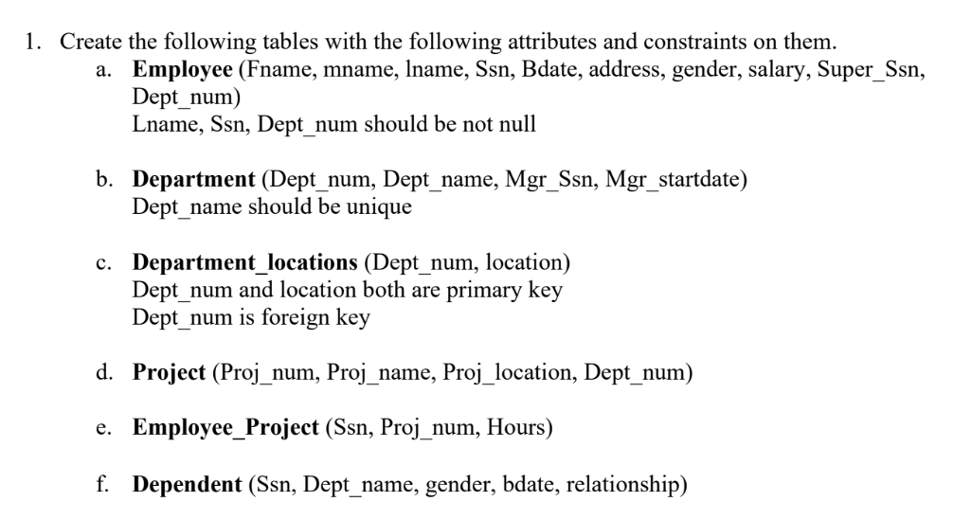

**Create table Departments (**

**dept_numnumeric(8, 0),**

**dept_namevarchar(10) unique,**

**mgr_ssnnumeric(7, 0),**

**mgr_startdatedate,**

**primary key(dept_num)**

**);**

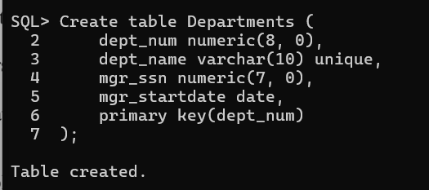

**Create table employee (**

**fnamevarchar(10),**

**mnamevarchar(1),**

**lnamevarchar(10) not null,**

**ssnnumeric(7, 0) not null,**

**bdatedate,**

**address varchar(15),**

**gender varchar(6),**

**salary numeric(6, 0),**

**super_ssnnumeric(7, 0),**

**dept_numnumeric(8, 0) not null,**

**primary key (ssn),**

**foreign key (dept_num) references**

**departments(dept_num) on delete cascade**

**);**

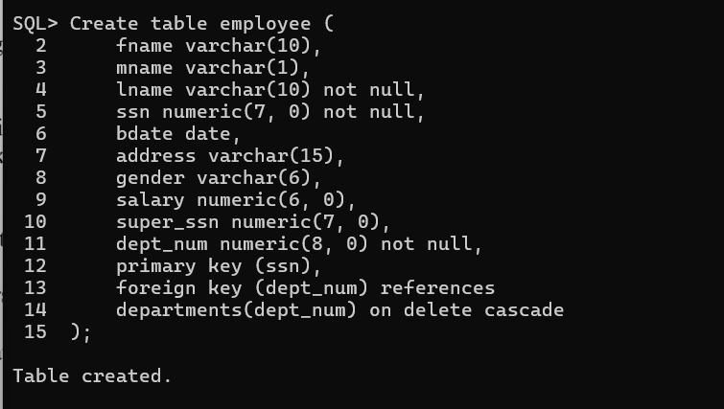

**Create table department_locations (**

**dept_num numeric (8, 0),**

**location varchar(8),**

**primary key(dept_num, location),**

**foreign key (dept_num) references**

**departments (dept_num) on delete cascade**

**);**

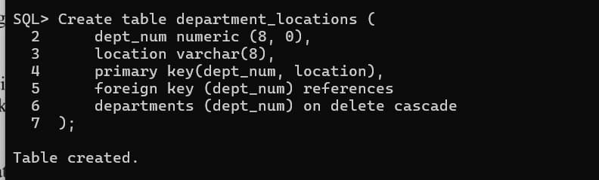

**Create table project (**

**proj_numnumeric(6, 0),**

**proj_namevarchar(9),**

**proj_locationvarchar(13),**

**dept_numnumeric(8, 0),**

**primary key (proj_num),**

**foreign key (dept_num) references**

**departments (dept_num) on delete cascade**

**);**

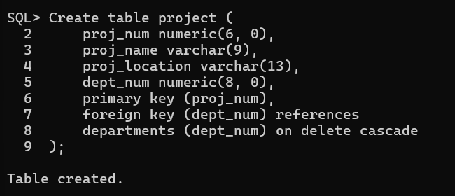

**Create table employee_project (**

**ssn numeric (7, 0),**

**proj_numnumeric(6, 0),**

**hours numeric(3, 0),**

**primary key (ssn, proj_num),**

**foreign key (ssn) references**

**employee(ssn) on delete cascade,**

**foreign key(proj_num) references**

**project (proj_num) on delete cascade**

**);**

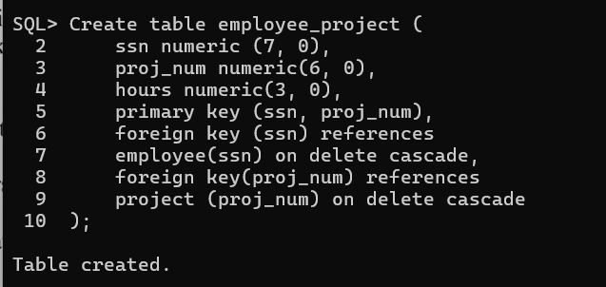

**Create table dependent (**

**ssnnumeric(7, 0),**

**depn_namevarchar(10),**

**gender varchar(6),**

**bdatedate,**

**relationship varchar(12),**

**primary key(ssn),**

**foreign key (ssn) references**

**employee on delete cascade**

**);**

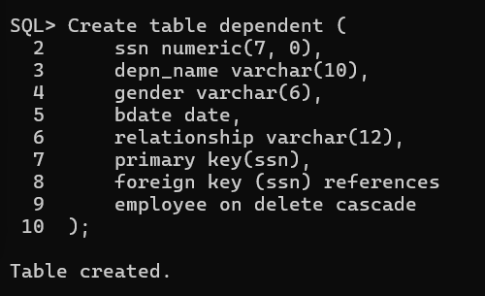

**2. Add two column blood group and hobbies to employee table.**

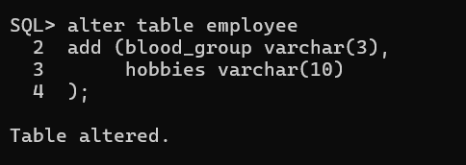

**3. Increase the size of column blood group to 15 to the employee table.**

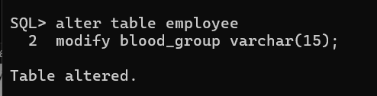

**4. Drop column hobbies from the employee table.**

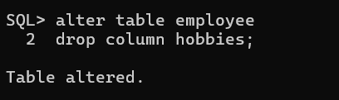

**5. Rename Employee Table to Employee_details.**

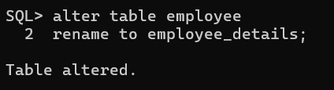

**6. Insert atleast five records in each table.**

**Insert into departments values (1, 'Sales', 892912, to_date('1989-11-23', 'yyyy-mm-dd'));**

**Insert into departments values (2, 'Marketing', 450350, to_date('1999-07-11', 'yyyy-mm-dd'));**

**Insert into departments values (3, 'Tech', 478393, to_date('2013-06-26', 'yyyy-mm-dd'));**

**Insert into departments values (4, 'Teaching', 387949, to_date('2024-06-08', 'yyyy-mm-dd'));**

**Insert into departments values (5, 'Finance', 098132, to_date('2025-03-31', 'yyyy-mm-dd'));**

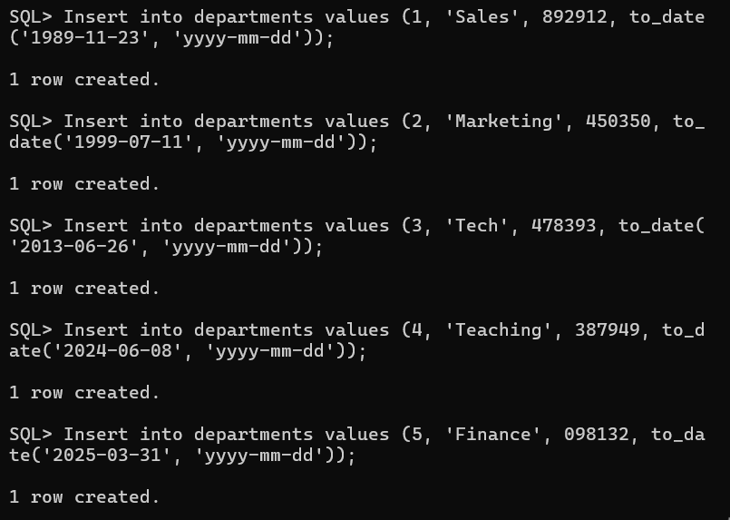

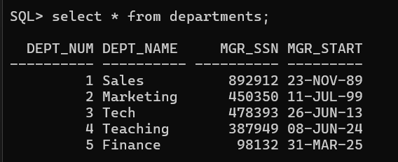

**Insert into employee_details values ('Smith', 'K', 'Kumar', 482928, to_date('1983-11-07', 'yyyy-mm-dd') , 'Kolkata', 'Male', 1098, 987650, 1, 'A+');**

**Insert into employee_details values ('Ravi', 'J', 'Pandey', 123458, to_date('1989-06-11', 'yyyy-mm-dd') , 'UP', 'Male', 99999, 908978, 2, 'B+');**

**Insert into employee_details values ('Payel', 'T', 'Devi', 897893, to_date('1985-03-06', 'yyyy-mm-dd') , 'Surathkal', 'Male', 3000, 987650, 3, 'O+');**

**Insert into employee_details values ('Smith', 'K', 'Kumar', 090890, to_date('1987-07-29', 'yyyy-mm-dd') , 'Chennai', 'Male', 2001, 987650, 4, 'AB+');**

**Insert into employee_details values ('Smith', 'K', 'Kumar', 010920, to_date('1945-11-07', 'yyyy-mm-dd') , 'Kerala', 'Male', 109873, 987650, 5, 'A+');**

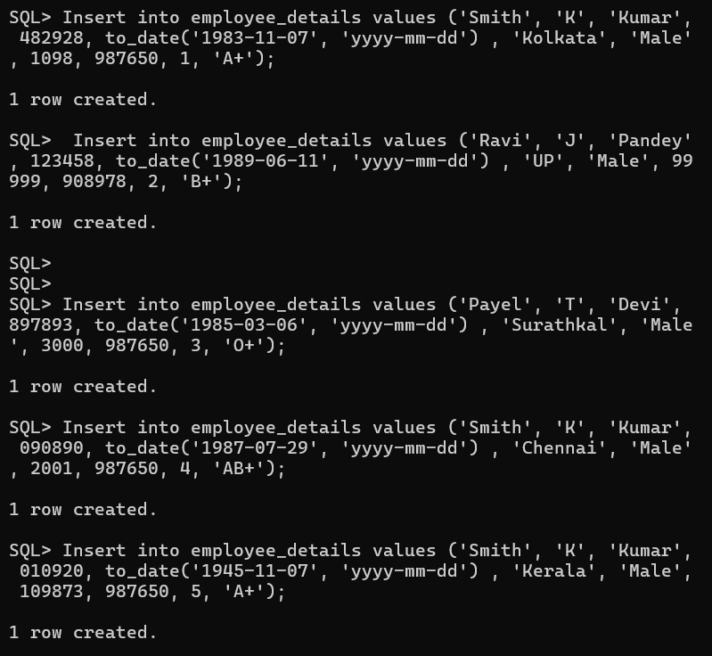

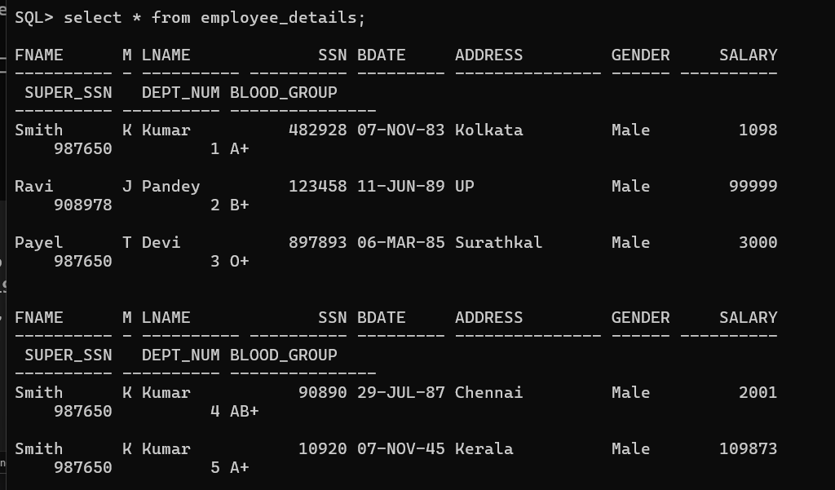

**Insert into department_locations values (1, 'Surathkal');**

**Insert into department_locations values (2, 'Delhi');**

**Insert into department_locations values (3, 'Haryana');**

**Insert into department_locations values (4, 'Chennai');**

**Insert into department_locations values (5, 'Mumbai');**

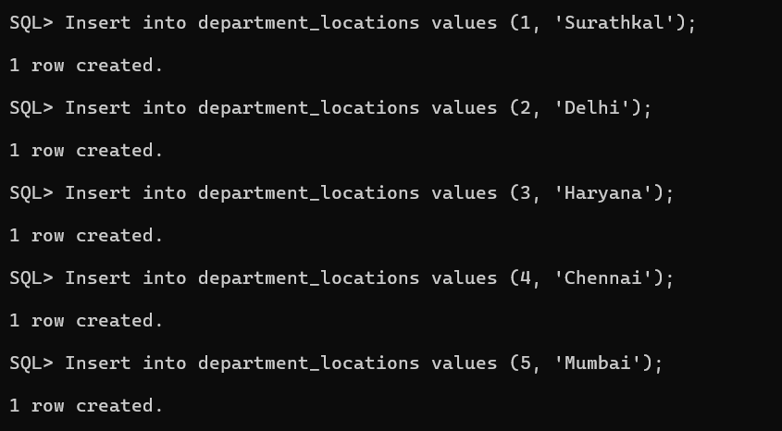

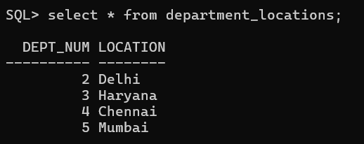

**Insert into project values (001, 'Super', 'Surathkal', 1);**

**Insert into project values (002, 'AI', 'Hyderabad', 2);**

**Insert into project values (003, 'ML', 'Surathkal', 3);**

**Insert into project values (004, 'Web', 'Chennai', 4);**

**Insert into project values (005, 'Super', 'Kolkata', 5);**

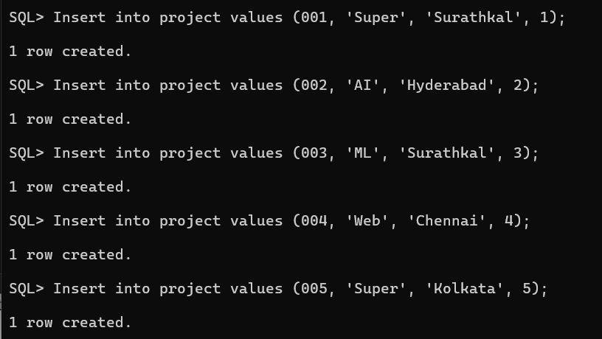

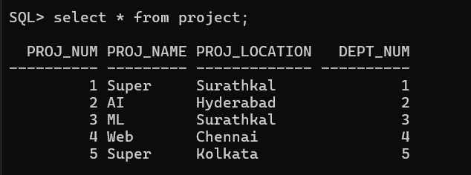

**Insert into employee_project values (482928, 001, 10);**

**Insert into employee_project values (123458, 002, 9);**

**Insert into employee_project values (897893, 003, 12);**

**Insert into employee_project values (90890, 004, 19);**

**Insert into employee_project values (10920, 005, 21);**

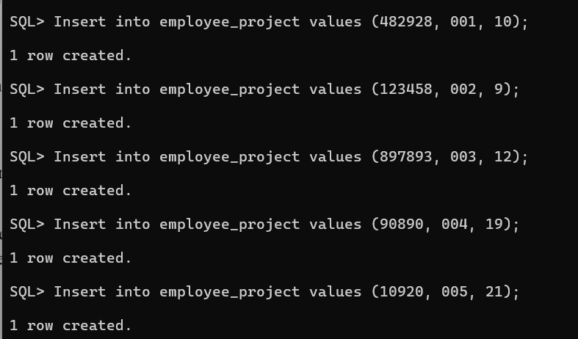

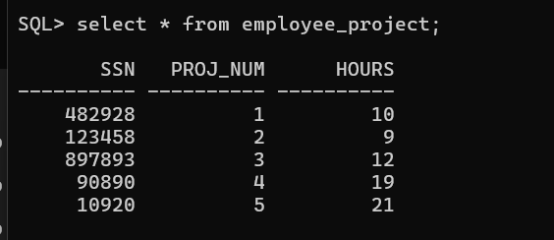

**Insert into dependent values (482928, 'Tina', 'Female',to_date('1900-09-11', 'yyyy-mm-dd'), 'Daughter');**

**Insert into dependent values (123458, 'Akash', 'Male',to_date('1991-11-23', 'yyyy-mm-dd'), 'Son');**

**Insert into dependent values (897893, 'Raj', 'Male',to_date('2011-09-09', 'yyyy-mm-dd'), 'Son');**

**Insert into dependent values (90890, 'Ritik', 'Male',to_date('1998-09-28', 'yyyy-mm-dd'), 'Son');**

**Insert into dependent values (10920, 'Tanmay', 'Male',to_date('1927-09-11', 'yyyy-mm-dd'), 'Son');**

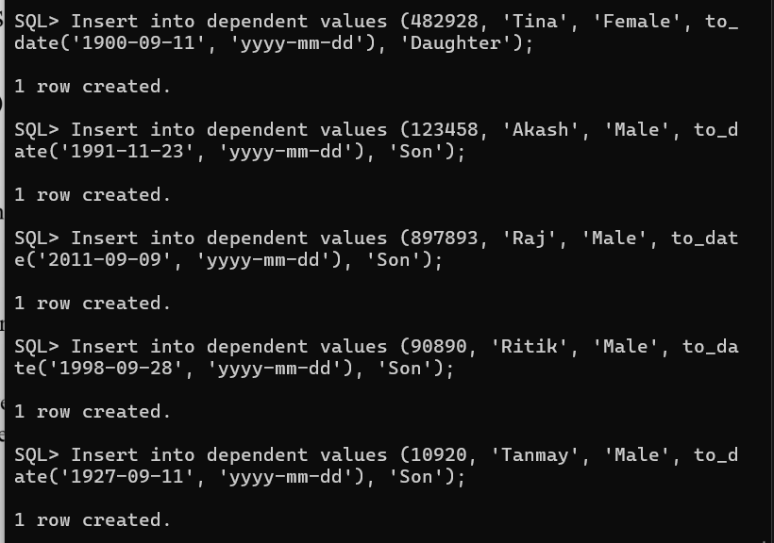

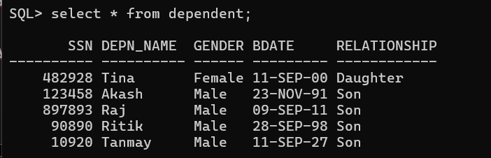

**7. Give 1000 rupees bonus to each employee.**

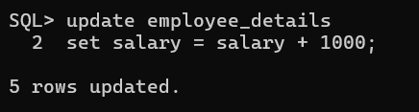

**8. Increase the salary of the employees having salary <5000 by 500 rupees.**

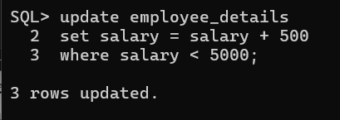

**9. Give 100 rupees bonus to employees having salary less than 10000 rupees and birth datebefore 1990.**

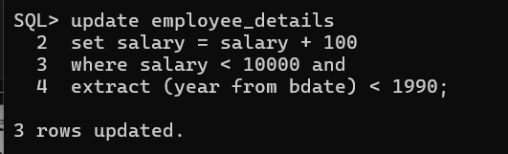

**10. Give 100 rupees bonus to employees having salary less than 10000 rupees or birth datebefore 1990.**

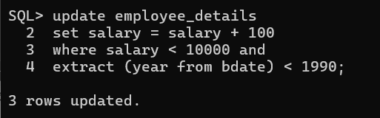

**11. Give 100 rupees bonus to employees having salary between 1000 to 5000 rupees and birth date before 1990.**

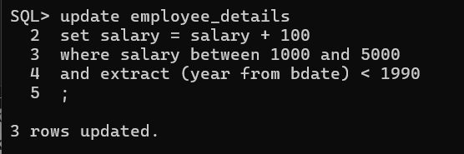

**12. Give 100 rupees bonus to employees having salary between 1000, 3000 and 5000 rupees.**

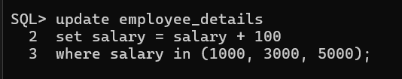

**13. Update phone number with 0000 where NULL.**

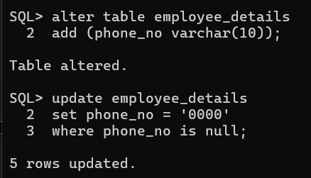

**14. Give 100 rupees bonus to employees having salary not between 1000 to 5000 rupees andbirth date before 1990.**

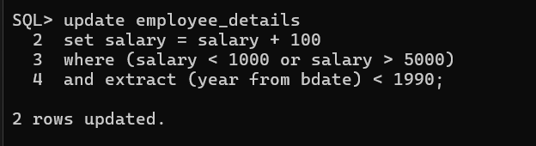

**15. Give 100 rupees bonus to employees having salary between 1000, 3000 and 5000 rupees.**

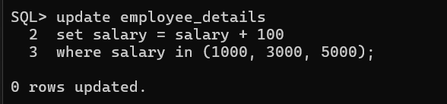

**16. Delete from employee the rows having bdate less than 1970.**

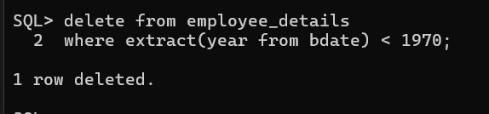

**17. List the name and age of all employees.**

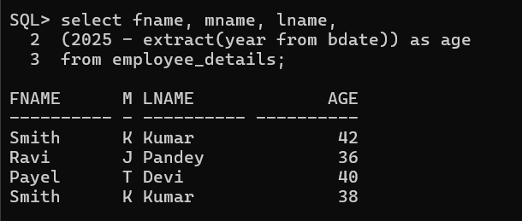

**18. Display the salaries offered to the employees.**

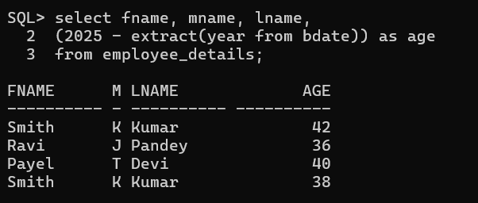

**19. List the Bdate and Salary of Employee ‘Smith’.**

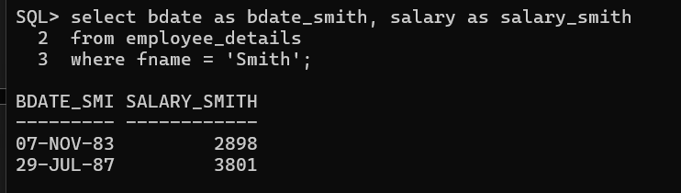

**20. Find the location of Project ‘SUPER’.**

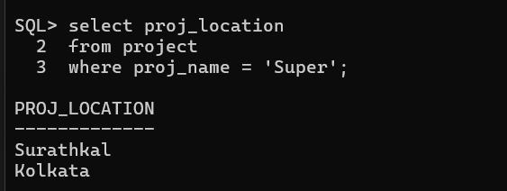

**21. Find the dependent details of Employee with Ssn number 482928.**

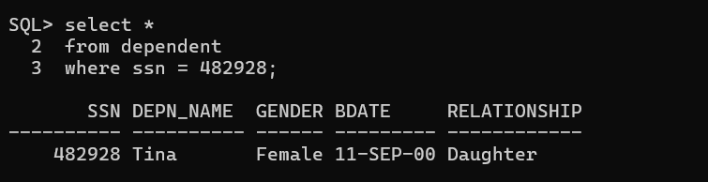

**22. List the employees having salary > 2000 and bdate before 1/1/1990.**

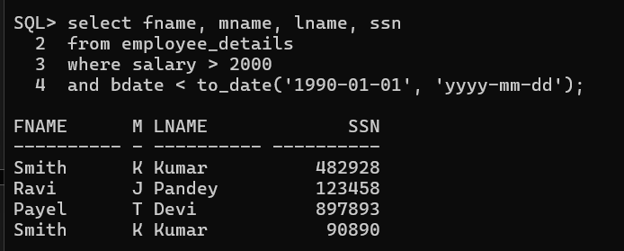

**23. List the employees belonging to dept_num 1.**

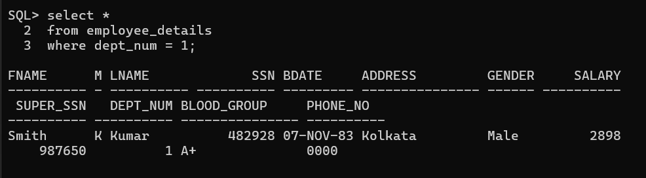

**24. List the project details of dept_num 5.**

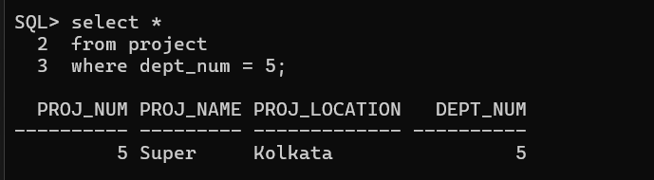

**25. List the employee details with their department name.**

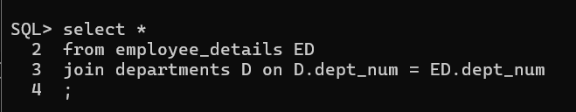

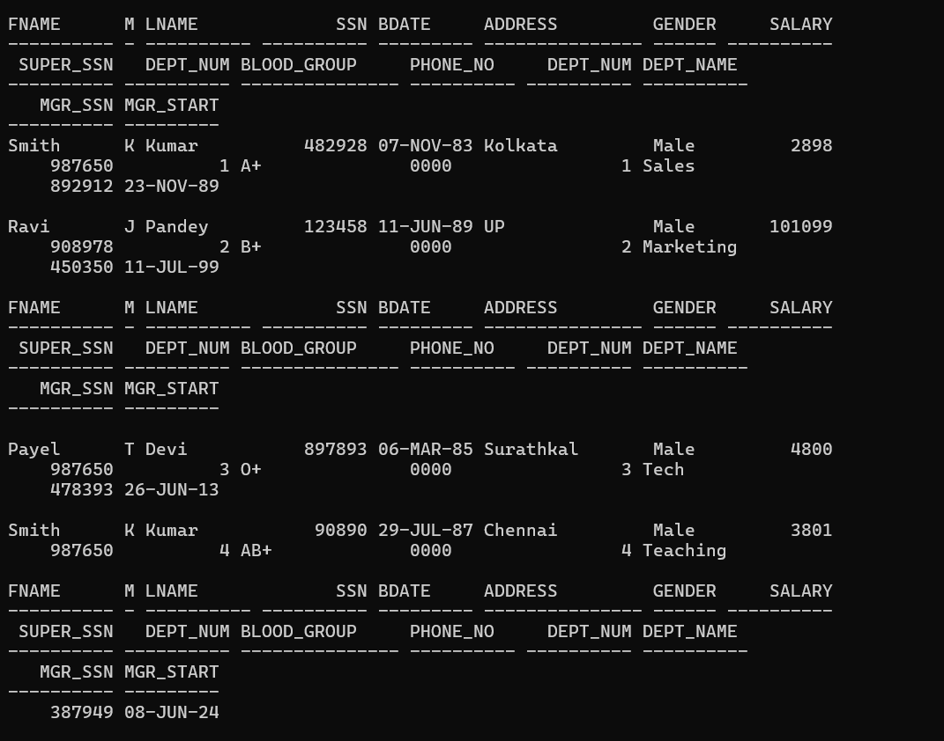

**26. List the employee details with their project names.**

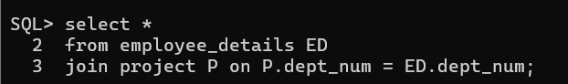

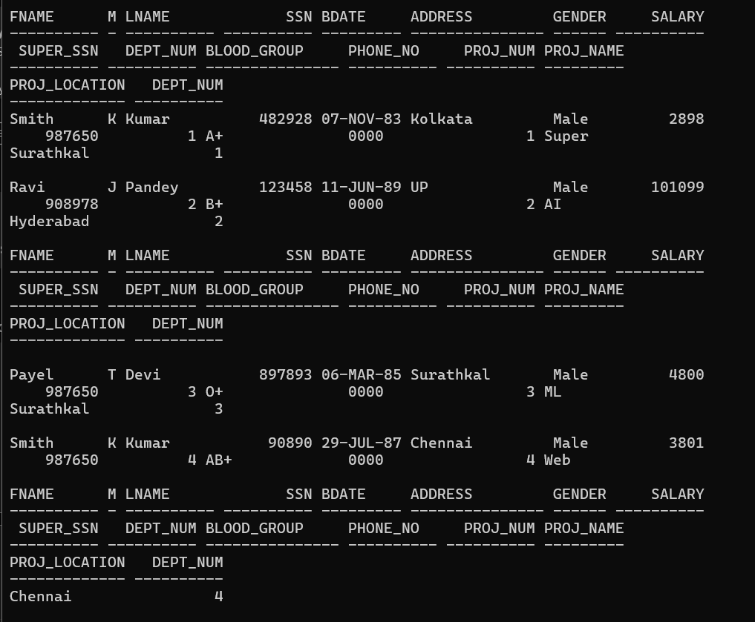

**27. List the employees belonging to Marketing department.**

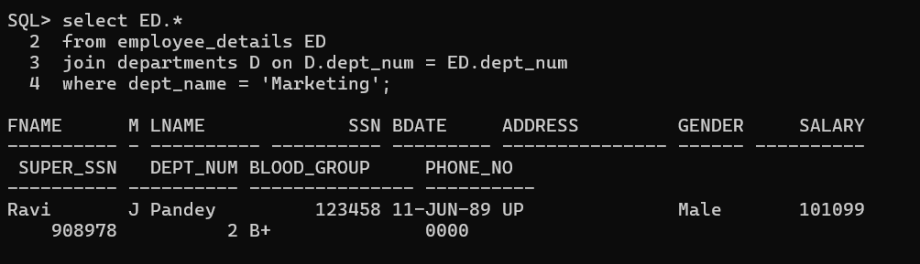

**28. List the project details belonging of Sales department.**

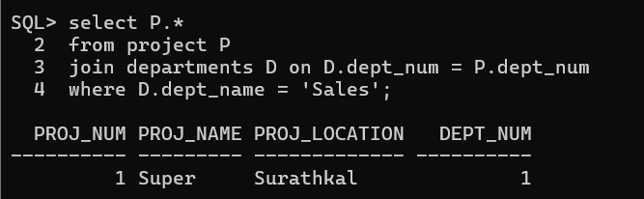

**29. List the dependent details of employee ‘Smith’.**

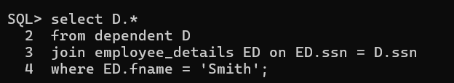

**30. List the various locations of ‘Marketing’ department.**

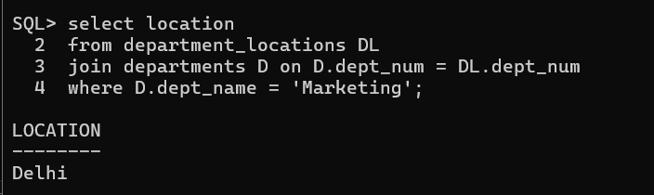

**31. List the employees going to ‘Surathkal’ branch.**

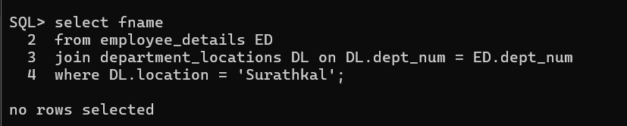

**32. List the employees in the descending order of their salary.**

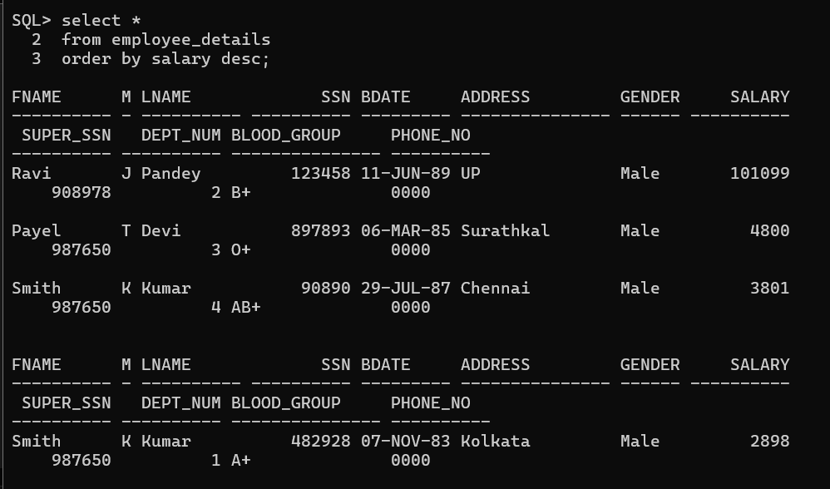

**33. List the dependents in the descending order of their names.**

