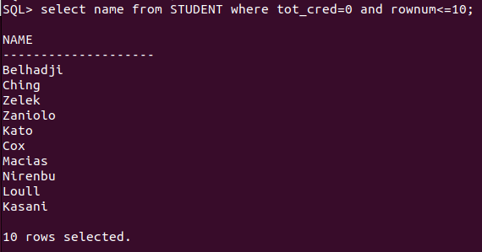
1. List all students with a total credit count of 0.

2. Find the names of all courses offered by the "Physics" department.

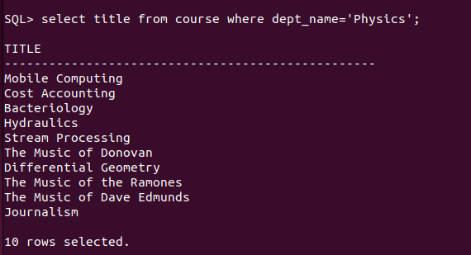
3. Retrieve the names of all instructors who earn exactly ₹50,000.

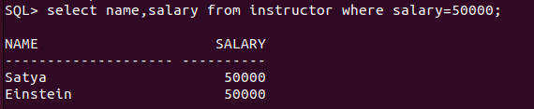
4. List all classrooms with a capacity of exactly 100.
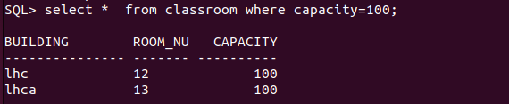

5. Find the total number of courses offered in the "Summer" semester.

6. List all students who have taken exactly 30 total credits.

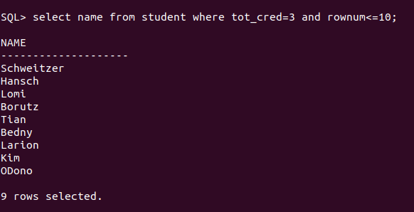
7. Find the names of all courses offered by the "Chemistry" department.

8. Retrieve the names of all instructors who earn more than ₹100,000.

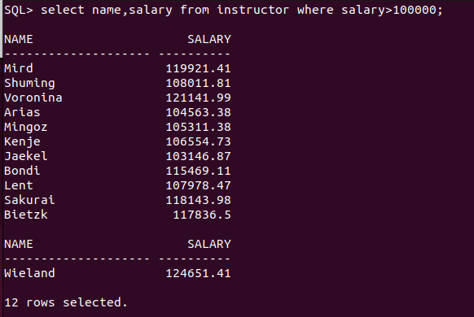
9. List all classrooms located in the "Taylor" building.
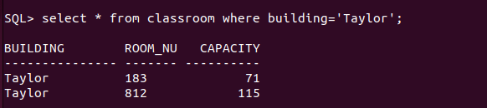

10. Find the total number of courses offered in the "Winter" semester.

11. List all students who have taken courses with a grade of "C" or lower.

12. Retrieve the names of instructors who have taught in the "Fall" semester of 2022.

