CREATE TABLE classroom
2 (building varchar(15),
3 room_number varchar(7),
4 capacity numeric(4,0),
5 primary key (building, room_number)
6 );

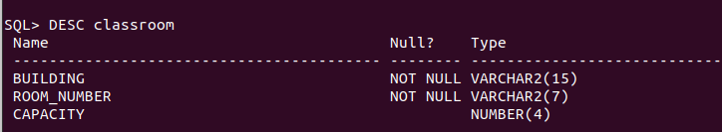

CREATE TABLE department
2 (dept_name varchar(20),
3 building varchar(15),
4 budget numeric(12,2) check (budget>0),
5 primary key (dept_name)
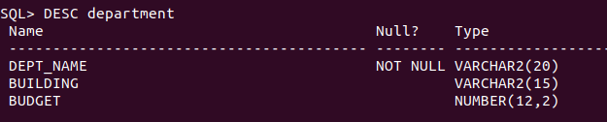
6 );CREATE TABLE course
CREATE TABLE course
2 (course_id varchar(8),
3 title varchar(50),
4 dept_name varchar(20),
5 credits numeric(2,0) check (credits>0),
6 primary key (course_id),
7 foreign key (dept_name) references department
8 on delete set null
9 );
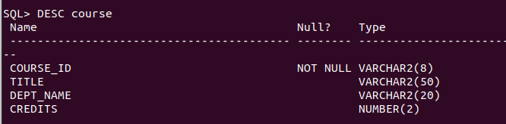
CREATE TABLE instructor
2 (ID varchar(5),
3 name varchar(20) not null,
4 dept_name varchar(20),
5 salary numeric(8,2) check (salary>29000),
6 primary key (ID),
7 foreign key (dept_name) references department
8 on delete set null
9 );
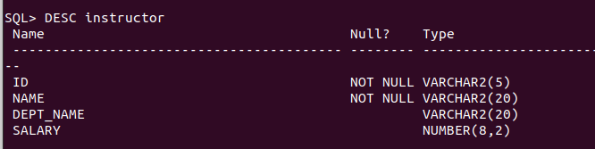
CREATE TABLE section
2 (course_id varchar(8),
3 sec_id varchar(8),
4 semester varchar(6)
5 check (semester in ('Fall','Winter','Spring','Summer')),
6 year numeric(4,0) check (year>1701 and year<2100),
7 building varchar(15),
8 room_number varchar(7),
9 time_slot_id varchar(4),
10 primary key (course_id, sec_id, semester,year),
11 foreign key (course_id) references course
12 on delete cascade,
13 foreign key (building,room_number) references classroom
14 on delete set null
15 );
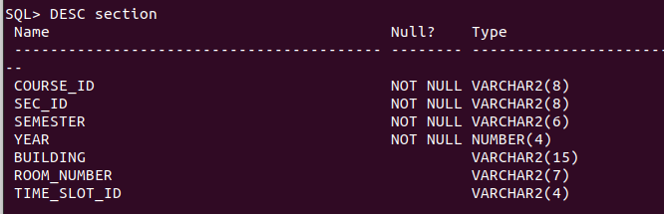
SQL> CREATE TABLE teaches
2 (ID varchar(5),
3 course_id varchar(8),
4 sec_id varchar(8),
5 semester varchar(6),
6 year numeric(4,0),
7 primary key (ID, course_id, sec_id, semester, year),
8 foreign key (course_id,sec_id, semester, year) references section
9 on delete cascade,
10 foreign key (ID) references instructor
11 on delete cascade
12 );
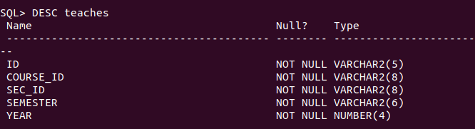
CREATE TABLE student
2 (ID varchar(5),
3 name varchar(20) not null,
4 dept_name varchar(20),
5 tot_cred numeric(3,0) check (tot_cred >= 0),
6 primary key (ID),
7 foreign key (dept_name) references department
8 on delete set null
9 );
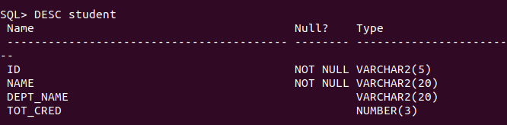
CREATE TABLE takes
2 (ID varchar(5),
3 course_id varchar(8),
4 sec_id varchar(8),
5 semester varchar(6),
6 year numeric(4,0),
7 grade varchar(2),
8 primary key (ID, course_id, sec_id, semester, year),
9 foreign key (course_id,sec_id, semester, year) references section
10 on delete cascade,
11 foreign key (ID) references student
12 on delete cascade
13 );
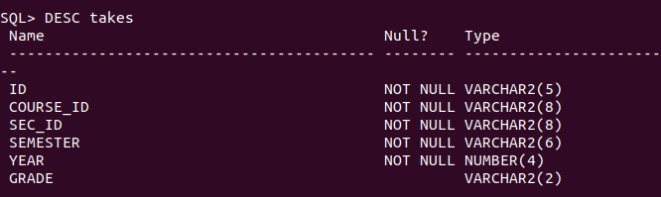
CREATE TABLE advisor
2 (s_ID varchar(5),
3 i_ID varchar(5),
4 primary key (s_ID),
5 foreign key (i_ID) references instructor (ID)
6 on delete set null,
7 foreign key (s_ID) references student (ID)
8 on delete cascade
9 );
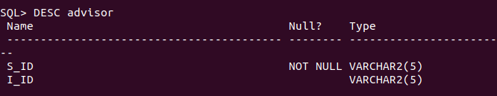
CREATE TABLE time_slot
2 (time_slot_id varchar(4),
3 day varchar(1),
4 start_hr numeric(2) check (start_hr >= 0 and start_hr <24),
5 start_min numeric(2) check (start_min >= 0 and start_min <60),
6 end_hr numeric(2) check (end_hr >= 0 and end_hr < 24),
7 end_min numeric(2) check (end_min >= 0 and end_min < 60),
8 primary key (time_slot_id, day, start_hr, start_min)
9 );
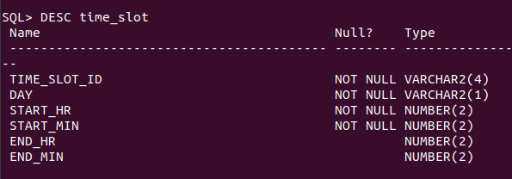
CREATE TABLE prereq
2 (course_id varchar(8),
3 prereq_id varchar(8),
4 primary key (course_id, prereq_id),
5 foreign key (course_id) references course
6 on delete cascade,
7 foreign key (prereq_id) references course
8 );
