Assignment 5

Create the following tables with the following attributes and constraints on them.
a. Bank (bk_code, bk_name, bk_address)
b. Branch (br_id, br_name, br_address, bk_code)
c. Customer (cust_ID, cust_name, phone_no, address)
d. Account (acc_no, acc_type, balance, br_id)
e. Customer_Account (cust_ID, acc_no)
f. Loan (loan_ID, loan_type, amount, br_id)
g. Customer_Loan (cust_ID, loan_ID)

1. Create all the tables by defining primary key, foreign key and other appropriate constraints

a.


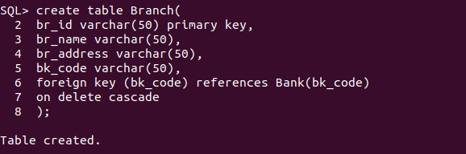
b.



c.

d.
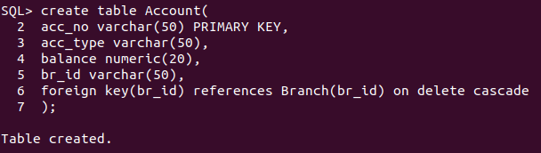
e.
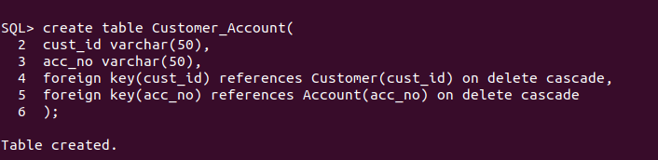
f.
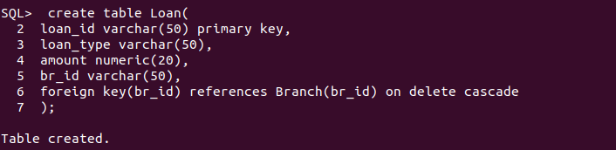
g.
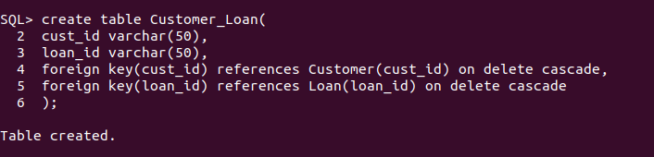

2.

