**SMART GARAGE DOOR OPENER**



A IoT Project Submitted to Institute Of Engineering & Management, Kolkata

Towards fulfilment for The Bachelor of Technology in **INFORMATION TECHNOLOGY**

**Under Guidance of:** – AVIJIT BOSE & KAJURI SUR

**Submitted by** – RAVI RANJAN (128)

ABIR BANERJEE (130)

BIBHAS MONDAL (132)

ARPAN GOSWAMI (144)

G-mail – [r.ranjan0102@gmail.com](mailto:r.ranjan0102@gmail.com)

[Abirbanerjee101@gmail.com](mailto:Abirbanerjee101@gmail.com)

[Mondalpiku5@gmail.com](mailto:Mondalpiku5@gmail.com)

arpangoswami151@gmail.com

Contains:- page no

* Abstract……………………………………………………………………..(II)
* Introduction………………………………………………………………(III)
* Working……..…………………………………………………………….(IV)
* Circuit and Output…..…………………………………………………(V)
* Conclusion……………………………………………………………….(VII)
* Reference……………………………………………………………….(VIII)

I

ABSTRACT:-

Nowadays, when the garage door slows

down in case any organization approaches the door

to close, door management is also seen as providing

sensory security, remotelyDesktop controller and

software. The advent of the Internet of Things (IoT)

has turned loyal companies, which have long been

unknowingly carriers of network attack. Nowadays

its new system for monitoring and controlling

unlocking.Online. but MyQ is different and has

more power than other IoT devices. Its control

Entrance to the house .thus Interent - a connected

garage door ("Ioot opener") is designed to be safe

enough.

Nowadays, when the garage door slows

down in case any organization approaches the door

to close, door management is also seen as providing

sensory security, remotelyDesktop controller and

software. The advent of the Internet of Things (IoT)

has turned loyal companies, which have long been

unknowingly carriers of network attack. Nowadays

its new system for monitoring and controlling

unlocking.Online. but MyQ is different and has

more power than other IoT devices. Its control

Entrance to the house .thus Interent - a connected

garage door ("Ioot opener") is designed to be safe

enough.

Nowadays, when the garage door slows

down in case any organization approaches the door

to close, door management is also seen as providing

sensory security, remotelyDesktop controller and

software. The advent of the Internet of Things (IoT)

has turned loyal companies, which have long been

unknowingly carriers of network attack. Nowadays

its new system for monitoring and controlling

unlocking.Online. but MyQ is different and has

more power than other IoT devices. Its control

Entrance to the house .thus Interent - a connected

garage door ("Ioot opener") is designed to be safe

enough.

Nowadays, when the garage door slows

down in case any organization approaches the door

to close, door management is also seen as providing

sensory security, remotelyDesktop controller and

software. The advent of the Internet of Things (IoT)

has turned loyal companies, which have long been

unknowingly carriers of network attack. Nowadays

its new system for monitoring and controlling

unlocking.Online. but MyQ is different and has

more power than other IoT devices. Its control

Entrance to the house .thus Interent - a connected

garage door ("Ioot opener") is designed to be safe

enough.

Nowadays, when the garage door slows

down in case any organization approaches the door

to close, door management is also seen as providing

sensory security, remotelyDesktop controller and

software. The advent of the Internet of Things (IoT)

has turned loyal companies, which have long been

unknowingly carriers of network attack. Nowadays

its new system for monitoring and controlling

unlocking.Online. but MyQ is different and has

more power than other IoT devices. Its control

Entrance to the house .thus Interent - a connected

garage door ("Ioot opener") is designed to be safe

enough.

Nowadays, when the garage door slows

down in case any organization approaches the door

to close, door management is also seen as providing

sensory security, remotelyDesktop controller and

software. The advent of the Internet of Things (IoT)

has turned loyal companies, which have long been

unknowingly carriers of network attack. Nowadays

its new system for monitoring and controlling

unlocking.Online. but MyQ is different and has

more power than other IoT devices. Its control

Entrance to the house .thus Interent - a connected

garage door ("Ioot opener") is designed to be safe

enough.

* Nowadays, when the garage door slows down in case any organization approaches the door to close, door management is also seen as providing sensory security, remotely Desktop controller and software. The advantage of the Internet of Things (IoT) has turned loyal companies, which have long been unknowingly carriers of network attack. Nowadays its new system for monitoring and controlling unlocking Online. but My Q is different and has more power than other IoT devices. Its control Entrance to the house .thus Internet - a connected garage door is designed to be safe enough.
* Keywords : Garage door, Iot based garage, Sensor Security, Smart Garage door

Using a smart door lock system has many of its own advantages :

* It's secure. simple and easy to access it’s pick-proof Entire lock and electronics housing is well constructed, We can use multiple smart locks.

II

INTRODUCTION:-

* Security describes protection of life and property. The safety in the house is very important. Besides the traditional method door that used a key can be easily open by not authorized person or burglar if they have the right key. This will allows them to steal the entire valuable thing in the house. Nowadays the telecommunication technologies become wider and more new features exist to make human life better This project will use an bluetooth feature in mobile phone to automatically open the door so that bluetooth technology syncs your phone directly with the lock . It will automatic open if authorized person is detected. The door will open for a certain delay and the door automatically closes within this time.
* Belt opener openers use a rubber band instead of a sequence.
* it unlocks the power of the chains. those have a sequence that connects the cart to the engine.
* jack shaft openers are located on the wall at both stops of the travel bar.
* The precise motivation for long-term steel openers is to connect the vehicle to the cart and use Steering gear wheel next to a chain.

III

Working and Basic Idea:-

Basic Idea:-

Basic idea of Smart Garage door opener is to controlling a garage door using password and with camera for Qr scan.

The front door is a crucial touchpoint for welcoming visitors, accepting packages and rebuffing sales people, but for many of us, the garage door is the much more regularly used portal into our homes. Whether you're pulling out the car or carrying some gardening tools to the front yard, the garage door big, motorized barrier.

We created a prototype of secure smart garage door opener to provide user to benefits of password for whom are new and camera for Qr scanning or Face recognition. This system help to have access or control over garage which is important part of any house. This System is designed to be low cost and expandable allowing a variety of device to be controlled.

**Hardware and Circuit Diagram:-**

1. Arduino uno R3:-

Arduino UNO is playing an important role on this project and responsible for reading data from keypad and activates Servo motor and show on LCD 16*2.

1. **Keypad 4*4:-**

Keypad is responsible for taking input from user(means password.)

1. Servo moter:-

Servo meter is responsible for getting view on door .

1. LCD 16*2:-

LCD is responsible for display about status on Iot Device.

IV

Circuit Diagram and Output:-

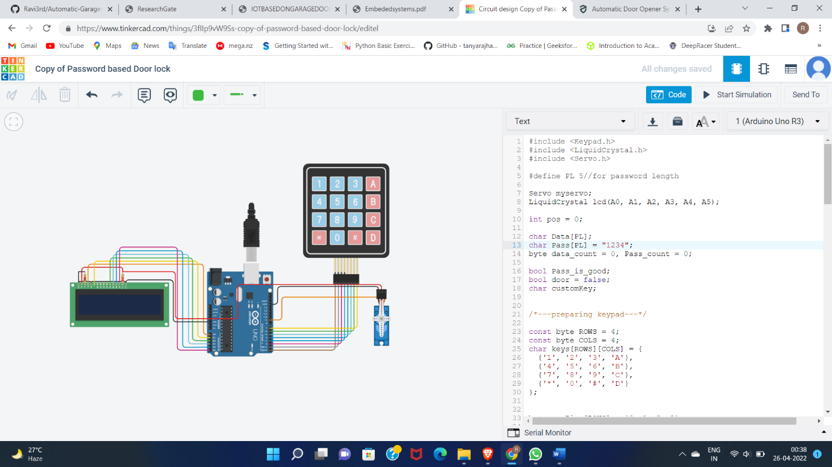

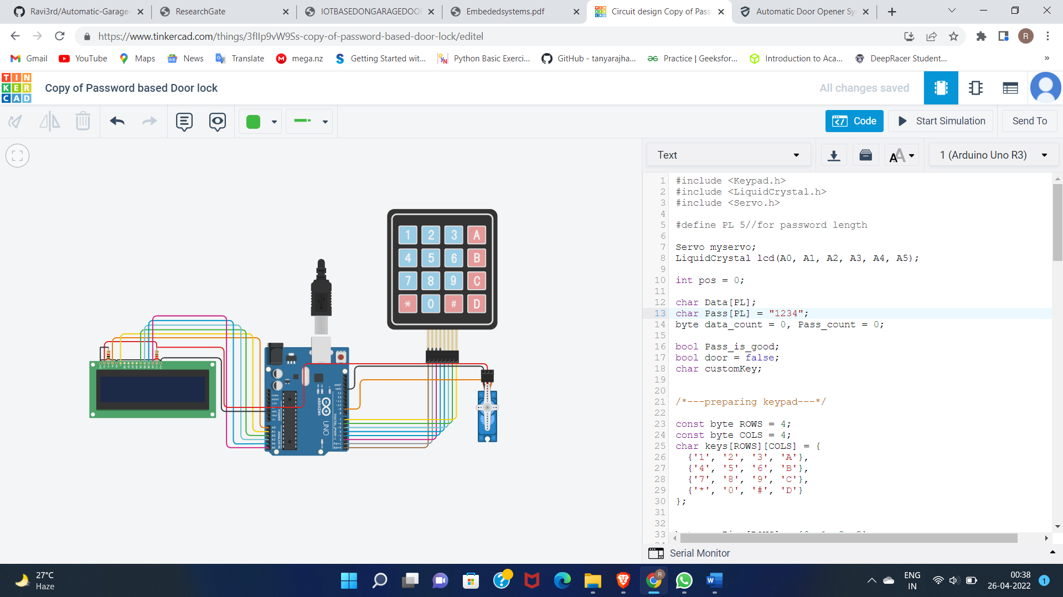

V

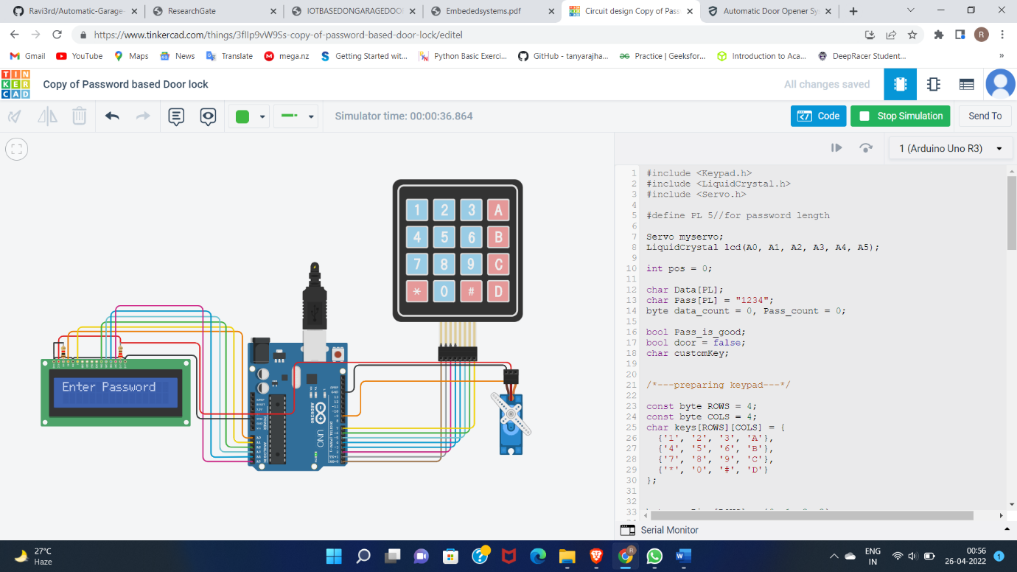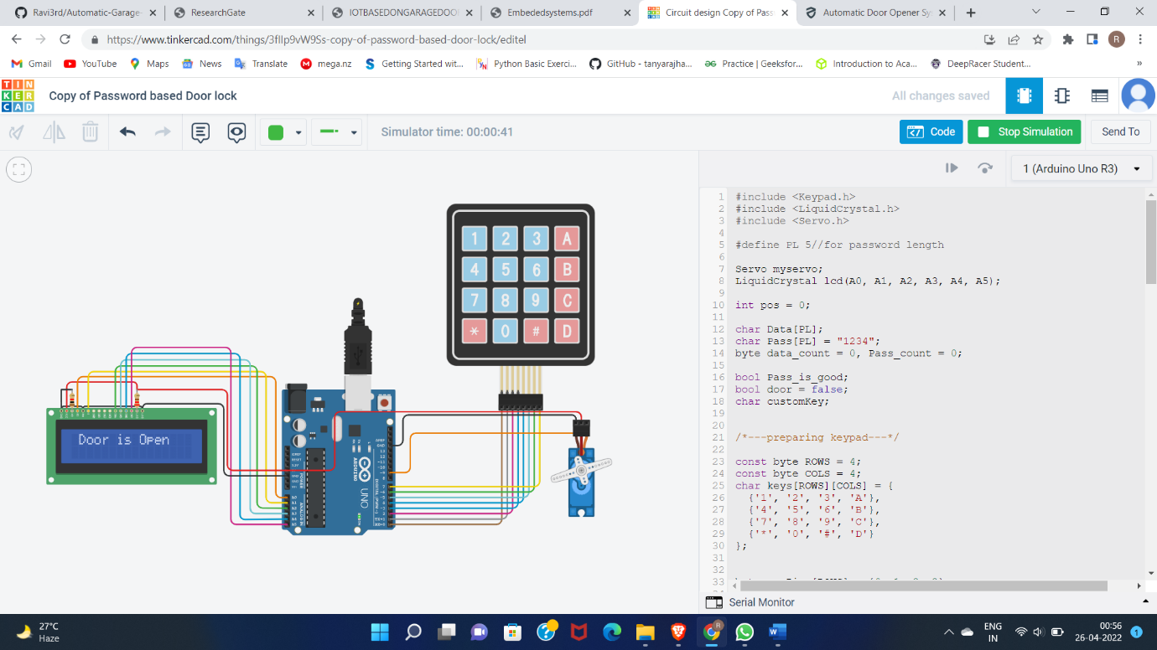

VI

Conclusion:-

Nowadays especially for

people who have difficulty opening the door, the

garage door enables the user to open the remote or

close the door. In the detection of fingerprints,

safety features on the remote are used to prevent

unauthorized use and entry. An automatic air-

opening door opens or closes the door with the help

of an electrically controlled deadbolt or lock or

open door.

Nowadays especially for people who have difficulty opening the door, the garage door enables the user to open the remote or close the door. In the detection of fingerprints, safety features on the remote are used to prevent unauthorized use and entry. An automatic air-opening door opens or closes the door with the help of an electrically controlled deadbolt or lock or open door.

VII

Reference:-

* <https://www.researchgate.net/publication/327474224_Depiction_of_IoT_Based_Smart_Vehicles_Garage_System>
* <https://www.researchgate.net/publication/357748542_IOT_BASED_ON_GARAGE_DOOR_OPENERS>

VIII