**Assignment-1**

1. What is a relational database management system (RDBMS)? What are the advantages of a database management system over a file system?

Ans:

The software used to store, manage, query, and retrieve data stored in a relational database is called a relational database management system (RDBMS).

RDBMS stores data in a row-based table structure which connects related data elements.

Advantages of DBMS:

* It is easy to use.
* It is secured in nature.
* The data manipulation can be done.
* It limits redundancy and replication of the data.
* It offers better data integrity.
* It provides better physical data independence.
* It offers logical database independence i.e. data can be viewed in different ways by the different users.
* It provides better backup and recovery procedures.
* It provides multiple interfaces.
* Multiple users can access the database which is not possible in DBMS.

Disadvantages of DBMS:

* Software is expensive.
* Complex software refers to expensive hardware and hence increases overall cost to avail the RDBMS service.
* It requires skilled human resources to implement.
* Certain applications are slow in processing.
* It is difficult to recover the lost data.

1. In a database management system, explain the ACID properties.

Ans:

The acronym ACID stands for Atomicity, Consistency, Isolation, and Durability.

1. Atomicity: Atomicity ensures that a transaction is treated as a single, indivisible unit of work. Either all the operations within the transaction are completed successfully, or none of them are. If any part of the transaction fails, the entire transaction is rolled back to its original state, ensuring data consistency and integrity.
2. Consistency: Consistency ensures that a transaction takes the database from one consistent state to another consistent state. The database is in a consistent state both before and after the transaction is executed. Constraints, such as unique keys and foreign keys, must be maintained to ensure data consistency.
3. Isolation: Isolation ensures that multiple transactions can execute concurrently without interfering with each other. Each transaction must be isolated from other transactions until it is completed. This isolation prevents dirty reads, non-repeatable reads, and phantom reads.
4. Durability: Durability ensures that once a transaction is committed, its changes are permanent and will survive any subsequent system failures. The transaction’s changes are saved to the database permanently, and even if the system crashes, the changes remain intact and can be recovered.
5. Explain the concept of normalization.

Ans:

* Normalization is the process of organizing the data in the database.
* Normalization is used to minimize the redundancy from a relation or set of relations. It is also used to eliminate undesirable characteristics like Insertion, Update, and Deletion Anomalies.
* Normalization divides the larger table into smaller and links them using relationships.

Types of Normal Forms:

* Normalization works through a series of stages called Normal forms. The normal forms apply to individual relations. The relation is said to be in particular normal form if it satisfies constraints.
* **Following are the various types of Normal forms:**
* 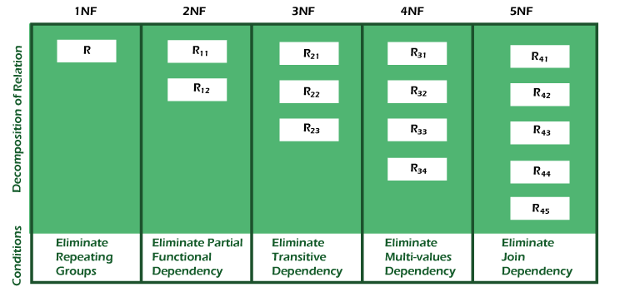

|  |  |
| --- | --- |
| **Normal Form** | **Description** |
| [1NF](https://www.javatpoint.com/dbms-first-normal-form) | A relation is in 1NF if it contains an atomic value. |
| [2NF](https://www.javatpoint.com/dbms-second-normal-form) | A relation will be in 2NF if it is in 1NF and all non-key attributes are fully functional dependent on the primary key. |
| [3NF](https://www.javatpoint.com/dbms-third-normal-form) | A relation will be in 3NF if it is in 2NF and no transition dependency exists. |
| BCNF | A stronger definition of 3NF is known as Boyce Codd's normal form. |
| [4NF](https://www.javatpoint.com/dbms-forth-normal-form) | A relation will be in 4NF if it is in Boyce Codd's normal form and has no multi-valued dependency. |
| [5NF](https://www.javatpoint.com/dbms-fifth-normal-form) | A relation is in 5NF. If it is in 4NF and does not contain any join dependency, joining should be lossless. |

1. Explain the many types of query languages used in relational databases. DQL, DML, DCL, and DDL are some examples.

Ans:

**DDL (Data Definition Language):**

DDL is a collection of SQL commands that are used to build, change, and destroy database structures and not the data itself.

**Here is the list of DDL commands:**

* **CREATE**: It is used in the creation of the database and includes items or objects, such as a table, views, index, or/and stored procedure function, and triggers.
* **DROP:** It is used in removing objects from any database.
* **ALTER:** This can be utilized to change the database’s design or structure.
* **TRUNCATE:** This command can be employed to eliminate all records or entries from a table, along with all allotted spaces for those items.
* **TRUNCATE:** This command can be employed to eliminate all records or entries from a table, along with all allotted spaces for those items.
* **COMMENT:** This command is used to insert comments into the data dictionaries.
* **RENAME:** It is used while renaming an existing object in the system of the database.

**DQL (Data Query Language):**

The DQL SQL commands are used to query data inside schema objects.

It contains the SELECT statement. It allows you to extract data from the database to execute actions on it.

**DML (Data Manipulation Language):**

This is a SQL statement component that governs the database and information access.

**Here is the list of DML commands:**

* **INSERT:** This command inserts data into an existing table.
* **UPDATE:** This command is employed in updating the existing data in a table.
* **DELETE:** This command is used to remove records from a database table.
* **LOCK:** Concurrent table control.
* **CALL:** This command invokes a [PL/SQL](https://trainings.internshala.com/blog/what-is-plsql/) or JAVA subprogram.
* **EXPLAIN PLAN:** This command is used in describing the data access path.

**DCL (Data Control Language):**

The DCL SQL commands comprise GRANT and REVOKE, which primarily interact with the database system’s rights, permits, and other restrictions. Here is the list of DCL commands:

**Here is the list of DCL commands:**

* **GRANT:** It grants people database access.
* **REVOKE:** It removes the user’s access permissions granted using the GRANT command.