**Assignment-2**

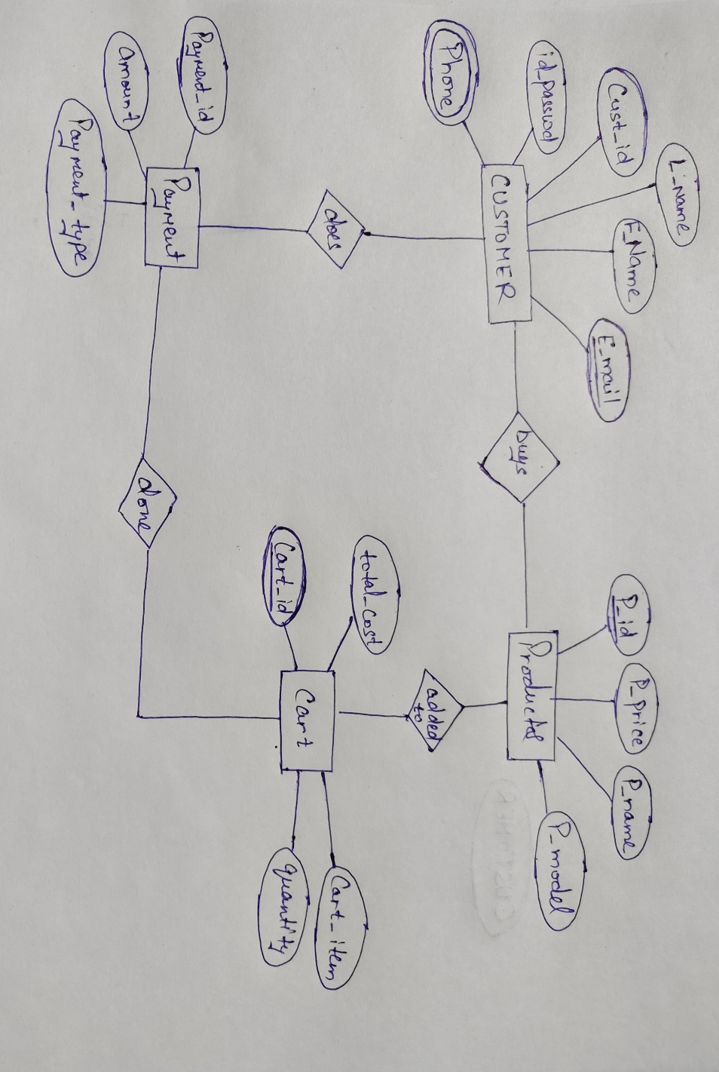

CREATE DATABASE ecommerce;

USE ecommerce;

------CREATING TABLE FOR CUSTOMER RECORDS------;

CREATE TABLE Customer(

customer_id int not null,

firstname varchar(50),

lastname varchar(50),

email varchar(50),

id_password varchar(50),

address varchar(250),

phone varchar(15),

PRIMARY KEY(customer_id)

);

------CREATING TABLE FOR PRODUCTS RECORDS------;

CREATE TABLE Products(

p_id int not null,

p_name varchar(50),

p_price double,

p_model varchar(30),

PRIMARY KEY(p_id)

);

------CREATING TABLE FOR CART ITEMS RECORDS------;

CREATE TABLE Cart(

cart_id int not null,

cart_item varchar(50),

quantity int,

total_cost double,

PRIMARY KEY(cart_id)

);

------CREATING TABLE FOR PAYMENT RECORDS------;

CREATE TABLE payments(

payment_id int not null,

amount double,

payment_type varchar(30),

PRIMARY KEY(payment_id)

);

SELECT * FROM payments;

SELECT * FROM Products;

SELECT * FROM Cart;

SELECT * FROM Customer;