Maximizing Predictive Accuracy: Leveraging Information Gain for Feature Ranking and Decision Tree Construction

  - ECE 59500 Spring 2024

  - Team Members:
  - Kevin Grimes
Ravi Mann
Tamim Delmar

  - Submission Date: 03/04/2024

Table of Contents
Introduction 3
Entropy 4
Conditional Entropy 5
Weighted Average Entropy 6
Information Gain 7
Feature Extraction & Selection 8
Feature Extraction 8
Feature Selection 8
Decision Tree 9
Construction of Decision Trees: 9
Representation of Decision Trees: 10
CART - Classification and Regression Trees: 10
Choosing Splitting Criteria: 10
Analysis and Results 10
Feature Ranking 10
Classifier Building Based on IG 12
Conclusion 15
References 16

Introduction
The dataset used in this project's decision tree construction is the one shown in Table 1. It consists of multiple predictors, each linked to particular attribute values, such as wind, temperature, humidity, and outlook. These characteristics offer vital information about the state of the environment, including temperature, humidity, wind speed, and weather forecast. A response column in the dataset also indicates whether or not a specific class will be held in accordance with the provided predictors.

Our goal in analyzing this dataset is to find trends and connections that can guide the development of a successful decision tree model. We may learn a lot about the decision-making process by examining the correlations between various combinations of predictors and the class outcomes. Metrics like information gain and entropy, which are essential in figuring out the best splits at each decision tree node, will serve as the foundation for this investigation. Ultimately, we aim to create a strong decision tree model that can precisely predict class outcomes based on the specified environmental conditions by utilizing the data extracted from this dataset and utilizing cutting-edge machine learning techniques [5]. This project will improve our comprehension of decision tree construction in addition to demonstrate the practical applicability of feature ranking methodologies in real-world scenarios.

Predictors |  |  |  | Response
Outlook | Temperature | Humidity | Wind | Class
Sunny | Hot | High | Weak | No
Sunny | Hot | High | Strong | No
Overcast | Hot | High | Weak | Yes
Rain | Mild | High | Weak | Yes
Rain | Cool | Normal | Weak | Yes
Rain | Cool | Normal | Strong | No
Overcast | Cool | Normal | Strong | Yes
Sunny | Mild | High | Weak | No
Sunny | Cool | Normal | Weak | Yes
Rain | Mild | Normal | Weak | Yes
Sunny | Mild | Normal | Strong | Yes
Overcast | Mild | High | Strong | Yes
Overcast | Hot | Normal | Weak | Yes
Rain | Mild | High | Strong | No
Table 1: Table of Dataset

Entropy
A fundamental idea in decision tree algorithms, entropy provides a way to measure the disorder or impurity in a dataset [3]. It is essential for directing the building of decision trees since it makes it easier to find the best splits to increase prediction accuracy.[3] Decision trees divide data according to the values of feature vectors that are connected to every data point. The data aim for homogeneity with each split, which lowers the entropy. Nonetheless, certain nodes might continue to be heterogeneous, which would result in greater entropy levels and more uncertainty. Reaching the terminal or leaf nodes, where maximum purity is attained, is the decision tree's objective[3].

P(X=i) represents the chance of selecting data from the class at random in the mathematical entropy Equation 1. Entropy equals zero to represent a pure node in a dataset where every observation is part of a single class. Entropy, on the other hand, achieves its maximum value of 1 if the number of observations in both groups is equal. Greater uncertainty and a varied distribution of classes within the dataset are indicated by high entropy values, whereas a more uniform distribution with a single dominant class is indicated by low entropy values. This capacity to determine how effective each class is emphasizes the importance of entropy in decision tree building.

$$H\left(x\right)= -\sum_{i=1}^{n}{P(x=i)\log_{2}{(P(x=i))}}$$
Equation 1: Entropy

In order to comprehend entropy, one must view it as a gauge of impurity inside a group. As Figure 1 illustrates, there are notable differences between a highly impure group and a less impure group. Sometimes a collection will show very little impurity, which indicates that there aren't many differences. In practice, entropy is computed using a function that accepts as input a dictionary data structure with feature keys and nested dictionaries with states and attributes. This function has a loop that iterates over each feature's properties and determines each one's probability based on true or false circumstances. This method produces the feature's entropy value by imitating the entropy equation's summing operator. This thorough comprehension of entropy establishes the foundation for efficient decision tree development.
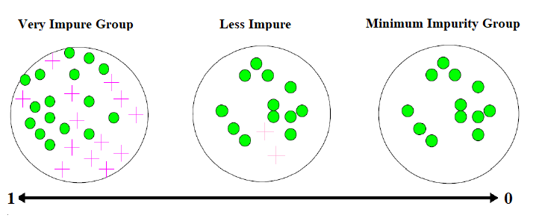
Figure 1: Entropy Purity

Conditional Entropy
Conditional entropy serves as an extension of entropy, offering insights into the amount of uncertainty remaining in a dataset after considering the value of another variable [1]. In the context of decision trees, conditional entropy becomes particularly relevant when assessing the effectiveness of attribute splits based on categorical features. It quantifies the average amount of entropy in the target variable given the values of a specific attribute, shedding light on how well a given attribute partitions the data.

$$H\left(x| y=v\right)= -\sum_{i=1}^{n}{P\left(x=i \right| y=v)\log_{2}\left(P\left(x=i \right| y=v\right)}$$ | (2)
Equation 2: Conditional Entropy

Conditional entropy can be interpreted as the average amount of uncertainty in Y given the observed values of X as shown in Equation 2. Lower values of conditional entropy indicate that attribute X effectively partitions the data into subsets with less variability in the target variable, making it a favorable choice for splitting nodes in decision trees. Conversely, higher values imply more randomness in the target variable given the attributes of X, suggesting it may not be suitable for data partitioning. This directly influences the expansion of tree nodes and informs decisions regarding whether to expand or not expand a node and its potential outcomes.

To calculate specific conditional entropy, a function named "Specific Entropy()" is employed. This function takes a dictionary containing the predictors and responses, as well as a parent representing the key in the dataset under exploration. By iteratively analyzing the dataset and calculating the entropy of a specific set given a particular value, the function computes the probability of positive or negative outcomes. This process enables the evaluation of attribute effectiveness in partitioning data and guides decision tree construction towards improved predictive accuracy [1].

Weighted Average Entropy
In order to assess the total uncertainty or impurity related to splits in the dataset, decision tree methods are developed using the Weighted Average Entropy (WAE) idea [5]. Nodes are frequently divided into subgroups of different sizes while building a decision tree, according to particular properties [4]. As such, it becomes crucial to take these subgroups' sizes into account when determining the total entropy for each split. In order to solve this problem, WAE takes into account the ratio of instances in each subset to all instances in the parent node.

Mathematically, the calculation of the weighted average entropy of a split based on attributes is represented as follows:
$$Weighted Avg. Entro= \sum_{i=1}^{k}{\frac{|C_i|}{n}}*\sum_{i=1}^{k}{P_{ij}{*log}_{2}(P_{ij})}$$
Equation 3: Weighted Average Entropy
In Equation 3: Weighted Average Entropy Equation, ∣C_i∣ denotes the number of instances in subset C_i resulting from splitting based on the value of the attribute, and Pij represents the entropy of each subset. Each subset's entropy is then multiplied by the proportion of instances in that subset compared to the total number of instances in the parent node. The calculated entropies for each subset are then summed to obtain the overall weighted average entropy of the split.

Compared to non-weighted entropy calculations, the inclusion of weighted calculations in WAE yields a more precise measurement of the total uncertainty or impurity arising from a split [4]. Decision tree algorithms can assess the quality of various attribute splits and more efficiently transform data as a result of this increased accuracy. Decision tree performance is optimized when attributes that result in subgroups with lower weighted average entropy are preferred over those with higher weighted averages.

Information Gain
Information Gain (IG) serves as a pivotal metric in decision tree algorithms, aiding in the selection of attributes for node splits to optimize prediction accuracy. It quantifies the utility of an attribute compared to others, providing insights into which feature is most informative for discriminating between classes [4]. Mathematically, IG is calculated using Equation 4, where I(x,y) represents the information gain H(x) denotes the entropy of the parent node, and WA signifies the weighted average entropy.
$$I\left(x,y\right)= H\left(x\right)-WAE$$
Equation 4: Information Gain

The entropy of the parent node is denoted by H(x) in this equation, and the weighted average entropy derived from the splits depending on various attribute values is denoted by WA. The information gain for each attribute is found as the difference between the parent entropy and the weighted average entropy.

To calculate information gain in Python, deduct the parent node's entropy from the weighted average entropy. The gain for each attribute is kept in a data structure, and this computation is iterated for each attribute using a nested loop. Then, in order to choose the next node, the attributes are ranked according to their information gain, where the attribute with the highest gain is the most informative [4].

Information Gain quantifies the anticipated drop in entropy, indicating a reduction in data impurity [3]. Sub-nodes that form as the tree expands result in these nodes becoming more homogeneous and having less entropy. Consequently, following each split, characteristics with higher information gain contribute to larger variance reduction, improving the decision tree's ability to classify data. The decision tree's root node is chosen to be the feature with the highest IG. The algorithm maximizes the prediction performance of the decision tree by determining the most important attribute for node splitting by analyzing the IG of each feature in the dataset.

Feature Extraction & Selection
In the fields of feature engineering, data analysis, and machine learning, feature extraction and selection are essential tools. These procedures are designed to enhance the efficacy, comprehensibility, and efficiency of predictive models through the optimization and assessment of feature vectors inside datasets. Datasets can be simplified without sacrificing prediction accuracy because they frequently include features and duplicated or unnecessary data. These superfluous components are eliminated by feature extraction and selection, producing simplified models that are either much more accurate or just as effective. These methods are crucial for enhancing model performance and enabling perceptive data analysis across a range of fields.

Feature Extraction
The process of feature extraction entails turning raw data into a more condensed and representative collection of features that capture the crucial details needed to create an accurate model. When working with high-dimensional data or when specific aspects are redundant or noisy, this procedure is especially helpful as it can enhance computing efficiency and shorten processing times. Principal Component Analysis (PCA), which finds principal components explaining highest variation and projects data onto a lower-dimensional subspace [2], is a well-known technique for feature extraction.

Feature Selection
Feature selection focuses on identifying and selecting the most relevant subset of features from the original feature set for model construction [6]. Unlike feature extraction, which transforms features into a new space, selection retains original features while choosing a new subset based on specific criteria. Feature selection methods are categorized into three main types: filter methods, wrapper methods, and embedded methods [2].
- Filter Methods: Filter methods evaluate features independently of the learning algorithm, typically based on statistical measures like significance tests. While computationally efficient and easy to implement, they may not always capture feature interactions.
- Wrapper Methods: Wrapper methods assess feature subsets by training a model and evaluating performance, often using cross-validation. While more accurate than filter methods, they are computationally expensive.
- Embedded Methods: Embedded methods integrate feature selection into the model training process, optimizing both feature selection and model fitting simultaneously.

Numerous advantages come with feature extraction and selection, including lowering the dimensionality curse, preventing overfitting, and improving model performance by concentrating on key characteristics [2]. These methods are essential for enhancing machine learning models and facilitating perceptive data analysis in a variety of fields.

Decision Tree
Decision trees are prominent algorithms utilized for both classification and regression tasks in machine learning. They divide the input space or dataset recursively into splits or regions, each of which is linked to a particular result or value of the target variable. In order to achieve homogeneity with regard to the target variable, the main strategy is to identify the feature that divides the data into subsets the best [3].

The decision tree in our example dataset, Table 1, will make judgments based on parameters like Outlook, Temperature, Humidity, and Wind. Each leaf node in the tree represents a forecast or an outcome. Building a transparent tree with accurate target variable determination is the main objective.

Construction of Decision Trees:
During the construction phase, each node's best feature for data splitting is chosen; this is usually done using metrics like entropy and information gain. The recursive splitting phase of the method is guided by information gain, which quantifies the homogeneity of the ensuing subsets following a split [3]. The procedure keeps on until a halting requirement is satisfied, which usually happens when more splits don't increase prediction accuracy.

Once built, decision trees can traverse the tree from the root node to a leaf node based on input feature values, allowing them to make predictions on fresh data. They are useful in many different applications because of their simplicity, interpretability, and capacity to handle both numerical and categorical data.

Representation of Decision Trees:
A decision tree is represented as a tree-like structure, with the root node at the top and internal nodes representing feature tests. Each branch represents an outcome of a test, leading to leaf nodes holding a class or prediction. This tree analogy is often visualized for better interpretation and understanding.

CART - Classification and Regression Trees:
One popular decision tree algorithm is called Classification and Regression Trees (CART). For numerical target variables, regression trees are employed, with the mean or average of answers in that region being stored at the terminal node [4]. However, for categorical target variables, classification trees are used, where the mode of replies is stored at the terminal node.

Although CART is easy to understand and straightforward, improper data handling might result in instability and overfitting. Making wise division choices and pruning are essential to reducing these problems.

Choosing Splitting Criteria:
With distinct standards for regression and tree classification, the choice to divide strategically influences the accuracy of the trees. The optimal split is chosen using metrics such as the Gini Index or Entropy/Information Gain [4]. The relationship between entropy and information gain sheds light on the importance of each trait.

To sum up, decision trees offer a clear and efficient method for predictive modeling, with transparency and interpretability that are essential for a range of applications in a variety of industries.

Analysis and Results

Feature Ranking
In the feature ranking section of the code, the entropy() function in Figure 2 serves as a foundational tool for assessing the uncertainty present within the dataset. This function determines the dataset's overall entropy, giving an indication of the degree of disorder or randomness present in the class labels [6]. The function uses Shannon's entropy formula to iterate through the dataset and calculate the likelihood of each class label occurrence in order to determine the entropy value. This figure indicates the typical amount of data needed to categorize a dataset instance that was chosen at random. To put it simply, before moving on to feature ranking, the entropy function establishes the foundation for comprehending the underlying uncertainty in the dataset.
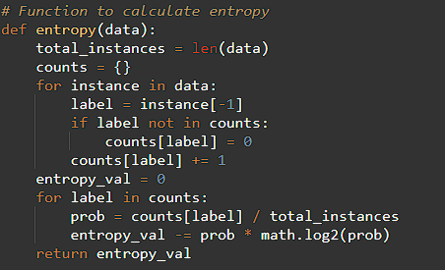
Figure 2: Entropy Function

The entropy() function in the feature ranking section of the code provides a basic means of evaluating the uncertainty in the dataset, and the information_gain() function in Figure 3 measures the amount of uncertainty that is reduced when the dataset is divided according to the values of each weather condition feature. Entropy establishes a baseline understanding of the uncertainty in the dataset by measuring the disorder or randomness inherent in the class labels. It is computed using Shannon's entropy formula. The information gain values that are then generated for every feature enable a comparative examination of their influence on the process of decision-making. Analysts are able to determine which features are most important for classification by measuring the reduction Features can be prioritized according to how well they can lower uncertainty and increase the performance of decision tree models thanks to this methodical methodology.in entropy that results from dividing the dataset according to each feature's values.
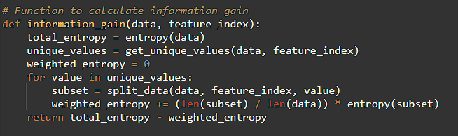
Figure 3: Information Gain Function

Each feature's information gain numbers show how much each feature has contributed to lowering uncertainty in the classification problem. The feature "Outlook" in Figure 4 has the maximum information gain of 0.25, meaning it plays the largest role in differentiating between outcomes. This implies that changes in the weather forecast have a big impact on whether or not people decide to go outside. Conversely, the information gain values for the features "Humidity," "Wind," and "Temperature" are significantly lower. With an information gain of 0.15, humidity has a moderate effect on judgment. Among the features that have been evaluated, wind and temperature have the least impact (information gain values of 0.0481 and 0.029, respectively). It is clear from comparing these information gain values that Outlook offers the most beneficial information for deciding on an outdoor activity, then considering temperature, wind, and humidity. In order to achieve the best classification accuracy, feature selection and model development are guided by this ranking, which indicates the relative significance of each meteorological condition feature in influencing the result.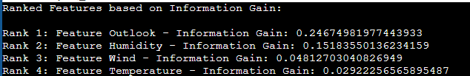
Figure 4: Ranked Features based on IG

Classifier Building Based on IG
On the other hand, in the classifier building based on information gain section, the “find_best_split()”, “Decision_build_tree()”, and “Output_print_tree()” functions are pivotal in constructing the decision tree. Firstly, the “find_best_split()” function identifies the feature that yields the maximum information gain when used to split the dataset. This function iterates over each feature, computing the information gain using the “information_gain()” function, and selects the feature with the highest information gain as the optimal split feature.
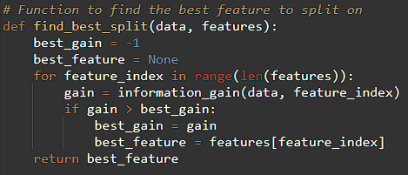
Figure 5: Find Best Split Function

Secondly, the `Decision_build_tree()` function in Figure 6 is employed to construct the decision tree recursively. It initializes a root node and splits the dataset based on the optimal feature obtained from the `find_best_split()` function. Child nodes are created for each unique value of the optimal feature, and the dataset is split further until termination conditions are met. Lastly, the `Output_print_tree()` function is utilized to print the decision tree in a readable format. It traverses the tree recursively, printing out each split and outcome decision, providing a visual representation of the decision-making process within the constructed tree. Together, these functions facilitate the construction of a decision tree based on the information gain of features, enabling effective classification of the dataset, and aiding in interpreting the decision-making process.

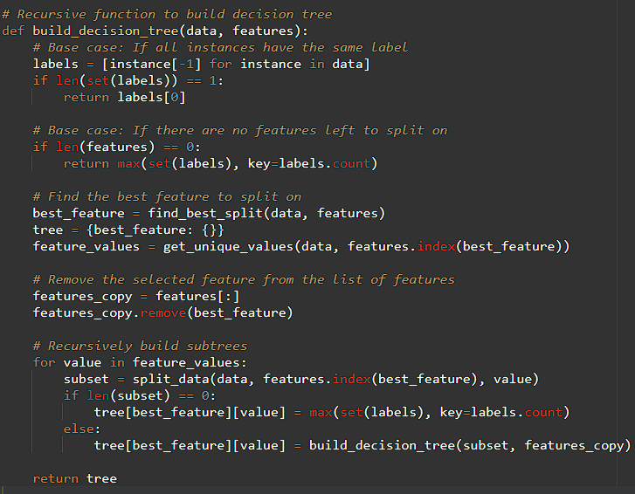
Figure 6: Build Decision Tree Function

After the print tree function is run, the outcomes shown in Figure 7 reveal the predictions made by the decision tree under different weather scenarios. For example, the model predicts a positive outcome ("Yes") when the weather prediction is cloudy, indicating ideal circumstances for outside activities. The tree then branches out to examine wind and humidity conditions. "No" and "Yes" forecasts are prompted by high and normal humidity levels, respectively, and equivalent results are produced by strong and mild wind conditions. These forecasts support the information gain analysis carried out for every feature, clarifying the rationale for the choices made at every decision tree node.
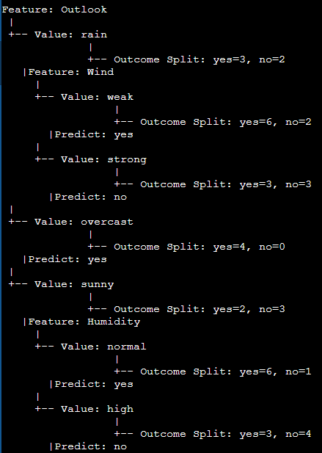
Figure 7: Decision Tree Output

Conclusion
When decision trees are created, the information gain approach is utilized as a potent tool for feature selection and tree optimization. Information gain aids in determining which features are more relevant for classification tasks by measuring the decrease in entropy brought about by segmenting the dataset according to distinct features. By ensuring that decision tree nodes are chosen based on their capacity to supply the most pertinent information, this optimization technique minimizes the size of the tree and reduces redundancy. For example, when comparing decision trees that use the information gain approach to those that do not, the latter produces a tree structure that is both larger and less effective. On the other hand, the optimized decision tree eliminates superfluous nodes and features, resulting in a more straightforward and more efficient model. Higher information gain feature prioritization makes the decision tree more efficient, facilitating quicker decision-making and lowering input-to-output latency.

To rank features and create a classifier based on these metrics, we applied the concepts of information gain and entropy in our research. We created mathematical formulas and programming functions to evaluate the importance of every feature in the dataset by using our understanding of information gain and entropy. This required the understanding of conditional entropy, the evaluation of entropy in splits, and the notion of weighted average entropy. Making use of this information, we created a decision tree that prioritized Outlook, Humidity, Wind, and Temperature in descending order of significance. The decision tree was based on the features' information gain values. This strategy gave us a better understanding of how various weather conditions affect our decision to engage in outside activities and gave us a framework for assessing and improving our classifier.

References
[1] Analytics Vidhya, "Entropy & Conditional Entropy," https://medium.com/analytics-vidhya/entropy-conditional-entropy-330d3152153 (accessed Mar. 30, 2024).
[2] GeeksforGeeks, "Difference between Feature Selection and Feature Extraction," https://www.geeksforgeeks.org/difference-between-feature-selection-and-feature-extraction/ (accessed Mar. 28, 2024).
[3] O. Pramod, "Decision Trees," Medium,https://medium.com/@ompramod9921/decision-trees-6a3c05e9cb82 (accessed Mar. 30, 2024).
[4] S. Krishnan, "Decision Tree for Classification: Entropy and Information Gain," Medium, https://medium.com/codex/decision-tree-for-classification-entropy-and-information-gain-cd9f99a26e0d (accessed Mar. 30, 2024).
[5] Q. Zhang, “Engineering Pattern Determination II”, ECE, Purdue School of Engineering and Technology, 2024 (accessed Mar. 28, 2024).
[6] Q. Zhang, “Engineering Pattern Determination III”, ECE, Purdue School of Engineering and Technology, 2024 (accessed Mar. 28, 2024).

