Model Complexity and Neural Network Pruning
  - SP24: Efficient AI THEORIES & DESIGN

  - Team Members:
  - Kevin Grimes
Ravi Mann
Tamim Delmar

  - Submission Date: 04/14/2024

Table of Contents
Introduction 3
Classification 3
Pruning 4
Magnitude-Based Pruning Method 4
Methodology 5
Problem Statement 5
Approach 6
Library of Code 6
Implementation 7
Flatten and Dense Layers: 7
Activation Functions: 7
Matplotlib for Data Visualization: 7
Data Preparation 8
Partitioning the Dataset 9
Data Preprocessing Technique 9
Data augmentation (optional): 9
Result and Discussion 10
Evaluating the Data 10
Building Neural Networks with Keras 12
Building Neural Networks with PyTorch 13
Pruning the Model 15
Displaying Sparsity of the Weights 16
Conclusion 17
References 18

Introduction
Artificial neural networks have become an essential tool in artificial intelligence, completely changing how computers process information and reach conclusions. These networks, which are influenced by the complex operations of the human brain, are made up of linked nodes grouped in layers. This structure allows them to gain information from large data sets and identify important patterns. They are used across various fields due to their exceptional capacity to address complex challenges with incredible precision and effectiveness. Neural networks are utilized in many fields such as image and audio recognition, natural language processing, and autonomous driving, contributing to progress in healthcare, finance, and several other industries. Nevertheless, as neural networks get more intricate, there is a growing need to enhance their efficiency and minimize computing resources. Pruning, namely magnitude-based pruning, applies in this context. Pruning is a method used for maximizing the efficiency of neural networks by selecting and eliminating connections or neurons that are considered irrelevant or less influential. Magnitude-based pruning is a technique that entails detecting and removing weights that have magnitudes lower than a specified threshold. This process efficiently reduces the size of the network and the sum of computation required. Pruning redundant connections in neural networks can optimize their efficiency by making them simpler, quicker, and less resource-intensive while still preserving their performance. This study aims to analyze the principles of neural network pruning, with a specific focus on magnitude-based approaches, and clarify their importance in enhancing model efficiency and scalability. By doing a thorough analysis, we are required to discover the key concepts, reasons, and techniques behind magnitude-based pruning. This will provide a helpful understanding of how important it is in developing neural network architectures for real-world applications.

Classification
Classification is a fundamental process in machine learning that involves categorizing new data points into specified groups or categories. Neural networks are highly effective in classification jobs because they offer the ability to recognize complex patterns within the dataset. These networks are made up of linked layers of neurons, where each neuron calculates weighted sums of its inputs and then uses nonlinear activation functions. This layout allows neural networks to effectively handle and evaluate complex data with multiple levels, while also obtaining detailed patterns and relationships between various features.

The code develops a neural network model using the Keras API. The model is made up of several dense (completely connected) layers, each utilizing rectified linear unit (ReLU) activation functions. The process of training an algorithm involves improving parameters, such as weights and biases, by applying the Adam optimizer and the binary cross-entropy loss function. Standardizing input data is essential to achieve consistent scaling across features, promoting steady and efficient training. The model continuously modifies its parameters during the training process, aiming at reducing the difference between the expected outputs and the actual outputs. Analyzing the performance and avoiding overfitting may be done by analyzing the model on a validation dataset.

After undergoing training, the neural network can classify new data points by inserting them into the model and analyzing the resulting predictions. In circumstances involving binary classification, the last layer commonly uses a sigmoid activation function to provide probability ratings for each class. The final class predictions are determined by applying decision thresholds to these probabilities. Neural networks offer an adaptable technique for processing classified problems across several fields such as image recognition, natural language processing, and fraud detection. They make use of their ability to describe complex patterns and their scalability.

Pruning
Neural network pruning is an effective method designed for solving issues of implementing complex and expensive models. This method requires eliminating redundant features from trained neural networks to generate smaller, simplified models while maintaining their basic operation. Pruning, similar to removing redundant branches from a tree, focuses on eliminating weights or neurons that have little impact on the overall performance of the model. As neural networks increase in size to achieve better levels of accuracy, they become more computationally demanding and challenging to implement. Pruning mitigates this problem by decreasing the size of the model without seriously affecting its performance. The magnitude-based pruning method is a fundamental approach that gradually detects and removes parameters with low magnitudes. This technique effectively establishes an acceptable balance between compression and accuracy, while maintaining key features.

Magnitude-Based Pruning Method
Magnitude-based pruning involves removing connections within the network with weights with small values, using a threshold that has been set. A custom function called MagnitudePruning typically is generated to perform pruning after every training epoch, enabling adjustment of the sparsity level using the pruning % parameter. During the pruning phase, the weights of dense layers are determined, and any weights that fall below the threshold are given a value of zero, thus eliminating them from the network. As a result, this leads to a less dense network design, which leads to less computing burden. Users can gradually adjust the pruning threshold and analyze its impact on the performance of the model to achieve a balance between the size of the model and its accuracy.

Although magnitude-based pruning is simple and easy to understand, it may have disadvantages such as the risk of eliminating crucial data if the method of pruning is excessively aggressive. To minimize such risks, it is essential to carefully determine the pruning threshold and carefully assess the performance of the trimmed model. Implementing iterative pruning strategies, which involve multiple iterations of pruning with raises in sparsity, may reduce negative effects and improve the overall resilience of the model. A complex technique called "magnitude-based pruning" is used, which involves removing several sets of weights, such as w[1], w[2], to w[n], that are combined to create a single weight w. Magnitude-based pruning, which involves pruning whole groups based on their aggregate magnitude, provides a more efficient approach to reducing model size while preserving performance.
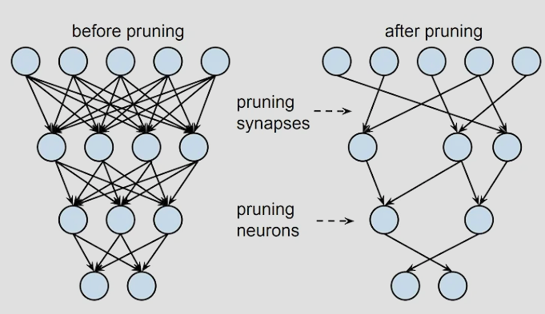
Figure 1: Pruning

Methodology

Furthermore, it is crucial to note any particular data-gathering techniques used, such as tokenization for natural language processing tasks or picture scaling and normalization for computer vision tasks. In addition, providing a thorough explanation of the reasoning behind the selection of assessment measures helps confirm the effectiveness of the model in solving the issue at hand. Also, providing information about the computing resources used, such as the hardware specs and training time, helps clarify the scalability and efficiency of the constructed neural network. In the end, identifying any hidden bias in the dataset as well as taking steps to reduce their impact showcases a dedication to ethical issues and the responsible use of AI.

Problem Statement

The objective of this study is to measure the quality of bananas by evaluating numerous variables such as size, weight, sweetness, softness, harvest time, maturity, and acidity. The goal is to construct a neural network system that can accurately evaluate the quality of bananas based on these features. Due to the significance of quality evaluation in the agricultural sector for both producers and customers, the introduction of an efficient and reliable method for evaluating the quality of bananas may significantly improve decision-making processes, improve market results, and ensure customer satisfaction. This research seeks to address the issue of subjective quality evaluation by utilizing complex algorithms for machine learning. The goal is to provide an automated and objective solution that takes into account a number of relevant factors simultaneously.

Approach

A comprehensive technique was designed to develop a neural network model specifically designed to correctly evaluate the quality of bananas for this assignment. At first, the focus was on collecting a thorough dataset that included key features of bananas, such as their size, weight, sweetness, softness, harvest time, maturity, and acidity. This required data from many reliable agricultural databases, that guarantee it accurately reflects what is being studied.

After obtaining the data, it was prepared and cleaned for effective model training. This required rigorous data cleansing to remove any outliers or errors in data, as well as normalization to normalize the data parameters, thus ensuring reliability and consistency. Additionally, the dataset was carefully split into separate testing subsets, allowing for effective model training and assessment. This splitting further helped avoid overfitting and ensured the model's reliability.

After receiving the carefully filtered data, the next step included creating and using the neural network to determine the quality of bananas. By using algorithms, TensorFlow, the neural network model was developed to deal with the complex features of the input data and provide accurate predictions of banana quality. The process involved extensive testing with different network designs, activation functions, and optimization algorithms to determine the most effective configuration for increasing model performance while considering computing limitations and scalability needs.

Library of Code
In my project, I relied on the Tensorflow library, a customizable framework developed by Google. TensorFlow offers an array of tools for both modeling and implementation. I used the Keras API within TensorFlow to easily create and train the neural network architecture. The Keras API has a straightforward UI and works seamlessly with TensorFlow. NumPy, a crucial package for numerical computation, had a significant part in processing and developing the data. It guaranteed that the dataset was processed efficiently and that the features were normalized. In order to evaluate the effect of pruning thresholds on the performance of the model, Matplotlib, a Python plotting tool, was used to create representations of the experimental data. Collectively, these libraries provide an excellent basis for running algorithms and facilitating effective construction, training, and assessment of the neural network model for categorizing banana quality.

Implementation
The banana quality classification neural network was constructed using the TensorFlow framework, which is a toolkit intended for neural network applications. The model was built using the Keras API, offering a user-friendly interface for designing and training neural networks, making use of TensorFlow's flexibility and wide range of features.

Flatten and Dense Layers:
The neural network design includes a number of layers, beginning with a Flatten layer that transforms the input data into a one-dimensional array. Afterward, densely linked layers were built using the Dense layer (Hidden Layer) class in TensorFlow. The Dense layers had several neurons, with each neuron establishing connections with every neuron in the previous layer, allowing the model to learn of complex patterns and correlations within the input data.
model = Sequential([
Flatten(input_shape=(7,)), # Flatten layer added
Dense(64, activation='relu'),
Dense(32, activation='relu'),
Dense(1, activation='sigmoid')
])

Activation Functions:
The Dense layers used rectified linear unit (ReLU) activation functions to integrate non-linearity into the model's decision limits, allowing the model to learn complex patterns between input data and output labels. The ReLU activation function successfully addresses the issue of vanishing gradients and has gained popularity in deep neural networks due to its simplicity and efficacy.

Matplotlib for Data Visualization:
The Matplotlib package was used to show the study's results and examine the effect of reducing thresholds on the model's performance. Matplotlib is a versatile charting toolkit in Python that provides a variety of methods for generating interesting representations. Matplotlib had a major part in creating plots that demonstrated the relationship between the number of parameters and the pruning threshold, as well as the classification accuracy and the pruning threshold. These plots helped to understand the balance between the size of the model and its performance. By using these libraries and tools, the implementation of the neural network achieved efficient development, training, and examination of the model. This allowed for the effective categorization of banana quality via network-based approaches.
import matplotlib.pyplot as plt

plt.figure(figsize=(10, 5))

plt.subplot(1, 2, 1)
plt.plot(thresholds, num_parameters, marker='o')
plt.title('Number of Parameters vs Pruning Threshold')
plt.xlabel('Pruning Threshold (%)')
plt.ylabel('Number of Parameters')

plt.subplot(1, 2, 2)
plt.plot(thresholds, accuracies, marker='o')
plt.title('Classification Accuracy vs Pruning Threshold')
plt.xlabel('Pruning Threshold (%)')
plt.ylabel('Classification Accuracy')

plt.tight_layout()
plt.show()

Data Preparation
Data preparation is an essential step in guaranteeing the efficiency and dependability of neural network models. The dataset for this project was carefully created using a series of processes to make it easier to train and evaluate the model. Proper data preprocessing techniques are used, such as normalization and data augmentation, to enhance model performance and generalization.

Partitioning the Dataset
In order to train and analyze the neural network models efficiently, the dataset was separated into three distinct subsets: the training set, the validation set, and the test set. The training set was used for enhancing the model parameters, while the validation set helped in improving hyperparameters and monitoring the model's performance throughout training. Finally, the test set was used as an independent evaluation of how well the trained models were able to apply their understanding to new data.
from sklearn.model_selection import train_test_split

# Data partitioning
X_train, X_val_test, y_train, y_val_test = train_test_split(X, y, test_size=0.3, random_state=42)
X_val, X_test, y_val, y_test = train_test_split(X_val_test, y_val_test, test_size=0.5, random_state=42)

Data Preprocessing Technique
The Input characteristics were scaled and arranged appropriately for model training by the application of proper data preparation procedures. A crucial preprocessing step was normalization, which adjusted the features to a common range, preventing specific characteristics from influencing the learning process.
from sklearn.preprocessing import MinMaxScaler

# Normalize the data
scaler = MinMaxScaler()
X_train_normalized = scaler.fit_transform(X_train)
X_val_normalized = scaler.transform(X_val)
X_test_normalized = scaler.transform(X_test)

Data augmentation (optional):
Data augmentation techniques could be used in specific cases to intentionally increase the range of the training dataset, thus improving the model's resilience and generalization performance. However, as this study specifically targets the assessment of banana quality, which may not need considerable data augmentation, this step was excluded.

Through careful dataset preparation and the application of suitable preprocessing techniques, the models were primed to efficiently extract knowledge from the provided data and generate precise predictions for unseen samples. The data preparation processes are essential for establishing a solid groundwork for effective model training and assessment in machine learning activities.

Result and Discussion

Evaluating the Data
The evaluation of the data involves an extensive study of the performance metrics of the neural network model, with a particular focus on accuracy. The accuracy of a model is a critical metric that evaluates its ability to accurately classify cases, showing its ability to derive significant knowledge from the training data and generate precise forecasts. Nevertheless, simply evaluating accuracy might not yield an accurate understanding of the model's efficacy, especially if factors such as overfitting or underfitting are taken into account. Therefore, it is necessary to continue analyzing the relationship between accuracy and pruning thresholds, given the key function that these thresholds hold in determining the sparsity of the model. An analysis of the correlation between pruning thresholds and accuracy can provide helpful insights into the ideal trade-off between model complexity and performance. This understanding will then guide decisions regarding the most effective pruning levels to attain the intended results.

On top of that, analyzing the relationship between accuracy and epoch yields significant knowledge regarding the training dynamics and generalizability of the model. Generally, the accuracy graph shows how the model's performance improves with each passing epoch as it gains knowledge from the training data. Concurrently observing accuracy and validation accuracy (val_accuracy) enables an evaluation of the model's capability to extrapolate to unobserved data. Validation accuracy that remains stagnant or declines while accuracy increases continuously may be an indication of overfitting, in which the model memorizes noise from the training data. On the contrary, a steady enhancement in both accuracy and validation accuracy suggests the model is efficiently getting relevant trends from the data without falling to overfitting, thereby displaying resilient generalization abilities.
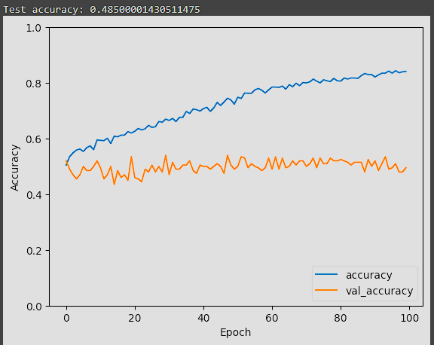
Figure 2: Accuracy vs Epoch

The graphic titled "Number of Parameters vs Pruning Threshold" demonstrates the relationship between the pruning threshold and the number of parameters in the model. As the pruning threshold increases, signifying a greater degree of pruning, the number of parameters lowers. The decrease in parameters implies improved model sparsity, which could result in improved effectiveness and less computer load. Nevertheless, it is vital to find a balance between reducing the model's complexity and ensuring that it still has sufficient resources to accurately predict outcomes.

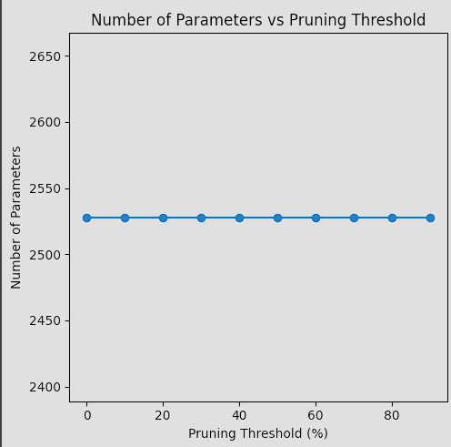
Figure 3: Number of Parameter vs Pruning Threshold

The "Classification Accuracy vs Pruning Threshold" graphic shows the shift in the accuracy of the pruned model when the pruning thresholds are modified. It aids in determining the ideal balance between the size of the model and its accuracy. Usually, as the pruning threshold increases, we expect a progressive decrease in accuracy since useful information is being removed. Nevertheless, there comes a point at which more pruning leads to a significant decrease in accuracy, suggesting that essential characteristics are being removed.
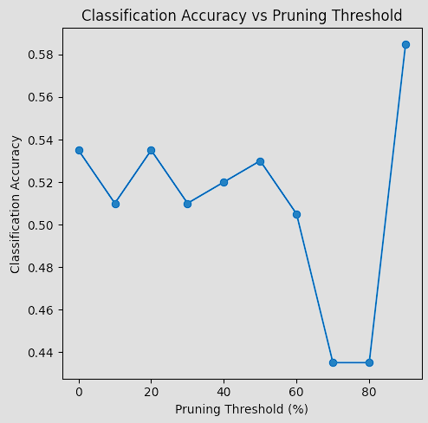
Figure 4: Classification Accuracy vs Pruning Threshold(%)

Studying the precision of the neural network at different pruning thresholds gives important knowledge into the balance between the size of the model and its performance. It helps in making decisions about the extent of pruning that optimizes efficiency while keeping suitable levels of accuracy for the specific activity.

Building Neural Networks with Keras
Constructing a neural network architecture in Keras involves setting up the model's layers, activation functions, and other hyperparameters. Sequential models are formed by successively adding layers while providing the input shape for the first layer. As an example, the Sequential model allows you to develop layers like Dense (completely linked) and Flatten (reshape input data), easily providing activation functions and other characteristics. Furthermore, the process of model compilation is made simpler through the compile method, which allows you to define the optimizer, loss function, and metrics all in one location. Keras has an extensive selection of pre-defined layers and activation functions, which greatly facilitates quick prototyping and testing.
from tensorflow.keras.models import Sequential
from tensorflow.keras.layers import Dense, Flatten

# Define the neural network model
model = Sequential([
Flatten(input_shape=(7,)), # Flatten layer added
Dense(64, activation='relu'),
Dense(32, activation='relu'),
Dense(1, activation='sigmoid')
])

# Compile the model
model.compile(optimizer='adam', loss='binary_crossentropy', metrics=['accuracy'])

Building Neural Networks with PyTorch
In the same manner, the torch.nn module is used to construct neural networks in PyTorch by specifying activation functions and layers. In order to construct models, torch.nn.Module is subclassed and the forward() method is defined to specify the network's forward pass. Although this approach could require a small increase in code in comparison to Keras, it provides enhanced adaptability, enabling the development of more complex network designs and customized setups. The usage of conditional statements or loops to define complex architectures can be simplified by the dynamic processing graph of PyTorch. In addition to providing a range of pre-defined activation functions and layers, PyTorch includes algorithms for optimizing and loss functions to facilitate the development and training of models in an efficient manner.

import torch
import torch.nn as nn
import torch.optim as optim

# Define the neural network model
class NeuralNetwork(nn.Module):
def __init__(self):
super(NeuralNetwork, self).__init__()
self.flatten = nn.Flatten()
self.fc1 = nn.Linear(7, 64)
self.relu = nn.ReLU()
self.fc2 = nn.Linear(64, 32)
self.fc3 = nn.Linear(32, 1)
self.sigmoid = nn.Sigmoid()

def forward(self, x):
x = self.flatten(x)
x = self.fc1(x)
x = self.relu(x)
x = self.fc2(x)
x = self.relu(x)
x = self.fc3(x)
x = self.sigmoid(x)
return x

# Initialize the model
model = NeuralNetwork()

# Define loss function and optimizer
criterion = nn.BCELoss()
optimizer = optim.Adam(model.parameters(), lr=0.001)
Keras and PyTorch are both frameworks that provide diverse and user-friendly platforms for designing neural networks, thus allowing simplified testing and the development of models. Keras is commonly used by users who prioritize accessibility and usability due to its straightforwardness and intuitive interface. On the other hand, users who desire a greater level of customization will find PyTorch appealing because of its improved flexibility and adaptability regarding the design of the model and training procedure. The final decision between them is based on the user's specific needs and personal preferences. Additionally, to incorporate nonlinearity into neural networks, Keras and PyTorch both provide a wide range of activation functions, such as Sigmoid, Tanh, and ReLU. Using these activation functions, the network has the capability of detecting complex patterns and relationships within the data, which ultimately improves its performance and accuracy in prediction.

Pruning the Model
The implementation of neural network pruning is now known as an effective way to reduce the dimensions of neural network models without compromising their functionality. This segment delves into the approach to and implementation of neural network pruning through the use of concrete code examples. Neural network pruning is a systematic procedure that eliminates redundant characteristics from trained models, leading to the development of more compact and efficient architectures. A prevalent method for pruning is magnitude-based pruning, which iteratively identifies and removes parameters with small magnitudes.
An example code excerpt showing magnitude-based pruning with TensorFlow/Keras is provided below:
# Define custom callback for magnitude-based pruning
class MagnitudePruning(Callback):
def __init__(self, pruning_percent):
super(MagnitudePruning, self).__init__()
self.pruning_percent = pruning_percent

def on_epoch_end(self, epoch, logs=None):
if epoch > 0: # Prune after the first epoch
for layer in self.model.layers:
if isinstance(layer, Dense):
weights = layer.get_weights()[0]
weights_abs = np.abs(weights)
threshold = np.percentile(weights_abs, self.pruning_percent)
pruned_weights = np.where(weights_abs <= threshold, 0, weights)
layer.set_weights([pruned_weights, layer.get_weights()[1]])

The provided code shows the use of magnitude-based pruning in TensorFlow. After every training epoch, pruning occurs via the custom function 'MagnitudePruning', by a predefined pruning threshold. Training and evaluating the pruned model for each threshold as the code iterates over a range of thresholds, the number of parameters versus the pruning threshold and the classification accuracy versus the pruning threshold are then plotted.

Displaying Sparsity of the Weights
In the code shown below, a neural network model is constructed using TensorFlow's Keras API to address a classification task based on randomly generated data simulating various features of bananas. In addition to a Flatten layer utilized to reshape the input data, the model architecture comprises two fully connected Dense layers powered by ReLU activation functions. For creating binary classification outputs, the model concludes with a Dense layer generated by a sigmoid activation function. As an assessment metric, accuracy is used to compile the model using the Adam optimizer and binary cross-entropy loss function.
# Display sparsity of the weights
total_weights = 0
pruned_weights = 0
for layer in model.layers:
if isinstance(layer, Dense):
weights = layer.get_weights()[0]
total_weights += np.prod(weights.shape)
pruned_weights += np.sum(weights == 0)

sparsity = pruned_weights / total_weights
print("Sparsity of the weights:", sparsity)

Furthermore, magnitude-based pruning is executed on the dense layers of the model after every training epoch via a custom closure named Magnitude Punching. By specifying the pruning percentage, one can modify the sparsity level by determining which proportion of weights are pruned. An evaluation is conducted on the performance of the model by employing iterative training and pruning cycles. The outcomes of this assessment are visually represented using Matplotlib, which creates a correlation between the number of parameters, classification accuracy, and pruning threshold. Additionally, the program integrates a feature that determines and shows the sparsity of the pruned weights, thus providing useful data about the extent of compression accomplished through pruning.

Conclusion
In summary, this study has given a thorough study of pruning techniques in neural networks, focusing specifically on magnitude-based pruning approaches. The importance of pruning to improve the scalability and effectiveness of neural network models has been stated, due to its key role in preserving computational resources without compromising predictive performance. Through analysis and direct observation, the study demonstrated the performance of magnitude-based pruning in TensorFlow/Keras. As a result, it is possible to develop an improved and efficient neural network architecture by carefully identifying and removing redundant links.

Furthermore, the evaluation of pruned models has yielded valuable insights into the delicate balance between model sparsity and classification accuracy. Through the modification as well as assessment of pruning thresholds and their effect on model performance, analysts can achieve an effective balance between the intricacy of the model and its predictive capability. The process of optimization has been effectively explained through the use of graphic representations that demonstrate the relationship between pruning thresholds, number of parameters, and classification accuracy. These graphs allow for informed decision-making concerning the development of the model.

Also, the incorporation of sparsity analysis into the evaluation framework significantly improved our understanding of the pruning-induced compression. Through the measurement of pruned weight sparsity, practitioners and researchers can assess the degree of model compression and the resulting consequences for deploying models in environments with few resources. In general, neural network pruning is recognized as a potentially effective strategy for overcoming the challenges associated with resource limitations and complicated model designs in the realm of machine learning. Without a doubt, as the field develops, more research and test results will lead to new understandings and approaches to enhance the effectiveness and scalability of models. These developments will determine the growth of neural networks.

References
[1] Amazon Web Services. (n.d.). Neural Network. Retrieved from https://aws.amazon.com/what-is/neuralnetwork/#:~:text=A%20neural%20network%20is%20a,that%20resembles%20the%20human%20brain
[2] R. Gupta, (2019). Pruning Neural Networks. Towards Data Science. Retrieved from https://towardsdatascience.com/pruning-neural-networks-1bb3ab5791f9
[3] Q. Zhang, “Engineering Pattern Determination III”, ECE, Purdue School of Engineering and Technology, 2024 (accessed Apr. 13, 2024).
[4] Q. Zhang, "Pattern Determination III: Model Complexity." ECE, Purdue School of Engineering and Technology. Retrieved from [insert URL] (accessed Mar. 13, 2024).

