

Cancel

OK

Add

250

$C$5 400

$C$6

4:

$C$4

Enter values for each of the changing cells.

1: $C$2 5000



Scenario Manager... ’!!"°

M N 0 tfiSM,

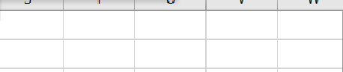

OK

Add

SCt3 450

SCt4 250

SCt5 400

scss 7P0

Enter values fDr each of the changing cells.





# fl SH. f"4 O Z

B

  

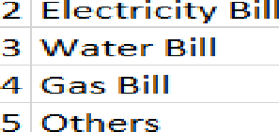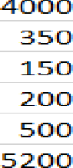1 Rent

 



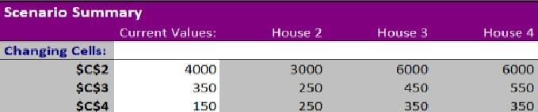



z1 z3

Pa ste









B

1 R e nt



4 G a s B i II

# B / U



4 00 0

## 2 OO

 



6 00 0

## 6 OO