***CANBERRA_ROAD_CRASH 2012 T0 2021 INSIGHTS***

**1. What is the total number of road accidents recorded in the ACT dataset?**

**Ans:- 71796** Accident happen from 2012 to 2021 in Canberra ACT.

**3. What is the distribution of accidents by time of day in the ACT dataset?**

**Ans**: 8:00 AM and 5:00 AM accident rates are higher. 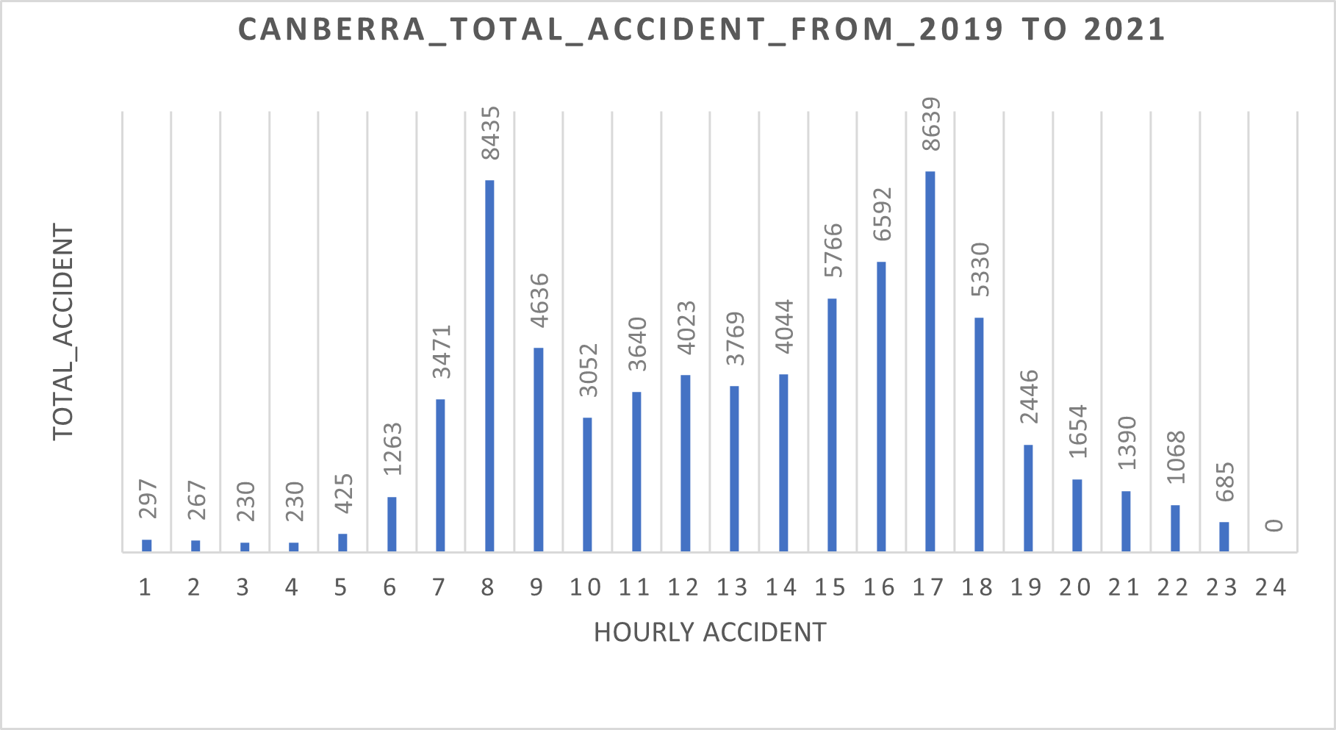

**3. Which road intersections or locations have the highest accident rates in the ACT dataset?**

**Ans:- Top 3 are:-** Canberra City, Canberra Belconnen, Canberra Gungahlin from 2019 to 2021.

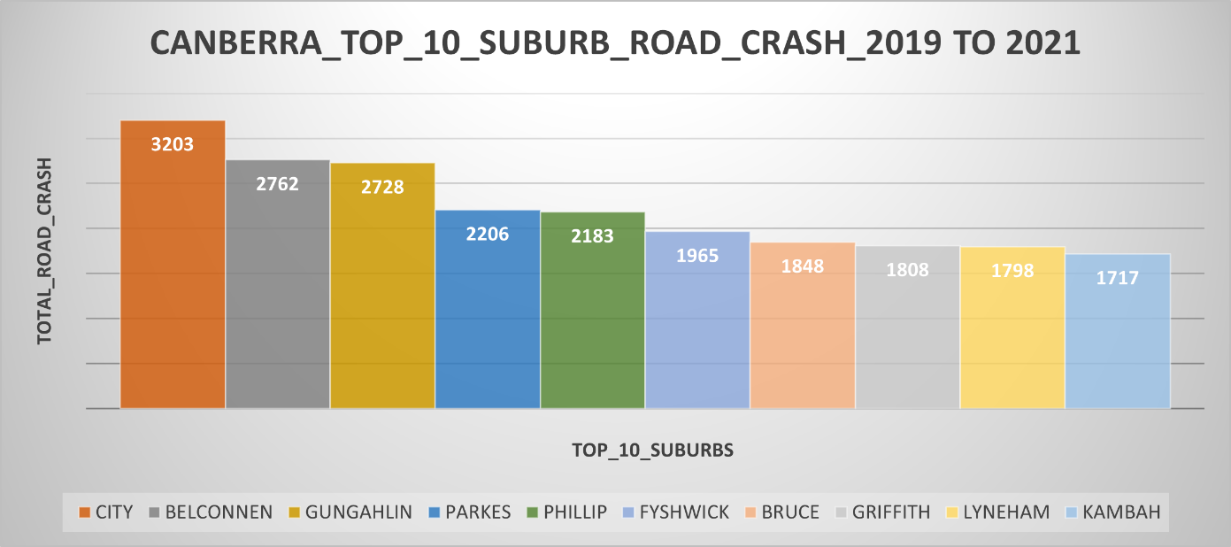

4. Are there any trends or patterns in the causes of accidents based on weather conditions in the ACT dataset?

