Hi There,

I have developed provided assignment in WebDriver using Cucumber BDD on Java Programming language. Project is successfully built on maven.

* I have developed report using on maven cucumber plugin.
* Machine should have chrome browser version 91

Project Structure

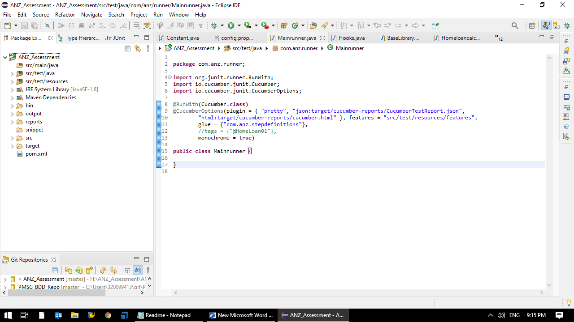

Feature file consists of 3 scenarios

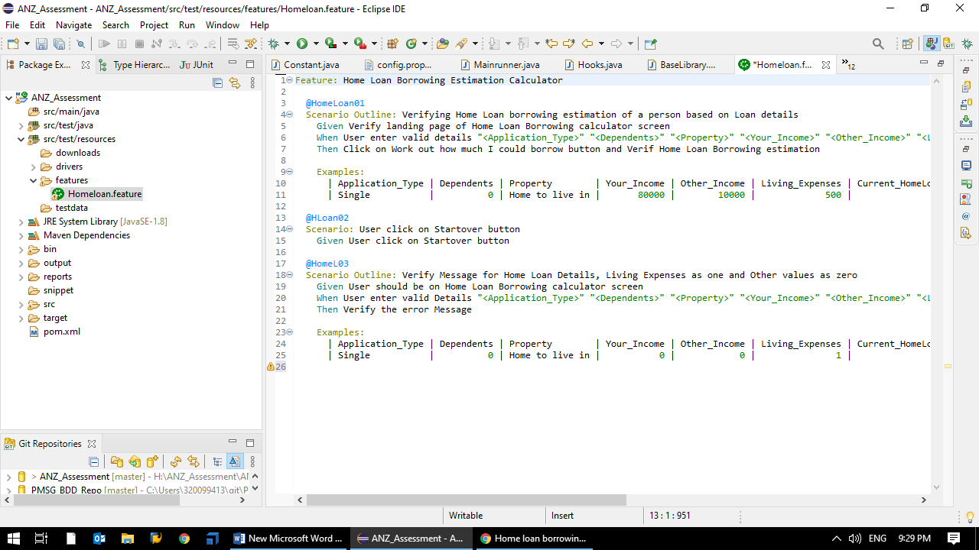

**Instructions to Building and Execute**

====================================

Step 1 – After importing project into eclipse IDE, please update the project like below

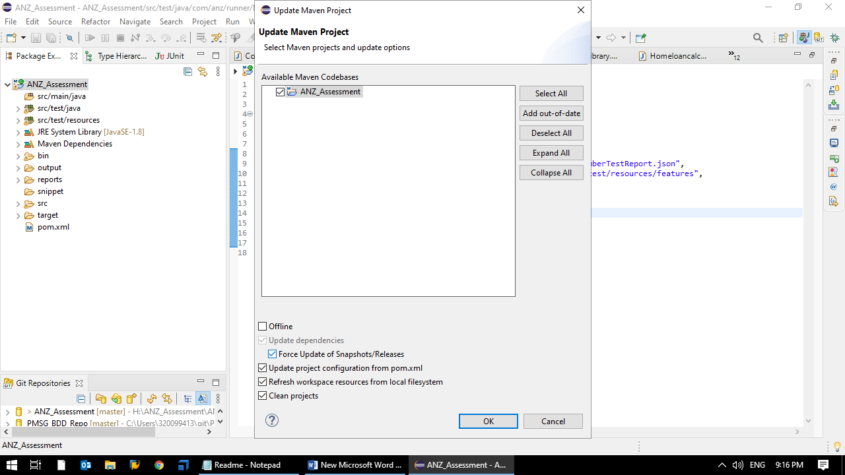

Step 2 – Click on the RUN-Dropdown

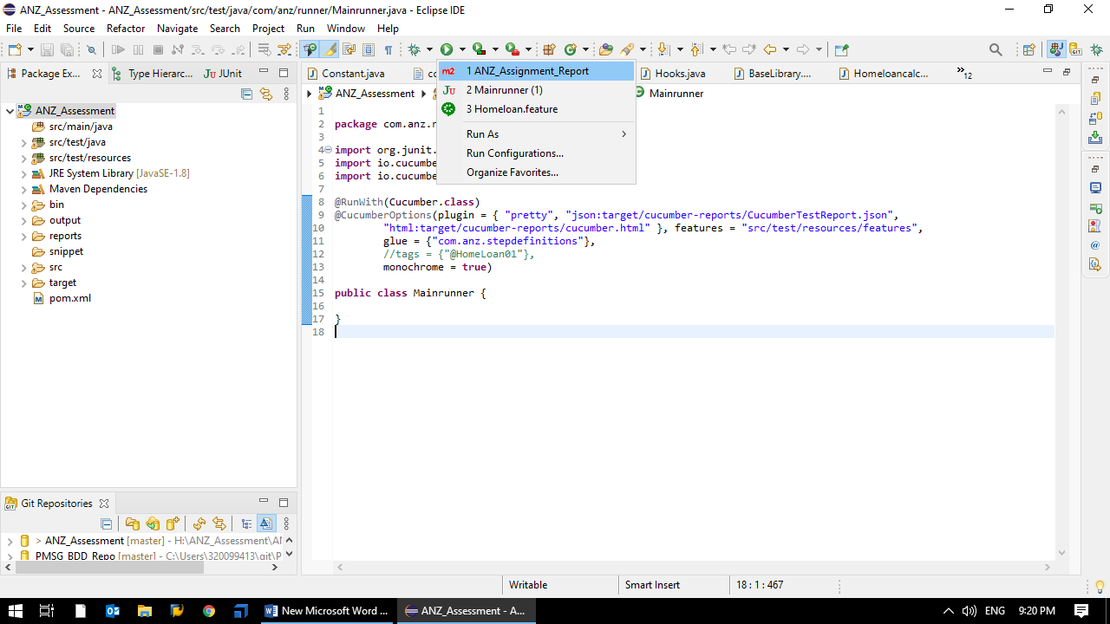

Step 3 – Click on “Run Configurations” Option

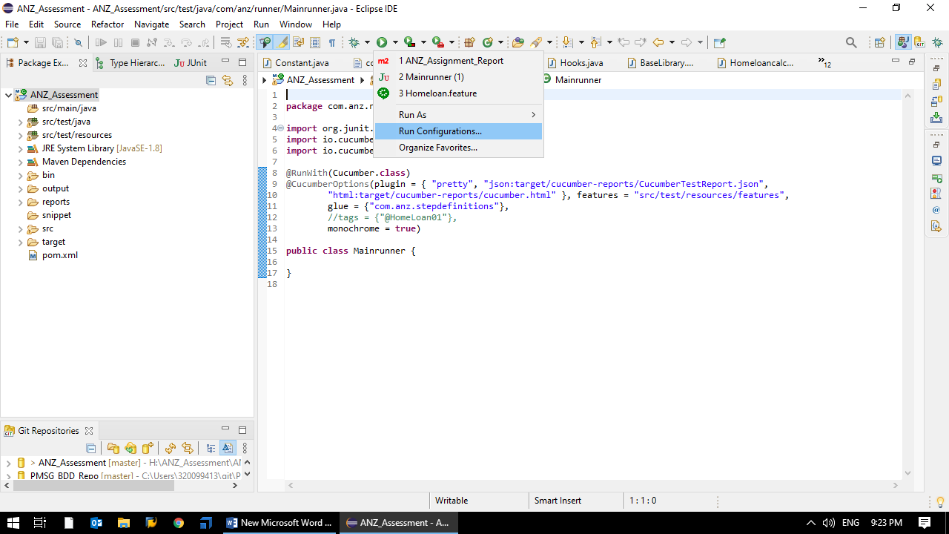

Step 4 – Created “ANZ_Assignment_Report” maven configuration to execute build

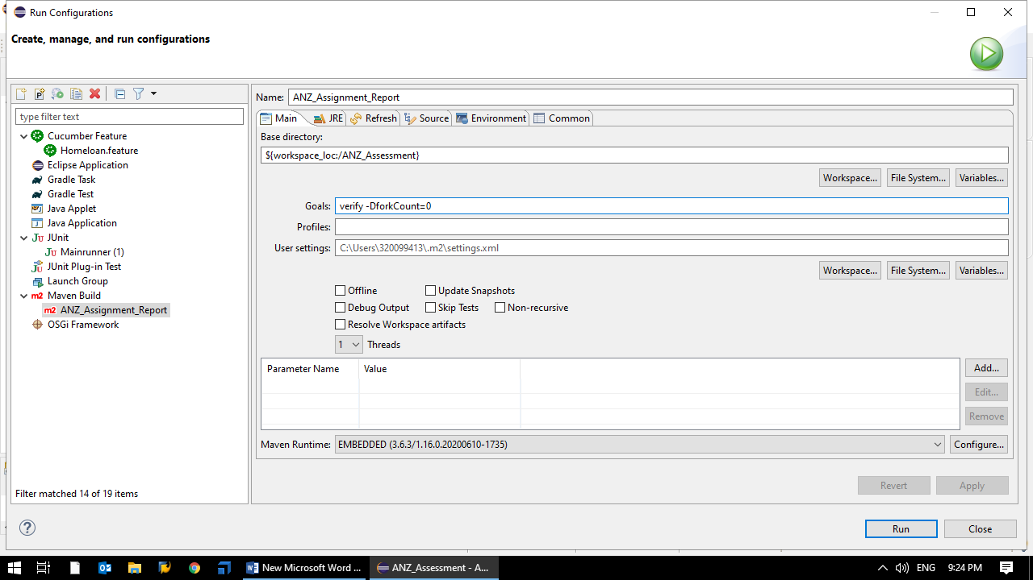

Step 5 – Click on “Run” Button

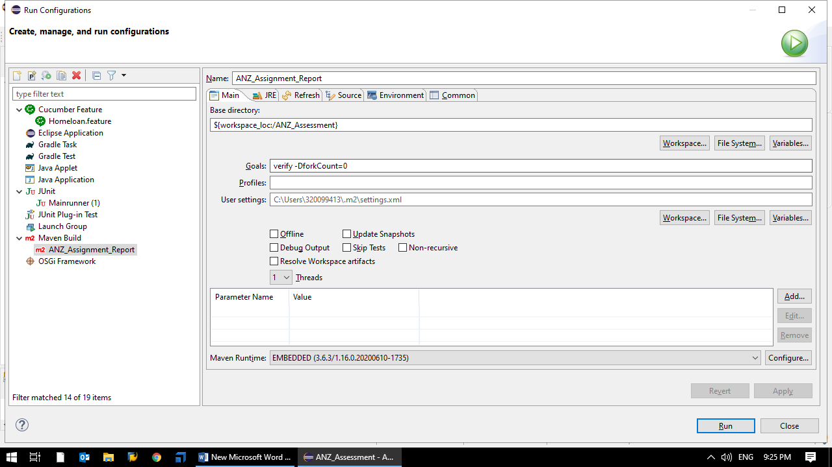

Step 6 – Project will start executing

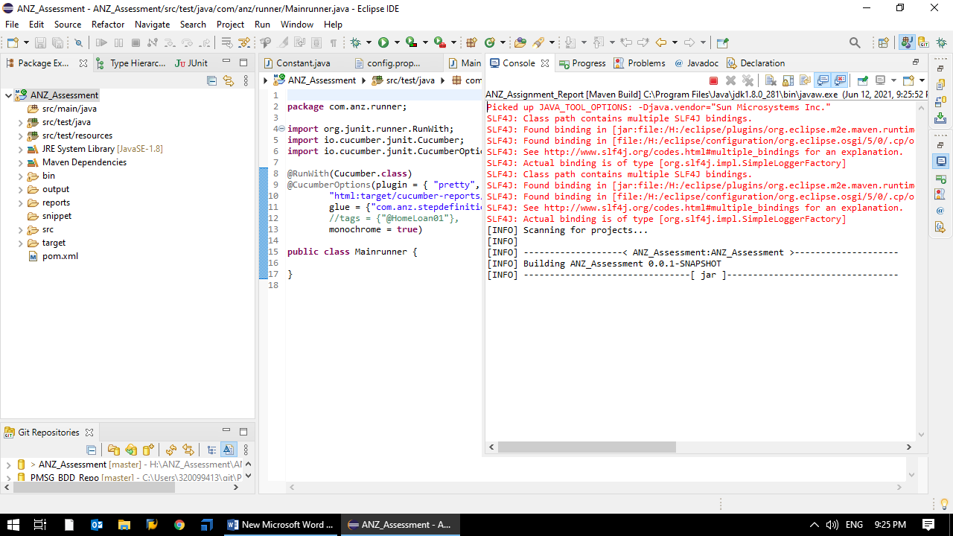

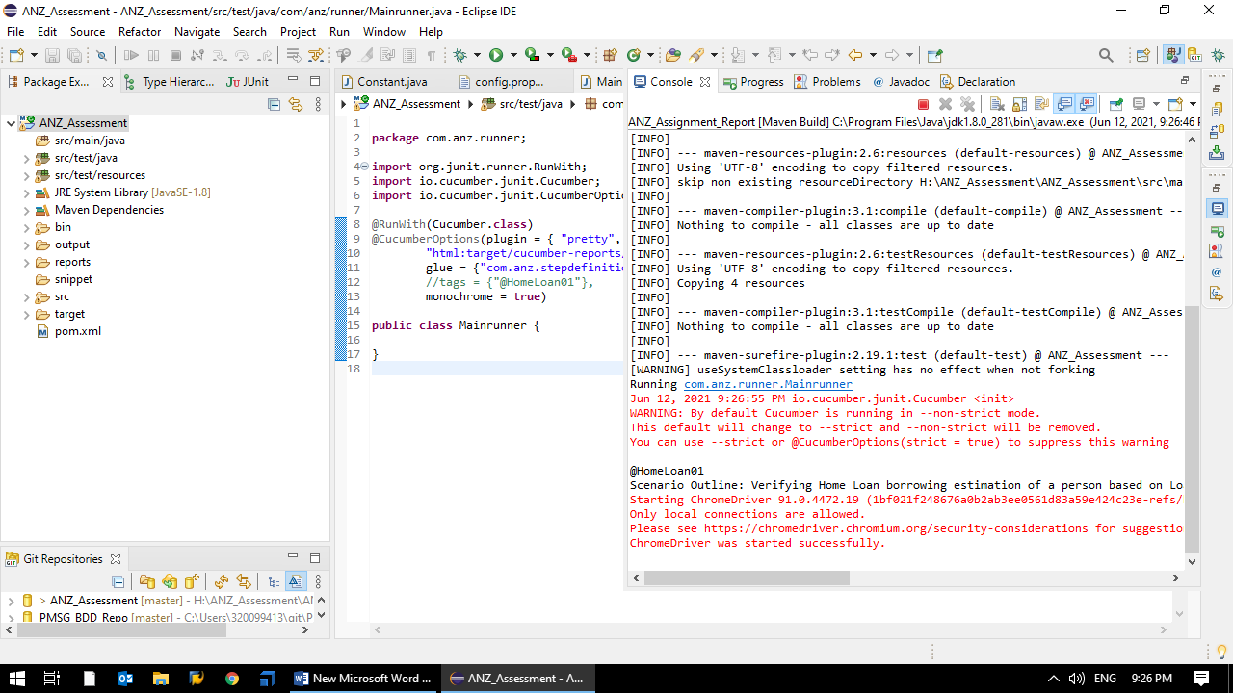

Step 7 – All 3 tests mentioned in the feature file will get executed successfully

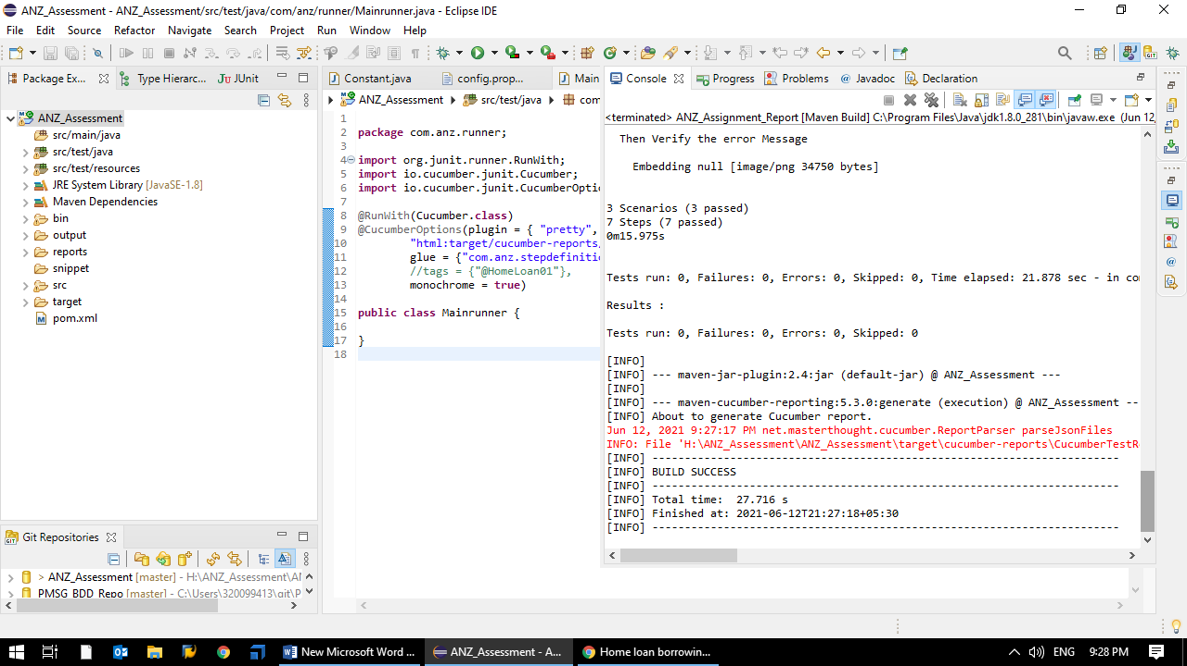

Step 8 – Navigate to following path to see the report and open “**overview-features**” file

**H:\ANZ_Assessment\ANZ_Assessment\target\cucumber-html-reports**

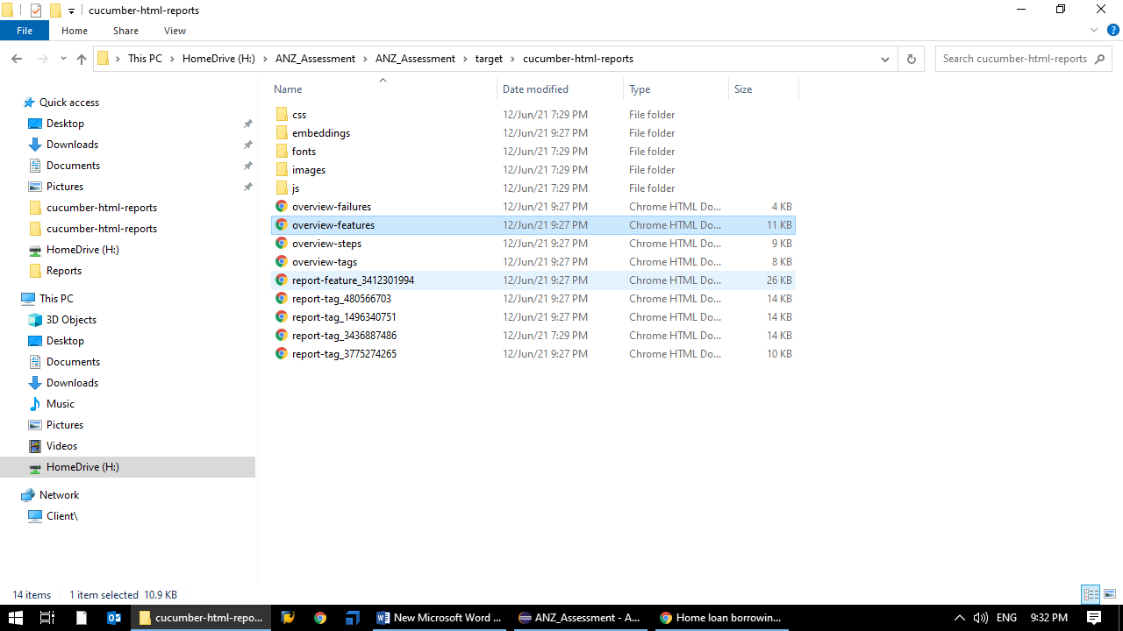

Report will looks like this

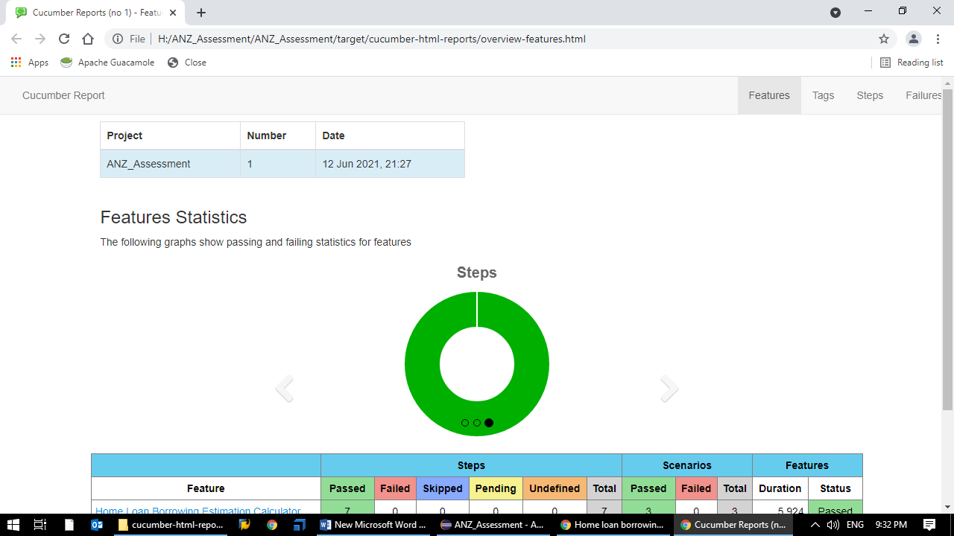

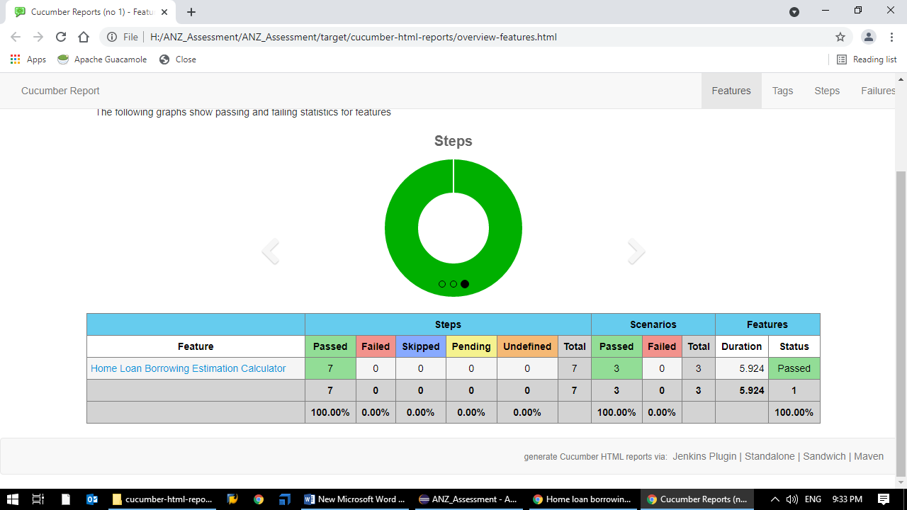

Step 9 – Click on the “**Home Loan Borrowing estimation calculator**” link

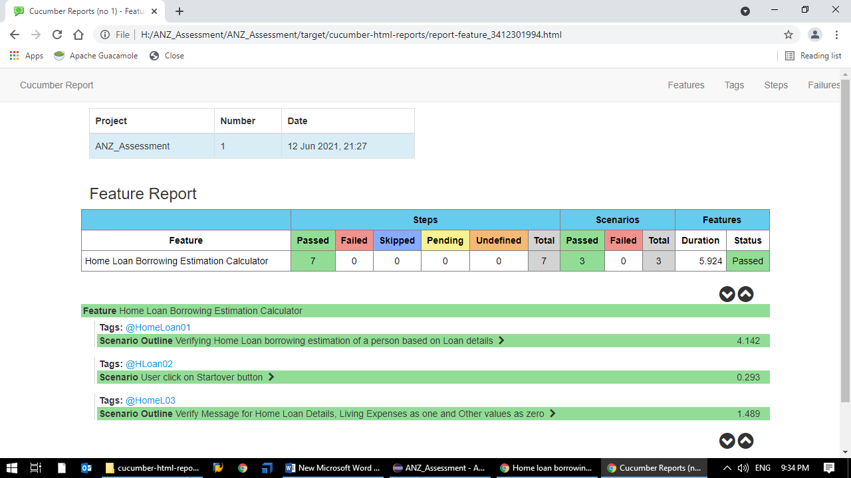

Step 10 – Click on “HomeLoan01” link

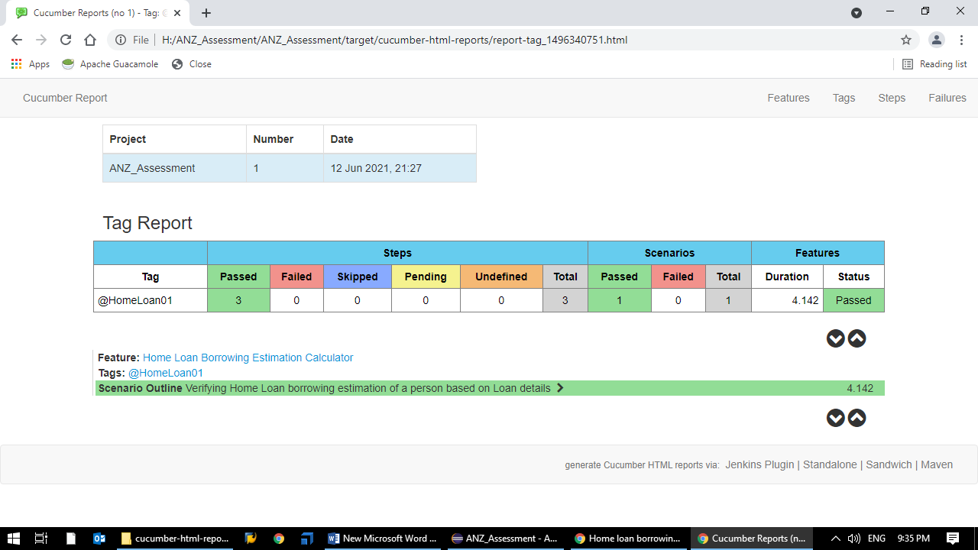

Step 11 – click on the below arrows to see the logs and screenshots of each step(**Screenshot captured for each step)**

