# Table of Contents

1 Table of Contents 1

Introduction 1

1 Pre-Setup Prerequisite 1

2 Update httpd.conf file 1

3 Configure SSL for Apache 2

4 Debtmanager URL redirection (fitagent redirection) 3

**Important notes**:

1. We configured Apache on port 444 because the primary Fitgent container is running on port 443 so there was a port conflict.

SSL Setup For Apache

# Introduction

This document has the steps for Setting up the SSL for Apache.

# Pre-Setup Prerequisite

Pre-requisite: the user should have XXX.crt and private.key.

# Update httpd.conf file

1. Edit /apps/Apache/httpd.conf file and Add the following lines at the end of the file and then save the file: **Include conf/httpd-DM-ssl.conf**

1. Add the following lines and save the file ( if you are getting PID error and SRV error while starting the Apache )

# 3 Configure SSL for Apache

1. Copy ssl.crt and private.key file to the ec2 server and Go to /apps/Apache/ httpd-DM-ssl.conf file and update ssl.crt and private.key path (where you copied the crt and private key)

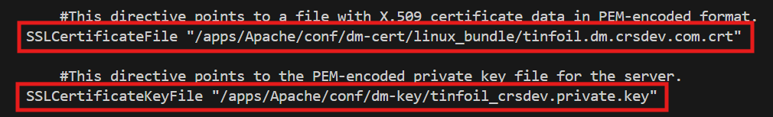

1. Add following content into httpd-DM-ssl.conf file

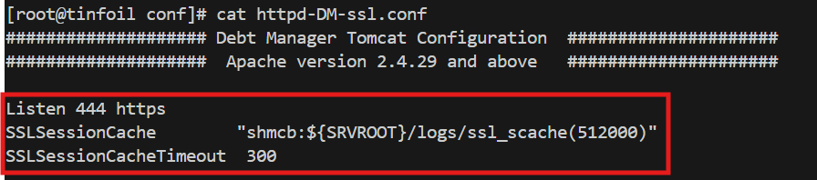

1. Make sure following module should be there in httpd-DM-ssl.conf

1. Comment SSLUseStapling



# Debtmanager URL redirection (fitagent redirection)

Add following line in httpd-DM-ssl.conf for redirection

