**Simulation Of Biohashing**

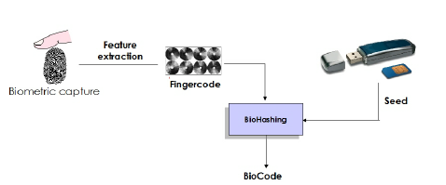

BioHashing is based on transforming the biometric template using pseudo-random projections that are generated using a user-specified key or token. In this project, a novel two factor authentication approach which combines user specified tokenized random data with fingerprint feature to generate a unique compact code per person is highlighted.

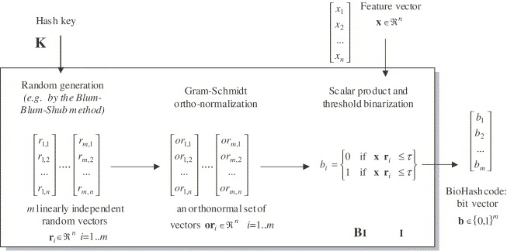

For simplicity, we have assumed a 1-D feature vector of fingerprint. Seed is generated automatically and discretisation on the feature vector is performed. The discretisation is carried out by iterated inner product between the pseudo-random number and the fingerprint feature vector, and finally deciding each bit on the sign based on the predefined threshold. At the end, the biohash code is displayed to the user.