PRACTICAL-6
1. Aim
To install/explore the open-source cloud computing platform OpenStack and study its major services by accessing the OpenStack Horizon Dashboard and creating a virtual machine instance.

2. Software / Hardware Requirements
- Windows 10/11 PC
- Google Chrome or Microsoft Edge
- Internet connection
- OpenStack cloud account or online OpenStack demo environment

3. What is OpenStack?
OpenStack is an open-source cloud computing platform used to build and manage Infrastructure as a Service (IaaS) clouds.
It allows users to manage:
- Virtual Machines
- Networks
- Storage
- Images
- Users and Projects
The web-based graphical interface of OpenStack is called Horizon.
Important OpenStack services include:
Service | Component | Purpose
Compute | Nova | Creates and manages virtual machines
Networking | Neutron | Manages networks and IP addresses
Image Service | Glance | Stores VM images
Identity | Keystone | Authentication and authorization
Block Storage | Cinder | Provides virtual disk storage
Object Storage | Swift | Stores files and objects
Dashboard | Horizon | Web-based GUI

4. OpenStack Architecture

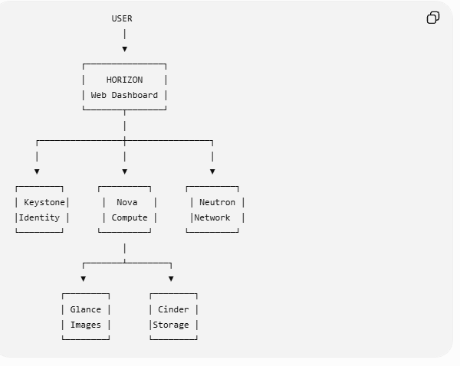
5. Practical Procedure: Explore OpenStack
Step 1: Open an OpenStack Horizon Dashboard
Open your browser and log in to the OpenStack cloud/dashboard provided for your practical.
After login, you should see the OpenStack Horizon Dashboard.
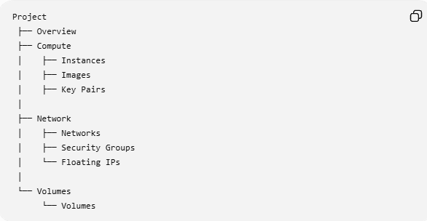
OpenStack Login Page

Step 2: Explore the Project Overview
After login:
- Click Project
- Click Overview
You can observe resources such as:
- Number of Instances
- Number of VCPUs
- RAM usage
- Storage usage
- Number of Volumes
- Security Groups
6. Explore Images
An image is an operating system template used to create a virtual machine.
Examples:
- Ubuntu
- Debian
- CentOS
- CirrOS
Steps
- Go to:
Project → Compute → Images
- Observe the available images.
Typical information displayed:
Image Name | Status | Format
Ubuntu | Active | QCOW2
CirrOS | Active | QCOW2

7. Explore Flavors
A Flavor defines the hardware configuration of a virtual machine.
For example:
Flavor | RAM | CPU | Disk
m1.tiny | 512 MB | 1 | 1 GB
m1.small | 2 GB | 1 | 20 GB
m1.medium | 4 GB | 2 | 40 GB
The exact flavors may be different in your OpenStack environment.

8. Create a Key Pair
A Key Pair is used for secure authentication to a Linux virtual machine.
Steps
- Go to:
Project → Compute → Key Pairs
- Click:
Import Key Pair
or
Create Key Pair
- Enter a name, for example:
student-key
- Download and save the generated key if your dashboard provides this option.

9. Configure Security Group
A Security Group acts like a virtual firewall.
Steps
Go to:
Project → Network → Security Groups
You may add rules such as:
Rule | Purpose
SSH – Port 22 | Remote Linux access
ICMP | Allows Ping
HTTP – Port 80 | Web server access
For a basic VM practical, you can use the default security group if it is already configured.

10. Launch a Virtual Machine Instance
This is the main implementation part of the practical.
Go to:
Project → Compute → Instances
Click:
Launch Instance
You will usually complete the following steps.
Step A: Details
Enter:
Instance Name: My-OpenStack-VM
Step B: Source
Select an operating system image, for example:
Ubuntu
or:
CirrOS
Step C: Flavor
Select a small flavor such as:
m1.tiny
Step D: Networks
Select the available private/project network.
Step E: Key Pair
Select:
student-key
Step F: Security Groups
Select:
default
Then click:
Launch Instance

11. Verify the Instance
After launching, go to:
Project → Compute → Instances
Wait until the status becomes:
ACTIVE
You should see information such as:
Instance Name: My-OpenStack-VM
Status: ACTIVE
Power State: Running
OpenStack Instances page showing the VM in ACTIVE state.

12. Explore the Instance
Click the instance name.
You can explore:
- Instance ID
- Status
- Image
- Flavor
- Networks
- IP Address
- Security Groups
Depending on your OpenStack environment, you may also see:
Console
Click the Console tab to view the virtual machine screen.

13. What You Have Explored
At the end of the practical, you should have explored:
✓ OpenStack Dashboard – Horizon
✓ Project Overview
✓ Images
✓ Flavors
✓ Key Pairs
✓ Networks
✓ Security Groups
✓ Virtual Machine Instances
✓ VM Console
✓ Storage/Volumes

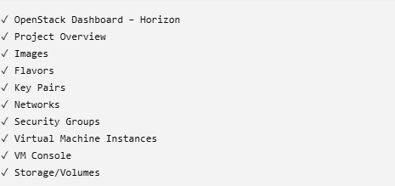

14. Result
The open-source cloud computing platform OpenStack was successfully explored using the Horizon Dashboard. Various cloud services such as Compute (Nova), Networking (Neutron), Identity (Keystone), Image Service (Glance), and Storage (Cinder) were studied. A virtual machine instance was launched and its configuration and status were successfully verified.

15. Viva Questions and Answers
1. What is OpenStack?
OpenStack is an open-source cloud computing platform used to create and manage private and public cloud infrastructure.
2. What is Horizon?
Horizon is the web-based dashboard of OpenStack.
3. What is Nova?
Nova is the OpenStack Compute service used to manage virtual machine instances.
4. What is Neutron?
Neutron is the OpenStack networking service.
5. What is Keystone?
Keystone provides identity management, authentication, and authorization.
6. What is Glance?
Glance is the OpenStack Image service that stores and manages VM images.
7. What is a Flavor?
A flavor defines the CPU, RAM, and disk resources allocated to a virtual machine.
8. What is an Instance?
An instance is a running virtual machine in OpenStack.
9. What is a Security Group?
A security group is a set of firewall rules controlling network access to an instance.
10. What is a Key Pair?
A key pair is used for secure authentication when accessing a virtual machine.
11. What type of cloud service does OpenStack mainly provide?
OpenStack is mainly used to provide Infrastructure as a Service (IaaS).

