PRACTICAL-7
Practical: Simulate a Cloud Scenario Using CloudSim
1. Aim
To simulate a cloud computing scenario using CloudSim and study the allocation and execution of cloudlets on virtual machines (VMs).

2. Objectives
- To understand the working of CloudSim.
- To create a simulated Data Center.
- To create Hosts and Virtual Machines (VMs).
- To create Cloudlets representing user tasks.
- To allocate cloudlets to VMs.
- To observe the execution time and resource utilization.

3. Software Requirements
Requirement | Details
Operating System | Windows 10/11
Programming Language | Java
JDK | JDK 8 or later
IDE | Eclipse / IntelliJ IDEA / VS Code
Simulation Toolkit | CloudSim
RAM | 4 GB or more
Important: CloudSim is a simulation toolkit. You do not need AWS or an actual cloud server for this practical.

4. CloudSim Architecture
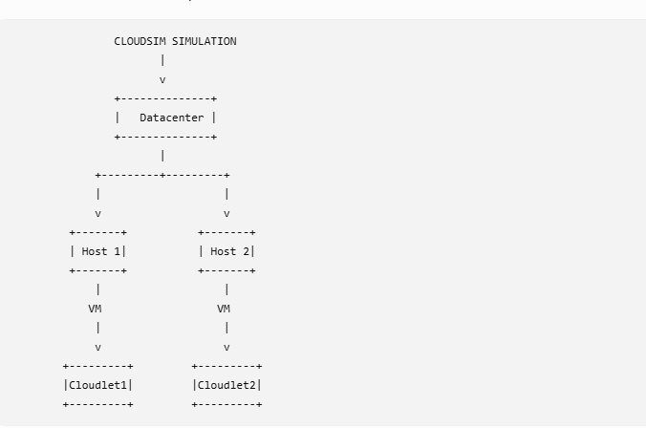
Main components
Datacenter
Represents a cloud infrastructure.
Host
Represents a physical machine/server inside the datacenter.
VM
Represents a virtual machine running on a host.
Cloudlet
Represents a task/application submitted by a cloud user.
DatacenterBroker
Acts as an intermediary between the cloud user and the datacenter. It submits VMs and cloudlets and manages their execution.
5. Procedure
Step 1: Install Java
Step 2: Download CloudSim
Download the CloudSim toolkit from the official CloudSim project repository.
CloudSim GitHub repository
For a beginner's college practical, CloudSim's Java examples are particularly useful.
Step 3: Create a Java Project
You can create a project in Eclipse, IntelliJ IDEA, or another Java IDE.
For example:
CloudSimPractical
|
└── src
|
└── CloudSimExample.java
Add the CloudSim library/JAR files to the project classpath.
6. Program
The following program creates:
- 1 Datacenter
- 1 Host
- 2 VMs
- 2 Cloudlets
- 1 Broker
and executes the cloudlets on the VMs.
8. Expected Output
The output will be similar to:
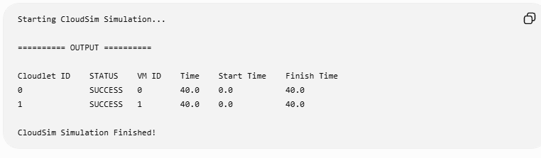
9. Result
Thus, a cloud computing scenario was successfully simulated using CloudSim. The simulation demonstrated the creation of a datacenter, physical host, virtual machines and cloudlets, and the execution of cloudlets on the allocated virtual machines.
11. Viva Questions
Q1. What is CloudSim?
CloudSim is a simulation toolkit for modeling and simulating cloud computing environments.
Q2. Why is CloudSim used?
It allows researchers and students to test cloud resource allocation, scheduling and VM management without using a real cloud infrastructure.
Q3. What is a Datacenter?
A datacenter represents the physical cloud infrastructure containing hosts/servers.
Q4. What is a Host?
A Host represents a physical computing machine inside a datacenter.
Q5. What is a VM?
A Virtual Machine is a virtualized computing resource running on a physical host.
Q6. What is a Cloudlet?
A Cloudlet represents a computational task/application submitted by a cloud user.
Q7. What is a DatacenterBroker?
The broker manages the submission of VMs and cloudlets and coordinates between users and datacenters.
Q8. What is MIPS?
MIPS = Million Instructions Per Second.
It is commonly used to represent processor computing capacity in CloudSim.
Q9. Does CloudSim create a real VM?
No. CloudSim simulates VMs rather than creating actual virtual machines.
Q10. What is the difference between CloudSim and AWS?
CloudSim | AWS
Simulation toolkit | Real cloud platform
No real cloud resources required | Uses real cloud infrastructure
Mainly for learning/research | Used for real applications
No cloud charges for simulation | Many services are paid
Runs locally | Cloud-based

