PRACTICAL-8
Practical: Explore Software as a Service (SaaS) Using Salesforce.com
Salesforce is a cloud-based Software as a Service (SaaS) platform. You use the software through a web browser without installing or maintaining the application on your computer.
1. Aim
To explore Software as a Service (SaaS) using Salesforce.com and understand its major cloud-based features.
2. Software/Hardware Requirements
- Windows PC/Laptop
- Internet connection
- Web browser – Chrome/Edge
- Salesforce account
- No local server required
3. Theory
What is SaaS?
Software as a Service (SaaS) is a cloud computing service model in which software applications are hosted by a cloud provider and accessed through the Internet.
Examples:
- Salesforce
- Google Workspace
- Microsoft 365
- Dropbox
Salesforce as SaaS
Salesforce provides CRM (Customer Relationship Management) software through the cloud.
The user does not need to:
- Install Salesforce on the computer
- Maintain the server
- Manage the database server
- Perform software upgrades manually
The Salesforce provider manages the infrastructure, application platform and updates.

4. Procedure
Step 1: Open Salesforce
Open your web browser and go to:
Salesforce
You can also use a Salesforce Developer Edition account for a college practical.
Step 2: Sign up / Log in
Create or use your Salesforce account.
After login, you will see the Salesforce interface.
Screenshot 1: Salesforce login page
Screenshot 2: Salesforce home page/dashboard

5. Explore Salesforce Applications
After logging in, explore the App Launcher.
You may see applications/features such as:
- Sales
- Service
- Marketing
- Reports
- Dashboards
- Contacts
- Accounts
- Leads
- Opportunities
For your practical, you can concentrate on Sales.

6. Create a Student Object
Since this is a college practical, you can create a simple Student custom object.
Go to:
Setup → Object Manager → Create → Custom Object
Enter:
Object Label: Student
Plural Label: Students
Create the object.

7. Create Student Fields
Create fields such as:
Field | Data Type
Student ID | Text
Student Name | Text
Email | Email
Phone | Phone
Department | Picklist
Admission Date | Date
For Department, you can create values such as:
- Computer Science
- Information Technology
- Electronics
- Mechanical
- Civil

8. Add Student Records
Open the Students tab and select New.
Example:
Field | Example
Student ID | ST001
Student Name | Rahul Patil
Email | rahul@example.com
Phone | 9876543210
Department | Computer Science
Admission Date | 15/07/2026
Click Save.
Create 3–5 student records.
Screenshot 3: Student object
Screenshot 4: New Student form
Screenshot 5: Student records/list

9. Explore Reports
Salesforce allows users to generate reports from stored data.
Go to:
App Launcher → Reports → New Report
Select the Students object and create a report.
For example:
Student Department Report
It can show:
- Student Name
- Student ID
- Department
- Admission Date
Screenshot 6: Salesforce Report

10. Explore Dashboard
You can also create a dashboard based on your report.
Go to:
Dashboards → New Dashboard
Create a dashboard such as:
Student Management Dashboard
Possible components:
- Total Students
- Students by Department
- Students by Admission Year
Screenshot 7: Salesforce Dashboard

11. SaaS Features Observed
During the practical, observe these characteristics:
SaaS Feature | Salesforce Example
Internet-based access | Access through browser
No local installation | Salesforce runs in cloud
Centralized data | Data stored on Salesforce cloud
Automatic updates | Salesforce manages updates
Scalability | Applications can support many users
Multi-user access | Multiple users can work simultaneously
Reports | Generate reports from cloud data
Dashboards | Visualize information
Security | Authentication and access controls

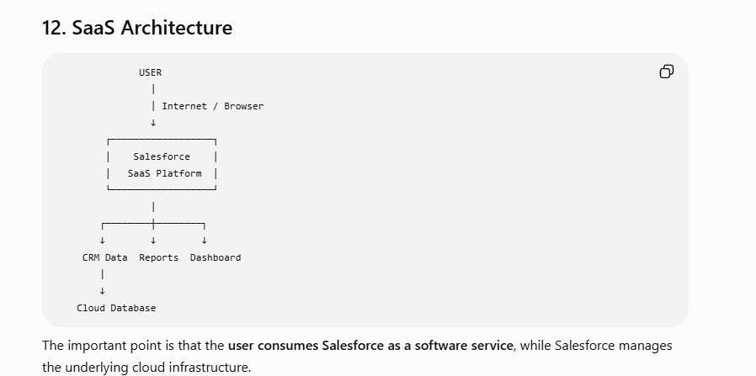

13. Advantages of Salesforce SaaS
- No software installation required.
- Accessible through the Internet.
- Reduces infrastructure cost.
- Automatic software updates.
- Centralized data management.
- Supports multiple users.
- Provides reports and dashboards.
- Scalable according to organizational requirements.
- Provides cloud-based security and access control.

14. Result
Thus, Software as a Service (SaaS) was successfully explored using Salesforce.com. A Student object was created, student records were added, and Salesforce reports and dashboards were explored using the cloud-based SaaS environment.

