1. Find the **title** of each film

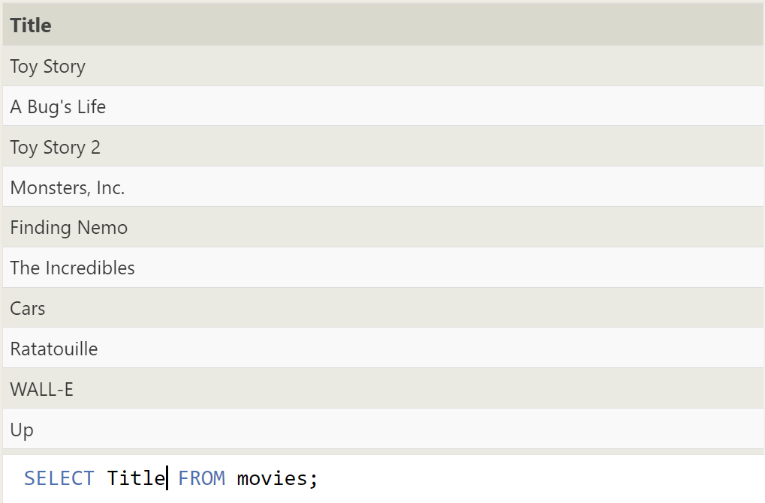

2. Find the **director** of each film

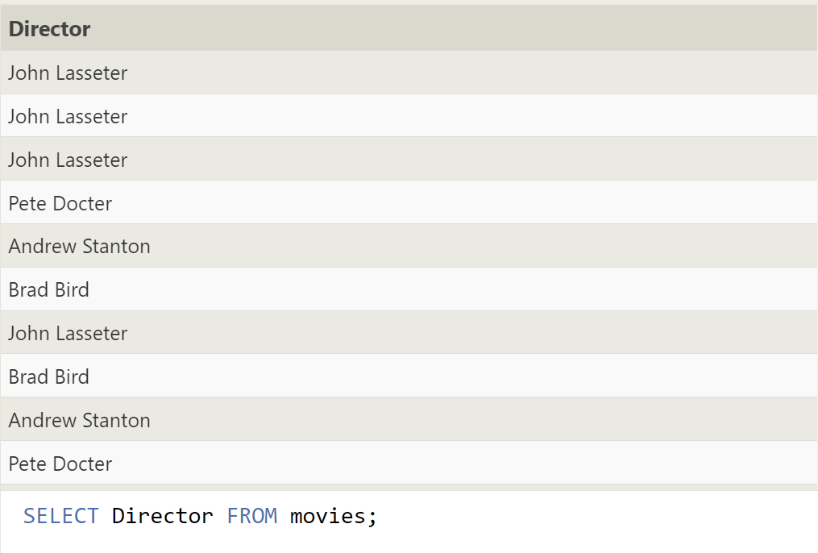

3.Find the **title** and **director** of each film

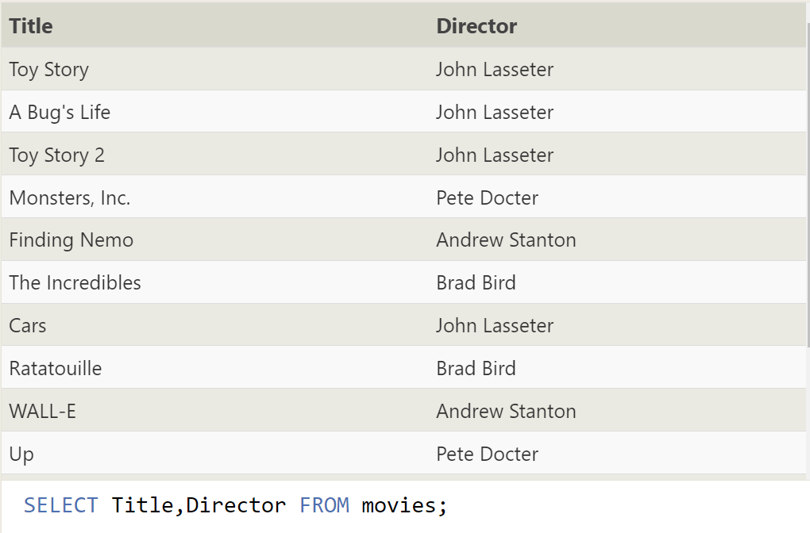

4.Find the **title** and **year** of each film

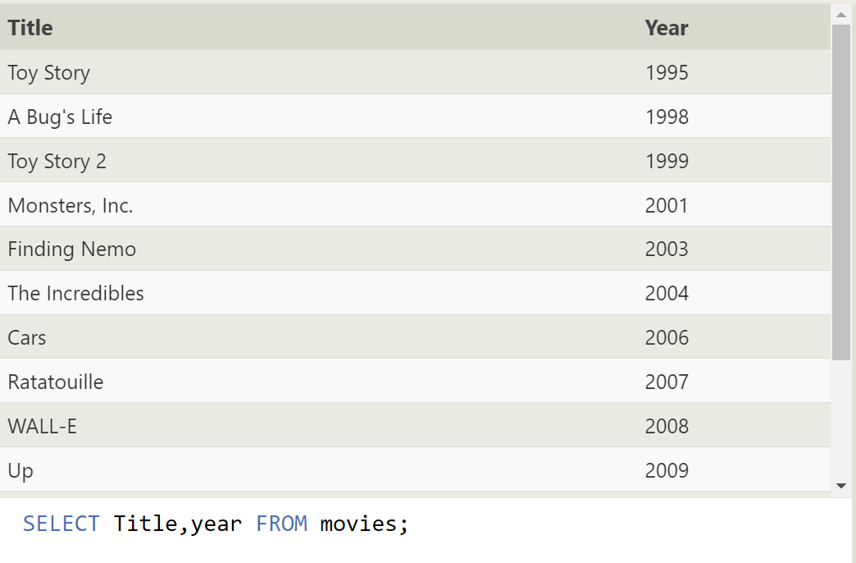

5.Find **all** the information about each film

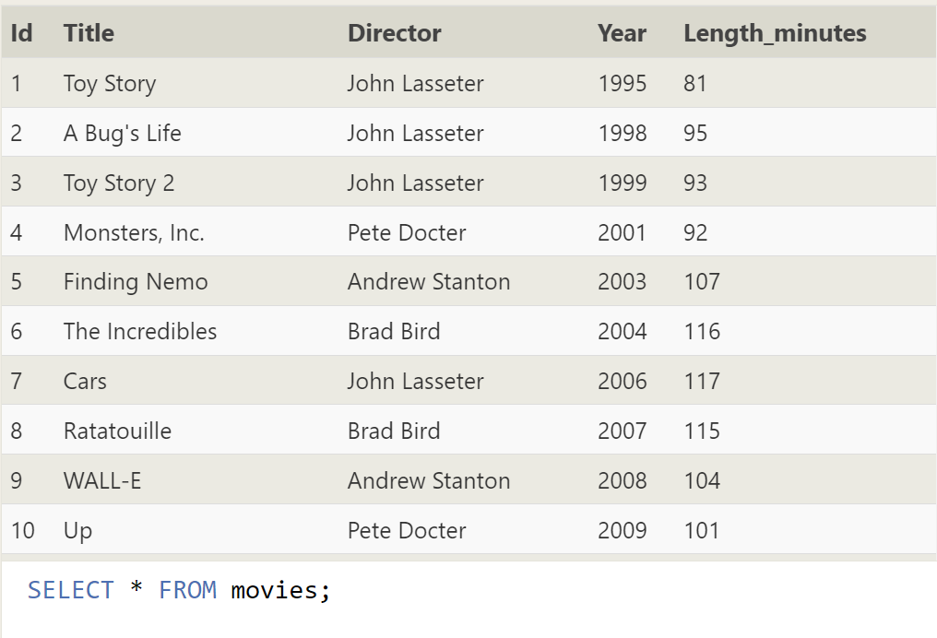

6.Find the movie with a row **id** of 6  
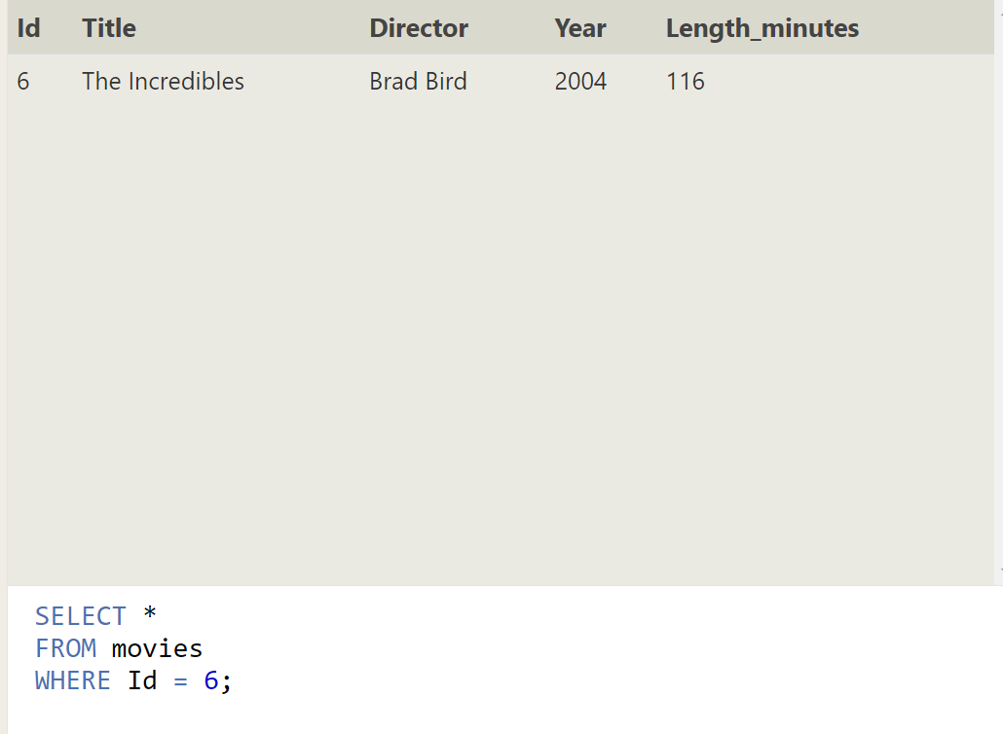

7.Find the movies released in the **year**s between 2000 and 2010

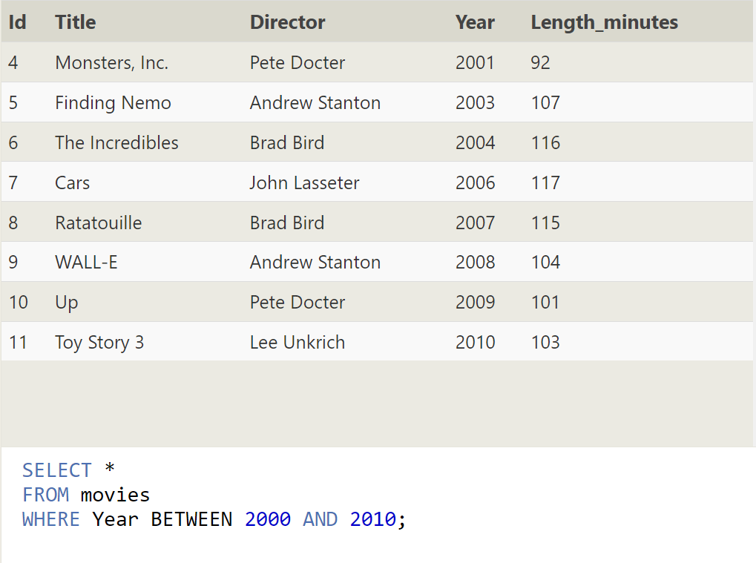

8.Find the movies **not** released in the **year**s between 2000 and 2010

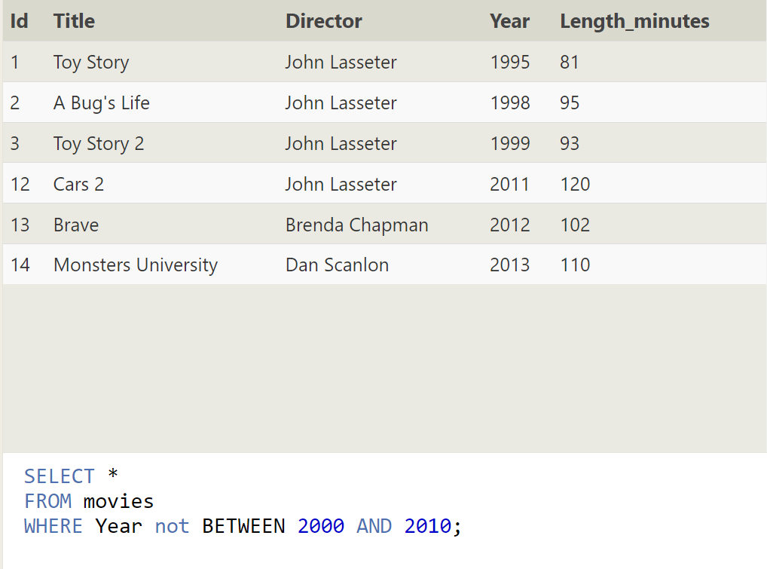

9.Find the first 5 Pixar movies and their release **year**

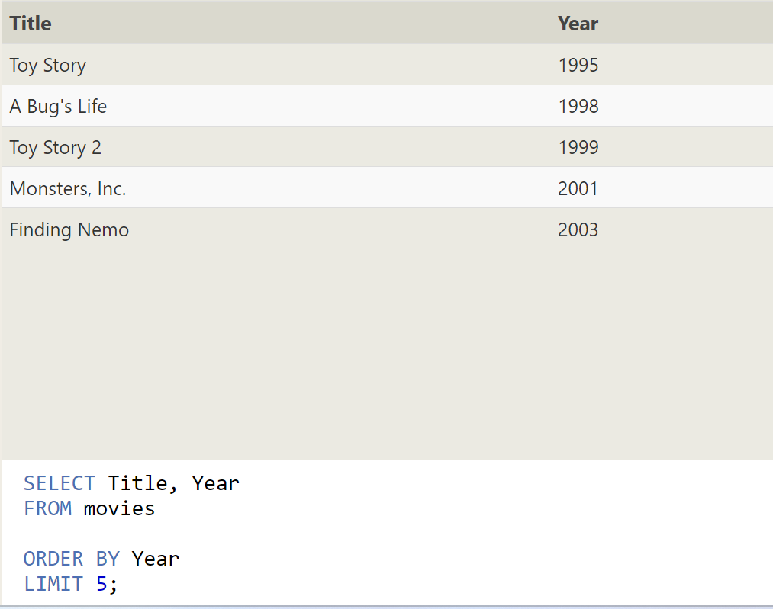

**10.Find all the Toy Story movies**

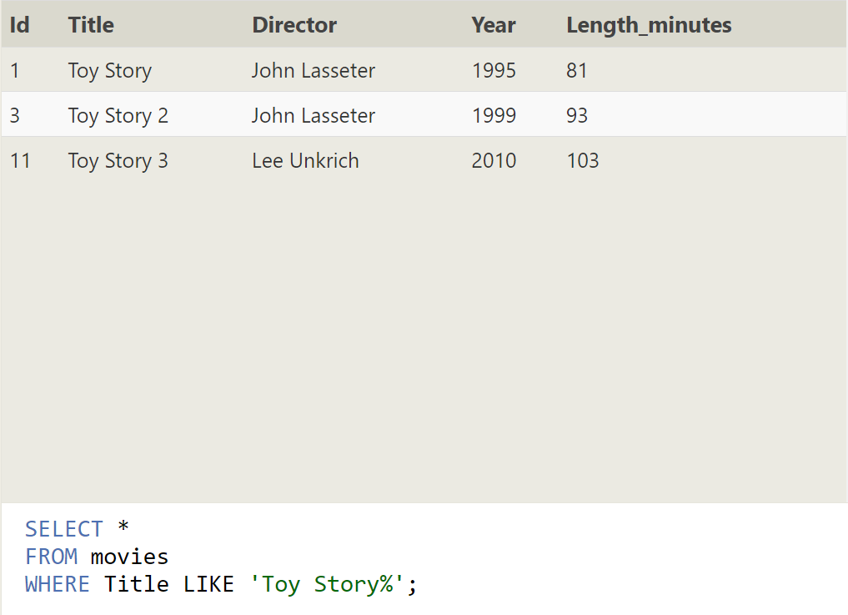

**11. Find all the movies directed by John Lasseter**

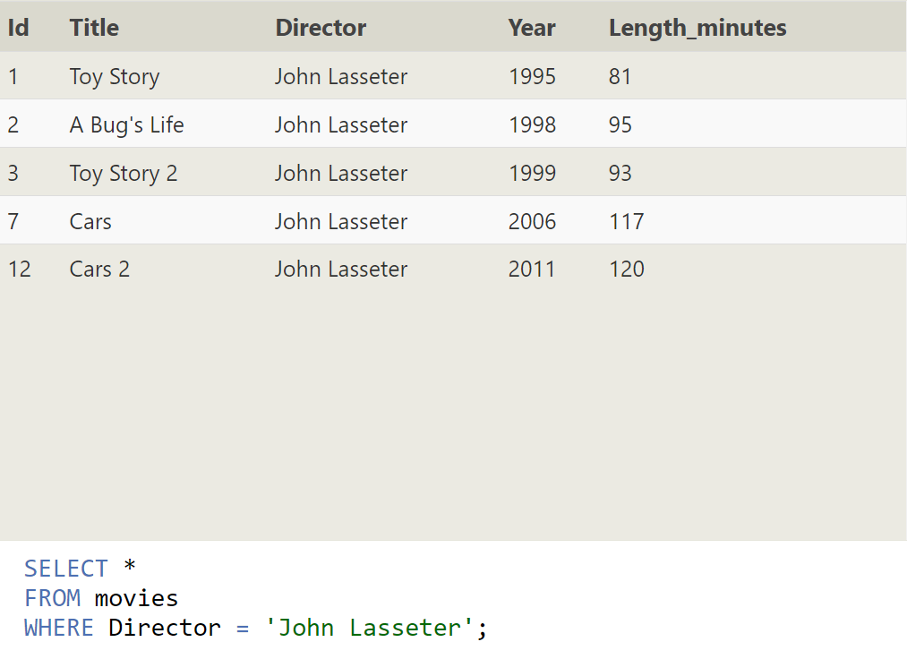

**12.Find all the movies (and director) not directed by John Lasseter**

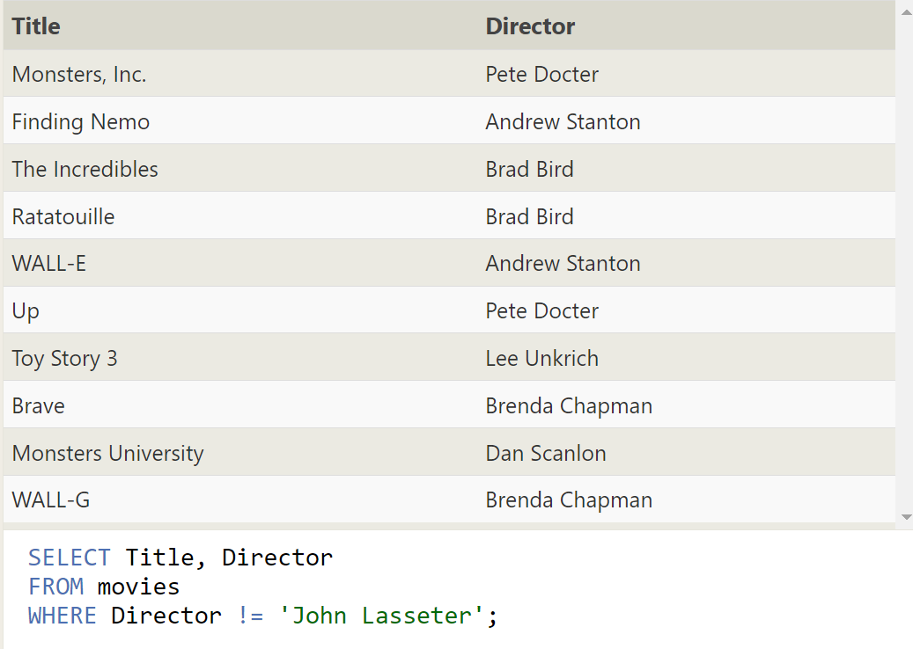

**13.Find all the WALL-* movies**

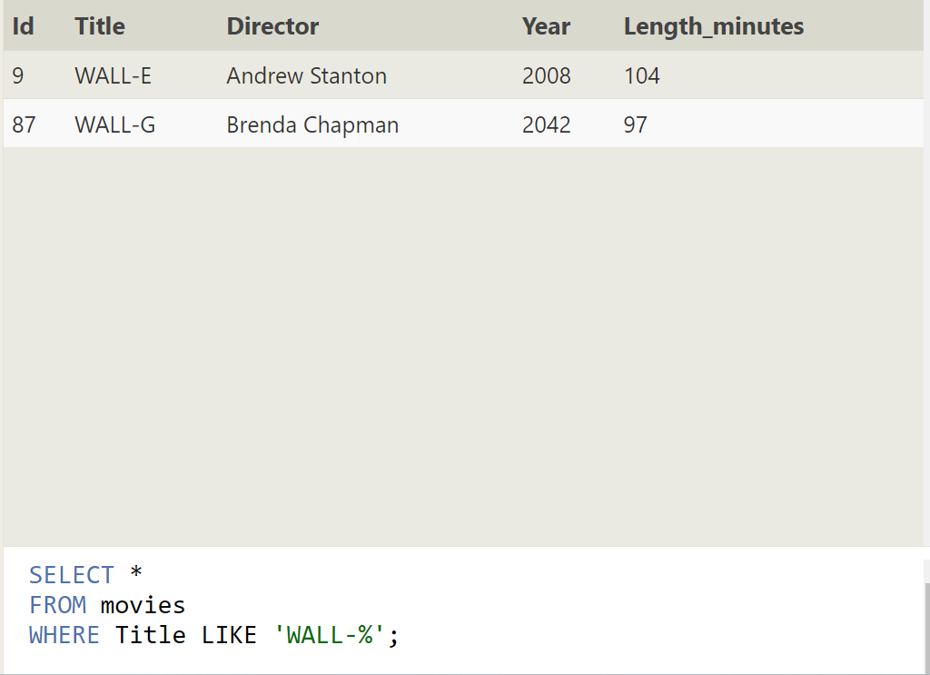

**14.List all directors of Pixar movies (alphabetically), without duplicates**

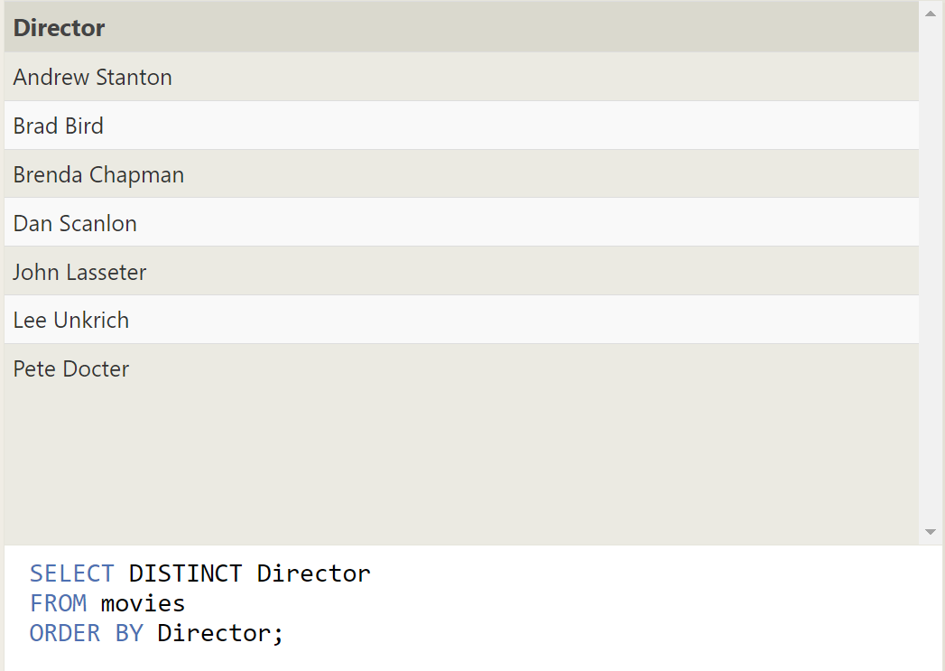

**15.List the last four Pixar movies released (ordered from most recent to least)**

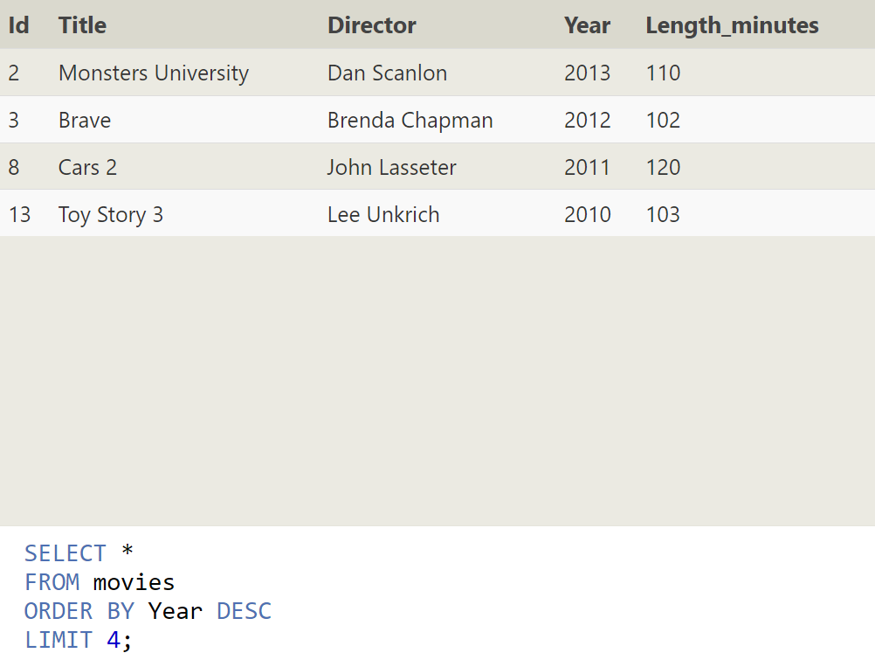

**16.List the first five Pixar movies sorted alphabetically**

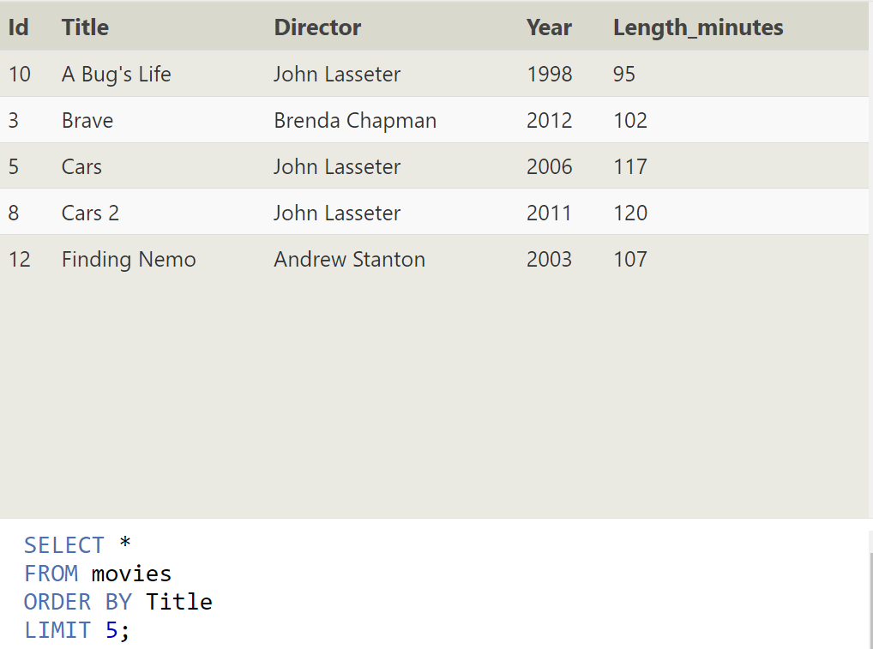

**17.List the next five Pixar movies sorted alphabetically**

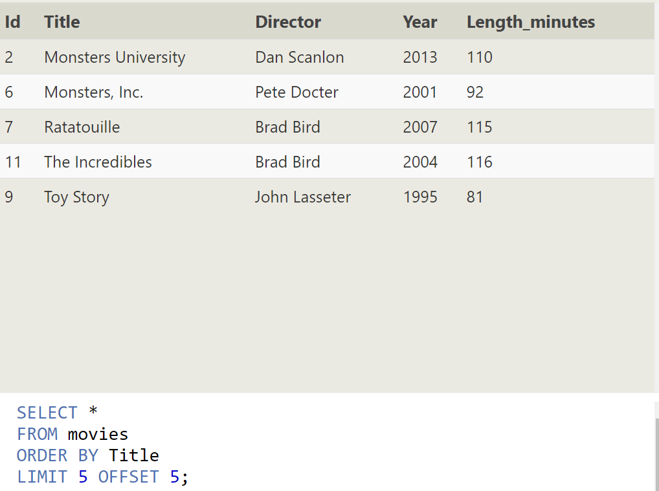

**18.List all the Canadian cities and their populations**

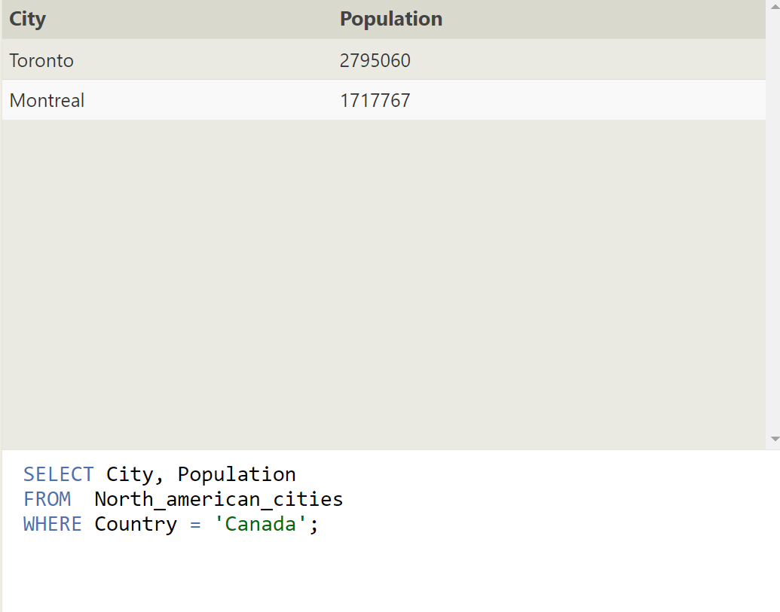

**19.Order all the cities in the United States by their latitude from north to south**

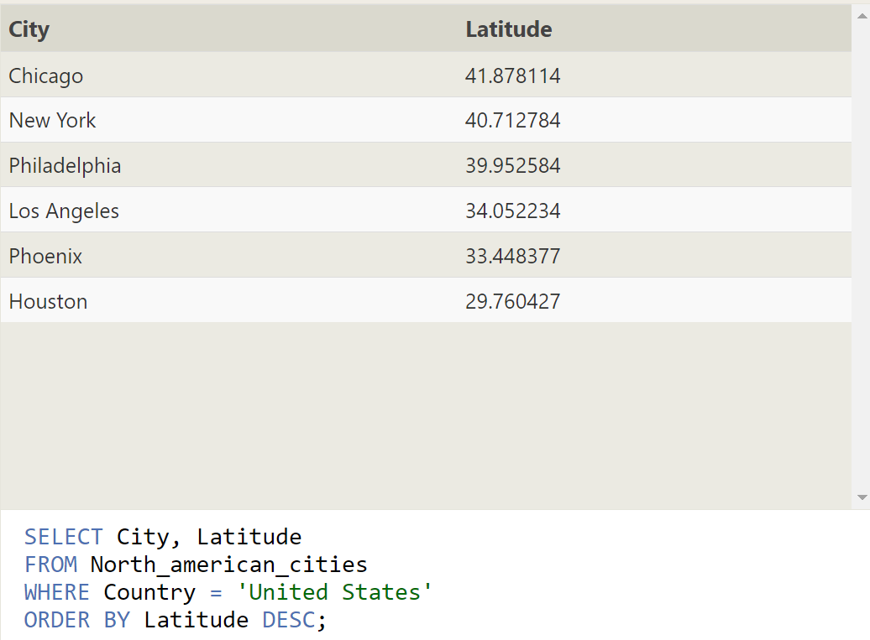

**20.List all the cities west of Chicago, ordered from west to east**

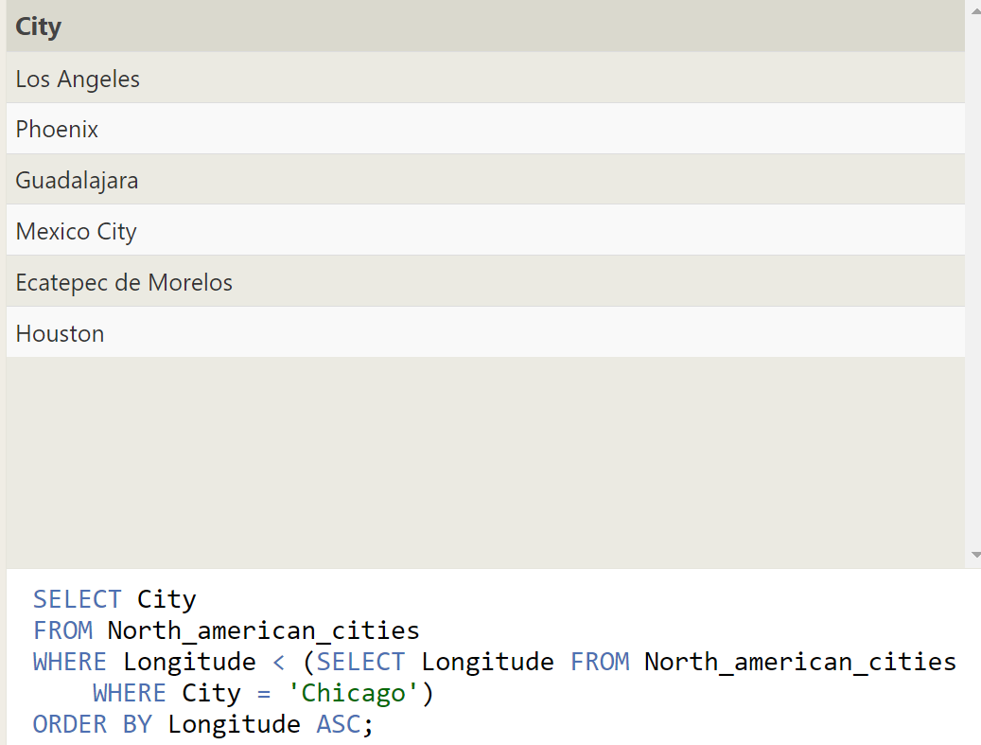

**21. List the two largest cities in Mexico (by population)**

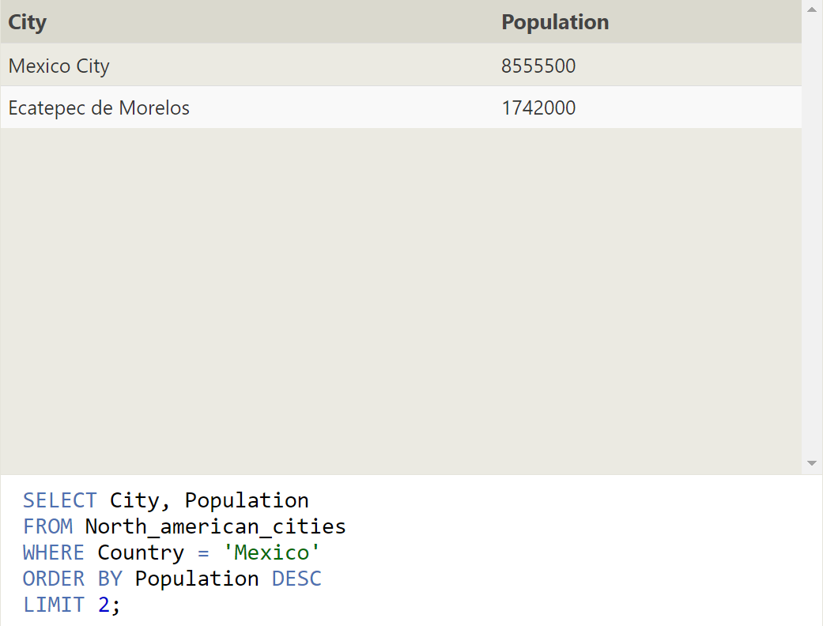

**22.List the third and fourth largest cities (by population) in the United States and their population**

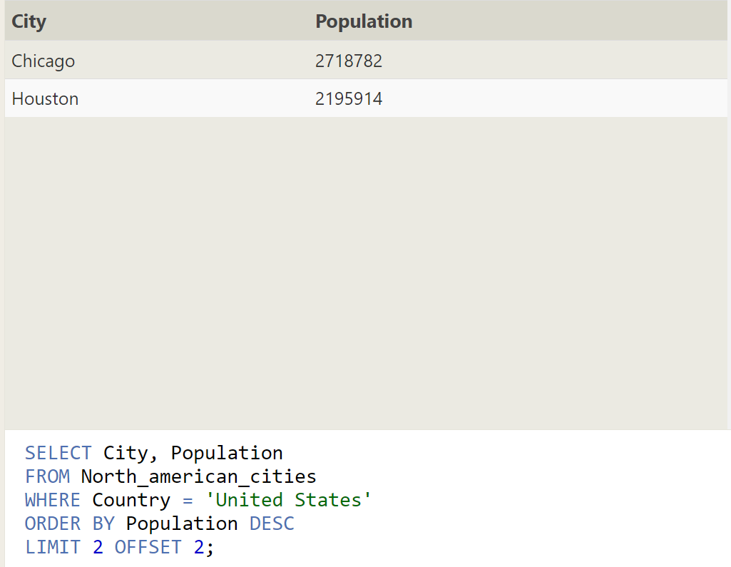

**23.Find the domestic and international sales for each movie**

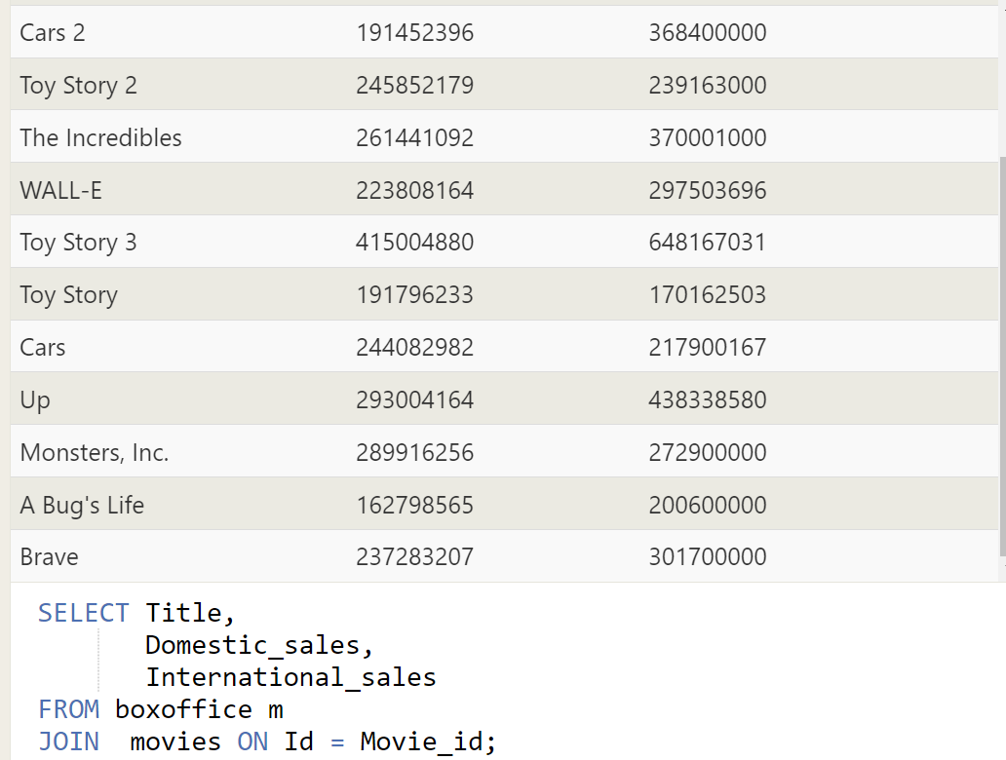

**24.Show the sales numbers for each movie that did better internationally rather than domestically**

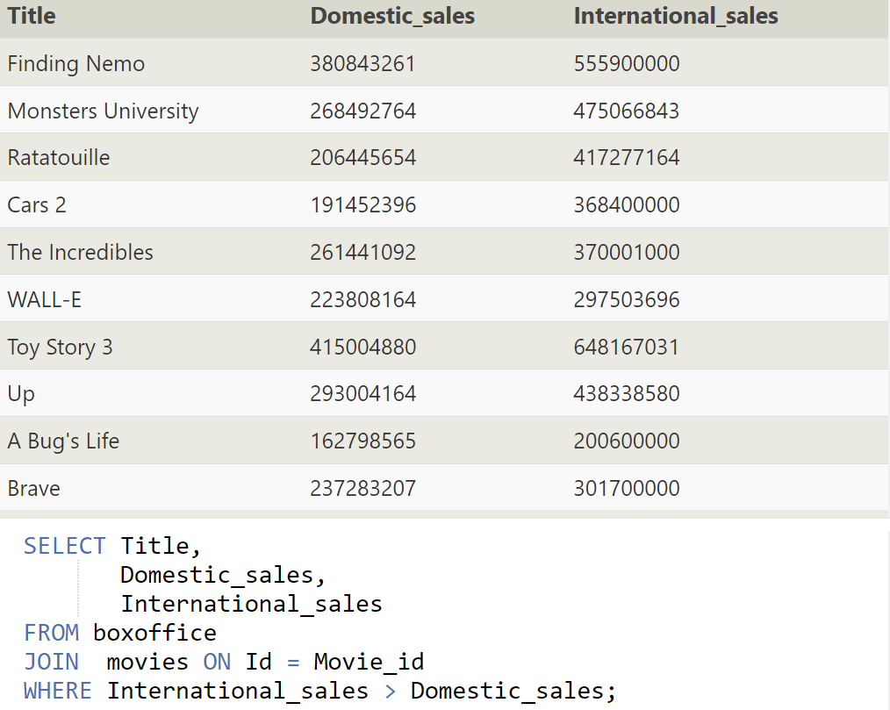

**25.List all the movies by their ratings in descending order**

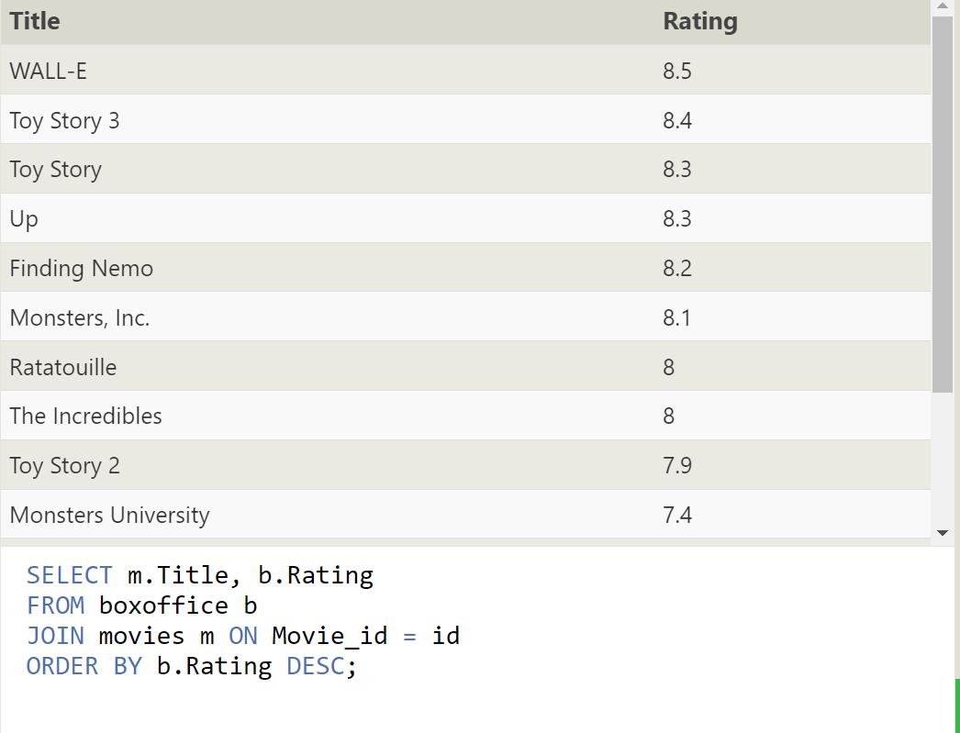

**26.Find the list of all buildings that have employees**

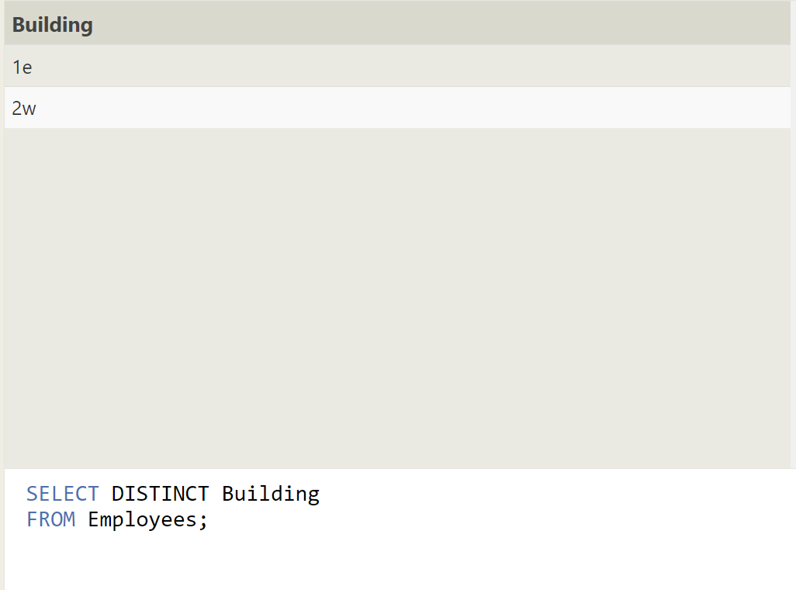

**27.Find the list of all buildings and their capacity**

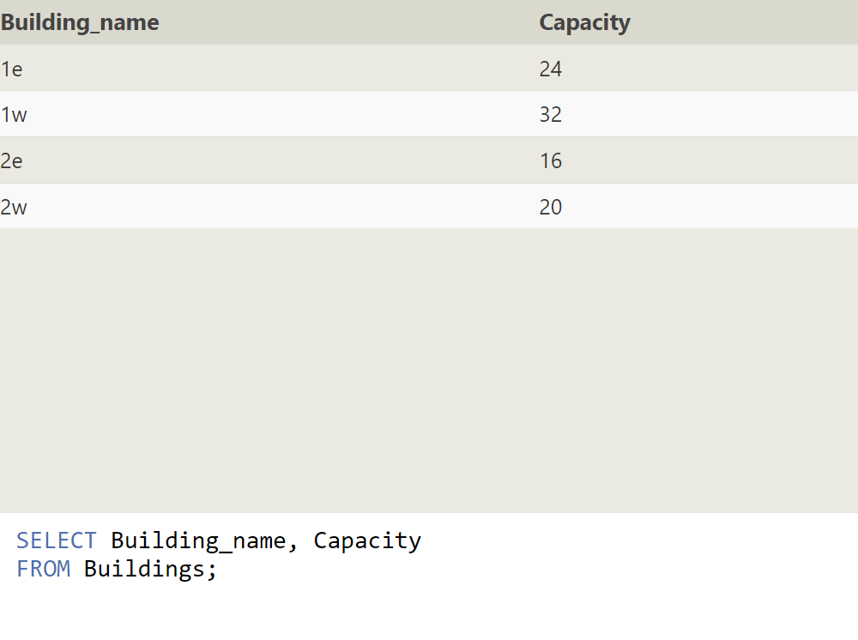

**28.List all buildings and the distinct employee roles in each building (including empty buildings)**

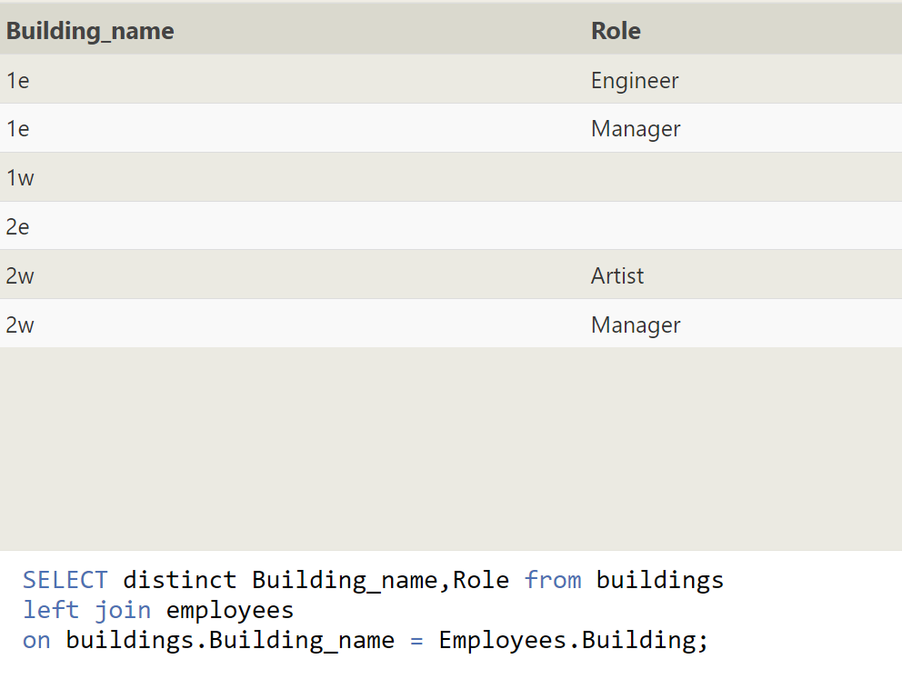

**29.Find the name and role of all employees who have not been assigned to a building**

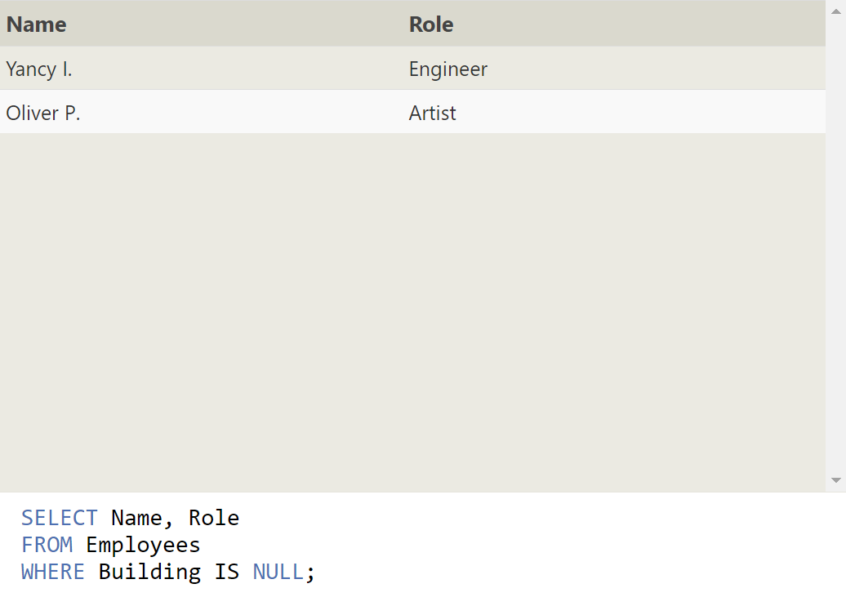

**30.Find the names of the buildings that hold no employees**

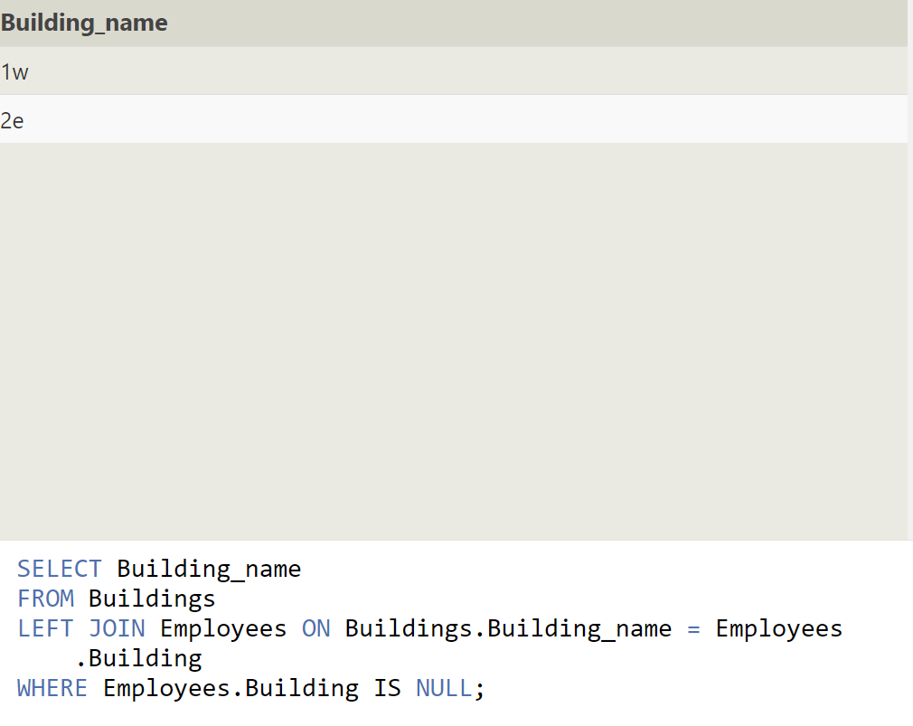

**31.List all movies and their combined sales in millions of dollars**

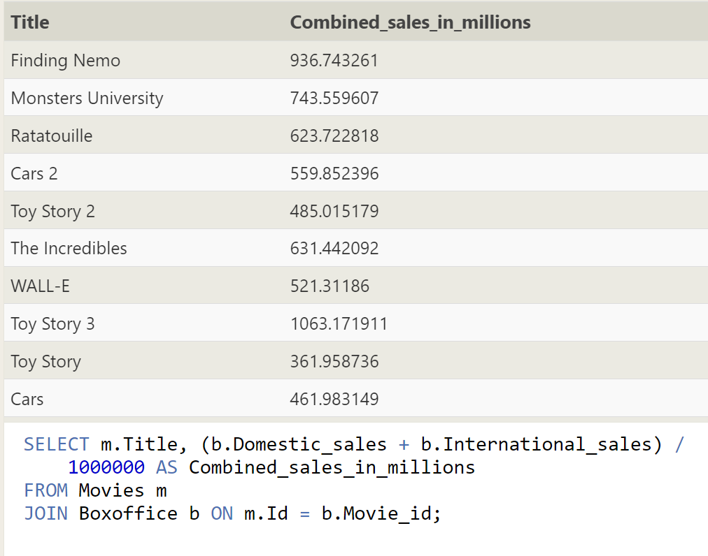

**32. List all movies and their ratings in percent**

**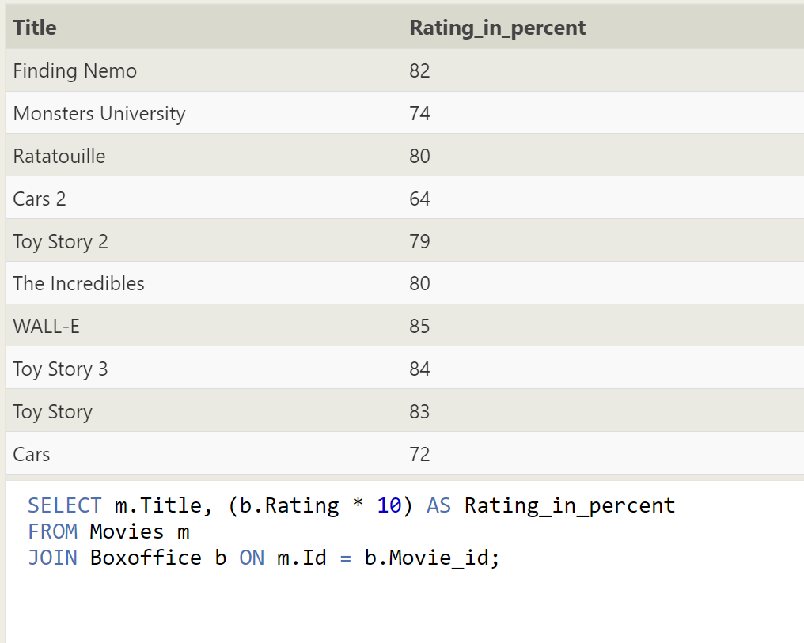  
33.List all movies that were released on even number years**

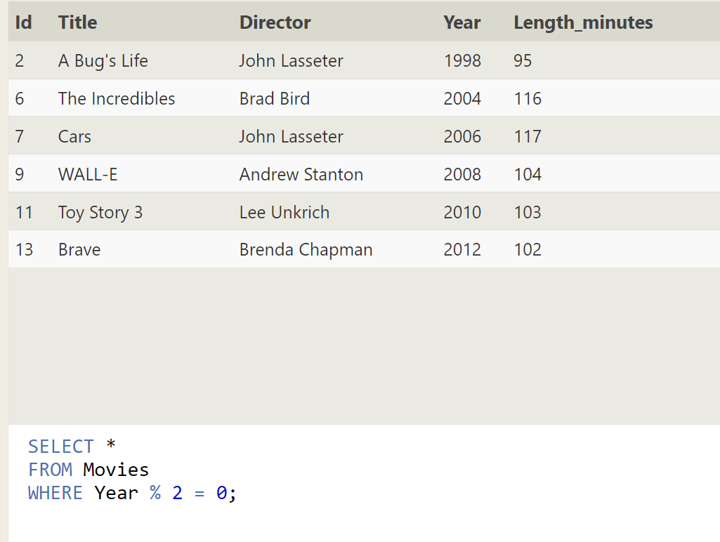

**34.Find the longest time that an employee has been at the studio**

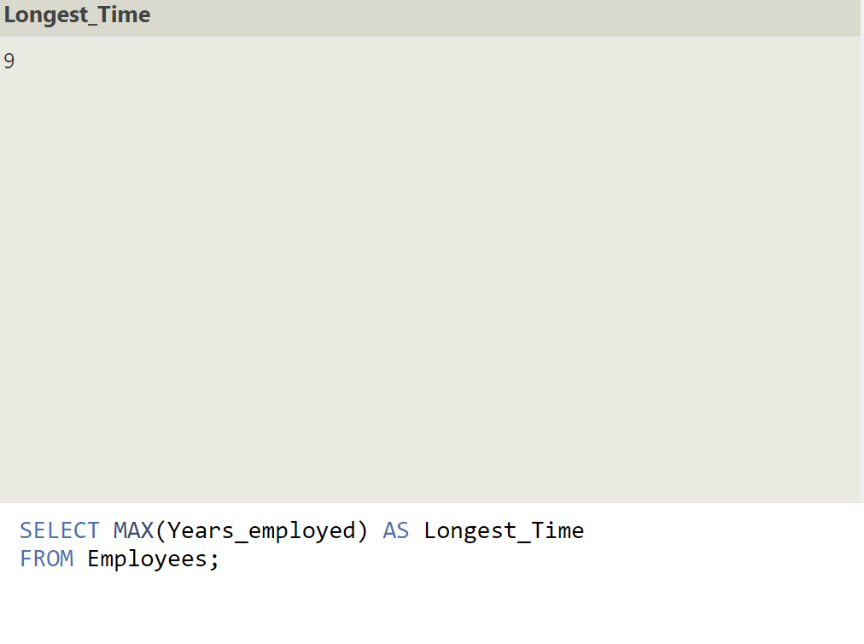

**35.For each role, find the average number of years employed by employees in that role**

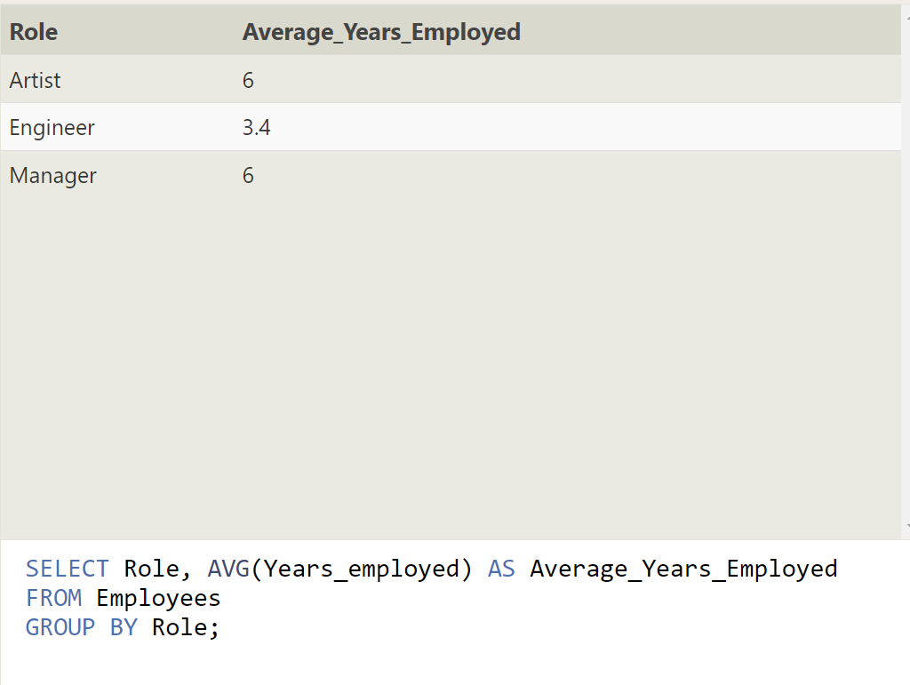

**36.Find the total number of employee years worked in each building**

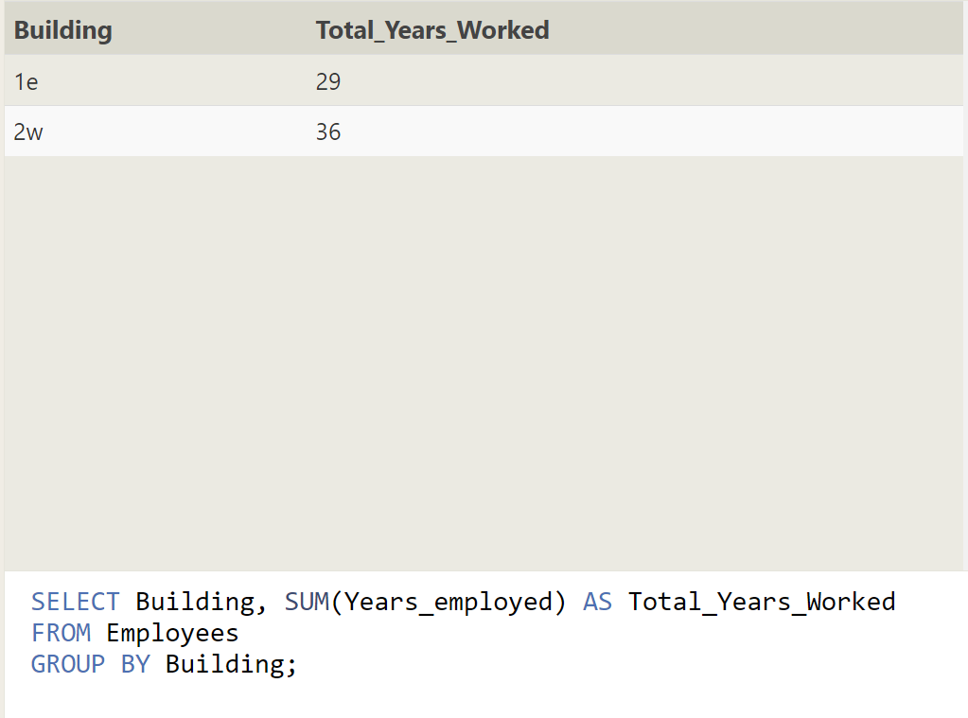

**37.Find the number of Artists in the studio (without a HAVING clause)**

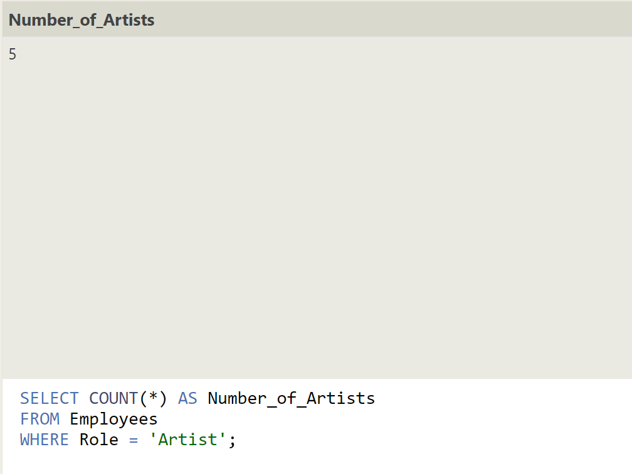

**38.Find the number of Employees of each role in the studio**

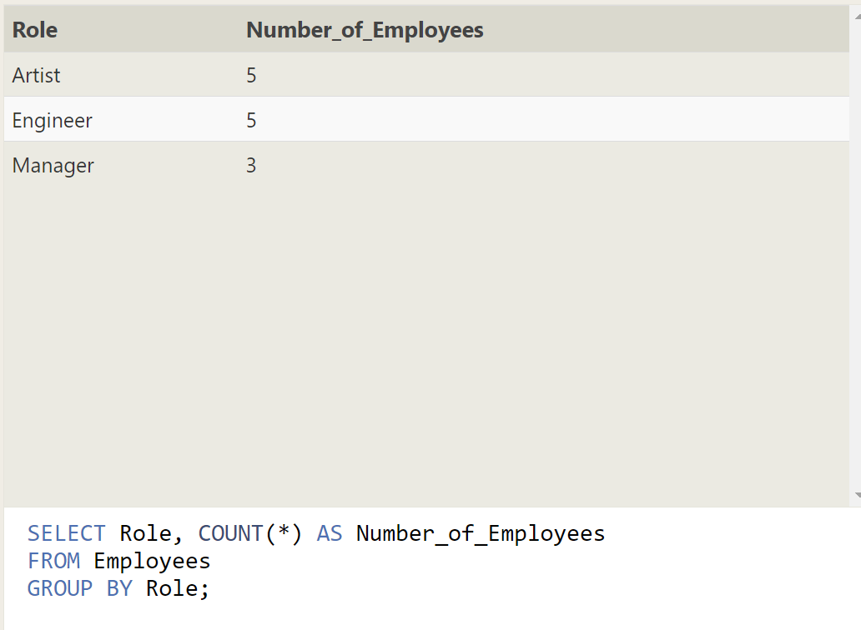

**39. Find the total number of years employed by all Engineers**

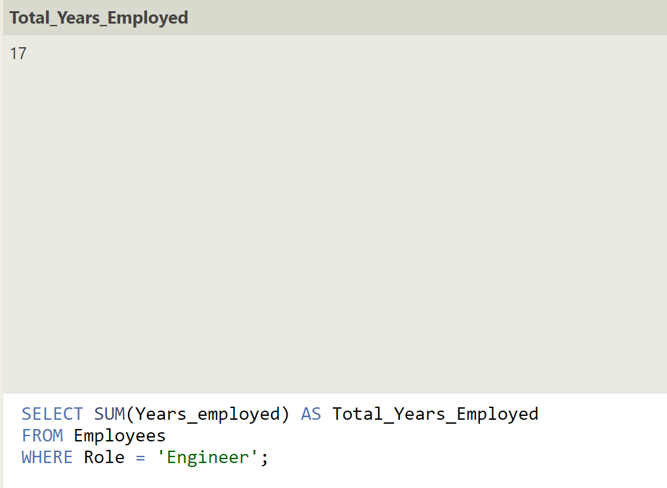

**40.Find the number of movies each director has directed**

