Process Model

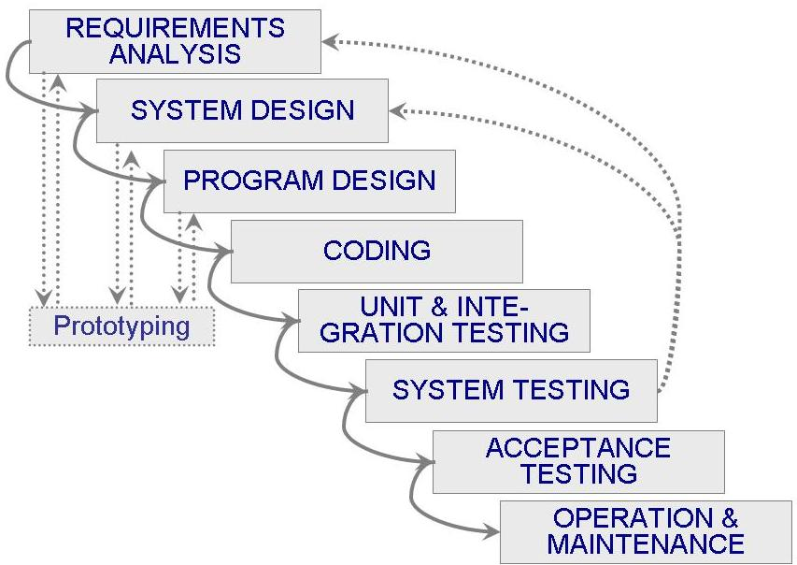

For this project I will be using a waterfall model with prototyping. Prototypes will be made and analyzed during the requirement analysis, system design and program design. Prototyping will determine whether the software is adequate or not. The game will follow the traditional waterfall model and may revert back to the design and requirement stages during system testing. The first step, in the process model, will be to collect requirements. This will be gathered by examining similar games and thinking about what features may improve the game. The second step is the design and architecture. This will be designed similar to battleship, but with new features and an efficient interface. The next step is development and coding of the program, which will be from the design document. After the coding, testing will take place to ensure there are no inconsistencies with the code. When the code is complete and correct, implementation is the next step and that consists of presenting and sending the software to the director. Maintenance and support will be the last step and consists of improvement and technical support.

Requirements

Functional Requirements:

1. The game shall display a 10x10 grid (map)
2. The game shall allow users to go by turn
3. The game shall let users strike each turn
4. The game shall determine whether user input matches an aircraft location
5. The game shall output whether a target location is hit
6. The game shall display a radar to assist the user per round
7. The game shall update map every time a strike is made
8. The game shall keep number of attempts made
9. The game shall keep score
10. The game shall display winner
11. The game shall allow users to play again

Nonfunctional Requirements:

1. A map should be generated at the moment of player turn
2. The map should be big enough to hold all aircrafts
3. The map should be generated in a two dimensional array
4. There should be a graphical user interface for the game
5. Striking should be by row and column
6. Hints shall be displayed for the user
7. There should be counters to make the game statistical

Domain Constraints:

1. Java requires large amount of memory
2. Striking is determined by cell