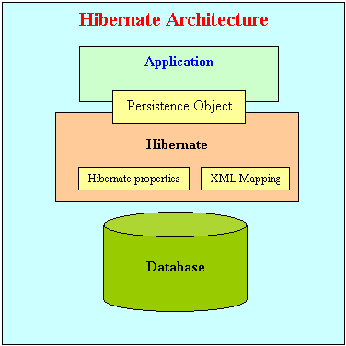

Hibernate is an open source framework from Redhat division. Some other products from Redhat are Linux, JBOSS, etc.
Architect of Hibernate is Gavin King.
Hibernate is the persistence framework which allows you to do the persistence operations in an easiest way.
Following are various persistent technologies which are available in the market –
- IOStreams
- JDBC
- XML (DOM API)
- Hibernate
- EJB 2.x
- EJB 3.0 using JPA (Java Persistent API)
- IBatis
- JDO (Java Database Object)
- TopLink
Hibernate is the best persistent framework among all the other persistent frameworks.
ORM –
Object-relational mapping (ORM) is a programming technique for converting data between incompatible type systems in relational databases and object-oriented programming languages. This creates, in effect, a "virtual object database" that can be used from within the programming language.
Advantages of using ORM rather than traditional JDBC –
1. Facilitates implementing the Domain Model pattern. This one reason supercedes all others. In short using this pattern means that you model entities based on real business concepts rather than based on your database structure. ORM tools provide this functionality through mapping between the logical business model and the physical storage model.
2. Huge reduction in code. ORM tools provide a host of services thereby allowing developers to focus on the business logic of the application rather than repetitive CRUD (Create Read Update Delete) logic.
3. Changes to the object model are made in one place. Once you update your object definitions, the ORM will automatically use the updated structure for retrievals and updates. There are no SQL Update, Delete and Insert statements strewn throughout different layers of the application that need modification.
4. Rich query capability. ORM tools provide an object oriented query language. This allows application developers to focus on the object model and not to have to be concerned with the database structure or SQL semantics. The ORM tool itself will translate the query language into the appropriate syntax for the database.
5. Navigation. You can navigate object relationships transparently. Related objects are automatically loaded as needed. For example if you load a PO (Purchase Order) and you want to access it's Customer, you can simply access PO. Customer and the ORM will take care of loading the data for you without any effort on your part.
6. Data loads are completely configurable allowing you to load the data appropriate for each scenario. For example in one scenario you might want to load a list of POs without any of it's child / related objects, while in other scenarious you can specify to load a PO, with all it's child LineItems, etc.
7. Concurrency support. Support for multiple users updating the same data simultaneously.
8. Cache managment. Entities are cached in memory thereby reducing load on the database.
9. Transaction management and Isolation. All object changes occur scoped to a transaction. The entire transaction can either be committed or rolled back. Multiple transactions can be active in memory in the same time, and each transactions changes are isolated form on another.
10. Key Management. Identifiers and surrogate keys are automatically propogated and managed.
ORM concepts are completely implemented in Hibernate framework. So we can say Hibernate is the best ORM tool among other tools like EJB 2.x, EJB 3.0, IBatis, JDO, etc.
Hibernate features:-
- Hibernate is an ORM (Object Relational Mapping) framework, because of this Java objects will be mapped to relational entities (database tables) in the easiest way.
- Hibernate supports various types of mappings –
    - Basic mapping
    - Inheritance mapping
    - Collection mapping
    - Association mapping
  - When you are using JDBC you are responsible for the following
    - Loading the driver class
    - Establishing the connection
    - Creation of appropriate statement
    - Preparing the required query and executing it.
    - After processing the results, cleanup the resources like connections.
Now when we are using hibernate no need to perform above tasks, hibernate is responsible to establish the connections with required database. Preparing the well tuned SQL queries, clean up the resources, etc. i.e., JDBC API is completely hidden from the hibernate developers. If you are using data source connections you should use JNDI API, when we are using hibernate then developer is not responsible to get the connection. So JNDI API is also hidden for the hibernate developers.
Hibernate supports powerful caching strategies and implementations. Cache is a copy of database which is near to the application in the application server, because of having the local copy in the application server we can reduce the network traffic between application server and database server and because of caching implementation performance of the application will be increased.
Hibernate supports batch update concept to a great extent. Hibernate always uses batch updates internally to submit the queries to SQL engine. Batch size will be decided by the hibernate automatically. Hibernate also uses batch time out to submit the batch of queries to the database. Because of the batch updates traffic between application server and database server will be reduced and performance of the application will be increased.
Hibernate provides the flexible and powerful transaction model. Hibernate supports both local and distributed transactions. When developer needs local transactions then internally hibernate uses JDBC transaction management. When developer needs distributed transactions then hibernate uses JTA transaction management.
Hibernate provides support for DriverManager database connections or datasource database connections. You can also use some third party connection management and integrate into hibernate very easily.
Hibernate provides powerful Object Oriented Query Language (OOQL). First OOQL was introduced by SUN in EJB as EJBQL. Hibernate provides the following OOQLs
- HQL (Hibernate Query Language)
- QBC (Query By Criteria)
- QBE (Query By Example)
As a ORM tool hibernate also supports stored procedure invocation.

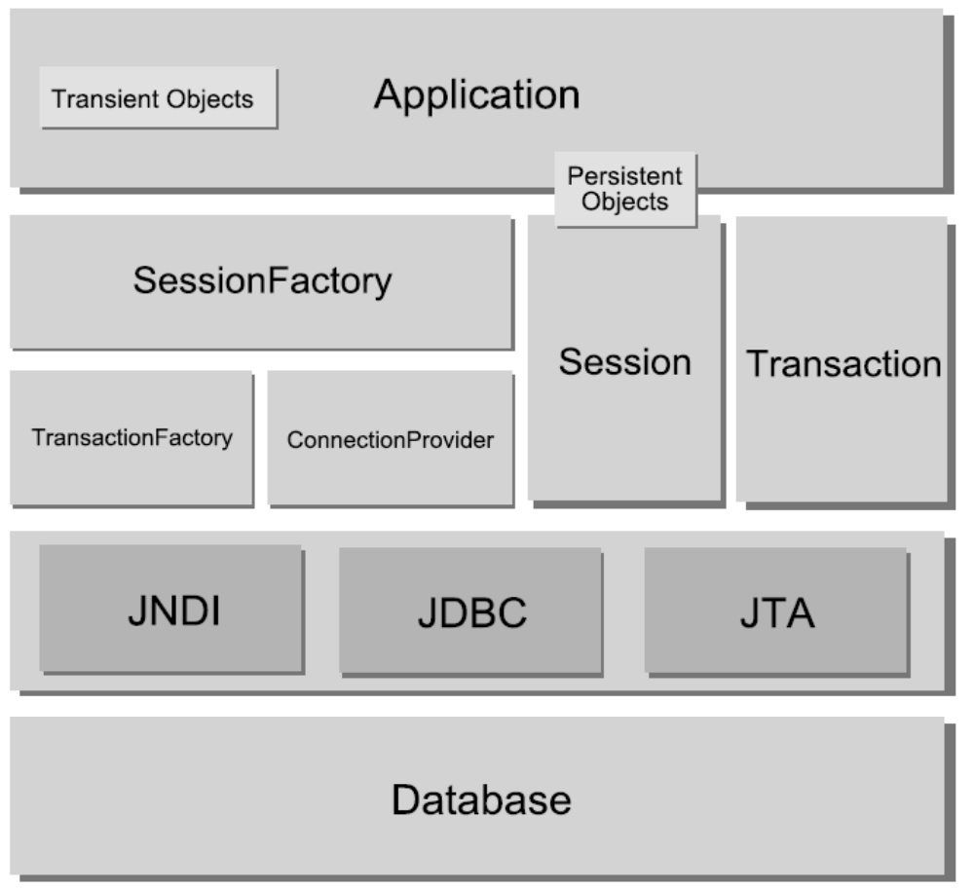

In the above hibernate system there are some low level and high level components. Following are the high level components used by the developer –
- Configuration
- SessionFactory
- Session
- Transaction
Following are the low level components which will be used by the hibernate system internally –
- Connection Provider
- Connection
- TransactionFactory
- JDBC API
- JNDI API
- JTA API

- Configuration – Configuration is a class which is available in org.hibernate.cfg package. Hibernate runtime system will be started by instantiating configuration class first. Configuration class has two important methods –
        - Configuration configure()
        - Configuration configure(String)
configure() is responsible to read all the properties defined in hibernate configuration document and all hibernate mapping documents.
After reading all the properties from hibernate configuration and mapping document, Configuration Object is responsible to create SessionFactory object.
Once SessionFactory object is created then there is no use of Configuration object.
- SessionFactory –
SessionFactory is an interface available in org.hibernate package.
SessionFactory is a longlived multithreaded object.
Usually one SessionFactory should be created for one database.
When you have multiple databases in your application you should create multiple SessionFactory objects.
Assume the scenario that you are using two databases called MySQL and Oracle in your hibernate application, then you need to build two SessionFactory objects. Following is the code –
Configuration cfg = new Configuration();
Configuration cfg1 = cfg.configure(“mysql.cfg.xml”);
SessionFactory sf1 = cfg1.buildSessionFactory();
Configuration cfg2 = cfg.configure(“oracle.cfg.xml”);
SessionFactory sf2 = cfg2.buildSessionFactory();
Have two configuration files –
        - mysql.cfg.xml
        - oracle.cfg.xml
Assume the scenario that you are using one DB called MySql in your application then following is the way to create the SessionFactory object.
Configuration cfg = new Configuration();
cfg = cfg.configure();
SessionFactory sf = cfg.buildSessionFactory();
cfg.configure() – Default looks for hibernate.cfg.xml
cfg – Filled with all the properties defined in the configuration and mapping document
SessionFactory object will be created once and it is used by multiple users for long time.
SessionFactory object is a factory for Session objects.
Following is the HibernateUtil class which is implemented based on SingleTon design pattern. We can ensure that one and only one SessionFactory object will be created for the entire application.
package com.cluster.hibernate.util;
import org.hibernate.SessionFactory;
import org.hibernate.cfg.Configuration;

public class HibernateUtil {
static SessionFactory sf = null;
static{
try{
Configuration cfg = new Configuration().configure();
sf = cfg.buildSessionFactory();
}catch(Exception e){
e.printStackTrace();
}
}

public static SessionFactory getSessionFactory(){
return sf;
}
}

- Session –
Session is an interface available in org.hibernate package. Session represents period of time where hibernate user does multiple persistent operations with the database.
Session object is created from the SessionFactory as follows –
Session session = sessionFactory.openSession();
Session is called as Persistent Manager because Session is playing a key role in doing all the persistent operations.
Following are various CRUD operations (Create, Read, Update, Delete) which you can do with the Session.
For Creating –
Student student = new Student ("XYZ","xyz@gmail.com", "99999 99999");
session.save(student);
session.save(student) – Generates id for Primary Key and inserts into DB.
For Reading / Retrieving –
Student student = (Student) session.load (Student.class, new Integer(1)); System.out.println("Student name - " + student.getSname());
System.out.println("Student's email id - " + student.getEmail());
System.out.println("Student's phone no. - " + student.getPhoneno());
For Updating –
Student student = (Student) session.load (Student.class, new Integer(1));
student.setPhoneno("00000 00000");
session.update(student);
For Deleting -
Student student = (Student) session.load (Student.class, new Integer(1));
session.delete (student);
Session is the factory for transactions. When user requests for transaction, session uses TransactionFactory internally to get the transactions.
Whenever Session object is created then one database connection will be established and will be associated with Session.
As long as Session is running Connection will be associated with Session. Once Session is closed then connection will be closed internally.
Session session = sf.openSession();
tx1 = session.beginTranaction();
operation 1
operation 2
tx1.commit();
tx2 = session.beginTranaction();
operation 3
operation 4
tx2.commit();
session.close();

Session session = sf.openSession() – Uses ConnectionProvider and opens one DB connection.
session.close() – Connection will be released automatically.
Session uses ConnectionProvider to get the database connections. Session can span to one or multiple transactions and one transaction can have one or multiple database operations.

- TransactionFactory –
TransactionFactory is an interface available in org.hibernate.transaction package.
TransactionFactory is a factory for Transaction objects.
TransactionFactory will be used by Session and not by Hibernate developers.
TransactionFactory can provide the following two types of transactions –
        - JDBC transaction
        - JTA transaction
The default transaction which is used by the SessionFactory is JDBC transaction.
If you want other transactions you need to write the corresponding properties in hibernate configuration document.
- ConnectionProvider
ConnectionProvider is an interface available in org.hibernate.connection package.
It is responsible to provide JDBC connections.
It will be used by Session objects.
ConnectionProvider can provide two types of database connections –
        - JDBC connection
        - Datasource connections
ConnectionProvider by default provides JDBC connections.
If you want Datasource connections you need to provide corresponding properties in hibernate configuration document.

In hibernate we can find 3 states of object
        - Transient object
        - Persistent object
        - Detached object.

        - Transient object – Object which is not participated in any hibernate session operations is called as transient object. The state of this object is called as transient state. When object is in transient state it does not contain any identity (primary key value).
        - Persistent object – Object which is participated in hibernate session operations is called persistent object. The state of this object is called persistent state. When object is in persistent state it contains an identity.
        - Detached object - Object which is just removed from hibernate session is called detached object and the state is called as detached state. When object is in detached state it contains identity but you can’t do persistent operations with that identity.

Types of mappings –
- Inheritance mapping
- Collection mapping
- Association mapping

