**Date: 10th April 2023**

# EXPERIMENT-10

**TITLE: Joins in SQL**

AIM: To execute and verify the SQL commands using Join.

OBJECTIVE: SQL joins are used to query data from two or more tables, based on a relationship between certain columns in these tables.

Refer Experiment 7 & 8 and execute the same questions by using join.

Write the Nested Queries for the following queries.

* 1. List the details of the emps whose Salaries more than the employee BLAKE.

**Query:**

select e1.* from emp e1 inner join (select ename, sal from emp) as e2 on e2.ename = "BLAKE" where e1.sal >e2.sal;

**Output:**

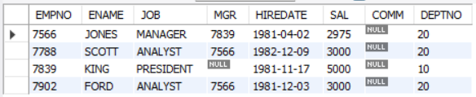

* 1. List the emps whose Jobs are same as ALLEN.

**Query:**

select e1.ename from emp e1 inner join emp e2 on e1.job = e2.job where e2.ename = "ALLEN" and e1.ename != "ALLEN";

**Output:**

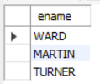

* 1. List the Emps whose Sal is same as FORD or SMITH in desc order of Names.

**Query:**

select e1.ename from emp e1 inner join (select ename, sal from emp) as e2 on e1.sal = e2.sal where e2.ename in ("FORD","SMITH") order by e1.ename desc;

**Output:**

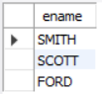

* 1. List the emps Whose Jobs are same as MILLER or Sal is more than ALLEN.

**Query:**

(select e1.ename from emp e1 inner join emp e2 on e1.job = e2.job where e2.ename = "MILLER")

union

(select e1.ename from emp e1 inner join emp e2 on e1.sal > e2.sal where e2.ename = "ALLEN");

**Output:**

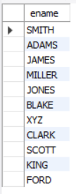

* 1. Find the highest paid employee of sales department.

**Query:**

select e.ename from emp e JOIN (select MAX(sal) as MAX_sal from emp where deptno =30) s ON e.sal = s.max_sal AND e.deptno = 30;

**Output:**



* 1. List the employees who are senior to most recently hired employee working under king.

**Query:**

select e.* from emp e JOIN (select MAX(hiredate) as recent_hire from emp where mgr = (select empno from emp where ename='KING'))r ON e.hiredate < r.recent_hire;

**Output:**

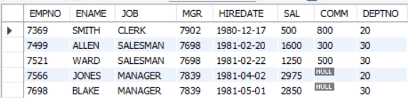

* 1. List the names of the emps who are getting the highest sal dept wise.

**Query:**

select e1.ename, e1.sal, e1.deptno from emp e1 join (select max(sal) as MaxSal, deptno from emp group by deptno) as tab on e1.deptno = tab.deptno and e1.sal = tab.MaxSal;

**Output:**

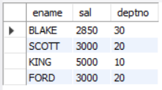

* 1. List the emps whose sal is equal to the average of max and minimum.

**Query:**

select e.ename from emp e JOIN (select AVG(sal) as avg_sal from (select MAX(sal) as sal from emp UNION select MIN(sal) as sal from emp) s)a ON e.sal = a.avg_sal;

**Output:**



* 1. List the emps who joined in the company on the same date.

**Query:**

select e1.* from emp e1 JOIN emp e2 ON e1.hiredate = e2.hiredate AND e1.empno<>e2.empno;

**Output:**

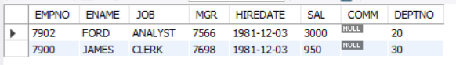

* 1. Find out the emps who joined in the company before their Managers.

**Query:**

select e1.* from emp e1 inner join emp e2 on e1.mgr = e2.empno where e1.hiredate < e2.hiredate;

**Output:**



