**Date : 16th January 2023**

# Experiment 2

**Title: DML commands with constraints**

**Objective: -** To understand the concept of different DML commands.

Exercise on retrieving records from a table.

1. Find out the names of all the clients.

**Query:**

use ravidb;

select name as Client_Name from client_master;

**Output:**

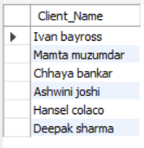

1. Retrieve the entire contents of the Client_Master table.

**Query:**

use ravidb;

select * from client_master;

**Output:**

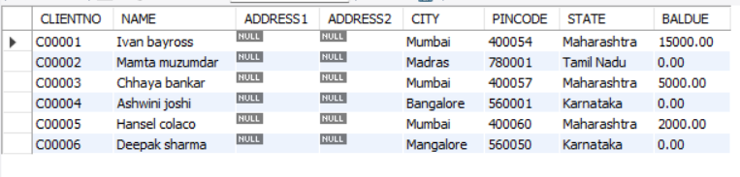

1. Retrieve the list of names,city and the state of all the clients.

**Query:**

use ravidb;

select name, city, state from client_master;

**Output:**

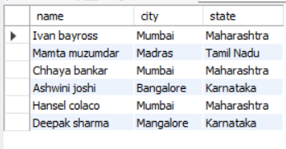

1. List the various products available from the Product_Master table.

**Query:**

use ravidb;

select description from product_master;

**Output:**

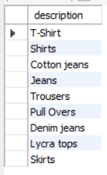

1. List all the clients who are located in Mumbai.

**Query:**

use ravidb;

select name from client_master where city="MUMBAI";

**Output:**

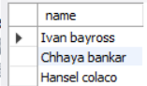

1. Find the names of salesman who have a salary equal to Rs.3000.

**Query:**

use ravidb;

select salesmanname from salesman_master where salamt = 3000;

**Output:**

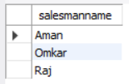

1. Exercise on updating records in a table
   1. Change the city of ClientNo ‘C00005’ to ‘Bangalore’.

**Query:**

use ravidb;

update client_master set city="Banglore" where clientno="C00005";

select * from client_master;

**Output:**

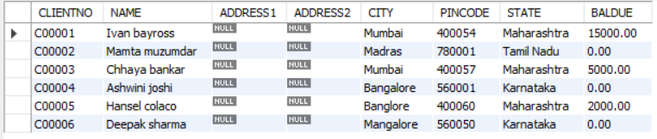

* 1. Change the BalDue of ClientNo ‘C00001’ to Rs.1000.

**Query:**

use ravidb;

update client_master set baldue=1000 where clientno="C00001";

select * from client_master;

**Output:**

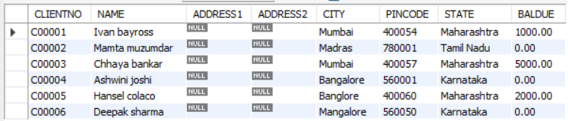

* 1. Change the cost price of ‘Trousers’ to rs.950.00.

**Query:**

use ravidb;

update product_master set costprice=950 where description="Trousers";

select * from product_master;

**Output:**

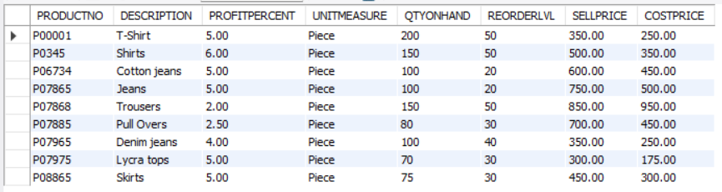

* 1. Change the city of the salesman to Pune.

**Query:**

use ravidb;

update salesman_master set city="Pune";

select * from salesman_master;

**Output:**

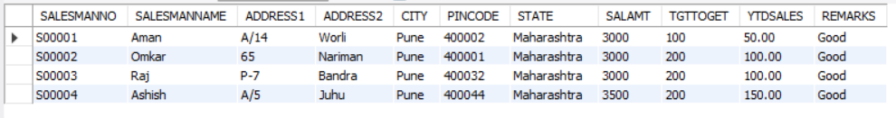

1. Exercise on deleting records in a table
   1. Delete all salesman from the Salesman_Master whose salaries are equal to Rs.3500.

**Query:**

use ravidb;

delete from salesman_master where salamt=3500;

select * from salesman_master;

**Output:**

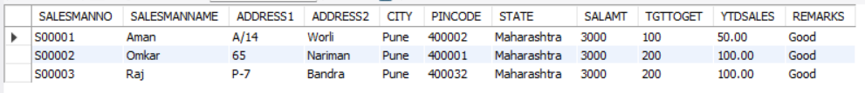

* 1. Delete all products from Product_Master where the quantity on hand is equal to 100.

**Query:**

use ravidb;

delete from product_master where qtyonhand=100;

select * from product_master;

**Output:**

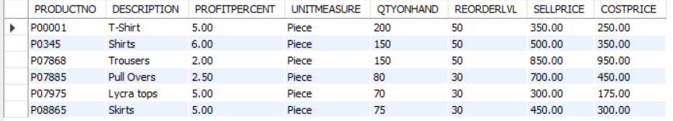

* 1. Delete from Client_Master where the column state holds the value ‘Tamil Nadu’.

**Query:**

use ravidb;

delete from client_master where state="Tamil Nadu";

select * from client_master;

**Output:**

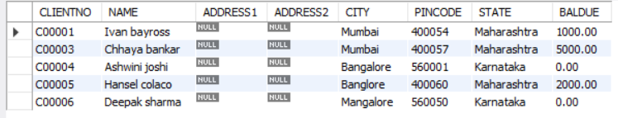

1. Exercise on altering the table structure
   1. Add a column called ‘Telephone’ of data type integer to the Client_Master table.

**Query:**

use ravidb;

alter table client_master add Telephone int;

select * from client_master;

**Output:**

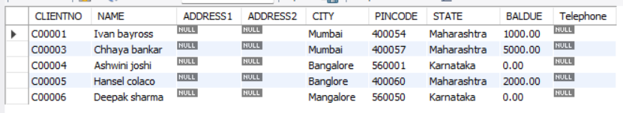

* 1. Change the size of SellPrice column in Product_Master to 10, 2.

**Query:**

use ravidb;

alter table product_master modify sellprice decimal(10,2);

desc product_master;

**Output:**

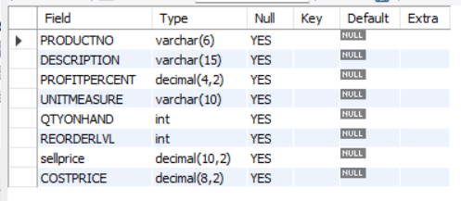

1. Exercise on deleting the table structure along with the data
   1. Destroy the table Client_Master along with its data.

**Query:**

drop table client_master;

show tables;

**Output:**

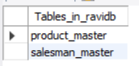

1. Exercise on renaming the table
   1. Change the name of the Salesman_Master to sman_mast.

**Query:**

use ravidb;

rename table salesman_master to sman_mast;

show tables;

**Output:**



