**Date: 30th January 2023**

# EXPERIMENT-4

**TITLE: DDL (Data Definition Language) commands with Data Constraints**

**Objective:** To understand the concept of data constraints that is enforced on data being stored in the table. Focus on Primary Key, The Foreign Key and constraints.

Review this diagram

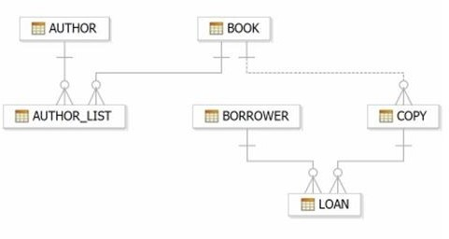

1. Create table AUTHOR = {Author_ID , Lastname, Firstname, Email, City, Country} Where:

Author_ID – text data type, 5 characters, primary key Lastname – text data type, 15 characters, not null Firstname – text data type, 15 characters, not null Email – text data type, 40 characters,

City – text data type, 15 characters, Country – text data type, 15 characters,

**Query:**

use ravidb;

create table AUTHOR (

Author_ID varchar(5) primary key,

Lastname varchar(15) not null,

Firtsname varchar(15) not null,

Email varchar(40),

City varchar(15),

Country varchar(15)

);

desc AUTHOR;

**Output:**

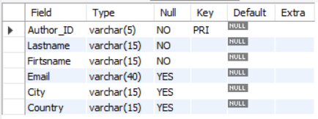

1. Create Table BOOK={ Book_ID, Book_Title, Copies) Where :

Book_ID – text data type, 5 characters Primary Key Start With Character **B**

Book_Title - Text data Type Not Null

Copies- No.of copies Data Type int always greater the 2

**Query:**

create table BOOK(

Book_ID varchar(5) primary key,

Book_Title varchar(100) not null,

Copies int check(Copies > 2),

constraint b_id_chk check(Book_ID like "B%")

);

desc BOOK;

**Output:**

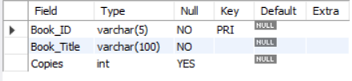

1. Create table AUTHOR_LIST = {Author_ID , Book_ID , Role} Where:

Author_ID – text data type, 5 characters, referenced by Author_ID from AUTHOR table

Book_ID – text data type, 5 characters

Role – text data type, 15 characters

and primary key is: Author_ID, Book_ID

**Query:**

create table AUTHOR_LIST(

Author_ID varchar(5),

Book_ID varchar(5),

Role varchar(15),

primary key (Author_ID, Book_ID),

foreign key (Author_ID) references AUTHOR(Author_ID),

foreign key (Book_ID) references BOOK(Book_ID)

);

desc AUTHOR_LIST;

**Output:**

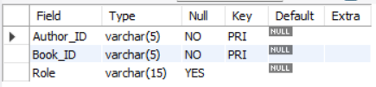

1. Add four records in each tables AUTHOR, BOOK, AUTHOR_LIST.

**Query:**

insert into AUTHOR values("A0001","Rowling","Joanne","j.krowl@gmail.com","Bristol","England");

insert into AUTHOR values("A0002","Brown","Robert","r.brown@gmail.com","Rome","Italy");

insert into AUTHOR values("A0003","Jenson","Clay","c.jenson@gmail.com","Tokyo","Japan");

insert into AUTHOR values("A0004","Tagore","Rabindranath","r.tagore@gmail.com","Kolkata","India");

select * from AUTHOR;

insert into BOOK values("B0001","Gitanjali",8);

insert into BOOK values("B0002","Harry Potter and The Chamber Of Secrets",7);

insert into BOOK values("B0003","Invisible Man",15);

insert into BOOK values("B0004","The Great Gatsby",7);

select * from BOOK;

insert into AUTHOR_LIST values("A0001","B0002","Co-author");

insert into AUTHOR_LIST values("A0002","B0004","Author");

insert into AUTHOR_LIST values("A0003","B0003","Co-author");

insert into AUTHOR_LIST values("A0004","B0001","Writer");

select * from AUTHOR_LIST;

**Output:**

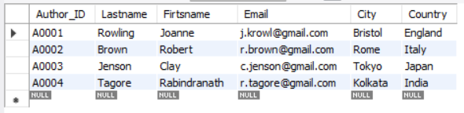



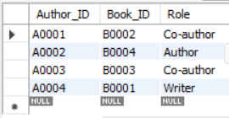

1. Alter structure of table AUTHOR_LIST add the field Publisher data type of 30 Character.

**Query:**

alter table AUTHOR_LIST add Publisher varchar(30);

desc AUTHOR_LIST;

**Output:**



