**Date: 6th February 2023**

# EXPERIMENT- 5,6

**Title:** Use of Inbuilt functions and relational algebra operation

**Objective:** To understand the use of inbuilt function and relational algebra with sql query.

1. Consider the following table structure and attempt.

Supplier-(scode,sname,scity,turnover)

Part-(pcode,weigh,color,cost,sellingprice)

Supplier_Part-(scode,pcode,qty)

1. **Create tables**

1) Supplier table:

**Query:**

use ravidb;

create table Supplier(

scode varchar(5) primary key,

sname varchar(15),

scity varchar(15),

turnover decimal(10,2)

);

desc Supplier;

**Output:**

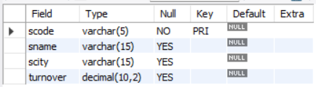

2) Part table:

**Query:**

create table Part(

pcode varchar(5) primary key,

weigh decimal(10,2),

color varchar(10),

cost decimal(10,2),

sellingprice decimal(10,2)

);

desc Part;

**Output:**

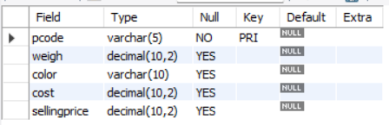

3) Supplier_Part table:

**Query:**

create table Supplier_Part(

scode varchar(5),

pcode varchar(5),

qty int,

constraint fk1 foreign key(scode) references Supplier(scode),

constraint fk2 foreign key(pcode) references Part(pcode)

);

desc Supplier_Part;

**Output:**

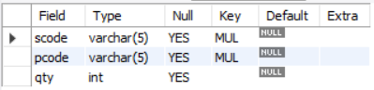

1. **Populate the table.**

1) Supplier table:

**Query:**

insert into Supplier values ("S1000","Ravi","Jamnagar",null),

("S1001","Khushi","Vadodara",120000),

("S1002","Atul","Banglore",124400),

("S1003","Dhyey","Pune",45000),

("S1004","Hrishi","Jaipur",78000);

select * from Supplier;

**Output:**

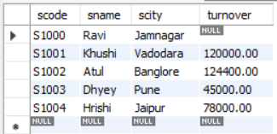

2)Part table:

**Query:**

insert into Part values ("P1000",27,"Blue",650,1000),

("P1001",28,"Purple",300,500),

("P1002",35,"Red",250,400),

("P1003",26,"Green",350,750),

("P1004",32,"Black",670,900);

select * from Part;

**Output:**

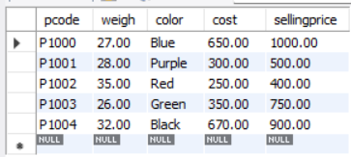

3) Supplier_Part table:

**Query:**

insert into Supplier_Part

values ("S1000","P1000",9),

("S1002","P1001",11),

("S1003","P1002",50),

("S1001","P1003",35),

("S1004","P1004",7);

select * from Supplier_Part;

**Output:**

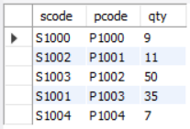

1. Write appropriate SQL Statement for the following:
   1. Get the supplier number and part number in ascending order of supplier number.

**Query:**

select scode,pcode from supplier_part order by scode;

**Output:**

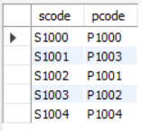

* 1. Get the details of supplier who operate from Bombay with turnover 50.

**Query:**

select * from supplier where scity="Bombay" && turnover=50;

**Output:**



* 1. Get the total number of supplier.

**Query:**

select count(*) as total_no_of_suppliers from supplier;

**Output:**

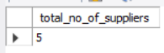

* 1. Get the part number weighing between 25 and 35.

**Query:**

select pcode from part where weigh between 25 and 35;

**Output:**

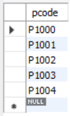

* 1. Get the supplier number whose turnover is null.

**Query:**

select scode from supplier where turnover is null;

**Output:**

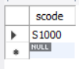

* 1. Get the part number that cost 20, 30 or 40 rupees.

**Query:**

select pcode from part where cost in(20,30,40);

**Output:**

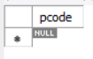

* 1. Get the total quantity of part 2 that is supplied.

**Query:**

select qty from supplier_part where scode="S1002";

**Output:**



* 1. Get the name of supplier who supply part 2.

**Query:**

select sname from supplier where scode in (select scode from supplier_part where pcode="P1002");

or

select sname from supplier inner join supplier_part on supplier.scode = supplier_part.scode where pcode="P1002";

**Output:**



* 1. Get the part number whose cost is greater than the average cost.

**Query:**

select pcode from part where cost > (select avg(cost) from part);

**Output:**

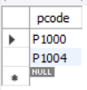

* 1. Get the supplier number and turnover in descending order of turnover.

**Query:**

select scode, turnover from supplier order by turnover desc;

**Output:**

