**Date: 20th February 2023**

# EXPERIMENT-7,8

**TITLE:** Nested sql queries or Subquries

**Objective:** To understand the use **SQL Subquery**

Create the following two tables (EMP and DEPT)

EMP TABLE

|  |  |  |  |  |  |  |
| --- | --- | --- | --- | --- | --- | --- |
| EMPNO DEPTNO | ENAME | JOB | MGR | HIREDATE | SAL | COMM |
|  | | | | | | |
| 7369  20 | SMITH | CLERK | 7902 | 17-DEC-80 | 500 | 800 |
| 7499  30 | ALLEN | SALESMAN | 7698 | 20-FEB-81 | 1600 | 300 |
| 7521  30 | WARD | SALESMAN | 7698 | 22-FEB-81 | 1250 | 500 |
| 7566 JONES MANAGER 7839 02-APR-81 2975 20 | | | | | | |
| 7654  30 | MARTIN | SALESMAN | 7698 | 28-SEP-81 | 1250 | 1400 |
| 7698 BLAKE MANAGER 7839 01-MAY-81 2850 30 | | | | | | |
| 7782 CLARK MANAGER 7839 09-JUN-81 2450 10 | | | | | | |
| 7788 SCOTT ANALYST 7566 09-DEC-82 3000 20 | | | | | | |
| 7839 KING PRESIDENT 17-NOV-81 5000 10 | | | | | | |
| 7844  30 | TURNER | SALESMAN | 7698 | 08-SEP-81 | 1500 | 0 |
| 7876 ADAMS CLERK 7788 12-JAN-83 1100 20 | | | | | | |
| 7900 JAMES CLERK 7698 03-DEC-81 950 30 | | | | | | |
| 7902 FORD ANALYST 7566 03-DEC-81 3000 20 | | | | | | |
| 7934 MILLER CLERK 7782 23-JAN-82 1300 10 | | | | | | |

**Query:**

create table EMP(

EMPNO int primary key,

ENAME char(15),

JOB char(15),

MGR int,

HIREDATE date,

SAL int,

COMM int,

DEPTNO int,

constraint cfk1 foreign key(DEPTNO) references DEPT(DEPTNO)

);

desc EMP;

**Output:**

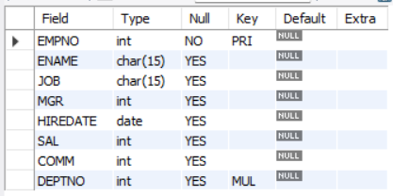

**Query:**

insert into EMP values(7369,"SMITH","CLERK",7902,'1980-12-17',500,800,20),

(7499,"ALLEN","SALESMAN",7698,"1981-02-20",1600,300,30),

(7521,"WARD","SALESMAN",7698,"1981-02-22",1250,500,30),

(7566,"JONES","MANAGER",7839,"1981-04-02",2975,NULL,20),

(7654,'MARTIN','SALESMAN',7698,'1981-09-28',1250,1400,30),

(7698,'BLAKE','MANAGER',7839,'1981-05-01',2850,NULL,30),

(7782,'CLARK','MANAGER',7839,'1981-06-09',2450,NULL,10),

(7788,'SCOTT','ANALYST',7566,'1982-12-09',3000,NULL,20),

(7739,'KING','PRESIDENT',NULL,'1981-11-17',5000,NULL,10),

(7844,'TURNER','SALESMAN',7698,'1981-09-08',1500,0,30),

(7876,'ADAMS','CLERK',7788,'1983-01-12',1100,NULL,20),

(7900,'JAMES','CLERK',7698,'1981-12-03',950,NULL,30),

(7902,'FORD','ANALYST',7566,'1981-12-03',3000,NULL,20),

(7934,'MILLER','CLERK',7782,'1982-01-23',1300,NULL,10);

select * from EMP;

**Output:**

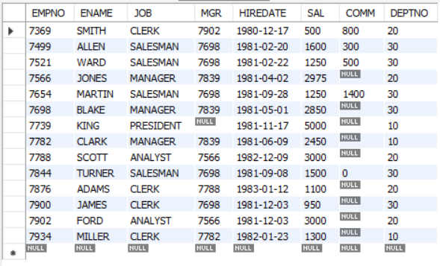

**DEPT TABLE**

|  |  |  |
| --- | --- | --- |
| DEPTNO | DNAME | LOC |
|  | | |
| 10 | ACCOUNTING | NEW YORK |
| 20 | RESEARCH | DALLAS |
| 30 | SALES | CHICAGO |

|  |
| --- |
| 40 OPERATIONS BOSTON |

**Query:**

create table DEPT(

DEPTNO int primary key,

DNAME char(15),

LOC char(15)

);

desc DEPT;

**Output:**

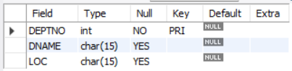

**Query:**

insert into DEPT values (10,"ACCOUNTING","NEW YORK"),

(20,"RESEARCH","DALLAS"),

(30,"SALES","CHICAGO"),

(40,"OPERATIONS","BOSTON");

select * from DEPT;

**Output:**

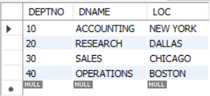

**Write the Nested Queries for the following queries.**

* 1. List the details of the emps whose Salaries more than the employee BLAKE.

**Query:**

select * from emp where sal > (select sal from emp where ENAME = "BLAKE");

**Output:**

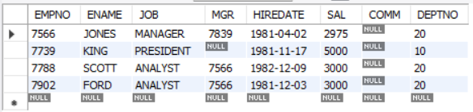

* 1. List the emps whose Jobs are same as ALLEN.

**Query:**

select ENAME from emp where job = (select job from emp where Ename = "ALLEN");

**Output:**

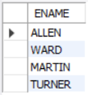

* 1. List the Emps whose Sal is same as FORD or SMITH in desc order of Names.

**Query:**

select ENAME from emp where sal in (select sal from emp where ENAME="FORD" or ENAME="SMITH") order by ENAME desc;

**Output:**

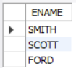

* 1. List the emps Whose Jobs are same as MILLER or Sal is more than ALLEN.

**Query:**

select ENAME from emp where job = (select job from emp where ENAME="MILLER") or sal > (select sal from emp where ENAME="ALLEN");

**Output:**

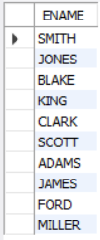

* 1. Find the highest paid employee of sales department.

**Query:**

select ename from emp where sal = (select max(sal) from (select * from emp as M where deptno = (select deptno from dept where dname="SALES")) as N);

or

select * from emp as A where sal = (select max(sal) from emp as B where deptno = (select deptno from dept as C where dname = "sales")) and deptno in (select deptno from dept where dname = "sales");

**Output:**



* 1. List the employees who are senior to most recently hired employee working under king.

**Query:**

select * from emp where hiredate < (select max(hiredate) from emp where mgr in (select empno from emp where ename = 'KING')) ;

**Output:**

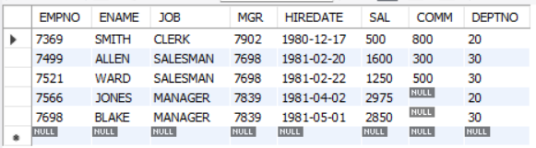

* 1. List the names of the emps who are getting the highest sal dept wise.

**Query:**

select ename, deptno from EMP where (sal,deptno) in (select max(sal),deptno as m from EMP group by deptno);

**Output:**

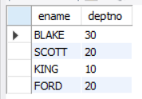

* 1. List the emps whose sal is equal to the average of max and minimum

**Query:**

select ename from EMP where sal = (select (max(sal)+min(sal))/2 from EMP);

**Output:**



* 1. List the emps who joined in the company on the same date.

**Query:**

select e1.* from EMP e1, EMP e2 where e1.hiredate=e2.hiredate and e1.empno!=e2.empno;

**Output:**

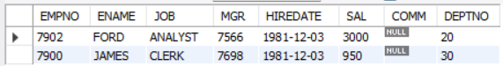

* 1. Find out the emps who joined in the company before their Managers.

**Query:**

select e_emp.* from EMP e_emp, EMP e_mgr where e_emp.hiredate<e_mgr.hiredate and e_emp.mgr=e_mgr.empno;

**Output:**



