**Date: 3rd April 2023**

# EXPERIMENT-9

**TITLE: Group by & having clause**

**Objective:** To understand the use of group by and having clause.

Write the SQL Queries for the following queries (use EMP and DEPT table of Exp 8).

1. List the Deptno where there are no emps.

**Query:**

select deptno from dept where deptno not in (select deptno from emp group by deptno having count(deptno)>=1);

**Output:**



1. List the No.of emp’s and Avg salary within each department for each job.

**Query:**

select deptno,job,count(Empno),avg(SAL) from Emp group by Deptno,Job order by Deptno;

**Output:**

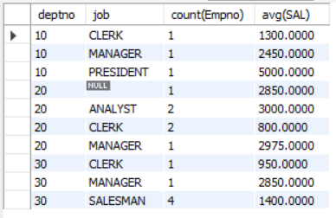

1. Find the maximum average salary drawn for each job except for ‘President’.

**Query:**

select max(avg_sal) from (select Avg(SAL) as avg_sal from Emp where Job != "President" group by job) as A;

**Output:**



1. List the department details where at least two emps are working.

**Query:**

select * from Dept where Deptno in (select Deptno from Emp group by Deptno having count(Empno>=2));

**Output:**

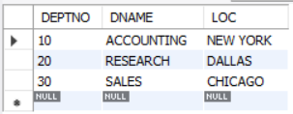

1. List the no. of emps in each department where the no. is more than 3.

**Query:**

select deptno, count(Empno) as No_of_Emp from Emp group by Deptno having count(empno) > 3;

**Output:**

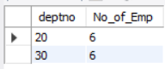

1. List the names of the emps who are getting the highest sal dept wise.

**Query:**

select deptno, ename from emp where (sal,deptno) in (select max(sal), deptno from emp group by deptno) order by deptno;

**Output:**

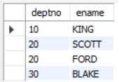

1. List the Deptno and their average salaries for dept with the average salary less than the averages for all departments.

**Query:**

select deptno, avg(sal) from emp group by deptno having avg(sal) < (select avg(sal) from emp);

**Output:**



****************************************************************