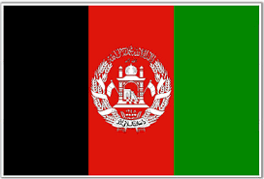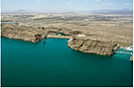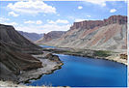

**Afghanistan**

**Capital** **Kabul** [**34°32′N 69°08′E**](https://tools.wmflabs.org/geohack/geohack.php?pagename=Afghanistan&params=34_32_N_69_08_E_type:city)

**Population** **3.3 M**

**Currency AFN**

**GDP $19.654 billion**

**Timezone UTC +4.30**

Over 99% of the Afghan population is Muslim; up to 90% are from the Sunni branch, 7–19% are Shia.

Pashto and Dari are the official languages of Afghanistan; bilingualism is very common.

**Language & Religion**

Afghanistan is a landlocked country located within South Asia and Central Asia. It has a population of approximately 32 million, making it the 42nd most populous country in the world. It is bordered by Pakistan in the south and east; Iran in the west; Turkmenistan, Uzbekistan, and Tajikistan in the north; and China in the far northeast. Its territory covers 652,000 km2, making it the 41st largest country in the world.

The country's natural resources include: coal, copper, iron ore, lithium, uranium, rare earth elements, chromite, gold, zinc.

The northeastern Hindu Kush Mountain range, in and around the Badakhshan Province of Afghanistan.

Despite having numerous rivers and reservoirs, large parts of the country are dry. The endorheic Sistan Basin is one of the driest regions in the world

**Geography**