Industrial Safety AI Chatbot
Software Development Life Cycle (SDLC) Model

Phase 1 — PLANNING
▸ Project Goal: AI-based Industrial Safety Monitoring Chatbot
▸ Technology Stack: React.js, Node.js, MongoDB, Google Gemini AI
▸ Risk Analysis: MongoDB fallback → Local JSON DB
▸ Timeline: 5-week iterative development cycle
↓
Phase 2 — REQUIREMENTS ANALYSIS
▸ Functional: User Login/Register, AI Chat, Safety Alerts, Admin Dashboard, Multilingual Support
▸ Non-Functional: Performance (<2s), Security (JWT + bcrypt), Scalability, 99.9% Availability
▸ Tools: Figma (UI), Postman (API), MongoDB Compass (DB)
↓
Phase 3 — SYSTEM DESIGN
▸ HLD: React Frontend ↔ Express Backend ↔ MongoDB Atlas + Gemini AI + Nodemailer
▸ LLD: API Routes (/api/auth, /api/chat, /api/alerts), DB Schemas, JWT Middleware
▸ DB Models: User, Alert, Document, Department, EmergencyContact, SafetyRule
↓
Phase 4 — IMPLEMENTATION
▸ Iteration 1 – Foundation: Express server, MongoDB schemas, React + Vite setup
▸ Iteration 2 – Auth System: Register/Login API, JWT middleware, Login/Landing UI
▸ Iteration 3 – Core Chat: Gemini AI integration, Chat UI, Multilingual support
▸ Iteration 4 – Alert System: Alert CRUD API, Nodemailer email service, Raise Alert UI
▸ Iteration 5 – Admin Panel: Dashboard, Analytics View, User/Data management
↓
Phase 5 — TESTING
▸ Unit Testing: API routes, JWT verification, bcrypt hashing, Gemini response format
▸ Integration Testing: Frontend ↔ Backend, MongoDB ↔ Mongoose, Email service
▸ System Testing: Full chat flow, Alert raise & email flow, Admin CRUD operations
▸ UAT: Hindi/Hinglish chat, Mobile responsive UI, Admin alert verification
↓
Phase 6 — DEPLOYMENT
▸ Frontend: Vercel (React Static Build)
▸ Backend: Vercel Serverless Functions (Node.js/Express)
▸ Database: MongoDB Atlas Cloud Cluster
▸ Email: Gmail SMTP via Nodemailer
▸ Config: .env variables (GEMINI_API_KEY, MONGODB_URI, JWT_SECRET)
↓
Phase 7 — MAINTENANCE
▸ Bug fixes and performance monitoring
▸ Future Scope: Voice input, Real-time push notifications, Mobile App (React Native)
▸ Feature additions: More safety categories, PDF report export, Vehicle tracking module
▸ Feedback loop: Phase 7 → Phase 2 for next iteration
↻ Next Iteration → Returns to Phase 2

Figure 3: Software Development Life Cycle (SDLC) Model — Industrial Safety AI Chatbot

SDLC Visual Diagram

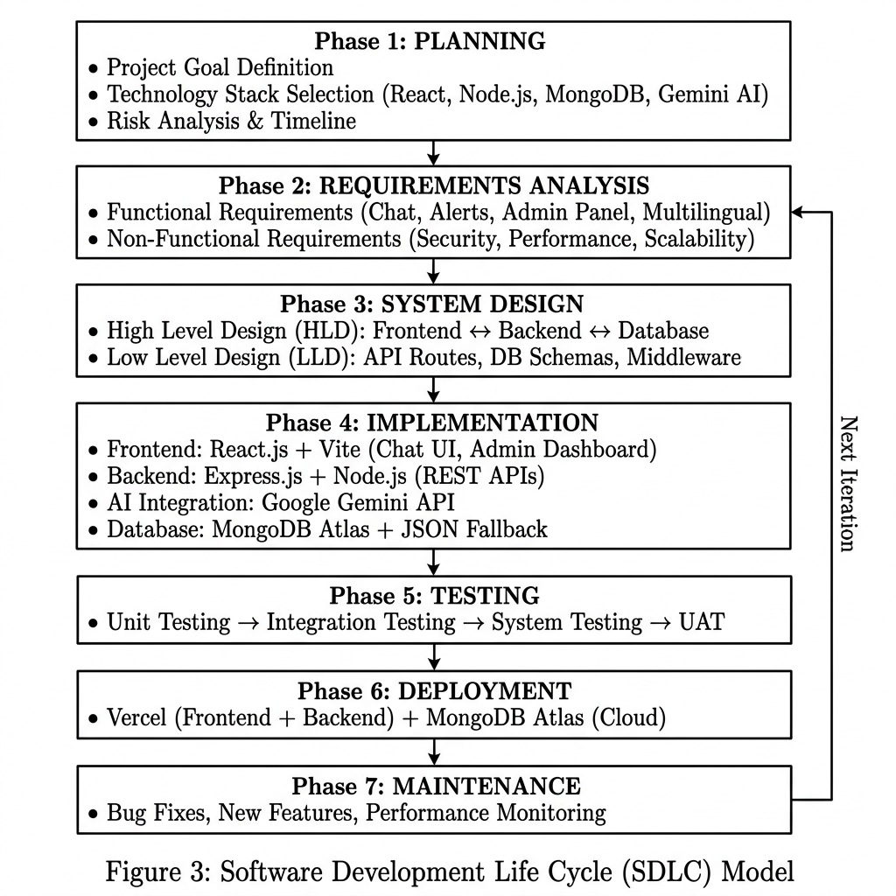
Figure 3(a): SDLC Flowchart — AI-Generated Visual

