**IIQ POC**

The IIQ POC has been created using the below software products,

a. BDD-Cucumber – is a test automation tool written in Gherkin format to support Behavior driven development.

b. Selenium WebDriver – creates browser based robust automation test scripts.

c. TestNG – is an open source test automation framework for Java.

d. Java jars – to support the entire framework with an integration of java jar files.

BDD-Cucumber:-

Feature file

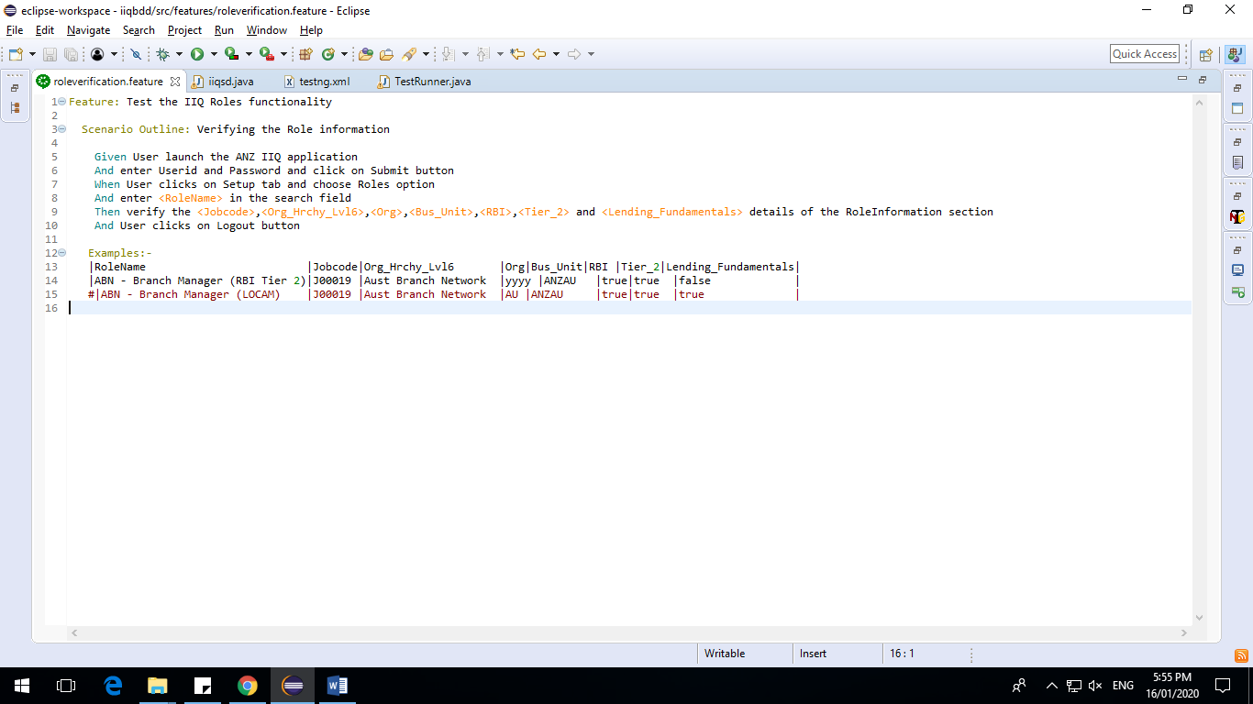

Step Definition file

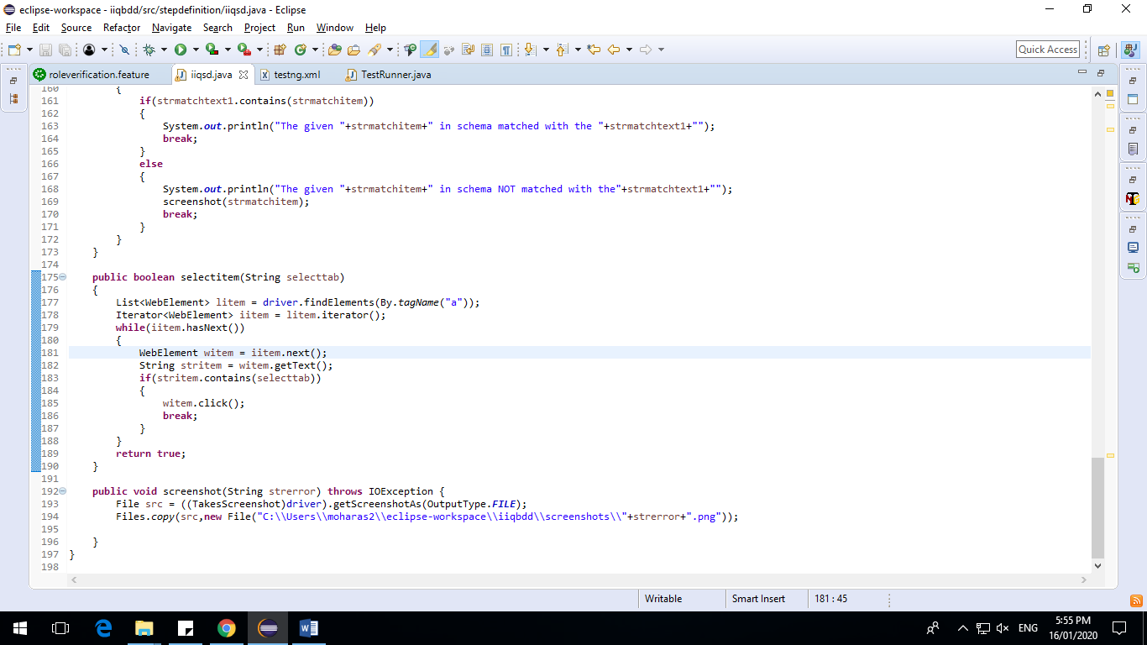

Test Runner file

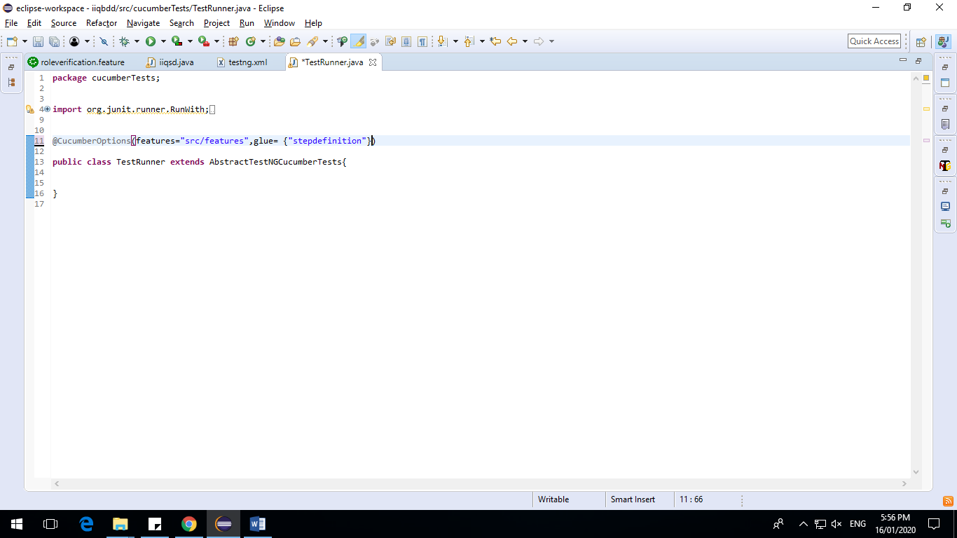

testng.xml

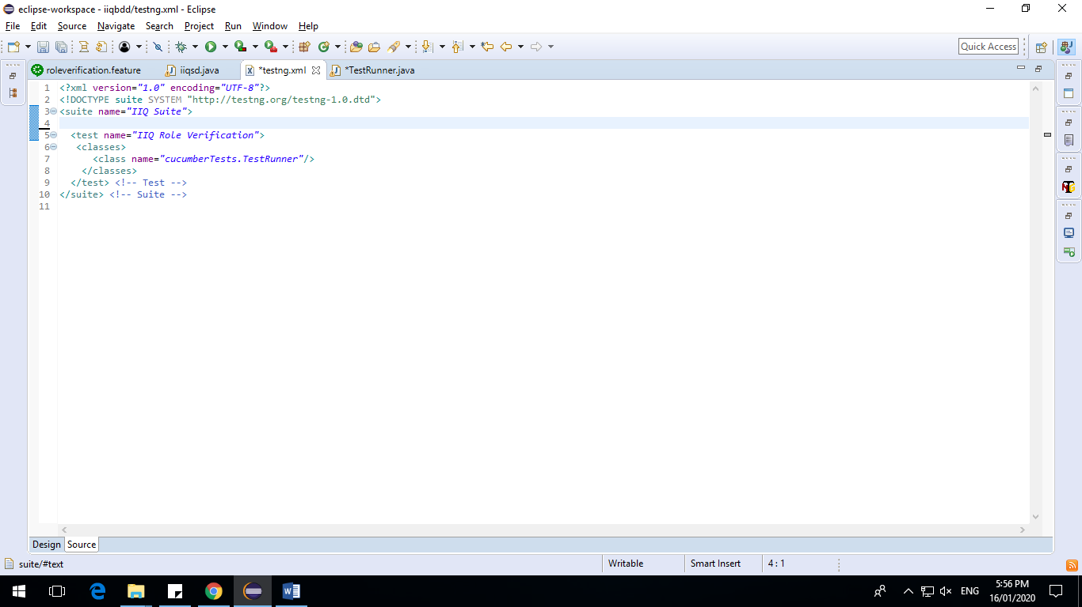

Jars List:-

Selenium server

Cucumber-java

Gherkin

Cucumber-testng

Test script execution:-

Right click on testng.xml file and choose Run->TestNG Suite option.

Reports:-

test-output->emailable-report.html, index.html – generates reports in html format.

The script basically does the User role details validation of the given schema against to the IIQ application, where it compares the given parameters and the values of the schema with the specific role details in the system.

With the help of parameterization, the script is capable of validating multiple Roles with a single feature file. This Role parameters can be extended based on the requirement and that can be validated appropriately.

Once the script is executed, it generates different type of testng reports by providing Suite level information.

Suggestions:-

As an enhancement, the below listed items can be achieved on this framework,

1. Jenkins setup with Continuous Integration & Continuous Deployment.
2. Supports Parallel Testing in both Standalone and Virtual machines – Selenium Grid/Docker etc.
3. Maven Integration along with advanced report plugins & tracking the script execution logs.